**Terms and definitions from Course 1, Module 1**

**Cybersecurity (or security):** The practice of ensuring confidentiality, integrity, and availability of information by protecting networks, devices, people, and data from unauthorized access or criminal exploitation

**Cloud security:** The process of ensuring that assets stored in the cloud are properly configured and access to those assets is limited to authorized users

**Internal threat:** A current or former employee, external vendor, or trusted partner who poses a security risk

**Network security:** The practice of keeping an organization's network infrastructure secure from unauthorized access

**Personally identifiable information (PII):** Any information used to infer an individual’s identity

**Security posture:** An organization’s ability to manage its defense of critical assets and data and react to change

**Sensitive personally identifiable information (SPII):** A specific type of PII that falls under stricter handling guidelines

**Technical skills:** Skills that require knowledge of specific tools, procedures, and policies

**Threat:** Any circumstance or event that can negatively impact assets

**Threat actor:** Any person or group who presents a security risk

**Transferable skills:** Skills from other areas that can apply to different careers

**Phishing**

**Phishing** is the use of digital communications to trick people into revealing sensitive data or deploying malicious software.

Some of the most common types of phishing attacks today include:

* **Business Email Compromise (BEC):** A threat actor sends an email message that seems to be from a known source to make a seemingly legitimate request for information, in order to obtain a financial advantage.
* **Spear phishing:** A malicious email attack that targets a specific user or group of users. The email seems to originate from a trusted source.
* **Whaling:** A form of spear phishing. Threat actors target company executives to gain access to sensitive data.
* **Vishing:** The exploitation of electronic voice communication to obtain sensitive information or to impersonate a known source.
* **Smishing:** The use of text messages to trick users, in order to obtain sensitive information or to impersonate a known source.

**Malware**

**Malware** is software designed to harm devices or networks. There are many types of malware. The primary purpose of malware is to obtain money, or in some cases, an intelligence advantage that can be used against a person, an organization, or a territory.

Some of the most common types of malware attacks today include:

* **Viruses:** Malicious code written to interfere with computer operations and cause damage to data and software. A virus needs to be initiated by a user (i.e., a threat actor), who transmits the virus via a malicious attachment or file download. When someone opens the malicious attachment or download, the virus hides itself in other files in the now infected system. When the infected files are opened, it allows the virus to insert its own code to damage and/or destroy data in the system.
* **Worms:** Malware that can duplicate and spread itself across systems on its own. In contrast to a virus, a worm does not need to be downloaded by a user. Instead, it self-replicates and spreads from an already infected computer to other devices on the same network.
* **Ransomware:** A malicious attack where threat actors encrypt an organization's data and demand payment to restore access.
* **Spyware:** Malware that’s used to gather and sell information without consent. Spyware can be used to access devices. This allows threat actors to collect personal data, such as private emails, texts, voice and image recordings, and locations.

**Social Engineering**

**Social engineering** is a manipulation technique that exploits human error to gain private information, access, or valuables. Human error is usually a result of trusting someone without question. It’s the mission of a threat actor, acting as a social engineer, to create an environment of false trust and lies to exploit as many people as possible.

Some of the most common types of social engineering attacks today include:

* **Social media phishing:** A threat actor collects detailed information about their target from social media sites. Then, they initiate an attack.
* **Watering hole attack:** A threat actor attacks a website frequently visited by a specific group of users.
* **USB baiting:** A threat actor strategically leaves a malware USB stick for an employee to find and install, to unknowingly infect a network.
* **Physical social engineering:** A threat actor impersonates an employee, customer, or vendor to obtain unauthorized access to a physical location.

**Social engineering principles**

Social engineering is incredibly effective. This is because people are generally trusting and conditioned to respect authority. The number of social engineering attacks is increasing with every new social media application that allows public access to people's data. Although sharing personal data—such as your location or photos—can be convenient, it’s also a risk.

Reasons why social engineering attacks are effective include:

* **Authority:** Threat actors impersonate individuals with power. This is because people, in general, have been conditioned to respect and follow authority figures.
* **Intimidation:** Threat actors use bullying tactics. This includes persuading and intimidating victims into doing what they’re told.
* **Consensus/Social proof:** Because people sometimes do things that they believe many others are doing, threat actors use others’ trust to pretend they are legitimate. For example, a threat actor might try to gain access to private data by telling an employee that other people at the company have given them access to that data in the past.
* **Scarcity:** A tactic used to imply that goods or services are in limited supply.
* **Familiarity:** Threat actors establish a fake emotional connection with users that can be exploited.
* **Trust:** Threat actors establish an emotional relationship with users that can be exploited *over time*. They use this relationship to develop trust and gain personal information.
* **Urgency:** A threat actor persuades others to respond quickly and without questioning.

**Understand attackers**

Previously, you were introduced to the concept of threat actors. As a reminder, a **threat actor** is any person or group who presents a security risk. In this reading, you’ll learn about different types of threat actors. You will also learn about their motivations, intentions, and how they’ve influenced the security industry.

**Threat actor types**

**Advanced persistent threats**

Advanced persistent threats (APTs) have significant expertise accessing an organization's network without authorization. APTs tend to research their targets (e.g., large corporations or government entities)  in advance and can remain undetected for an extended period of time. Their intentions and motivations can include:

* Damaging critical infrastructure, such as the power grid and natural resources
* Gaining access to intellectual property, such as trade secrets or patents

**Insider threats**

Insider threats abuse their authorized access to obtain data that may harm an organization. Their intentions and motivations can include:

* Sabotage
* Corruption
* Espionage
* Unauthorized data access or leaks

**Hacktivists**

Hacktivists are threat actors that are driven by a political agenda. They abuse digital technology to accomplish their goals, which may include:

* Demonstrations
* Propaganda
* Social change campaigns
* Fame

**Hacker types**



A **hacker** is any person who uses computers to gain access to computer systems, networks, or data. They can be beginner or advanced technology professionals who use their skills for a variety of reasons. There are three main categories of hackers:

* Authorized hackers are also called ethical hackers. They follow a code of ethics and adhere to the law to conduct organizational risk evaluations. They are motivated to safeguard people and organizations from malicious threat actors.
* Semi-authorized hackers are considered researchers. They search for vulnerabilities but don’t take advantage of the vulnerabilities they find.
* Unauthorized hackers are also called unethical hackers. They are malicious threat actors who do not follow or respect the law. Their goal is to collect and sell confidential data for financial gain.

**Note:** There are multiple hacker types that fall into one or more of these three categories.

New and unskilled threat actors have various goals, including:

* To learn and enhance their hacking skills
* To seek revenge
* To exploit security weaknesses by using existing malware, programming scripts, and other tactics

Other types of hackers are not motivated by any particular agenda other than completing the job they were contracted to do. These types of hackers can be considered unethical or ethical hackers. They have been known to work on both illegal and legal tasks for pay.

There are also hackers who consider themselves vigilantes. Their main goal is to protect the world from unethical hackers.

**Key takeaways**

**Terms and definitions from Course 1, Module 2**

**Adversarial artificial intelligence (AI):** A technique that manipulates artificial intelligence (AI) and machine learning (ML) technology to conduct attacks more efficiently

**Business Email Compromise (BEC):** A type of phishing attack where a threat actor impersonates a known source to obtain financial advantage

**CISSP:** Certified Information Systems Security Professional is a globally recognized and highly sought-after information security certification, awarded by the International Information Systems Security Certification Consortium

**Computer virus:** Malicious code written to interfere with computer operations and cause damage to data and software

**Cryptographic attack:** An attack that affects secure forms of communication between a sender and intended recipient

**Hacker:** Any person who uses computers to gain access to computer systems, networks, or data

**Malware:** Software designed to harm devices or networks

**Password attack:** An attempt to access password secured devices, systems, networks, or data

**Phishing:** The use of digital communications to trick people into revealing sensitive data or deploying malicious software

**Physical attack:** A security incident that affects not only digital but also physical environments where the incident is deployed

**Physical social engineering:** An attack in which a threat actor impersonates an employee, customer, or vendor to obtain unauthorized access to a physical location

**Social engineering:** A manipulation technique that exploits human error to gain private information, access, or valuables

**Social media phishing:** A type of attack where a threat actor collects detailed information about their target on social media sites before initiating the attack

**Spear phishing:** A malicious email attack targeting a specific user or group of users, appearing to originate from a trusted source

**Supply-chain attack:** An attack that targets systems, applications, hardware, and/or software to locate a vulnerability where malware can be deployed

**USB baiting:** An attack in which a threat actor strategically leaves a malware USB stick for an employee to find and install to unknowingly infect a network

**Virus:** refer to “computer virus”

**Vishing:** The exploitation of electronic voice communication to obtain sensitive information or to impersonate a known source

**Watering hole attack**: A type of attack when a threat actor compromises a website frequently visited by a specific group of users

Previously, you were introduced to security frameworks and how they provide a structured approach to implementing a security lifecycle. As a reminder, a security lifecycle is a constantly evolving set of policies and standards. In this reading, you will learn more about how security frameworks, controls, and compliance regulations—or laws—are used together to manage security and make sure everyone does their part to minimize risk.

**How controls, frameworks, and compliance are related**

The **confidentiality, integrity, and availability (CIA) triad** is a model that helps inform how organizations consider risk when setting up systems and security policies.

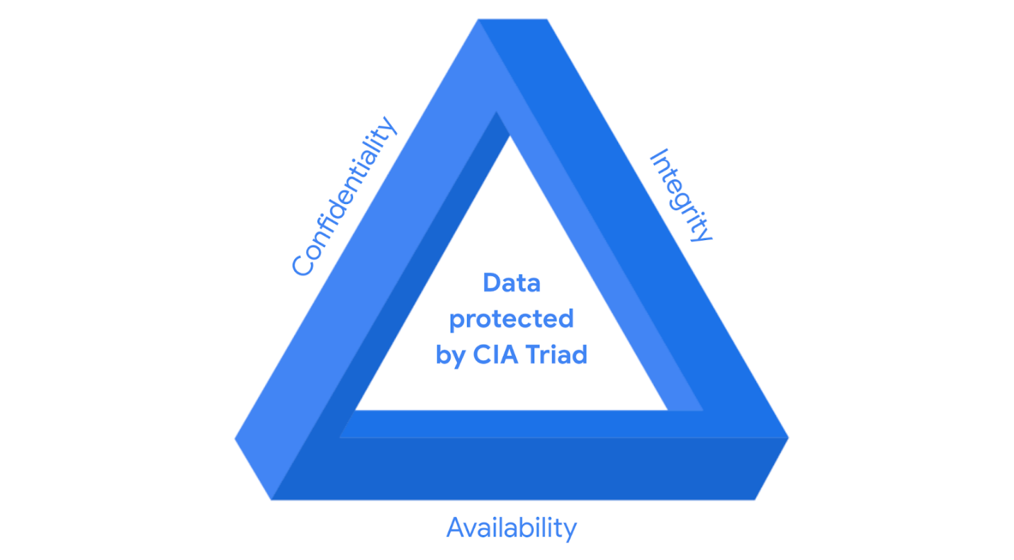

CIA are the three foundational principles used by cybersecurity professionals to establish appropriate controls that mitigate threats, risks, and vulnerabilities.

As you may recall, **security** **controls** are safeguards designed to reduce specific security risks. So they are used alongside frameworks to ensure that security goals and processes are implemented correctly and that organizations meet regulatory compliance requirements.

**Security frameworks** are guidelines used for building plans to help mitigate risks and threats to data and privacy. They have four core components:

1. Identifying and documenting security goals
2. Setting guidelines to achieve security goals
3. Implementing strong security processes
4. Monitoring and communicating results

**Compliance** is the process of adhering to internal standards and external regulations.

**Specific controls, frameworks, and compliance**

The National Institute of Standards and Technology (NIST) is a U.S.-based agency that develops multiple voluntary compliance frameworks that organizations worldwide can use to help manage risk. The more aligned an organization is with compliance, the lower the risk.

Examples of frameworks include the NIST Cybersecurity Framework (CSF) and the NIST Risk Management Framework (RMF).

**Note:** Specifications and guidelines can change depending on the type of organization you work for.

In addition to the [NIST CSF](https://www.nist.gov/cyberframework)

and [NIST RMF](https://csrc.nist.gov/projects/risk-management/about-rmf)

, there are several other controls, frameworks, and compliance standards that it is important for security professionals to be familiar with to help keep organizations and the people they serve safe.

**The Federal Energy Regulatory Commission - North American Electric Reliability Corporation (FERC-NERC)**

FERC-NERC is a regulation that applies to organizations that work with electricity or that are involved with the U.S. and North American power grid. These types of organizations have an obligation to prepare for, mitigate, and report any potential security incident that can negatively affect the power grid. They are also legally required to adhere to the Critical Infrastructure Protection (CIP) Reliability Standards defined by the FERC.

**The Federal Risk and Authorization Management Program (FedRAMP®)**

FedRAMP is a U.S. federal government program that standardizes security assessment, authorization, monitoring, and handling of cloud services and product offerings. Its purpose is to provide consistency across the government sector and third-party cloud providers.

**Center for Internet Security (CIS®)**

CIS is a nonprofit with multiple areas of emphasis. It provides a set of controls that can be used to safeguard systems and networks against attacks. Its purpose is to help organizations establish a better plan of defense. CIS also provides actionable controls that security professionals may follow if a security incident occurs.

**General Data Protection Regulation (GDPR)**

GDPR is a European Union (E.U.) general data regulation that protects the processing of E.U. residents’ data and their right to privacy in and out of E.U. territory. For example, if an organization is not being transparent about the data they are holding about an E.U. citizen and why they are holding that data, this is an infringement that can result in a fine to the organization. Additionally, if a breach occurs and an E.U. citizen’s data is compromised, they must be informed. The affected organization has 72 hours to notify the E.U. citizen about the breach.

**Payment Card Industry Data Security Standard (PCI DSS)**

PCI DSS is an international security standard meant to ensure that organizations storing, accepting, processing, and transmitting credit card information do so in a secure environment. The objective of this compliance standard is to reduce credit card fraud.

**The Health Insurance Portability and Accountability Act (HIPAA)**

HIPAA is a U.S. federal law established in 1996 to protect patients' health information. This law prohibits patient information from being shared without their consent. It is governed by three rules:

1. Privacy
2. Security
3. Breach notification

Organizations that store patient data have a legal obligation to inform patients of a breach because if patients' **Protected Health Information** (PHI) is exposed, it can lead to identity theft and insurance fraud. PHI relates to the past, present, or future physical or mental health or condition of an individual, whether it’s a plan of care or payments for care. Along with understanding HIPAA as a law, security professionals also need to be familiar with the Health Information Trust Alliance (HITRUST®), which is a security framework and assurance program that helps institutions meet HIPAA compliance.

**International Organization for Standardization (ISO)**

ISO was created to establish international standards related to technology, manufacturing, and management across borders. It helps organizations improve their processes and procedures for staff retention, planning, waste, and services.

**System and Organizations Controls (SOC type 1, SOC type 2)**

The American Institute of Certified Public Accountants® (AICPA) auditing standards board developed this standard. The SOC1 and SOC2 are a series of reports that focus on an organization's user access policies at different organizational levels such as:

* Associate
* Supervisor
* Manager
* Executive
* Vendor
* Others

They are used to assess an organization’s financial compliance and levels of risk. They also cover confidentiality, privacy, integrity, availability, security, and overall data safety. Control failures in these areas can lead to fraud.

**Pro tip**: There are a number of regulations that are frequently revised. You are encouraged to keep up-to-date with changes and explore more frameworks, controls, and compliance. Two suggestions to research: the Gramm-Leach-Bliley Act and the Sarbanes-Oxley Act.

**United States Presidential Executive Order 14028**

On May 12, 2021, President Joe Biden released an executive order related to improving the nation’s cybersecurity to remediate the increase in threat actor activity. Remediation efforts are directed toward federal agencies and third parties with ties to U.S. [critical infrastructure](https://csrc.nist.gov/glossary/term/critical_infrastructure#:~:text=Definition(s)%3A,any%20combination%20of%20those%20matters.)

. For additional information, review the [Executive Order on Improving the Nation’s Cybersecurity](https://www.whitehouse.gov/briefing-room/presidential-actions/2021/05/12/executive-order-on-improving-the-nations-cybersecurity/).

**Ethical concepts that guide cybersecurity decisions**

Previously, you were introduced to the concept of security ethics. **Security ethics** are guidelines for making appropriate decisions as a security professional. Being ethical requires that security professionals remain unbiased and maintain the security and confidentiality of private data. Having a strong sense of ethics can help you navigate your decisions as a cybersecurity professional so you’re able to mitigate threats posed by threat actors’ constantly evolving tactics and techniques. In this reading, you’ll learn about more ethical concepts that are essential to know so you can make appropriate decisions about how to legally and ethically respond to attacks in a way that protects organizations and people alike.

**Ethical concerns and laws related to counterattacks**

**United States standpoint on counterattacks**

In the U.S., deploying a counterattack on a threat actor is illegal because of laws like the Computer Fraud and Abuse Act of 1986 and the Cybersecurity Information Sharing Act of 2015, among others. You can only defend. The act of counterattacking in the U.S. is perceived as an act of vigilantism. Avigilante is a person who is not a member of law enforcement who decides to stop a crime on their own. And because threat actors are criminals, counterattacks can lead to further escalation of the attack, which can cause even more damage and harm. Lastly, if the threat actor in question is a state-sponsored hacktivist, a counterattack can lead to serious international implications. A **hacktivist** is a person who uses hacking to achieve a political goal. The political goal may be to promote social change or civil disobedience.

For these reasons, the only individuals in the U.S. who are allowed to counterattack are approved employees of the federal government or military personnel.

**International standpoint on counterattacks**

The International Court of Justice (ICJ), which updates its guidance regularly, states that a person or group can counterattack if:

* The counterattack will only affect the party that attacked first.
* The counterattack is a direct communication asking the initial attacker to stop.
* The counterattack does not escalate the situation.
* The counterattack effects can be reversed.

Organizations typically do not counterattack because the above scenarios and parameters are hard to measure. There is a lot of uncertainty dictating what is and is not lawful, and at times negative outcomes are very difficult to control. Counterattack actions generally lead to a worse outcome, especially when you are not an experienced professional in the field.

To learn more about specific scenarios and ethical concerns from an international perspective, review updates provided in the [Tallinn Manual online](https://ccdcoe.org/research/tallinn-manual/)

.

**Ethical principles and methodologies**

Because counterattacks are generally disapproved of or illegal, the security realm has created frameworks and controls—such as the confidentiality, integrity, and availability (CIA) triad and others discussed earlier in the program—to address issues of confidentiality, privacy protections, and laws. To better understand the relationship between these issues and the ethical obligations of cybersecurity professionals, review the following key concepts as they relate to using ethics to protect organizations and the people they serve.

**Confidentiality** means that only authorized users can access specific assets or data. Confidentiality as it relates to professional ethics means that there needs to be a high level of respect for privacy to safeguard private assets and data.

**Privacy protection** means safeguarding personal information from unauthorized use. Personally identifiable information (PII) and sensitive personally identifiable information (SPII)are types of personal data that can cause people harm if they are stolen. **PII** data is any information used to infer an individual's identity, like their name and phone number. **SPII** data is a specific type of PII that falls under stricter handling guidelines, including social security numbers and credit card numbers. To effectively safeguard PII and SPIIdata, security professionals hold an ethical obligation to secure private information, identify security vulnerabilities, manage organizational risks, and align security with business goals.

**Laws** are rules that are recognized by a community and enforced by a governing entity. As a security professional, you will have an ethical obligation to protect your organization, its internal infrastructure, and the people involved with the organization. To do this:

* You must remain unbiased and conduct your work honestly, responsibly, and with the highest respect for the law.
* Be transparent and just, and rely on evidence.
* Ensure that you are consistently invested in the work you are doing, so you can appropriately and ethically address issues that arise.
* Stay informed and strive to advance your skills, so you can contribute to the betterment of the cyber landscape.

 As an example, consider the **Health Insurance Portability and Accountability Act (HIPAA)**, which is a U.S. federal law established to protect patients' health information, also known as PHI, or protected health information. This law prohibits patient information from being shared without their consent. So, as a security professional, you might help ensure that the organization you work for adheres to both its legal and ethical obligation to inform patients of a breach if their health care data is exposed.

**Key takeaways**

**Terms and definitions from Course 1, Module 3**

**Asset:** An item perceived as having value to an organization

**Availability:** The idea that data is accessible to those who are authorized to access it

**Compliance:** The process of adhering to internal standards and external regulations

**Confidentiality:** The idea that only authorized users can access specific assets or data

**Confidentiality, integrity, availability (CIA) triad:** A model that helps inform how organizations consider risk when setting up systems and security policies

**Hacktivist:** A person who uses hacking to achieve a political goal

**Health Insurance Portability and Accountability Act (HIPAA):** A U.S. federal law established to protect patients' health information

**Integrity:** The idea that the data is correct, authentic, and reliable

**National Institute of Standards and Technology (NIST) Cyber Security Framework (CSF):** A voluntary framework that consists of standards, guidelines, and best practices to manage cybersecurity risk

**Privacy protection:** The act of safeguarding personal information from unauthorized use

**Protected health information (PHI):** Information that relates to the past, present, or future physical or mental health or condition of an individual

**Security architecture:** A type of security design composed of multiple components, such as tools and processes, that are used to protect an organization from risks and external threats

**Security controls:** Safeguards designed to reduce specific security risks

**Security ethics:** Guidelines for making appropriate decisions as a security professional

**Security frameworks:** Guidelines used for building plans to help mitigate risk and threats to data and privacy

**Security governance:** Practices that help support, define, and direct security efforts of an organization

**Sensitive personally identifiable information (SPII):** A specific type of PII that falls under stricter handling guidelines

**An entry-level analyst’s toolkit**

Every organization may provide a different toolkit, depending on its security needs. As a future analyst, it’s important that you are familiar with industry standard tools and can demonstrate your ability to learn how to use similar tools in a potential workplace.



**Security information and event management (SIEM) tools**

A **SIEM tool** is an application that collects and analyzes log data to monitor critical activities in an organization. A **log** is a record of events that occur within an organization’s systems. Depending on the amount of data you’re working with, it could take hours or days to filter through log data on your own. SIEM tools reduce the amount of data an analyst must review by providing alerts for specific types of threats, risks, and vulnerabilities.

SIEM tools provide a series of dashboardsthat visually organize data into categories, allowing users to select the data they wish to analyze. Different SIEM toolshave different dashboard types that display the information you have access to.

SIEM tools also come with different hosting options, including on-premise and cloud. Organizations may choose one hosting option over another based on a security team member’s expertise. For example, because a cloud-hosted version tends to be easier to set up, use, and maintain than an on-premise version, a less experienced security team may choose this option for their organization.

**Network protocol analyzers (packet sniffers)**

A **network protocol analyzer**, also known as a **packet sniffer**, is a tool designed to capture and analyze data traffic in a network. This means that the tool keeps a record of all the data that a computer within an organization's network encounters. Later in the program, you’ll have an opportunity to practice using some common network protocol analyzer (packet sniffer) tools.

**Playbooks**

A **playbook** is a manual that provides details about any operational action, such as how to respond to a security incident. Organizations usually have multiple playbooks documenting processes and procedures for their teams to follow. Playbooks vary from one organization to the next, but they all have a similar purpose: To guide analysts through a series of steps to complete specific security-related tasks.

For example, consider the following scenario: You are working as a security analyst for an incident response firm. You are given a case involving a small medical practice that has suffered a security breach. Your job is to help with the forensic investigation and provide evidence to a cybersecurity insurance company. They will then use your investigative findings to determine whether the medical practice will receive their insurance payout.

In this scenario, playbooks would outline the specific actions you need to take to conduct the investigation. Playbooks also help ensure that you are following proper protocols and procedures. When working on a forensic case, there are two playbooks you might follow:

* The first type of playbook you might consult is called the **chain of custody** playbook.Chain of custody is the process of documenting evidence possession and control during an incident lifecycle. As a security analyst involved in a forensic analysis, you will work with the computer data that was breached. You and the forensic team will also need to document who, what, where, and why you have the collected evidence. The evidence is your responsibility while it is in your possession. Evidence must be kept safe and tracked. Every time evidence is moved, it should be reported. This allows all parties involved to know exactly where the evidence is at all times.
* The second playbook your team might use is called the **protecting and preserving evidence** playbook. Protecting and preserving evidence is the process of properly working with fragile and volatile digital evidence. As a security analyst, understanding what fragile and volatile digital evidence is, along with why there is a procedure, is critical. As you follow this playbook, you will consult the **order of volatility**,which is a sequence outlining the order of data that must be preserved from first to last. It prioritizes volatile data, which is data that may be lost if the device in question powers off, regardless of the reason. While conducting an investigation, improper management of digital evidence can compromise and alter that evidence. When evidence is improperly managed during an investigation, it can no longer be used. For this reason, the first priority in any investigation is to properly preserve the data. You can preserve the data by making copies and conducting your investigation using those copies.
* Previously, you were introduced to programming, operating systems, and tools commonly used by cybersecurity professionals. In this reading, you’ll learn more about programming and operating systems, as well as other tools that entry-level analysts use to help protect organizations and the people they serve.
* **Tools and their purposes**
* **Programming**
* **Programming** is a process that can be used to create a specific set of instructions for a computer to execute tasks. Security analysts use programming languages, such as Python, to execute automation. **Automation** is the use of technology to reduce human and manual effort in performing common and repetitive tasks. Automation also helps reduce the risk of human error.
* Another programming language used by analysts is called Structured Query Language (SQL). **SQL** is used to create, interact with, and request information from a database. A **database** is an organized collection of information or data. There can be millions of data pointsin a database. A **data point** is a specific piece of information.
* **Operating systems**
* An **operating system** is the interface between computer hardware and the user. Linux®, macOS®, and Windows are operating systems. They each offer different functionality and user experiences.
* Previously, you were introduced to **Linux** as an open-source operating system. Open source means that the code is available to the public and allows people to make contributions to improve the software. Linux is not a programming language; however, it does involve the use of a command line within the operating system. A **command** is an instruction telling the computer to do something. A **command-line** interfaceis a text-based user interface that uses commands to interact with the computer. You will learn more about Linux, including the Linux kernel and GNU, in a later course.
* **Web vulnerability**
* A **web vulnerability** is a unique flaw in a web application that a threat actor could exploit by using malicious code or behavior, to allow unauthorized access, data theft, and malware deployment.
* To stay up-to-date on the most critical risks to web applications, review the [Open Web Application Security Project (OWASP) Top 10](https://owasp.org/www-project-top-ten/)
* .
* **Antivirus software**
* **Antivirus software** is a software program used to prevent, detect, and eliminate malware and viruses. It is also called anti-malware. Depending on the type of antivirus software, it can scan the memory of a device to find patterns that indicate the presence of malware.
* **Intrusion detection system**
* An **intrusion detection system** (IDS) is an application that monitors system activity and alerts on possible intrusions. The system scans and analyzes network packets, which carry small amounts of data through a network. The small amount of data makes the detection process easier for an IDS to identify potential threats to sensitive data. Other occurrences an IDS might detect can include theft and unauthorized access.
* **Encryption**
* Encryption makes data unreadable and difficult to decode for an unauthorized user; its main goal is to ensure confidentiality of private data. **Encryption** is the process of converting data from a readable format to a cryptographically encoded format. **Cryptographic encoding** means converting plaintext into secure ciphertext. **Plaintext** is unencrypted information and **secure ciphertext** is the result of encryption.
* **Note:** Encoding and encryption serve different purposes. Encoding uses a public conversion algorithm to enable systems that use different data representations to share information.
* **Penetration testing**
* **Penetration testing**, also called pen testing, is the act of participating in a simulated attack that helps identify vulnerabilities in systems, networks, websites, applications, and processes. It is a thorough risk assessment that can evaluate and identify external and internal threats as well as weaknesses.

**Create a cybersecurity portfolio**

Throughout this certificate program, you will have multiple opportunities to develop a professional cybersecurity portfolio to showcase your security skills and knowledge.

In this reading, you’ll learn what a portfolio is and why it’s important to develop a professional cybersecurity portfolio. You’ll also learn about options for creating an online or self-hosted portfolio that you can share with potential employers when you begin to look for cybersecurity jobs.

**What is a portfolio, and why is it necessary?**

Cybersecurity professionals use portfolios to demonstrate their security education, skills, and knowledge. Professionals typically use portfolios when they apply for jobs to show potential employers that they are passionate about their work and can do the job they are applying for. Portfolios are more in depth than a resume, which is typically a one-to-two page summary of relevant education, work experience, and accomplishments. You will have the opportunity to develop a resume, and finalize your portfolio, in the last course of this program.

**Options for creating your portfolio**

There are many ways to present a portfolio, including self-hosted and online options such as:

* Documents folder
* Google Drive or Dropbox™
* Google Sites
* Git repository

**Option 1: Documents folder**

**Description:** A documents folder is a folder created and saved to your computer’s hard drive. You manage the folder, subfolders, documents, and images within it.

Document folders allow you to have direct access to your documentation. Ensuring that your professional documents, images, and other information are well organized can save you a lot of time when you’re ready to apply for jobs. For example, you may want to create a main folder titled something like “Professional documents.” Then, within your main folder, you could create subfolders with titles such as:

* Resume
* Education
* Portfolio documents
* Cybersecurity tools
* Programming

**Setup:** Document folders can be created in multiple ways, depending on the type of computer you are using. If you’re unsure about how to create a folder on your device, you can search the internet for instructional videos or documents related to the type of computer you use.

**Option 2: Google Drive or Dropbox**

**Description:** Google Drive and Dropbox offer similar features that allow you to store your professional documentation on a cloud platform. Both options also have file-sharing features, so you can easily share your portfolio documents with potential employers. Any additions or changes you make to a document within that folder will be updated automatically for anyone with access to your portfolio.

Similar to a documents folder, keeping your Google Drive or Dropbox-based portfolio well organized will be helpful as you begin or progress through your career.

**Setup:** To learn how to upload and share files on these applications, visit the Google Drive and Dropbox websites for more information.

**Option 3: Google Sites**

**Description:** Google Sites and similar website hosting options have a variety of easy-to-use features to help you present your portfolio items, including customizable layouts, responsive webpages, embedded content capabilities, and web publishing.

Responsive webpages automatically adjust their content to fit a variety of devices and screen sizes. This is helpful because potential employers can review your content using any device and your media will display just as you intend.When you’re ready, you can publish your website and receive a unique URL. You can add this link to your resume so hiring managers can easily access your work.

**Setup:** To learn how to create a website in Google Sites, visit the Google Sites website.

**Option 4: Git repository**

**Description:** A Git repository is a folder within a project. In this instance, the project is your portfolio, and you can use your repository to store the documents, labs, and screenshots you complete during each course of the certificate program. There are several Git repository sites you can use, including:

* GitLab
* Bitbucket™
* GitHub

Each Git repository allows you to showcase your skills and knowledge in a customizable space. To create an online project portfolio on any of the repositories listed, you need to use a version of Markdown.

**Setup:** To learn about how to create a GitHub account and use Markdown, follow the steps outlined in the document [Get started with GitHub](https://docs.google.com/document/d/13nqRTU4H14NFytodh_tbafXthjNRD7aWU_4Cjq7pKG8/template/preview#heading=h.m08l38wqbrm0)

.

**Portfolio projects**

As previously mentioned, you will have multiple opportunities throughout the certificate program to develop items to include in your portfolio. These opportunities include:

* Drafting a professional statement
* Conducting a security audit
* Analyzing network structure and security
* Using Linux commands to manage file permissions
* Applying filters to SQL queries
* Identifying vulnerabilities for a small business
* Documenting incidents with an incident handler’s journal
* Importing and parsing a text file in a security-related scenario
* Creating or revising a resume

**Note:** Do not include any private, copyrighted, or proprietary documents in your portfolio. Also, if you use one of the sites described in this reading, keep your site set to “private” until it is finalized.

**Terms and definitions from Course 1, Module 4**

**Antivirus software:** A software program used to prevent, detect, and eliminate malware and viruses

**Database:** An organized collection of information or data

**Data point:** A specific piece of information

**Intrusion detection system (IDS):** An application that monitors system activity and alerts on possible intrusions

**Linux:** An open-source operating system

**Log:** A record of events that occur within an organization’s systems

**Network protocol analyzer (packet sniffer):** A tool designed to capture and analyze data traffic within a network

**Order of volatility:** A sequence outlining the order of data that must be preserved from first to last

**Programming:** A process that can be used to create a specific set of instructions for a computer to execute tasks

**Protecting and preserving evidence:** The process of properly working with fragile and volatile digital evidence

**Security information and event management (SIEM)**: An application that collects and analyzes log data to monitor critical activities in an organization

**SQL (Structured Query Language):** A programming language used to create, interact with, and request information from a database

**Domain one: Security and risk management**

All organizations must develop their security posture. Security posture is an organization’s ability to manage its defense of critical assets and data and react to change. Elements of the security and risk management domain that impact an organization's security posture include:

* Security goals and objectives
* Risk mitigation processes
* Compliance
* Business continuity plans
* Legal regulations
* Professional and organizational ethics

Information security, or InfoSec, is also related to this domain and refers to a set of processes established to secure information. An organization may use playbooks and implement training as a part of their security and risk management program, based on their needs and perceived risk. There are many InfoSec design processes, such as:

* Incident response
* Vulnerability management
* Application security
* Cloud security
* Infrastructure security

As an example, a security team may need to alter how personally identifiable information (PII) is treated in order to adhere to the European Union's General Data Protection Regulation (GDPR).

**Domain two: Asset security**

Asset security involves managing the cybersecurity processes of organizational assets, including the storage, maintenance, retention, and destruction of physical and virtual data. Because the loss or theft of assets can expose an organization and increase the level of risk, keeping track of assets and the data they hold is essential. Conducting a security impact analysis, establishing a recovery plan, and managing data exposure will depend on the level of risk associated with each asset. Security analysts may need to store, maintain, and retain data by creating backups to ensure they are able to restore the environment if a security incident places the organization’s data at risk.

**Domain three: Security architecture and engineering**

This domain focuses on managing data security. Ensuring effective tools, systems, and processes are in place helps protect an organization’s assets and data. Security architects and engineers create these processes.

One important aspect of this domain is the concept of shared responsibility. Shared responsibility means all individuals involved take an active role in lowering risk during the design of a security system. Additional design principles related to this domain, which are discussed later in the program, include:

* Threat modeling
* Least privilege
* Defense in depth
* Fail securely
* Separation of duties
* Keep it simple
* Zero trust
* Trust but verify

An example of managing data is the use of a security information and event management (SIEM) tool to monitor for flags related to unusual login or user activity that could indicate a threat actor is attempting to access private data.

**Domain four: Communication and network security**

This domain focuses on managing and securing physical networks and wireless communications. This includes on-site, remote, and cloud communications.

Organizations with remote, hybrid, and on-site work environments must ensure data remains secure, but managing external connections to make certain that remote workers are securely accessing an organization’s networks is a challenge. Designing network security controls—such as restricted network access—can help protect users and ensure an organization’s network remains secure when employees travel or work outside of the main office.

**Domain five: Identity and access management**

The identity and access management (IAM) domain focuses on keeping data secure. It does this by ensuring user identities are trusted and authenticated and that access to physical and logical assets is authorized. This helps prevent unauthorized users, while allowing authorized users to perform their tasks.

Essentially, IAM uses what is referred to as the principle of least privilege, which is the concept of granting only the minimal access and authorization required to complete a task. As an example, a cybersecurity analyst might be asked to ensure that customer service representatives can only view the private data of a customer, such as their phone number, while working to resolve the customer's issue; then remove access when the customer's issue is resolved.

**Domain six: Security assessment and testing**

The security assessment and testing domain focuses on identifying and mitigating risks, threats, and vulnerabilities. Security assessments help organizations determine whether their internal systems are secure or at risk. Organizations might employ penetration testers, often referred to as “pen testers,” to find vulnerabilities that could be exploited by a threat actor.

This domain suggests that organizations conduct security control testing, as well as collect and analyze data. Additionally, it emphasizes the importance of conducting security audits to monitor for and reduce the probability of a data breach. To contribute to these types of tasks, cybersecurity professionals may be tasked with auditing user permissions to validate that users have the correct levels of access to internal systems.

**Domain seven: Security operations**

The security operations domain focuses on the investigation of a potential data breach and the implementation of preventative measures after a security incident has occurred. This includes using strategies, processes, and tools such as:

* Training and awareness
* Reporting and documentation
* Intrusion detection and prevention
* SIEM tools
* Log management
* Incident management
* Playbooks
* Post-breach forensics
* Reflecting on lessons learned

The cybersecurity professionals involved in this domain work as a team to manage, prevent, and investigate threats, risks, and vulnerabilities. These individuals are trained to handle active attacks, such as large amounts of data being accessed from an organization's internal network, outside of normal working hours. Once a threat is identified, the team works diligently to keep private data and information safe from threat actors.

**Domain eight: Software development security**

The software development security domain is focused on using secure programming practices and guidelines to create secure applications. Having secure applications helps deliver secure and reliable services, which helps protect organizations and their users.

Security must be incorporated into each element of the software development life cycle, from design and development to testing and release. To achieve security, the software development process must have security in mind at each step. Security cannot be an afterthought.

Performing application security tests can help ensure vulnerabilities are identified and mitigated accordingly. Having a system in place to test the programming conventions, software executables, and security measures embedded in the software is necessary. Having quality assurance and pen tester professionals ensure the software has met security and performance standards is also an essential part of the software development process. For example, an entry-level analyst working for a pharmaceutical company might be asked to make sure encryption is properly configured for a new medical device that will store private patient data.

# Control categories

## Control categories

Controls within cybersecurity are grouped into three main categories:

* Administrative/Managerial controls
* Technical controls
* Physical controls

**Administrative/Managerial controls** address the human component of cybersecurity. These controls include policies and procedures that define how an organization manages data and clearly defines employee responsibilities, including their role in protecting the organization. While administrative controls are typically policy based, the enforcement of those policies may require the use of technical or physical controls.

**Technical controls** consist of solutions such as firewalls, intrusion detection systems (IDS), intrusion prevention systems (IPS), antivirus (AV) products, encryption, etc. Technical controls can be used in a number of ways to meet organizational goals and objectives.

**Physical controls** include door locks, cabinet locks, surveillance cameras, badge readers, etc. They are used to limit physical access to physical assets by unauthorized personnel.

## Control types

Control types include, but are not limited to:

1. Preventative
2. Corrective
3. Detective
4. Deterrent

These controls work together to provide defense in depth and protect assets. **Preventative controls** are designed to prevent an incident from occurring in the first place. **Corrective controls** are used to restore an asset after an incident. **Detective controls** are implemented to determine whether an incident has occurred or is in progress. **Deterrent controls** are designed to discourage attacks.

Review the following charts for specific details about each type of control and its purpose.

| **Administrative Controls** | | |
| --- | --- | --- |
| **Control Name** | **Control Type** | **Control Purpose** |
| Least Privilege | Preventative | Reduce risk and overall impact of malicious insider or compromised accounts |
| Disaster recovery plans | Corrective | Provide business continuity |
| Password policies | Preventative | Reduce likelihood of account compromise through brute force or dictionary attack techniques |
| Access control policies | Preventative | Bolster confidentiality and integrity by defining which groups can access or modify data |
| Account management policies | Preventative | Managing account lifecycle, reducing attack surface, and limiting overall impact from disgruntled former employees and default account usage |
| Separation of duties | Preventative | Reduce risk and overall impact of malicious insider or compromised accounts |

|  |  |  |
| --- | --- | --- |
| **Technical Controls** | | |
| **Control Name** | **Control Type** | **Control Purpose** |
| Firewall | Preventative | To filter unwanted or malicious traffic from entering the network |
| IDS/IPS | Detective | To detect and prevent anomalous traffic that matches a signature or rule |
| Encryption | Deterrent | Provide confidentiality to sensitive information |
| Backups | Corrective | Restore/recover from an event |
| Password management | Preventative | Reduce password fatigue |
| Antivirus (AV) software | Corrective | Detect and quarantine known threats |
| Manual monitoring, maintenance, and intervention | Preventative | Necessary to identify and manage threats, risks, or vulnerabilities to out-of-date systems |

|  |  |  |
| --- | --- | --- |
| **Physical Controls** | | |
| **Control Name** | **Control Type** | **Control Purpose** |
| Time-controlled safe | Deterrent | Reduce attack surface and overall impact from physical threats |
| Adequate lighting | Deterrent | Deter threats by limiting “hiding” places |
| Closed-circuit television (CCTV) | Preventative/Detective | Closed circuit television is both a preventative and detective control because it’s presence can reduce risk of certain types of events from occurring, and can be used after an event to inform on event conditions |
| Locking cabinets (for network gear) | Preventative | Bolster integrity by preventing unauthorized personnel and other individuals from physically accessing or modifying network infrastructure gear |
| Signage indicating alarm service provider | Deterrent | Deter certain types of threats by making the likelihood of a successful attack seem low |
| Locks | Deterrent/Preventative | Bolster integrity by deterring and preventing unauthorized personnel, individuals from physically accessing assets |
| Fire detection and prevention (fire alarm, sprinkler system, etc.) | Detective/Preventative | Detect fire in physical location and prevent damage to physical assets such as inventory, servers, etc. |

# More about security audits

Previously, you were introduced to how to plan and complete an internal security audit. In this reading, you will learn more about security audits, including the goals and objectives of audits.

## Security audits

A **security audit** is a review of an organization's security controls, policies, and procedures against a set of expectations. Audits are independent reviews that evaluate whether an organization is meeting internal and external criteria. Internal criteria include outlined policies, procedures, and best practices. External criteria include regulatory compliance, laws, and federal regulations.

Additionally, a security audit can be used to assess an organization's established security controls. As a reminder, **security controls** are safeguards designed to reduce specific security risks.

Audits help ensure that security checks are made (i.e., daily monitoring of security information and event management dashboards), to identify threats, risks, and vulnerabilities. This helps maintain an organization’s security posture. And, if there are security issues, a remediation process must be in place.

## Goals and objectives of an audit

The goal of an audit is to ensure an organization's information technology (IT) practices are meeting industry and organizational standards. The objective is to identify and address areas of remediation and growth. Audits provide direction and clarity by identifying what the current failures are and developing a plan to correct them.

Security audits must be performed to safeguard data and avoid penalties and fines from governmental agencies. The frequency of audits is dependent on local laws and federal compliance regulations.

## Factors that affect audits

Factors that determine the types of audits an organization implements include:

* Industry type
* Organization size
* Ties to the applicable government regulations
* A business’s geographical location
* A business decision to adhere to a specific regulatory compliance

To review common compliance regulations that different organizations need to adhere to, refer to [the reading about controls, frameworks, and compliance](https://www.coursera.org/learn/foundations-of-cybersecurity/supplement/xu4pr/controls-frameworks-and-compliance)

.

## The role of frameworks and controls in audits

Along with compliance, it’s important to mention the role of frameworks and controls in security audits. Frameworks such as the National Institute of Standards and Technology Cybersecurity Framework (NIST CSF) and the international standard for information security (ISO 27000) series are designed to help organizations prepare for regulatory compliance security audits. By adhering to these and other relevant frameworks, organizations can save time when conducting external and internal audits. Additionally, frameworks, when used alongside controls, can support organizations’ ability to align with regulatory compliance requirements and standards.

There are three main categories of controls to review during an audit, which are administrative and/or managerial, technical, and physical controls. To learn more about specific controls related to each category, click the following link and select “Use Template.”

Link to template: [Control categories](https://docs.google.com/document/d/1Ut_H5A9FHwuQEy6_qG6Lfy3zwF6GSJnj3DZTMaNRWEE/template/preview?resourcekey=0-i4dR5qZFqQyfzr8uk3OOmA)

OR

If you don’t have a Google account, you can download the template directly from the following attachment

## Audit checklist

It’s necessary to create an audit checklist before conducting an audit. A checklist is generally made up of the following areas of focus:

**Identify the scope of the audit**

* The audit should:
  + List assets that will be assessed (e.g., firewalls are configured correctly, PII is secure, physical assets are locked, etc.)
  + Note how the audit will help the organization achieve its desired goals
  + Indicate how often an audit should be performed
  + Include an evaluation of organizational policies, protocols, and procedures to make sure they are working as intended and being implemented by employees

**Complete a risk assessment**

* A risk assessment is used to evaluate identified organizational risks related to budget, controls, internal processes, and external standards (i.e., regulations).

**Conduct the audit**

* When conducting an internal audit, you will assess the security of the identified assets listed in the audit scope.

**Create a mitigation plan**

* A mitigation plan is a strategy established to lower the level of risk and potential costs, penalties, or other issues that can negatively affect the organization’s security posture.

**Communicate results to stakeholders**

* The end result of this process is providing a detailed report of findings, suggested improvements needed to lower the organization's level of risk, and compliance regulations and standards the organization needs to adhere to.

## Key takeaways

# Glossary terms from module 2

## **Terms and definitions from Course 2, Module 2**

**Asset:** An item perceived as having value to an organization

**Attack vectors:** The pathways attackers use to penetrate security defenses

**Authentication:** The process of verifying who someone is

**Authorization:** The concept of granting access to specific resources in a system

**Availability:** The idea that data is accessible to those who are authorized to access it

**Biometrics:** The unique physical characteristics that can be used to verify a person’s identity

**Confidentiality:** The idea that only authorized users can access specific assets or data

**Confidentiality, integrity, availability (CIA) triad:** A model that helps inform how organizations consider risk when setting up systems and security policies

**Detect:** A NIST core function related to identifying potential security incidents and improving monitoring capabilities to increase the speed and efficiency of detections

**Encryption:** The process of converting data from a readable format to an encoded format

**Identify**: A NIST core function related to management of cybersecurity risk and its effect on an organization’s people and assets

**Integrity:** The idea that the data is correct, authentic, and reliable

**National Institute of Standards and Technology (NIST) Cybersecurity Framework (CSF):** A voluntary framework that consists of standards, guidelines, and best practices to manage cybersecurity risk

**National Institute of Standards and Technology (NIST) Special Publication (S.P.) 800-53:** A unified framework for protecting the security of information systems within the U.S. federal government

**Open Web Application Security Project/Open Worldwide Application Security Project (OWASP):** A non-profit organization focused on improving software security

**Protect:** A NIST core function used to protect an organization through the implementation of policies, procedures, training, and tools that help mitigate cybersecurity threats

**Recover:** A NIST core function related to returning affected systems back to normal operation

**Respond:** A NIST core function related to making sure that the proper procedures are used to contain, neutralize, and analyze security incidents, and implement improvements to the security process

**Risk:** Anything that can impact the confidentiality, integrity, or availability of an asset

**Security audit:** A review of an organization's security controls, policies, and procedures against a set of expectations

**Security controls:** Safeguards designed to reduce specific security risks

**Security frameworks:** Guidelines used for building plans to help mitigate risk and threats to data and privacy

**Security posture:** An organization’s ability to manage its defense of critical assets and data and react to change

**Threat:** Any circumstance or event that can negatively impact assets

# The future of SIEM tools

Previously, you were introduced to security information and event management (SIEM) tools, along with a few examples of SIEM tools. In this reading, you will learn more about how SIEM tools are used to protect organizational operations. You will also gain insight into how and why SIEM tools are changing to help protect organizations and the people they serve from evolving threat actor tactics and techniques.

## Current SIEM solutions

A **SIEM** tool is an application that collects and analyzes log data to monitor critical activities in an organization. SIEM tools offer real-time monitoring and tracking of security event logs. The data is then used to conduct a thorough analysis of any potential security threat, risk, or vulnerability identified. SIEM tools have many dashboard options. Each dashboard option helps cybersecurity team members manage and monitor organizational data. However, currently, SIEM tools require human interaction for analysis of security events.

## The future of SIEM tools

As cybersecurity continues to evolve, the need for cloud functionality has increased. SIEM tools have and continue to evolve to function in cloud-hosted and cloud-native environments. Cloud-hosted SIEM tools are operated by vendors who are responsible for maintaining and managing the infrastructure required to use the tools. Cloud-hosted tools are simply accessed through the internet and are an ideal solution for organizations that don’t want to invest in creating and maintaining their own infrastructure.

Similar to cloud-hosted SIEM tools, cloud-native SIEM tools are also fully maintained and managed by vendors and accessed through the internet. However, cloud-native tools are designed to take full advantage of cloud computing capabilities, such as availability, flexibility, and scalability.

Yet, the evolution of SIEM tools is expected to continue in order to accommodate the changing nature of technology, as well as new threat actor tactics and techniques. For example, consider the current development of interconnected devices with access to the internet, known as the Internet of Things (IoT). The more interconnected devices there are, the larger the cybersecurity attack surface and the amount of data that threat actors can exploit. The diversity of attacks and data that require special attention is expected to grow significantly. Additionally, as artificial intelligence (AI) and machine learning (ML) technology continues to progress, SIEM capabilities will be enhanced to better identify threat-related terminology, dashboard visualization, and data storage functionality.

The implementation of automation will also help security teams respond faster to possible incidents, performing many actions without waiting for a human response. **Security orchestration, automation, and response (SOAR)** is a collection of applications, tools, and workflows that uses automation to respond to security events. Essentially, this means that handling common security-related incidents with the use of SIEM tools is expected to become a more streamlined process requiring less manual intervention. This frees up security analysts to handle more complex and uncommon incidents that, consequently, can’t be automated with a SOAR. Nevertheless, the expectation is for cybersecurity-related platforms to communicate and interact with one another. Although the technology allowing interconnected systems and devices to communicate with each other exists, it is still a work in progress.

# More about cybersecurity tools

Previously, you learned about several tools that are used by cybersecurity team members to monitor for and identify potential security threats, risks, and vulnerabilities. In this reading, you’ll learn more about common open-source and proprietary cybersecurity tools that you may use as a cybersecurity professional.

## Open-source tools

Open-source tools are often free to use and can be user friendly. The objective of open-source tools is to provide users with software that is built by the public in a collaborative way, which can result in the software being more secure. Additionally, open-source tools allow for more customization by users, resulting in a variety of new services built from the same open-source software package.

Software engineers create open-source projects to improve software and make it available for anyone to use, as long as the specified license is respected. The source code for open-source projects is readily available to users, as well as the training material that accompanies them. Having these sources readily available allows users to modify and improve project materials.

## Proprietary tools

Proprietary tools are developed and owned by a person or company, and users typically pay a fee for usage and training. The owners of proprietary tools are the only ones who can access and modify the source code. This means that users generally need to wait for updates to be made to the software, and at times they might need to pay a fee for those updates. Proprietary software generally allows users to modify a limited number of features to meet individual and organizational needs. Examples of proprietary tools include Splunk® and Chronicle SIEM tools.

### **Common misconceptions**

There is a common misconception that open-source tools are less effective and not as safe to use as proprietary tools. However, developers have been creating open-source materials for years that have become industry standards. Although it is true that threat actors have attempted to manipulate open-source tools, because these tools are open source it is actually harder for people with malicious intent to successfully cause harm. The wide exposure and immediate access to the source code by well-intentioned and informed users and professionals makes it less likely for issues to occur, because they can fix issues as soon as they’re identified.

## Examples of open-source tools

In security, there are many tools in use that are open-source and commonly available. Two examples are Linux and Suricata.

### **Linux**

Linux is an open-source operating system that is widely used. It allows you to tailor the operating system to your needs using a command-line interface. An **operating system** is the interface between computer hardware and the user. It’s used to communicate with the hardware of a computer and manage software applications.

There are multiple versions of Linux that exist to accomplish specific tasks. Linux and its command-line interface will be discussed in detail, later in the certificate program.

### **Suricata**

Suricata is an open-source network analysis and threat detection software.  Network analysis and threat detection software is used to inspect network traffic to identify suspicious behavior and generate network data logs. The detection software finds activity across users, computers, or Internet Protocol (IP) addresses to help uncover potential threats, risks, or vulnerabilities.

Suricata was developed by the Open Information Security Foundation (OISF). OISF is dedicated to maintaining open-source use of the Suricata project to ensure it’s free and publicly available. Suricata is widely used in the public and private sector, and it integrates with many SIEM tools and other security tools. Suricata will also be discussed in greater detail later in the program.

# Use SIEM tools to protect organizations

Previously, you were introduced to security information and event management (SIEM) tools and a few SIEM dashboards. You also learned about different threats, risks, and vulnerabilities an organization may experience. In this reading, you will learn more about SIEM dashboard data and how cybersecurity professionals use that data to identify a potential threat, risk, or vulnerability.

## Splunk

Splunk offers different SIEM tool options: Splunk® Enterprise and Splunk® Cloud. Both allow you to review an organization's data on dashboards. This helps security professionals manage an organization's internal infrastructure by collecting, searching, monitoring, and analyzing log data from multiple sources to obtain full visibility into an organization’s everyday operations.

Review the following Splunk dashboards and their purposes:

### **Security posture dashboard**

The security posture dashboard is designed for security operations centers (SOCs). It displays the last 24 hours of an organization’s notable security-related events and trends and allows security professionals to determine if security infrastructure and policies are performing as designed. Security analysts can use this dashboard to monitor and investigate potential threats in real time, such as suspicious network activity originating from a specific IP address.

### **Executive summary dashboard**

The executive summary dashboard analyzes and monitors the overall health of the organization over time. This helps security teams improve security measures that reduce risk. Security analysts might use this dashboard to provide high-level insights to stakeholders, such as generating a summary of security incidents and trends over a specific period of time.

### **Incident review dashboard**

The incident review dashboard allows analysts to identify suspicious patterns that can occur in the event of an incident. It assists by highlighting higher risk items that need immediate review by an analyst. This dashboard can be very helpful because it provides a visual timeline of the events leading up to an incident.

### **Risk analysis dashboard**

The risk analysis dashboard helps analysts identify risk for each risk object (e.g., a specific user, a computer, or an IP address). It shows changes in risk-related activity or behavior, such as a user logging in outside of normal working hours or unusually high network traffic from a specific computer. A security analyst might use this dashboard to analyze the potential impact of vulnerabilities in critical assets, which helps analysts prioritize their risk mitigation efforts.

## Chronicle

Chronicle is a cloud-native SIEM tool from Google that retains, analyzes, and searches log data to identify potential security threats, risks, and vulnerabilities. Chronicle allows you to collect and analyze log data according to:

* A specific asset
* A domain name
* A user
* An IP address

Chronicle provides multiple dashboards that help analysts monitor an organization’s logs, create filters and alerts, and track suspicious domain names.

Review the following Chronicle dashboards and their purposes:

### **Enterprise insights dashboard**

The enterprise insights dashboard highlights recent alerts. It identifies suspicious domain names in logs, known as indicators of compromise (IOCs). Each result is labeled with a confidence score to indicate the likelihood of a threat. It also provides a severity level that indicates the significance of each threat to the organization. A security analyst might use this dashboard to monitor login or data access attempts related to a critical asset—like an application or system—from unusual locations or devices.

### **Data ingestion and health** **dashboard**

The data ingestion and health dashboard shows the number of event logs, log sources, and success rates of data being processed into Chronicle. A security analyst might use this dashboard to ensure that log sources are correctly configured and that logs are received without error. This helps ensure that log related issues are addressed so that the security team has access to the log data they need.

### **IOC** **matches** **dashboard**

The IOC matches dashboard indicates the top threats, risks, and vulnerabilities to the organization. Security professionals use this dashboard to observe domain names, IP addresses, and device IOCs over time in order to identify trends. This information is then used to direct the security team’s focus to the highest priority threats. For example, security analysts can use this dashboard to search for additional activity associated with an alert, such as a suspicious user login from an unusual geographic location.

### **Main** **dashboard**

The main dashboard displays a high-level summary of information related to the organization’s data ingestion, alerting, and event activity over time. Security professionals can use this dashboard to access a timeline of security events—such as a spike in failed login attempts— to identify threat trends across log sources, devices, IP addresses, and physical locations.

### **Rule detections** **dashboard**

The rule detections dashboard provides statistics related to incidents with the highest occurrences, severities, and detections over time. Security analysts can use this dashboard to access a list of all the alerts triggered by a specific detection rule, such as a rule designed to alert whenever a user opens a known malicious attachment from an email. Analysts then use those statistics to help manage recurring incidents and establish mitigation tactics to reduce an organization's level of risk.

### **User sign in overview** **dashboard**

The user sign in overview dashboard provides information about user access behavior across the organization. Security analysts can use this dashboard to access a list of all user sign-in events to identify unusual user activity, such as a user signing in from multiple locations at the same time. This information is then used to help mitigate threats, risks, and vulnerabilities to user accounts and the organization’s applications.

# Glossary terms from module 3

## Terms and definitions from Course 2, Module 3

**Chronicle:** A cloud-native tool designed to retain, analyze, and search data

**Incident response:** An organization’s quick attempt to identify an attack, contain the damage, and correct the effects of a security breach

**Log:** A record of events that occur within an organization’s systems

**Metrics:** Key technical attributes such as response time, availability, and failure rate, which are used to assess the performance of a software application

**Operating system (OS):** The interface between computer hardware and the user

**Playbook:** A manual that provides details about any operational action

**Security information and event management (SIEM):** An application that collects and analyzes log data to monitor critical activities in an organization

**Security orchestration, automation, and response (SOAR):** A collection of applications, tools, and workflows that use automation to respond to security events

**SIEM tools:** A software platform that collects, analyzes, and correlates security data from various sources across your IT infrastructure that helps identify and respond to security threats in real-time, investigate security incidents, and comply with security regulations

**Splunk Cloud:** A cloud-hosted tool used to collect, search, and monitor log data

**Splunk Enterprise:** A self-hosted tool used to retain, analyze, and search an organization's log data to provide security information and alerts in real-time

# More about playbooks

Previously, you learned that playbooks are tools used by cybersecurity professionals to identify and respond to security issues. In this reading, you’ll learn more about playbooks and their purpose in the field of cybersecurity.

## Playbook overview

A **playbook** is a manual that provides details about any operational action. Essentially, a playbook provides a predefined and up-to-date list of steps to perform when responding to an incident.



Playbooks are accompanied by a strategy. The strategy outlines expectations of team members who are assigned a task, and some playbooks also list the individuals responsible. The outlined expectations are accompanied by a plan. The plan dictates how the specific task outlined in the playbook must be completed.

Playbooks should be treated as living documents, which means that they are frequently updated by security team members to address industry changes and new threats. Playbooks are generally managed as a collaborative effort, since security team members have different levels of expertise.

Updates are often made if:

* A failure is identified, such as an oversight in the outlined policies and procedures, or in the playbook itself.
* There is a change in industry standards, such as changes in laws or regulatory compliance.
* The cybersecurity landscape changes due to evolving threat actor tactics and techniques.

## Types of playbooks

Playbooks sometimes cover specific incidents and vulnerabilities. These might include ransomware, vishing, business email compromise (BEC), and other attacks previously discussed. Incident and vulnerability response playbooks are very common, but they are not the only types of playbooks organizations develop.

Each organization has a different set of playbook tools, methodologies, protocols, and procedures that they adhere to, and different individuals are involved at each step of the response process, depending on the country they are in. For example, incident notification requirements from government-imposed laws and regulations, along with compliance standards, affect the content in the playbooks. These requirements are subject to change based on where the incident originated and the type of data affected.

### **Incident and vulnerability response playbooks**

Incident and vulnerability response playbooks are commonly used by entry-level cybersecurity professionals. They are developed based on the goals outlined in an organization’s business continuity plan. A business continuity plan is an established path forward allowing a business to recover and continue to operate as normal, despite a disruption like a security breach.

These two types of playbooks are similar in that they both contain predefined and up-to-date lists of steps to perform when responding to an incident. Following these steps is necessary to ensure that you, as a security professional, are adhering to legal and organizational standards and protocols. These playbooks also help minimize errors and ensure that important actions are performed within a specific timeframe.

When an incident, threat, or vulnerability occurs or is identified, the level of risk to the organization depends on the potential damage to its assets. A basic formula for determining the level of risk is that risk equals the likelihood of a threat. For this reason, a sense of urgency is essential. Following the steps outlined in playbooks is also important if any forensic task is being carried out. Mishandling data can easily compromise forensic data, rendering it unusable.

Common steps included in incident and vulnerability playbooks include:

* Preparation
* Detection
* Analysis
* Containment
* Eradication
* Recovery from an incident

Additional steps include performing post-incident activities, and a coordination of efforts throughout the investigation and incident and vulnerability response stages.

# Playbooks, SIEM tools, and SOAR tools

Previously, you learned that security teams encounter threats, risks, vulnerabilities, and incidents on a regular basis and that they follow playbooks to address security-related issues. In this reading, you will learn more about playbooks, including how they are used in security information and event management (SIEM) and security orchestration, automation, and response (SOAR).

## Playbooks and SIEM tools

Playbooks are used by cybersecurity teams in the event of an incident. Playbooks help security teams respond to incidents by ensuring that a consistent list of actions are followed in a prescribed way, regardless of who is working on the case. Playbooks can be very detailed and may include flow charts and tables to clarify what actions to take and in which order. Playbooks are also used for recovery procedures in the event of a ransomware attack. Different types of security incidents have their own playbooks that detail who should take what action and when.

Playbooks are generally used alongside SIEM tools. If, for example, unusual user behavior is flagged by a SIEM tool, a playbook provides analysts with instructions about how to address the issue.

## Playbooks and SOAR tools

Playbooks are also used with SOAR tools. SOAR tools are similar to SIEM tools in that they are used for threat monitoring. SOAR is a piece of software used to automate repetitive tasks generated by tools such as a SIEM or managed detection and response (MDR). For example, if a user attempts to log into their computer too many times with the wrong password, a SOAR would automatically block their account to stop a possible intrusion. Then, analysts would refer to a playbook to take steps to resolve the issue.

# Network components, devices, and diagrams

In this reading, you will review network devices and connections and investigate a simple network diagram similar to those used every day by network security professionals.

A foundational understanding of network architecture, sometimes referred to as network design, will help you as you learn about security vulnerabilities inherent in all networks and how malicious actors attempt to exploit them. Let’s get started!

## **Network devices**

Network devices maintain information and services for users of a network. These devices connect over wired and wireless connections. After establishing a connection to the network, the devices send data packets. The data packets provide information about the source and the destination of the data.  This is how the information is sent and received via different devices on a network.

The network is the overall infrastructure that allows devices to communicate with each other. Network devices are specialized vehicles like routers and switches that manage what is being sent and received over the network. Additionally, devices like computers and phones connect to the network via network devices.

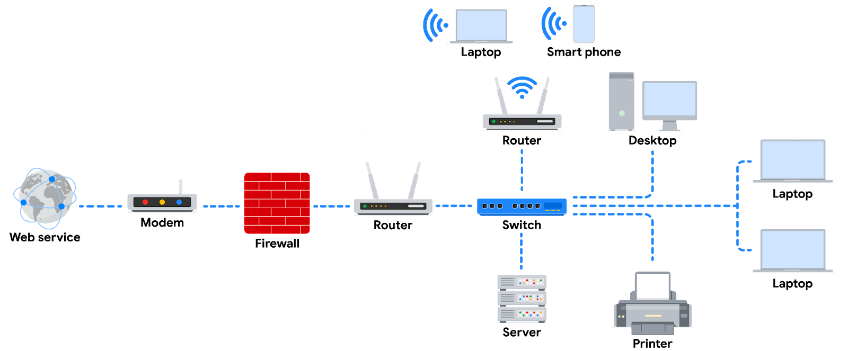

**Note:** In this diagram, a **router** connects to the internet through a **modem**, which is provided by your internet service provider (ISP). The firewall is a security device that monitors incoming and outgoing traffic on your network. The router then directs traffic to the devices on your home network, which can include computers, laptops, smartphones, tablets, printers, and other devices. You can imagine here that the server is a file server. All devices on this network can access the files in this **server**. This diagram also includes a **switch** which is an optional device that can be used to connect more devices to your network by providing additional ports and Ethernet connections. Additionally, there are 2 routers connected to the switch here for load balancing purposes which will improve the performance of the network.

### **Devices and desktop computers**

Most internet users are familiar with everyday devices, such as personal computers, laptops, mobile phones, and tablets. Each device and desktop computer has a unique MAC address and IP address, which identify it on the network. They also have a network interface that sends and receives data packets. These devices can connect to the network via a hard wire or a wireless connection.

### **Firewalls**

A **firewall** is a network security device that monitors traffic to or from your network. It is like your first line of defense. Firewalls can also restrict specific incoming and outgoing network traffic. The organization configures the security rules of the firewall. Firewalls often reside between the secured and controlled internal network and the untrusted network resources outside the organization, such as the internet. Remember, though, firewalls are just one line of defense in the cybersecurity landscape.

### **Servers**

**Servers** provide information and services for devices like computers, smart home devices, and smartphones on the network. The devices that connect to a server are called clients. The following graphic outlines this model, which is called the client-server model. In this model, clients send requests to the server for information and services. The server performs the requests for the clients. Common examples include DNS servers that perform domain name lookups for internet sites, file servers that store and retrieve files from a database, and corporate mail servers that organize mail for a company.

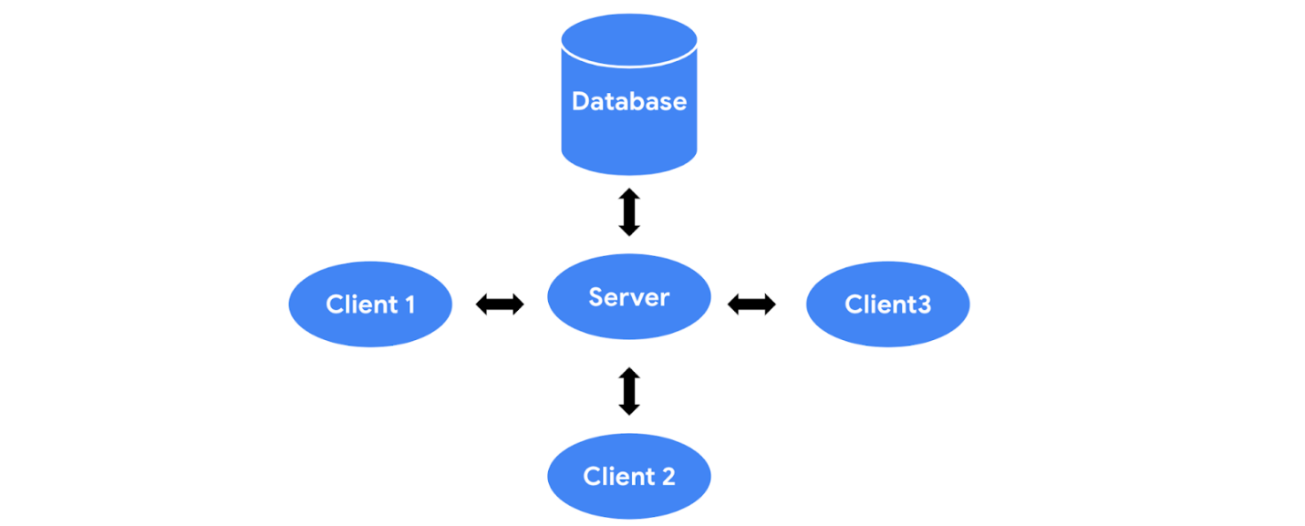

### **Hubs and switches**

Hubs and switches both direct traffic on a local network. A **hub** is a device that provides a common point of connection for all devices directly connected to it. Hubs additionally repeat all information out to all ports. From a security perspective, this makes hubs vulnerable to eavesdropping. For this reason, hubs are not used as often on modern networks; most organizations use switches instead. Hubs are more commonly used for a limited network setup like a home office.

Switches are the preferred choice for most networks. A **switch** forwards packets between devices directly connected to it. They analyze the destination address of each data packet and send it to the intended device. Switches maintain a MAC address table that matches MAC addresses of devices on the network to port numbers on the switch and forwards incoming data packets according to the destination MAC address. Switches are a part of the data link layer in the TCP/IP model. Overall, switches improve performance and security.

### **Routers**

**Routers** connect networks and direct traffic, based on the IP address of the destination network. Routers allow devices on different networks to communicate with each other. In the TCP/IP model, routers are a part of the network layer. The IP address of the destination network is contained in the IP header. The router reads the IP header information and forwards the packet to the next router on the path to the destination. This continues until the packet reaches the destination network. Routers can also include a firewall feature that allows or blocks incoming traffic based on information in the transmission. This stops malicious traffic from entering the private network and damaging the local area network.

### **Modems and wireless access points**

**Modems** usually connect your home or office with an internet service provider (ISP). ISPs provide internet connectivity via telephone lines or coaxial cables. Modems receive transmissions or digital signals from the internet and translate them into analog signals that can travel through the physical connection provided by your ISP. Usually, modems connect to a router that takes the decoded transmissions and sends them on to the local network.

**Note:** Enterprise networks used by large organizations to connect their users and devices often use other broadband technologies to handle high-volume traffic, instead of using a modem.

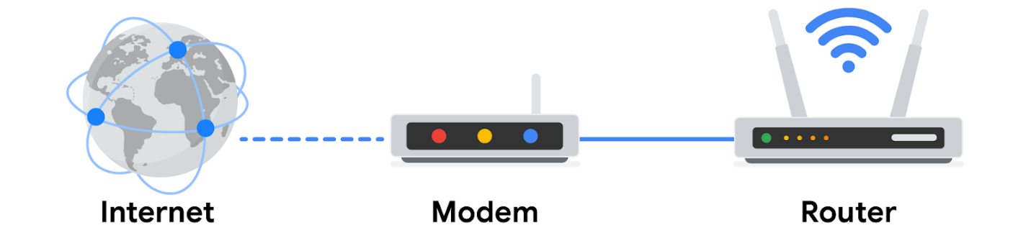

**Wireless access point**

A **wireless access point** sends and receives digital signals over radio waves creating a wireless network. Devices with wireless adapters connect to the access point using Wi-Fi. **Wi-Fi** refers to a set of standards that are used by network devices to communicate wirelessly. Wireless access points and the devices connected to them use Wi-Fi protocols to send data through radio waves where they are sent to routers and switches and directed along the path to their final destination.

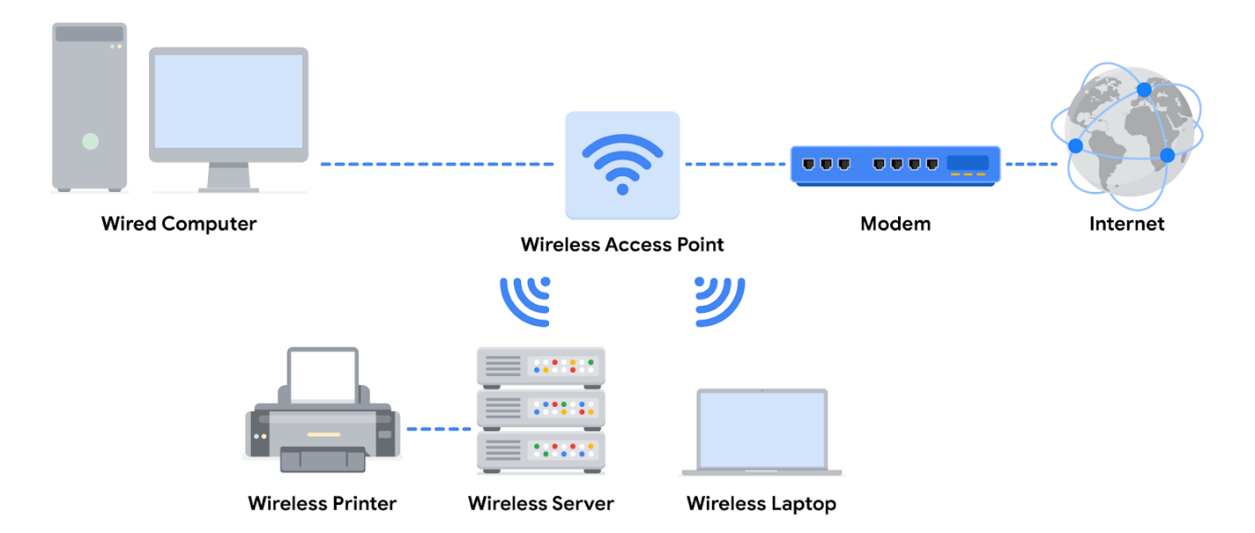

## **Using network diagrams as a security analyst**

Network diagrams allow network administrators and security personnel to imagine the architecture and design of their organization’s private network.

**Network diagrams** are maps that show the devices on the network and how they connect. Network diagrams use small representative graphics to portray each network device and dotted lines to show how each device connects to the other. By studying network diagrams, security analysts develop and refine their strategies for securing network architectures.

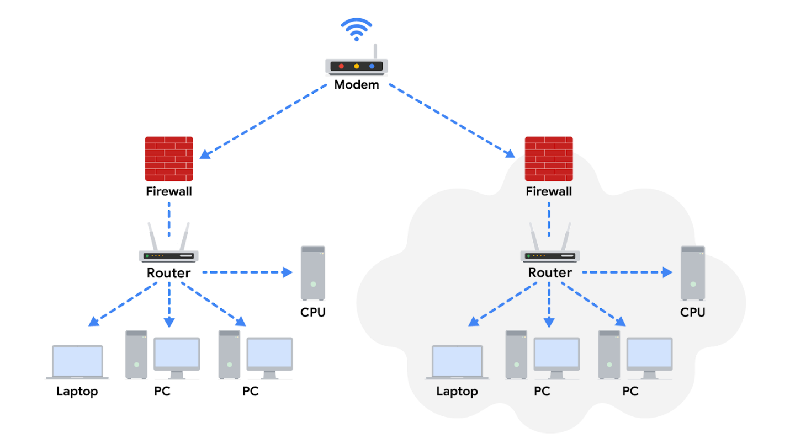

# Cloud computing and software-defined networks

In this section of the course, you’ve been learning the basic architecture of networks. You’ve learned about how physical network devices like workstations, servers, routers, and switches connect to each other to create a network. Networks may cover small geographical areas, as is the case in a local area network (LAN). Or they may span a large geographic area, like a city, state, or country, as is the case in a wide area network (WAN). You also learned about cloud networks and how cloud computing has grown in recent years.

In this reading, you will further examine the concepts of cloud computing and cloud networking. You’ll also learn about hybrid networks and software-defined networks, as well as the benefits they offer. This reading will also cover the benefits of hosting networks in the cloud and why cloud-hosting is beneficial for large organizations.

## Computing processes in the cloud

Traditional networks are called on-premise networks, which means that all of the devices used for network operations are kept at a physical location owned by the company, like in an office building, for example. **Cloud computing**, however, refers to the practice of using remote servers, applications, and network services that are hosted on the internet instead of at a physical location owned by the company.

A cloud service provider (CSP) is a company that offers cloud computing services. These companies own large data centers in locations around the globe that house millions of servers. Data centers provide technology services, such as storage, and compute at such a large scale that they can sell their services to other companies for a fee. Companies can pay for the storage and services they need and consume them through the CSP’s application programming interface (API) or web console.

CSPs provide three main categories of services:

* **Software as a service (SaaS)** refers to software suites operated by the CSP that a company can use remotely without hosting the software.
* **Infrastructure as a service** **(Iaas)** refers to the use of virtual computer components offered by the CSP. These include virtual containers and storage that are configured remotely through the CSP’s API or web console. Cloud-compute and storage services can be used to operate existing applications and other technology workloads without significant modifications. Existing applications can be modified to take advantage of the availability, performance, and security features that are unique to cloud provider services.
* **Platform as a service (PaaS)** refers to tools that application developers can use to design custom applications for their company. Custom applications are designed and accessed in the cloud and used for a company’s specific business needs.

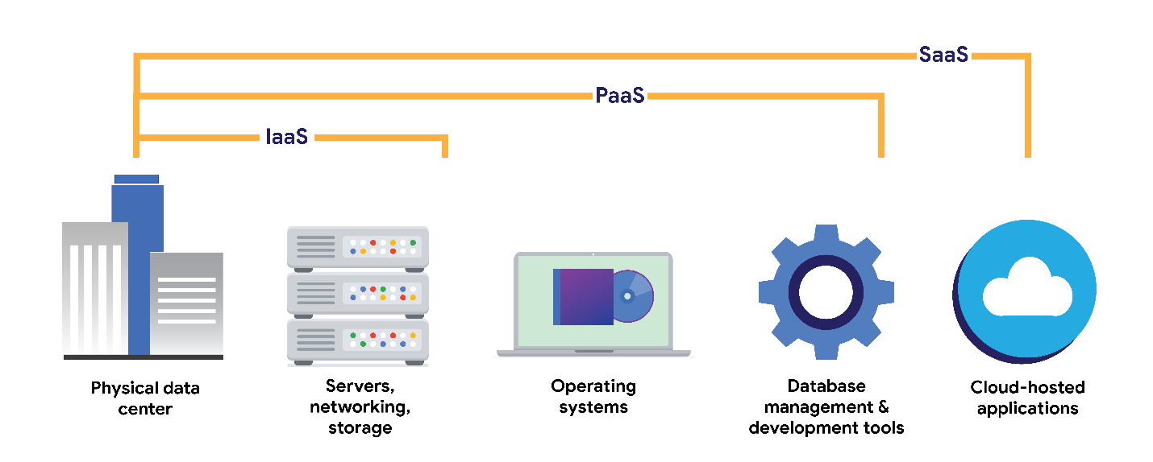

## Hybrid cloud environments

When organizations use a CSP’s services in addition to their on-premise computers, networks, and storage, it is referred to as a hybrid cloud environment. When organizations use more than one CSP, it is called a multi-cloud environment. The vast majority of organizations use hybrid cloud environments to reduce costs and maintain control over network resources.

## Software-defined networks

CSPs offer networking tools similar to the physical devices that you have learned about in this section of the course. Next, you’ll review  software-defined networking in the cloud. Software-defined networks (SDNs) are made up of virtual network devices and services. Just like CSPs provide virtual computers, many SDNs also provide virtual switches, routers, firewalls, and more. Most modern network hardware devices also support network virtualization and software-defined networking. This means that physical switches and routers use software to perform packet routing. In the case of cloud networking, the SDN tools are hosted on servers located at the CSP’s data center.

## Benefits of cloud computing and software-defined networks

Three of the main reasons that cloud computing is so attractive to businesses are reliability, decreased cost, and increased scalability.

### Reliability

Reliability in cloud computing is based on how available cloud services and resources are, how secure connections are, and how often the services are effectively running. Cloud computing allows employees and customers to access the resources they need consistently and with minimal interruption.

### Cost

Traditionally, companies have had to provide their own network infrastructure, at least for internet connections. This meant there could be potentially significant upfront costs for companies. However, because CSPs have such large data centers, they are able to offer virtual devices and services at a fraction of the cost required for companies to install, patch, upgrade, and manage the components and software themselves.

### Scalability

Another challenge that companies face with traditional computing is scalability. When organizations experience an increase in their business needs, they might be forced to buy more equipment and software to keep up. But what if business decreases shortly after? They might no longer have the business to justify the cost incurred by the upgraded components. CSPs reduce this risk by making it easy to consume services in an elastic utility model as needed. This means that companies only pay for what they need when they need it.

Changes can be made quickly through the CSPs, APIs, or web console—much more quickly than if network technicians had to purchase their own hardware and set it up. For example, if a company needs to protect against a threat to their network, web application firewalls (WAFs), intrusion detection/protection systems (IDS/IPS), or L3/L4 firewalls can be configured quickly whenever necessary, leading to better network performance and security.

# Learn more about the TCP/IP model

In this reading, you will build on what you have learned about the Transmission Control Protocol/Internet Protocol (TCP/IP) model, consider the differences between the Open Systems Interconnection (OSI) model and TCP/IP model, and learn how they’re related. Then, you’ll review each layer of the TCP/IP model and go over common protocols used in each layer.

As a security professional, it's important that you understand the TCP/IP model because it describes the functions of various network protocols. The TCP/IP model is based on the TCP/IP protocols suite that includes all network protocols that support the main TCP/IP protocol. To reiterate from previous lessons, a network protocol, also known as an internet protocol, is a set of standards used for routing and addressing data packets as they travel between devices on a network. In this reading, you will learn which network protocols operate on which communication layers of the TCP/IP model. The two most common models available are the TCP/IP and the OSI model. These models are a representative guideline of how hosts communicate across a network. The examples provided in this course will follow the TCP/IP model.

## The TCP/IP model

The **TCP/IP model** is a framework used to visualize how data is organized and transmitted across a network. This model helps network engineers and network security analysts conceptualize processes on the network and communicate where disruptions or security threats occur.

The TCP/IP model has four layers: the network access layer, internet layer, transport layer, and application layer. When troubleshooting issues on the network, security professionals can analyze which layers were impacted by an attack based on what processes were involved in an incident.

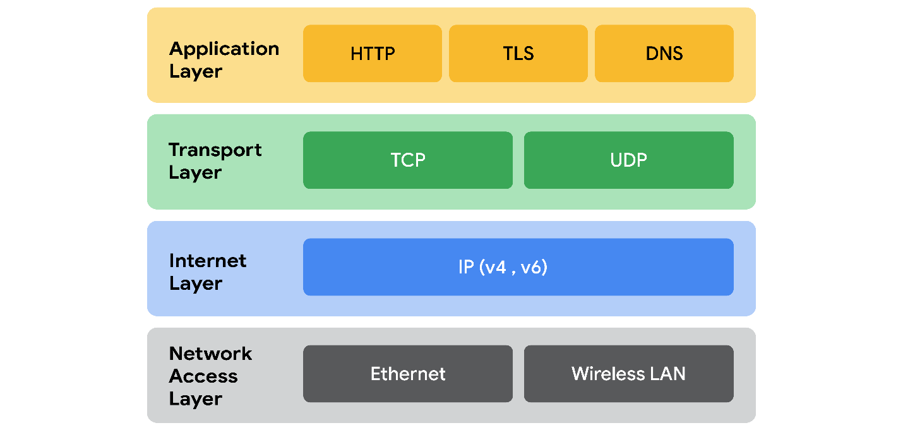

## Network access layer

The network access layer, sometimes called the data link layer, deals with the creation of data packets and their transmission across a network. This layer corresponds to the physical hardware involved in network transmission. Hubs, modems, cables, and wiring are all considered part of this layer. The address resolution protocol (ARP) is part of the network access layer. Since MAC addresses are used to identify hosts on the same physical network, ARP is needed to map IP addresses to MAC addresses for local network communication.

## Internet layer

The internet layer, sometimes referred to as the network layer, is responsible for ensuring the delivery to the destination host, which potentially resides on a different network. It ensures IP addresses are attached to data packets to indicate the location of the sender and receiver. The internet layer also determines which protocol is responsible for delivering the data packets and ensures the delivery to the destination host. Here are some of the common protocols that operate at the internet layer:

* **Internet Protocol (IP)**. IP sends the data packets to the correct destination and relies on the Transmission Control Protocol/User Datagram Protocol (TCP/UDP) to deliver them to the corresponding service. IP packets allow communication between two networks. They are routed from the sending network to the receiving network. TCP in particular retransmits any data that is lost or corrupt.
* **Internet Control Message Protocol (ICMP)**. The ICMP shares error information and status updates of data packets. This is useful for detecting and troubleshooting network errors. The ICMP reports information about packets that were dropped or that disappeared in transit, issues with network connectivity, and packets redirected to other routers.

## Transport layer

The transport layer is responsible for delivering data between two systems or networks and includes protocols to control the flow of traffic across a network. TCP and UDP are the two transport protocols that occur at this layer.

### Transmission Control Protocol

The **Transmission Control Protocol (TCP)** is an internet communication protocol that allows two devices to form a connection and stream data. It ensures that data is reliably transmitted to the destination service. TCP contains the port number of the intended destination service, which resides in the TCP header of a TCP/IP packet.

### User Datagram Protocol

The **User Datagram Protocol (UDP)** is a connectionless protocol that does not establish a connection between devices before transmissions. It is used by applications that are not concerned with the reliability of the transmission. Data sent over UDP is not tracked as extensively as data sent using TCP. Because UDP does not establish network connections, it is used mostly for performance sensitive applications that operate in real time, such as video streaming.

## Application layer

The application layer in the TCP/IP model is similar to the application, presentation, and session layers of the OSI model. The application layer is responsible for making network requests or responding to requests. This layer defines which internet services and applications any user can access. Protocols in the application layer determine how the data packets will interact with receiving devices. Some common protocols used on this layer are:

* Hypertext transfer protocol (HTTP)
* Simple mail transfer protocol (SMTP)
* Secure shell (SSH)
* File transfer protocol (FTP)
* Domain name system (DNS)

Application layer protocols rely on underlying layers to transfer the data across the network.

## TCP/IP model versus OSI model

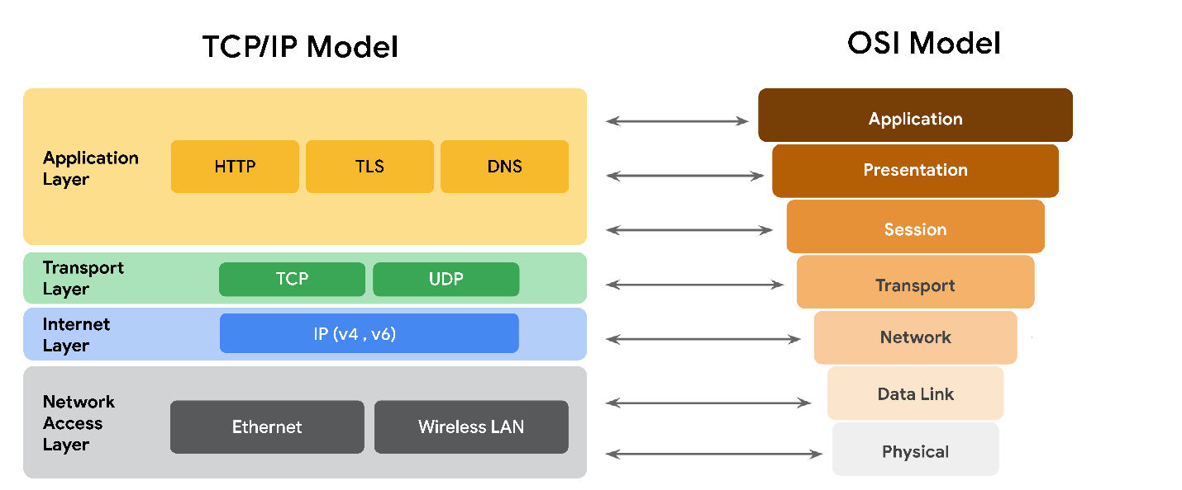

The **OSI** visually organizes network protocols into different layers. Network professionals often use this model to communicate with each other about potential sources of problems or security threats when they occur.

The TCP/IP model combines multiple layers of the OSI model. There are many similarities between the two models. Both models define standards for networking and divide the network communication process into different layers. The TCP/IP model is a simplified version of the OSI model.

# Components of network layer communication

In the reading about the [OSI model](https://www.coursera.org/learn/networks-and-network-security/supplement/YbKL0/the-osi-model-explained)

, you learned about the seven layers of the OSI model that are used to conceptualize the way data is transmitted across the internet. In this reading, you will learn more about operations that take place at layer 3 of the OSI model: the network layer.

## Operations at the network layer

Functions at the network layer organize the addressing and delivery of data packets across the network from the host device to the destination device. This includes directing the packets from one router to another router across the internet, till it reaches the internet protocol (IP) address of the destination network. The destination IP address is contained within the header of each data packet. This address will be stored for future routing purposes in  routing tables along the packet’s path to its destination.

All data packets include an IP address. A data packet is also referred to as an IP packet for TCP connections or a datagram for UDP connections. A router uses the IP address to route packets from network to network based on information contained in the IP header of a data packet. Header information communicates more than just the address of the destination. It also includes information such as the source IP address, the size of the packet, and which protocol will be used for the data portion of the packet.

## Format of an IPv4 packet

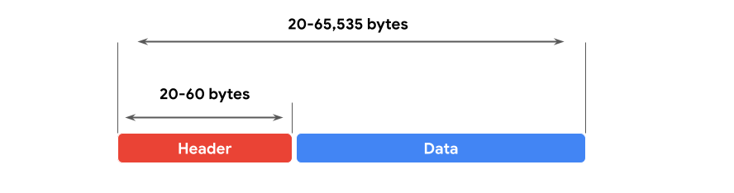

Next, you can review the format of an IP version 4 (IPv4) packet and review a detailed graphic of the packet header. An IPv4 packet is made up of two sections, the header and the data:

* An IPv4 header format is determined by the IPv4 protocol and includes the IP routing information that devices use to direct the packet. The size of the IPv4 header ranges from 20 to 60 bytes. The first 20 bytes are a fixed set of information containing data such as the source and destination IP address, header length, and total length of the packet. The last set of bytes can range from 0 to 40 and consists of the options field.
* The length of the data section of an IPv4 packet can vary greatly in size. However, the maximum possible size of an IPv4 packet is 65,535 bytes. It contains the message being transferred over the internet, like website information or email text.

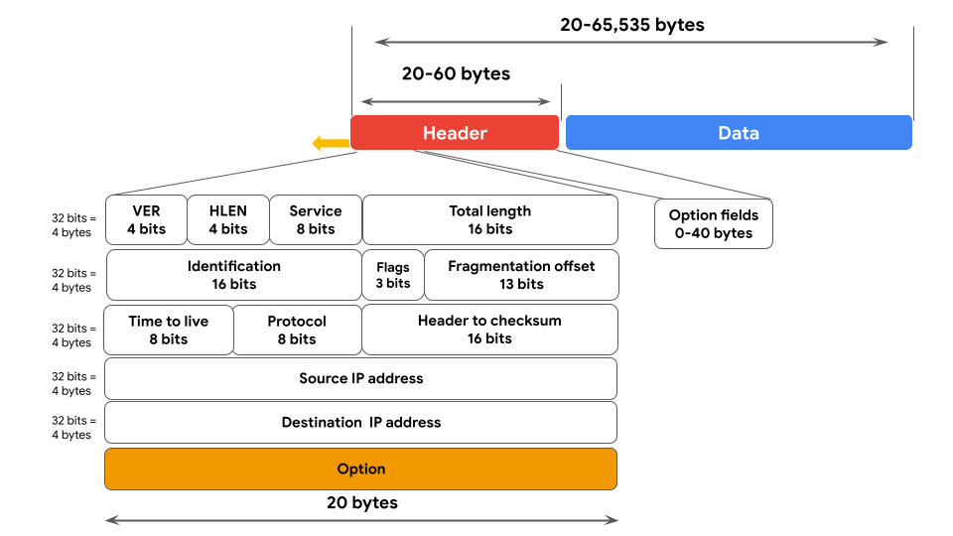

There are 13 fields within the header of an IPv4 packet:

* **Version (VER):** This 4 bit component tells receiving devices what protocol the packet is using. The packet used in the illustration above is an IPv4 packet.
* **IP Header Length (HLEN or IHL):** HLEN is the packet’s header length. This value indicates where the packet header ends and the data segment begins.
* **Type of Service (ToS):** Routers prioritize packets for delivery to maintain quality of service on the network. The ToS field provides the router with this information.
* **Total Length:** This field communicates the total length of the entire IP packet, including the header and data. The maximum size of an IPv4 packet is 65,535 bytes.
* **Identification:** For IPv4 packets that are larger than 65, 535 bytes, the packets are divided, or fragmented, into smaller IP packets. The identification field provides a unique identifier for all the fragments of the original IP packet so that they can be reassembled once they reach their destination.
* **Flags:** This field provides the routing device with more information about whether the original packet has been fragmented and if there are more fragments in transit.
* **Fragmentation Offset:** The fragment offset field tells routing devices where in the original packet the fragment belongs.
* **Time to Live (TTL):** TTL prevents data packets from being forwarded by routers indefinitely. It contains a counter that is set by the source. The counter is decremented by one as it passes through each router along its path. When the TTL counter reaches zero, the router currently holding the packet will discard the packet and return an ICMP Time Exceeded error message to the sender.
* **Protocol:** The protocol field tells the receiving device which protocol will be used for the data portion of the packet.
* **Header Checksum:** The header checksum field contains a checksum that can be used to detect corruption of the IP header in transit. Corrupted packets are discarded.
* **Source IP Address:** The source IP address is the IPv4 address of the sending device.
* **Destination IP Address:** The destination IP address is the IPv4 address of the destination device.
* **Options:** The options field allows for security options to be applied to the packet if the HLEN value is greater than five. The field communicates these options to the routing devices.

## Difference between IPv4 and IPv6

In an earlier part of this course, you learned about the history of IP addressing. As the internet grew, it became clear that all of the IPv4 addresses would eventually be depleted; this is called IPv4 address exhaustion. At the time, no one had anticipated how many computing devices would need an IP address. IPv6 was developed to mitigate IPv4 address exhaustion and other related concerns.

Some of the key differences between IPv4 and IPv6 include the length and the format of the addresses. IPv4 addresses are made up of four decimal numbers separated by periods, each number ranging from 0 to 255. Together the numbers span 4 bytes, and allow for up to 4.3 billion possible addresses. An example of an IPv4 address would be: 198.51.100.0. IPv6 addresses are made of eight hexadecimal numbers separated by colons, each number consisting of up to four hexadecimal digits. Together, all numbers span 16 bytes, and allow for up to 340 undecillion addresses (340 followed by 36 zeros). An example of an IPv6 address would be: 2002:0db8:0000:0000:0000:ff21:0023:1234.

***Note:*** to represent one or more consecutive sets of all zeros, you can replace the zeros with a double colon "::", so the above IPv6 address would be "2002:0db8::ff21:0023:1234."

There are also some differences in the layout of an IPv6 packet header. The IPv6 header format is much simpler than IPv4. For example, the IPv4 Header includes the IHL, Identification, and Flags fields, whereas the IPv6 does not. The IPv6 header only introduces the Flow Label field, where the Flow Label identifies a packet as requiring special handling by other IPv6 routers.

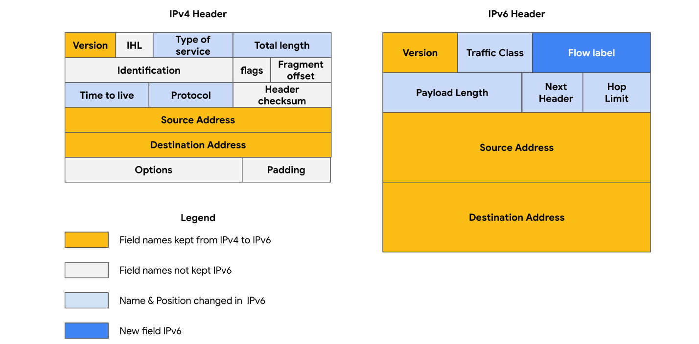

There are some important security differences between IPv4 and IPv6. IPv6 offers more efficient routing and eliminates private address collisions that can occur on IPv4 when two devices on the same network are attempting to use the same address.

# Common network protocols

In this section of the course, you learned about network protocols and how they organize communication over a network. This reading will discuss network protocols in more depth and review some basic protocols that you have learned previously. You will also learn new protocols and discuss some of the ways protocols are involved in network security.

## Overview of network protocols

A **network protocol** is a set of rules used by two or more devices on a network to describe the order of delivery and the structure of data. Network protocols serve as instructions that come with the information in the data packet. These instructions tell the receiving device what to do with the data. Protocols are like a common language that allows devices all across the world to communicate with and understand each other.

Even though network protocols perform an essential function in network communication, security analysts should still understand their associated security implications. Some protocols have vulnerabilities that malicious actors exploit. For example, a nefarious actor could use the Domain Name System (DNS) protocol, which resolves web addresses to IP addresses, to divert traffic from a legitimate website to a malicious website containing malware. You’ll learn more about this topic in upcoming course materials.

## Three categories of network protocols

Network protocols can be divided into three main categories: communication protocols, management protocols, and security protocols. There are dozens of different network protocols, but you don’t need to memorize all of them for an entry-level security analyst role. However, it’s important for you to know the ones listed in this reading.

### **Communication protocols**

Communication protocols govern the exchange of information in network transmission. They dictate how the data is transmitted between devices and the timing of the communication. They also include methods to recover data lost in transit. Here are a few of them.

* **Transmission Control Protocol (TCP)** is an internet communication protocol that allows two devices to form a connection and stream data. TCP uses a three-way handshake process. First, the device sends a synchronize (SYN) request to a server. Then the server responds with a SYN/ACK packet to acknowledge receipt of the device's request. Once the server receives the final ACK packet from the device, a TCP connection is established. In the TCP/IP model, TCP occurs at the transport layer.
* **User Datagram Protocol (UDP)** is a connectionless protocol that does not establish a connection between devices before a transmission. This makes it less reliable than TCP. But it also means that it works well for transmissions that need to get to their destination quickly. For example, one use of UDP is for internet gaming transmissions. In the TCP/IP model, UDP occurs at the transport layer.
* **Hypertext Transfer Protocol (HTTP)** is an application layer protocol that provides a method of communication between clients and website servers. HTTP uses port 80. HTTP is considered insecure, so it is being replaced on most websites by a secure version, called HTTPS. However, there are still many websites that use the insecure HTTP protocol. In the TCP/IP model, HTTP occurs at the application layer.
* **Domain Name System (DNS)** is a protocol that translates internet domain names into IP addresses. When a client computer wishes to access a website domain using their internet browser, a query is sent to a dedicated DNS server. The DNS server then looks up the IP address that corresponds to the website domain. DNS normally uses UDP on port 53. However, if the DNS reply to a request is large, it will switch to using the TCP protocol. In the TCP/IP model, DNS occurs at the application layer.

### **Management Protocols**

The next category of network protocols is management protocols. Management protocols are used for monitoring and managing activity on a network. They include protocols for error reporting and optimizing performance on the network.

* **Simple Network Management Protocol (SNMP)** is a network protocol used for monitoring and managing devices on a network. SNMP can reset a password on a network device or change its baseline configuration. It can also send requests to network devices for a report on how much of the network’s bandwidth is being used up. In the TCP/IP model, SNMP occurs at the application layer.
* **Internet Control Message Protocol (ICMP)** is an internet protocol used by devices to tell each other about data transmission errors across the network. ICMP is used by a receiving device to send a report to the sending device about the data transmission. ICMP is commonly used as a quick way to troubleshoot network connectivity and latency by issuing the “ping” command on a Linux operating system. In the TCP/IP model, ICMP occurs at the internet layer.

### **Security Protocols**

Security protocols are network protocols that ensure that data is sent and received securely across a network. Security protocols use encryption algorithms to protect data in transit. Below are some common security protocols.

* **Hypertext Transfer Protocol Secure (HTTPS)** is a network protocol that provides a secure method of communication between clients and website servers. HTTPS is a secure version of HTTP that uses secure sockets layer/transport layer security (SSL/TLS) encryption on all transmissions so that malicious actors cannot read the information contained. HTTPS uses port 443. In the TCP/IP model, HTTPS occurs at the application layer.
* **Secure File Transfer Protocol (SFTP)** is a secure protocol used to transfer files from one device to another over a network. SFTP uses secure shell (SSH), typically through TCP port 22. SSH uses Advanced Encryption Standard (AES) and other types of encryption to ensure that unintended recipients cannot intercept the transmissions. In the TCP/IP model, SFTP occurs at the application layer. SFTP is used often with cloud storage. Every time a user uploads or downloads a file from cloud storage, the file is transferred using the SFTP protocol.

**Note:** The encryption protocols mentioned do not conceal the source or destination IP address of network traffic. This means a malicious actor can still learn some basic information about the network traffic if they intercept it.

# Additional network protocols

In previous readings and videos, you learned how network protocols organize the sending and receiving of data across a network. You also learned that protocols can be divided into three categories: communication protocols, management protocols, and security protocols.

This reading will introduce you to a few additional concepts and protocols that will come up regularly in your work as a security analyst. Some protocols are assigned port numbers by the Internet Assigned Numbers Authority (IANA). These port numbers are included in the description of each protocol, if assigned.

## Network Address Translation

The devices on your local home or office network each have a private IP address that they use to communicate directly with each other. In order for the devices with private IP addresses to communicate with the public internet, they need to have a public IP address. Otherwise, responses will not be routed correctly. Instead of having a dedicated public IP address for each of the devices on the local network, the router can replace a private source IP address with its public IP address and perform the reverse operation for responses. This process is known as Network Address Translation (NAT) and it generally requires a router or firewall to be specifically configured to perform NAT. NAT is a part of layer 2 (internet layer) and layer 3 (transport layer) of the TCP/IP model.

| **Private IP Addresses** | **Public IP Addresses** |
| --- | --- |
| * Assigned by network admins * Unique only within private network * No cost to use * Address ranges:   + 10.0.0.0-10.255.255.255   + 172.16.0.0-172.31.255.255   + 192.168.0.0-192.168.255.255 | * Assigned by ISP and IANA * Unique address in global internet * Costs to lease a public IP address * Address ranges:   + 1.0.0.0-9.255.255.255   + 11.0.0.0-126.255.255.255   + 128.0.0.0-172.15.255.255   + 172.32.0.0-192.167.255.255   + 192.169.0.0-233.255.255.255 |

## Dynamic Host Configuration Protocol

Dynamic Host Configuration Protocol (DHCP) is in the management family of network protocols. DHCP is an application layer protocol used on a network to configure devices. It assigns a unique IP address and provides the addresses of the appropriate DNS server and default gateway for each device. DHCP servers operate on UDP port 67 while DHCP clients operate on UDP port 68.

## Address Resolution Protocol

By now, you are familiar with IP and MAC addresses. You’ve learned that each device on a network has both an IP address that identifies it on the network and a MAC address that is unique to that network interface. A device’s IP address may change over time, but its MAC address is permanent. Address Resolution Protocol (ARP) is mainly a network access layer protocol in the TCP/IP model used to translate the IP addresses that are found in data packets into the MAC address of the hardware device.

Each device on the network performs ARP and keeps track of matching IP and MAC addresses in an ARP cache. ARP does not have a specific port number.

## Telnet

Telnet is an application layer protocol that allows a device to communicate with another device or server. Telnet sends all information in clear text. It uses command line prompts to control another device similar to secure shell (SSH), but Telnet is not as secure as SSH. Telnet can be used to connect to local or remote devices and uses TCP port 23.

## Secure shell

Secure shell protocol (SSH) is used to create a secure connection with a remote system. This application layer protocol provides an alternative for secure authentication and encrypted communication. SSH operates over the TCP port 22 and is a replacement for less secure protocols, such as Telnet.

## Post office protocol

Post office protocol (POP) is an application layer (layer 4 of the TCP/IP model) protocol used to manage and retrieve email from a mail server. Many organizations have a dedicated mail server on the network that handles incoming and outgoing mail for users on the network. User devices will send requests to the remote mail server and download email messages locally. If you have ever refreshed your email application and had new emails populate in your inbox, you are experiencing POP and internet message access protocol (IMAP) in action. Unencrypted, plaintext authentication uses TCP/UDP port 110 and encrypted emails use Secure Sockets Layer/Transport Layer Security (SSL/TLS) over TCP/UDP port 995.  When using POP, mail has to finish downloading on a local device before it can be read and it does not allow a user to sync emails.

## Internet Message Access Protocol (IMAP)

IMAP is used for incoming email. It downloads the headers of emails, but not the content. The content remains on the email server, which allows users to access their email from multiple devices. IMAP uses TCP port 143 for unencrypted email and TCP port 993 over the TLS protocol. Using IMAP allows users to partially read email before it is finished downloading and to sync emails. However, IMAP is slower than POP3.

## Simple Mail Transfer Protocol

Simple Mail Transfer Protocol (SMTP) is used to transmit and route email from the sender to the recipient’s address. SMTP works with Message Transfer Agent (MTA) software, which searches DNS servers to resolve email addresses to IP addresses, to ensure emails reach their intended destination. SMTP uses TCP/UDP port 25 for unencrypted emails and TCP/UDP port 587 using TLS for encrypted emails. The TCP port 25 is often used by high-volume spam. SMTP helps to filter out spam by regulating how many emails a source can send at a time.

## Protocols and port numbers

Remember that port numbers are used by network devices to determine what should be done with the information contained in each data packet once they reach their destination. Firewalls can filter out unwanted traffic based on port numbers. For example, an organization may configure a firewall to only allow access to TCP port 995 (POP3) by IP addresses belonging to the organization.

As a security analyst, you will need to know about many of the protocols and port numbers mentioned in this course. They may be used to determine your technical knowledge in interviews, so it’s a good idea to memorize them. You will also learn about new protocols on the job in a security position.

## Key takeaways

As a cybersecurity analyst, you will encounter various common protocols in your everyday work. The protocols covered in this reading include NAT, DHCP, ARP, Telnet, SSH, POP3, IMAP, and SMTP. It is equally important to understand where each protocol is structured in the TCP/IP model and which ports they occupy.

| **Protocol** | **Port** |
| --- | --- |
| DHCP | UDP port 67 (servers)  UDP port 68 (clients) |
| ARP | none |
| Telnet | TCP port 23 |
| SSH | TCP port 22 |
| POP3 | TCP/UDP port 110 (unencrypted)  TCP/UDP port 995 (encrypted, SSL/TLS) |
| IMAP | TCP port 143 (unencrypted)  TCP port 993 (encrypted, SSL/TLS) |
| SMTP | TCP/UDP port 587 (encrypted, TLS) |

# The evolution of wireless security protocols

In the early days of the internet, all internet communication happened across physical cables. It wasn’t until the mid-1980s that authorities in the United States designated a spectrum of radio wave frequencies that could be used without a license, so there was more opportunity for the internet to expand.

In the late 1990s and early 2000s, technologies were developed to send and receive data over radio. Today, users access wireless internet through laptops, smart phones, tablets, and desktops. Smart devices, like thermostats, door locks, and security cameras, also use wireless internet to communicate with each other and with services on the internet.

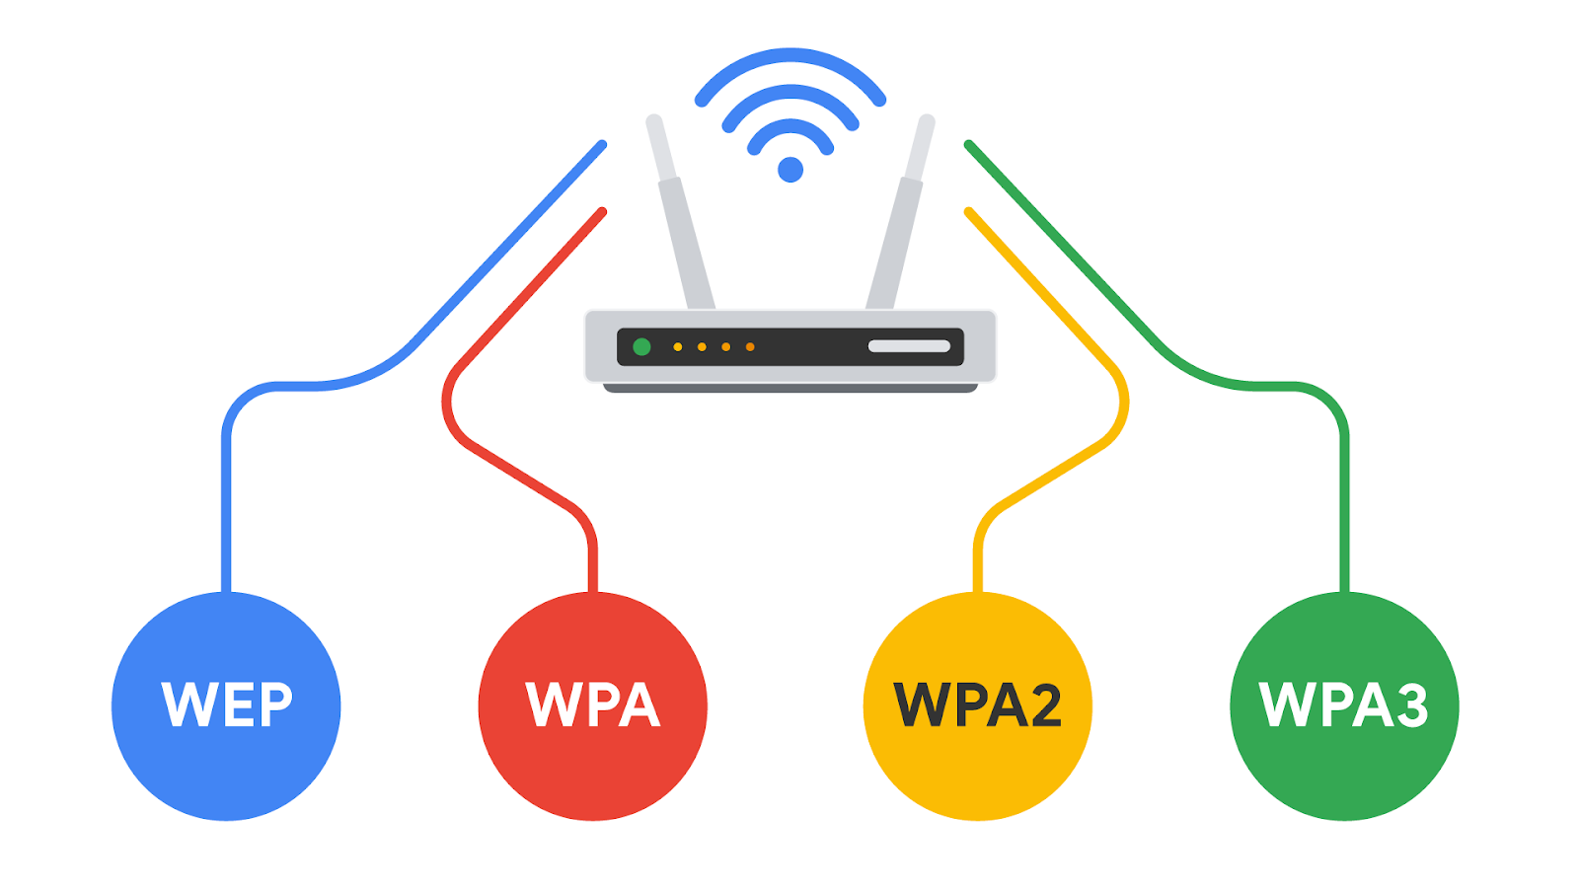

## Introduction to wireless communication protocols

Many people today refer to wireless internet as Wi-Fi. **Wi-Fi** refers to a set of standards that define communication for wireless LANs. Wi-Fi is a marketing term commissioned by the Wireless Ethernet Compatibility Alliance (WECA). WECA has since renamed their organization Wi-Fi Alliance.

Wi-Fi standards and protocols are based on the 802.11 family of internet communication standards determined by the Institute of Electrical and Electronics Engineers (IEEE). So, as a security analyst, you might also see Wi-Fi referred to as IEEE 802.11.

Wi-Fi communications are secured by wireless networking protocols. Wireless security protocols have evolved over the years, helping to identify and resolve vulnerabilities with more advanced wireless technologies.

In this reading, you will learn about the evolution of wireless security protocols from WEP to WPA, WPA2, and WPA3. You’ll also learn how the Wireless Application Protocol was used for mobile internet communications.

### **Wired Equivalent Privacy**

Wired equivalent privacy (WEP) is a wireless security protocol designed to provide users with the same level of privacy on wireless network connections as they have on wired network connections. WEP was developed in 1999 and is the oldest of the wireless security standards.

WEP is largely out of use today, but security analysts should still understand WEP in case they encounter it. For example, a network router might have used WEP as the default security protocol and the network administrator never changed it. Or, devices on a network might be too old to support newer Wi-Fi security protocols. Nevertheless, a malicious actor could potentially break the WEP encryption, so it’s now considered a high-risk security protocol.

### **Wi-Fi Protected Access**

Wi-Fi Protected Access (WPA) was developed in 2003 to improve upon WEP, address the security issues that it presented, and replace it. WPA was always intended to be a transitional measure so backwards compatibility could be established with older hardware.

The flaws with WEP were in the protocol itself and how the encryption was used. WPA addressed this weakness by using a protocol called Temporal Key Integrity Protocol (TKIP). WPA encryption algorithm uses larger secret keys than WEPs, making it more difficult to guess the key by trial and error.

WPA also includes a message integrity check that includes a message authentication tag with each transmission. If a malicious actor attempts to alter the transmission in any way or resend at another time, WPA’s message integrity check will identify the attack and reject the transmission.

Despite the security improvements of WPA, it still has vulnerabilities. Malicious actors can use a key reinstallation attack (or KRACK attack) to decrypt transmissions using WPA. Attackers can insert themselves in the WPA authentication handshake process and insert a new encryption key instead of the dynamic one assigned by WPA. If they set the new key to all zeros, it is as if the transmission is not encrypted at all.

Because of this significant vulnerability, WPA was replaced with an updated version of the protocol called WPA2.

### **WPA2 & WPA3**

#### **WPA2**

The second version of Wi-Fi Protected Access—known as WPA2—was released in 2004. WPA2 improves upon WPA by using the Advanced Encryption Standard (AES). WPA2 also improves upon WPA’s use of TKIP. WPA2 uses the Counter Mode Cipher Block Chain Message Authentication Code Protocol (CCMP), which provides encapsulation and ensures message authentication and integrity. Because of the strength of WPA2, it is considered the security standard for all Wi-Fi transmissions today. WPA2, like its predecessor, is vulnerable to KRACK attacks. This led to the development of WPA3 in 2018.

#### **Personal**

WPA2 personal mode is best suited for home networks for a variety of reasons. It is easy to implement, initial setup takes less time for personal than enterprise version. The global passphrase for WPA2 personal version needs to be applied to each individual computer and access point in a network. This makes it ideal for home networks, but unmanageable for organizations.

#### **Enterprise**

WPA2 enterprise mode works best for business applications. It provides the necessary security for wireless networks in business settings. The initial setup is more complicated than WPA2 personal mode, but enterprise mode offers individualized and centralized control over the Wi-Fi access to a business network. This means that network administrators can grant or remove user access to a network at any time. Users never have access to encryption keys, this prevents potential attackers from recovering network keys on individual computers.

#### **WPA3**

WPA3 is a secure Wi-Fi protocol and is growing in usage as more WPA3 compatible devices are released. These are the key differences between WPA2 and WPA3:

* WPA3 addresses the authentication handshake vulnerability to KRACK attacks, which is present in WPA2.
* WPA3 uses Simultaneous Authentication of Equals (SAE), a password-authenticated, cipher-key-sharing agreement. This prevents attackers from downloading data from wireless network connections to their systems to attempt to decode it.
* WPA3 has increased encryption to make passwords more secure  by using 128-bit encryption, with WPA3-Enterprise mode offering optional 192-bit encryption.

# Subnetting and CIDR

Earlier in this course, you learned about network segmentation, a security technique that divides networks into sections. A private network can be segmented to protect portions of the network from the internet, which is an unsecured global network.

For example, you learned about the uncontrolled zone, the controlled zone, the demilitarized zone, and the restricted zone. Feel free to review the video about [security zones](https://www.coursera.org/learn/networks-and-network-security/lecture/GccYm/security-zones)

for a refresher on how network segmentation can be used to add a layer of security to your organization’s network operations. Creating security zones is one example of a networking strategy called subnetting.

## Overview of subnetting

**Subnetting** is the subdivision of a network into logical groups called subnets. It works like a network inside a network. Subnetting divides up a network address range into smaller subnets within the network. These smaller subnets form based on the IP addresses and network mask of the devices on the network. Subnetting creates a network of devices to function as their own network. This makes the network more efficient and can also be used to create security zones. If devices on the same subnet communicate with each other, the switch changes the transmissions to stay on the same subnet, improving speed and efficiency of the communications.

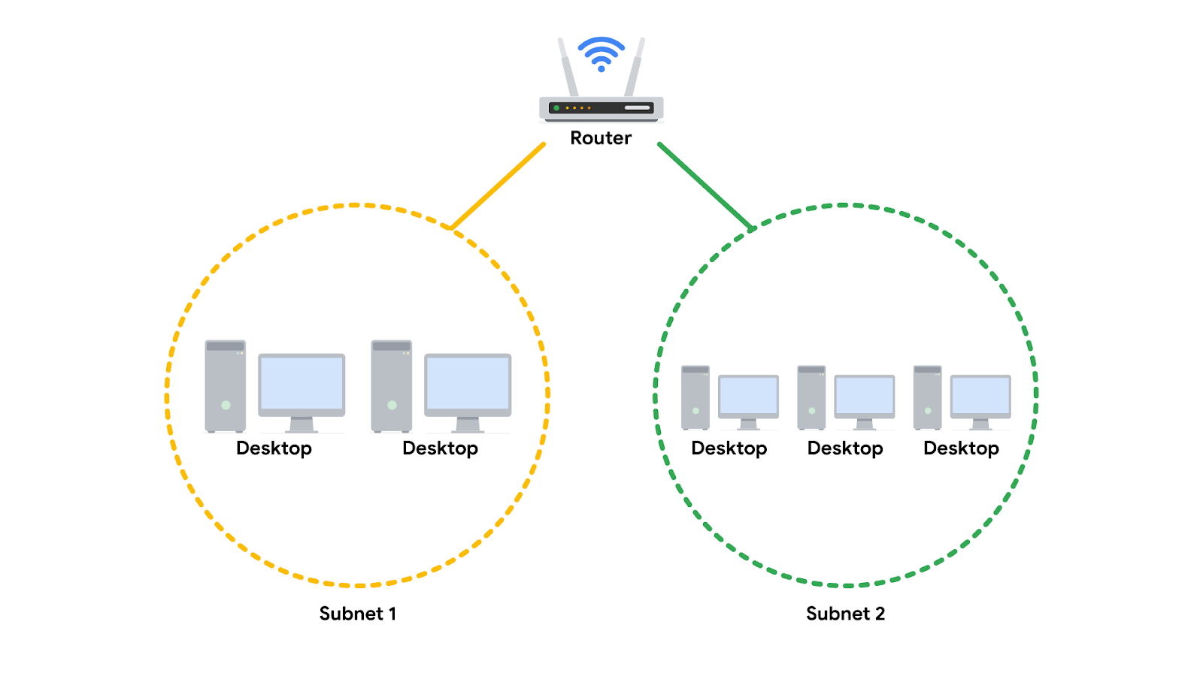

## Classless Inter-Domain Routing notation for subnetting

Classless Inter-Domain Routing (CIDR) is a method of assigning subnet masks to IP addresses to create a subnet. Classless addressing replaces classful addressing. Classful addressing was used in the 1980s as a system of grouping IP addresses into classes (Class A to Class E). Each class included a limited number of IP addresses, which were depleted as the number of devices connecting to the internet outgrew the classful range in the 1990s. Classless CIDR addressing expanded the number of available IPv4 addresses.

CIDR allows cybersecurity professionals to segment classful networks into smaller chunks. CIDR IP addresses are formatted like IPv4 addresses, but they include a slash (“/’”) followed by a number at the end of the address, This extra number is called the IP network prefix.  For example, a regular IPv4 address uses the 198.51.100.0 format, whereas a CIDR IP address would include the IP network prefix at the end of the address, 198.51.100.0/24. This CIDR address encompasses all IP addresses between 198.51.100.0 and 198.51.100.255. The system of CIDR addressing reduces the number of entries in routing tables and provides more available IP addresses within networks. You can try converting CIDR to IPv4 addresses and vice versa through an online conversion tool, like [IPAddressGuide](https://www.ipaddressguide.com/cidr)

, for practice and to better understand this concept.

**Note:** You may learn more about CIDR during your career, but it won't be covered in any additional depth in this certificate program. For now, you only need a basic understanding of this concept.

## Security benefits of subnetting

Subnetting allows network professionals and analysts to create a network within their own network without requesting another network IP address from their internet service provider. This process uses network bandwidth more efficiently and improves network performance. Subnetting is one component of creating isolated subnetworks through physical isolation, routing configuration, and firewalls.

# Virtual networks and privacy

This section of the course covered a lot of information about network operations. You reviewed the fundamentals of network architecture and communication and can now use this knowledge as you learn how to secure networks. Securing a private network requires maintaining the confidentiality of your data and restricting access to authorized users.

In this reading, you will review several network security topics previously covered in the course, including virtual private networks (VPNs), proxy servers, firewalls, and security zones. You'll continue to learn more about these concepts and how they relate to each other as you continue through the course.

## **Common network protocols**

Network protocols are used to direct traffic to the correct device and service depending on the kind of communication being performed by the devices on the network. Protocols are the rules used by all network devices that provide a mutually agreed upon foundation for how to transfer data across a network.

There are three main categories of network protocols: communication protocols, management protocols, and security protocols.

1. Communication protocols are used to establish connections between servers. Examples include TCP, UDP, and Simple Mail Transfer Protocol (SMTP), which provides a framework for email communication.
2. Management protocols are used to troubleshoot network issues. One example is the Internet Control Message Protocol (ICMP).
3. Security protocols provide encryption for data in transit. Examples include IPSec and SSL/TLS.

Some other commonly used protocols are:

* HyperText Transfer Protocol (HTTP). HTTP is an application layer communication protocol. This allows the browser and the web server to communicate with one another.
* Domain Name System (DNS). DNS is an application layer protocol that translates, or maps, host names to IP addresses.
* Address Resolution Protocol (ARP). ARP is a network layer communication protocol that maps IP addresses to physical machines or a MAC address recognized on the local area network.

## **Wi-Fi**

This section of the course also introduced various wireless security protocols, including WEP, WPA, WPA2, and WPA3. WPA3 encrypts traffic with the Advanced Encryption Standard (AES) cipher as it travels from your device to the wireless access point. WPA2 and WPA3 offer two modes: personal and enterprise. Personal mode is best suited for home networks while enterprise mode is generally utilized for business networks and applications.

## **Network security tools and practices**

### **Firewalls**

Previously, you learned that firewalls are network virtual appliances (NVAs) or hardware devices that inspect and can filter network traffic before it’s permitted to enter the private network. Traditional firewalls are configured with rules that tell it what types of data packets are allowed based on the port number and IP address of the data packet.

There are two main categories of firewalls.

* **Stateless:** A class of firewall that operates based on predefined rules and does not keep track of information from data packets
* **Stateful:** A class of firewall that keeps track of information passing through it and proactively filters out threats. Unlike stateless firewalls, which require rules to be configured in two directions, a stateful firewall only requires a rule in one direction. This is because it uses a "state table" to track connections, so it can match return traffic to an existing session

Next generation firewalls (NGFWs) are the most technologically advanced firewall protection. They exceed the security offered by stateful firewalls because they include deep packet inspection (a kind of packet sniffing that examines data packets and takes actions if threats exist) and intrusion prevention features that detect security threats and notify firewall administrators. NGFWs can inspect traffic at the application layer of the TCP/IP model and are typically application aware. Unlike traditional firewalls that block traffic based on IP address and ports, NGFWs rules can be configured to block or allow traffic based on the application. Some NGFWs have additional features like Malware Sandboxing, Network Anti-Virus, and URL and DNS Filtering.

### **Proxy servers**

A proxy server is another way to add security to your private network. Proxy servers utilize network address translation (NAT) to serve as a barrier between clients on the network and external threats. Forward proxies handle queries from internal clients when they access resources external to the network. Reverse proxies function opposite of forward proxies; they handle requests from external systems to services on the internal network. Some proxy servers can also be configured with rules, like a firewall.  For example, you can create filters to block websites identified as containing malware.

### **Virtual Private Networks (VPN)**

A VPN is a service that encrypts data in transit and disguises your IP address. VPNs use a process called encapsulation. Encapsulation wraps your encrypted data in an unencrypted data packet, which allows your data to be sent across the public network while remaining anonymous. Enterprises and other organizations use VPNs to help protect communications from users’ devices to corporate resources. Some of these resources include servers or virtual machines that host business applications. Individuals also use VPNs to increase personal privacy. VPNs protect user privacy by concealing personal information, including IP addresses, from external servers. A reputable VPN also minimizes its own access to user internet activity by using strong encryption and other security measures. Organizations are increasingly using a combination of VPN and SD-WAN capabilities to secure their networks. A software-defined wide area network (SD-WAN) is a virtual WAN service that allows organizations to securely connect users to applications across multiple locations and over large geographical distances.

# VPN protocols: Wireguard and IPSec

A VPN, or virtual private network, is a network security service that changes your public IP address and hides your virtual location so that you can keep your data private when you’re using a public network like the internet. VPNs provide a server that acts as a gateway between a computer and the internet. This server creates a path similar to a virtual tunnel that hides the computer’s IP address and encrypts the data in transit to the internet. The main purpose of a VPN is to create a secure connection between a computer and a network. Additionally, a VPN allows trusted connections to be established on non-trusted networks. VPN protocols determine how the secure network tunnel is formed. Different VPN providers provide different VPN protocols.

This reading will cover the differences between remote access and site-to-site VPNs, and two VPN protocols: WireGuard VPN and IPSec VPN. A VPN protocol is similar to a network protocol: It’s a set of rules or instructions that will determine how data moves between endpoints. An endpoint is any device connected on a network. Some examples of endpoints include computers, mobile devices, and servers.

## Remote access and site-to-site VPNs

Individual users use remote access VPNs to establish a connection between a personal device and a VPN server. Remote access VPNs encrypt data sent or received through a personal device. The connection between the user and the remote access VPN is established through the internet.

Enterprises use site-to-site VPNs largely to extend their network to other networks and locations. This is particularly useful for organizations that have many offices across the globe. IPSec is commonly used in site-to-site VPNs to create an encrypted tunnel between the primary network and the remote network. One disadvantage of site-to-site VPNs is how complex they can be to configure and manage compared to remote VPNs.

## WireGuard VPN vs. IPSec VPN

WireGuard and IPSec are two different VPN protocols used to encrypt traffic over a secure network tunnel. The majority of VPN providers offer a variety of options for VPN protocols, such as WireGuard or IPSec. Ultimately, choosing between IPSec and WireGuard depends on many factors, including connection speeds, compatibility with existing network infrastructure, and business or individual needs.

### WireGuard VPN

WireGuard is a high-speed VPN protocol, with advanced encryption, to protect users when they are accessing the internet. It’s designed to be simple to set up and maintain. WireGuard can be used for both site-to-site connection and client-server connections. WireGuard is relatively newer than IPSec, and is used by many people due to the fact that its download speed is enhanced by using fewer lines of code. WireGuard is also open source, which makes it easier for users to deploy and debug. This protocol is useful for processes that require faster download speeds, such as streaming video content or downloading large files.

### IPSec VPN

IPSec is another VPN protocol that may be used to set up VPNs. Most VPN providers use IPSec to encrypt and authenticate data packets in order to establish secure, encrypted connections. Since IPSec is one of the earlier VPN protocols, many operating systems support IPSec from VPN providers.

Although IPSec and WireGuard are both VPN protocols, IPSec is older and more complex than WireGuard. Some clients may prefer IPSec due to its longer history of use, extensive security testing, and widespread adoption. However, others may prefer WireGuard because of its potential for better performance and simpler configuration.

# How intrusions compromise your system

In this section of the course, you learned that every network has inherent vulnerabilities and could become the target of a network attack.

Attackers could have varying motivations for attacking your organization’s network. They may have financial, personal, or political motivations, or they may be a disgruntled employee or an activist who disagrees with the company's values and wants to harm an organization’s operations. Malicious actors can target any network. Security analysts must be constantly alert to potential vulnerabilities in their organization’s network and take quick action to mitigate them.

In this reading, you’ll learn about network interception attacks and backdoor attacks, and the possible impacts these attacks could have on an organization.

## Network interception attacks

Network interception attacks work by intercepting network traffic and stealing valuable information or interfering with the transmission in some way.

Malicious actors can use hardware or software tools to capture and inspect data in transit. This is referred to as **packet sniffing**. In addition to seeing information that they are not entitled to, malicious actors can also intercept network traffic and alter it. These attacks can cause damage to an organization’s network by inserting malicious code modifications or altering the message and interrupting network operations. For example, an attacker can intercept a bank transfer and change the account receiving the funds to one that the attacker controls.

Later in this course you will learn more about malicious packet sniffing, and other types of network interception attacks: on-path attacks and replay attacks.

## Backdoor attacks

A **backdoor attack** is another type of attack you will need to be aware of as a security analyst. An organization may have a lot of security measures in place, including cameras, biometric scans and access codes to keep employees from entering and exiting without being seen. However, an employee might work around the security measures by finding a backdoor to the building that is not as heavily monitored, allowing them to sneak out for the afternoon without being seen.

In cybersecurity, backdoors are weaknesses intentionally left by programmers or system and network administrators that bypass normal access control mechanisms. Backdoors are intended to help programmers conduct troubleshooting or administrative tasks. However, backdoors can also be installed by attackers after they’ve compromised an organization to ensure they have persistent access.

Once the hacker has entered an insecure network through a backdoor, they can cause extensive damage: installing malware, performing a denial of service (DoS) attack, stealing private information or changing other security settings that leaves the system vulnerable to other attacks. A **DoS attack** is an attack that targets a network or server and floods it with network traffic.

## Possible impacts on an organization

As you’ve learned already, network attacks can have a significant negative impact on an organization. Let’s examine some potential consequences.

* **Financial**: When a system is taken offline with a DoS attack, or business operations are halted or slowed down by some other tactic, they prevent a company from performing the tasks that generate revenue. Depending on the size of an organization, interrupted operations can cost millions of dollars. In addition, if a malicious actor gets access to the personal information of the company’s clients or customers, the company may face heavy litigation and settlement costs if customers seek legal recourse.
* **Reputation**: Attacks can also have a negative impact on the reputation of an organization. If it becomes public knowledge that a company has experienced a cyber attack, the public may become concerned about the security practices of the organization. They may stop trusting the company with their personal information and choose a competitor to fulfill their needs.
* **Public safety**: If an attack occurs on a government network, this can potentially impact the safety and welfare of the citizens of a country. In recent years, defense agencies across the globe are investing heavily in combating cyber warfare tactics. If a malicious actor gained access to a power grid, a public water system, or even a military defense communication system, the public could face physical harm due to a network intrusion attack.

# Read tcpdump logs

A **network protocol analyzer**, sometimes called a packet sniffer or a packet analyzer, is a tool designed to capture and analyze data traffic within a network. They are commonly used as investigative tools to monitor networks and identify suspicious activity. There are a wide variety of network protocol analyzers available, but some of the most common analyzers  include:

* SolarWinds NetFlow Traffic Analyzer
* ManageEngine OpManager
* Azure Network Watcher
* Wireshark
* tcpdump

This reading will focus exclusively on tcpdump, though you can apply what you learn here to many of the other network protocol analyzers you'll use as a cybersecurity analyst to defend against any network intrusions. In an upcoming activity, you’ll review a tcpdump data traffic log and identify a DoS attack to practice these skills.

## tcpdump

**tcpdump** is a command-line network protocol analyzer. It is popular, lightweight–meaning it uses little memory and has a low CPU usage–and uses the open-source libpcap library. tcpdump is text based, meaning all commands in tcpdump are executed in the terminal. It can also be installed on other Unix-based operating systems, such as macOS®. It is preinstalled on many Linux distributions.

tcpdump provides a brief packet analysis and converts key information about network traffic into formats easily read by humans. It prints information about each packet directly into your terminal. tcpdump also displays the source IP address, destination IP addresses, and the port numbers being used in the communications.

## Interpreting output

tcpdump prints the output of the command as the sniffed packets in the command line, and optionally to a log file, after a command is executed. The output of a packet capture contains many pieces of important information about the network traffic.

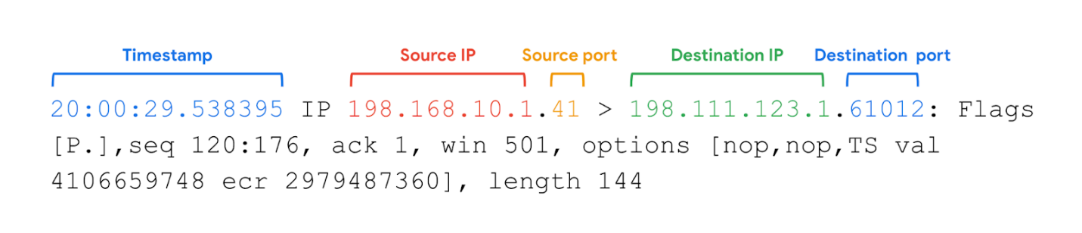

Some information you receive from a packet capture includes:

* **Timestamp**: The output begins with the timestamp, formatted as hours, minutes, seconds, and fractions of a second.
* **Source IP**: The packet’s origin is provided by its source IP address.
* **Source port**: This port number is where the packet originated.
* **Destination IP**: The destination IP address is where the packet is being transmitted to.
* **Destination port**: This port number is where the packet is being transmitted to.

**Note:** By default, tcpdump will attempt to resolve host addresses to hostnames. It'll also replace port numbers with commonly associated services that use these ports.

## Common uses

tcpdump and other network protocol analyzers are commonly used to capture and view network communications and to collect statistics about the network, such as troubleshooting network performance issues. They can also be used to:

* Establish a baseline for network traffic patterns and network utilization metrics.
* Detect and identify malicious traffic
* Create customized alerts to send the right notifications when network issues or security threats arise.
* Locate unauthorized instant messaging (IM), traffic, or wireless access points.

However, attackers can also use network protocol analyzers maliciously to gain information about a specific network. For example, attackers can capture data packets that contain sensitive information, such as account usernames and passwords. As a cybersecurity analyst, It’s important to understand the purpose and uses of network protocol analyzers.

# Real-life DDoS attack

Previously, you were introduced to Denial of Service (DoS) attacks. You also learned that volumetric distributed DoS (DDoS) attacks overwhelm a network by sending unwanted data packets in such large quantities that the servers become unable to service normal users. This can be detrimental to an organization. When systems fail, organizations cannot meet their customers' needs. They often lose money, and in some cases, incur other losses. An organization’s reputation may also suffer if news of a successful DDoS attack reaches consumers, who then question the security of the organization.

In this reading you’ll learn about a 2016 DDoS attack against DNS servers that caused major outages at multiple organizations that have millions of daily users.

## A DDoS targeting a widely used DNS server

In previous videos, you learned about the function of a DNS server. As a review, DNS servers translate website domain names into the IP address of the system that contains the information for the website. For instance, if a user were to type in a website URL, a DNS server would translate that into a numeric IP address that directs network traffic to the location of the website’s server.

On the day of the DDoS attack we are studying, many large companies were using a DNS service provider. The service provider was hosting the DNS system for these companies. This meant that when internet users typed in the URL of the website they wanted to access, their devices would be directed to the right place. On October 21, 2016, the service provider was the victim of a DDoS attack.

## Leading up to the attack

Before the attack on the service provider, a group of university students created a botnet with the intention to attack various gaming servers and networks. A **botnet** is a collection of computers infected by malware that are under the control of a single threat actor, known as the “bot-herder." Each computer in the botnet can be remotely controlled to send a data packet to a target system. In a botnet attack, cyber criminals instruct all the bots on the botnet to send data packets to the target system at the same time, resulting in a DDoS attack.

The group of university students posted the code for the botnet online so that it would be accessible to thousands of internet users and authorities wouldn’t be able to trace the botnet back to the students. In doing so, they made it possible for other malicious actors to learn the code to the botnet and control it remotely. This included the cyber criminals who attacked the DNS service provider.

## The day of attack

At 7:00 a.m. on the day of the attack, the botnet sent tens of millions of DNS requests to the service provider. This overwhelmed the system and the DNS service shut down. This meant that all of the websites that used the service provider could not be reached. When users tried to access various websites that used the service provider, they were not directed to the website they typed in their browser. Outages for each web service occurred all over North America and Europe.

The service provider’s systems were restored after only two hours of downtime. Although the cyber criminals sent subsequent waves of botnet attacks, the DNS company was prepared and able to mitigate the impact.

In the previous course items, you learned how packet sniffing and IP spoofing are used in network attacks. Because these attacks intercept data packets as they travel across the network, they are called interception attacks.

This reading will introduce you to some specific attacks that use packet sniffing and IP spoofing. You will learn how hackers use these tactics and how security analysts can counter the threat of interception attacks.

## A closer review of packet sniffing

As you learned in a previous video, **packet sniffing** is the practice of capturing and inspecting data packets across a network. On a private network, data packets are directed to the matching destination device on the network.

The device’s Network Interface Card (NIC) is a piece of hardware that connects the device to a network. The NIC reads the data transmission, and if it contains the device’s MAC address, it accepts the packet and sends it to the device to process the information based on the protocol. This occurs in all standard network operations. However, a NIC can be set to promiscuous mode, which means that it accepts all traffic on the network, even the packets that aren’t addressed to the NIC’s device. You’ll learn more about NIC’s later in the program. Malicious actors might use software like Wireshark to capture the data on a private network and store it for later use. They can then use the personal information to their own advantage. Alternatively, they might use the IP and MAC addresses of authorized users of the private network to perform IP spoofing.

## A closer review of IP spoofing

After a malicious actor has sniffed packets on the network, they can impersonate the IP and MAC addresses of authorized devices to perform an IP spoofing attack. Firewalls can prevent IP spoofing attacks by configuring it to refuse unauthorized IP packets and suspicious traffic. Next, you’ll examine a few common IP spoofing attacks that are important to be familiar with as a security analyst.

### **On-path attack**

An **on-path attack** happens when a hacker intercepts the communication between two devices or servers that have a trusted relationship. The transmission between these two trusted network devices could contain valuable information like usernames and passwords that the malicious actor can collect. An on-path attack is sometimes referred to as a **meddler-in-the middle attack** because the hacker is hiding in the middle of communications between two trusted parties.

Or, it could be that the intercepted transmission contains a DNS system look-up. You’ll recall from an earlier video that a DNS server translates website domain names into IP addresses. If a malicious actor intercepts a transmission containing a DNS lookup, they could spoof the DNS response from the server and redirect a domain name to a different IP address, perhaps one that contains malicious code or other threats. The most important way to protect against an on-path attack is to encrypt your data in transit, e.g. using TLS.

### **Smurf attack**

A **smurf attack** is a network attack that is performed when an attacker sniffs an authorized user’s IP address and floods it with packets. Once the spoofed packet reaches the broadcast address, it is sent to all of the devices and servers on the network.

In a smurf attack, IP spoofing is combined with another denial of service (DoS) technique to flood the network with unwanted traffic. For example, the spoofed packet could include an Internet Control Message Protocol (ICMP) ping. As you learned earlier, ICMP is used to troubleshoot a network. But if too many ICMP messages are transmitted, the ICMP echo responses overwhelm the servers on the network and they shut down. This creates a denial of service and can bring an organization’s operations to a halt.

An important way to protect against a smurf attack is to use an advanced firewall that can monitor any unusual traffic on the network. Most next generation firewalls (NGFW) include features that detect network anomalies to ensure that oversized broadcasts are detected before they have a chance to bring down the network.

### **DoS attack**

As you’ve learned, once the malicious actor has sniffed the network traffic, they can impersonate an authorized user. A **Denial of Service attack** is a class of attacks where the attacker prevents the compromised system from performing legitimate activity or responding to legitimate traffic. Unlike IP spoofing, however, the attacker will not receive a response from the targeted host. Everything about the data packet is authorized including the IP address in the header of the packet. In IP spoofing attacks, the malicious actor uses IP packets containing fake IP addresses. The attackers keep sending IP packets containing fake IP addresses until the network server crashes.

**Pro Tip**: Remember the principle of defense-in-depth. There isn’t one perfect strategy for stopping each kind of attack. You can layer your defense by using multiple strategies. In this case, using industry standard encryption will strengthen your security and help you defend from DoS attacks on more than one level.

## Terms and definitions from Course 3, Module 3

**Active packet sniffing:** A type of attack where data packets are manipulated in transit

**Botnet:** A collection of computers infected by malware that are under the control of a single threat actor, known as the “bot-herder"

**Denial of service (DoS) attack:** An attack that targets a network or server and floods it with network traffic

**Distributed denial of service (DDoS) attack:** A type of denial of service attack that uses multiple devices or servers located in different locations to flood the target network with unwanted traffic

**Internet Control Message Protocol (ICMP):** An internet protocol used by devices to tell each other about data transmission errors across the network

**Internet Control Message Protocol (ICMP) flood:** A type of DoS attack performed by an attacker repeatedly sending ICMP request packets to a network server

**IP spoofing:** A network attack performed when an attacker changes the source IP of a data packet to impersonate an authorized system and gain access to a network

**On-path attack:** An attack where a malicious actor places themselves in the middle of an authorized connection and intercepts or alters the data in transit

**Packet sniffing:** The practice of capturing and inspecting data packets across a network

**Passive packet sniffing:** A type of attack where a malicious actor connects to a network hub and looks at all traffic on the network

**Ping of death:** A type of DoS attack caused when a hacker pings a system by sending it an oversized ICMP packet that is bigger than 64KB

**Replay attack:** A network attack performed when a malicious actor intercepts a data packet in transit and delays it or repeats it at another time

**Smurf attack:** A network attack performed when an attacker sniffs an authorized user’s IP address and floods it with ICMP packets

**Synchronize (SYN) flood attack:** A type of DoS attack that simulates a TCP/IP connection and floods a server with SYN packets

# Brute force attacks and OS hardening

In this reading, you’ll learn about brute force attacks. You’ll consider how vulnerabilities can be assessed using virtual machines and sandboxes, and learn ways to prevent brute force attacks using a combination of authentication measures. Implementing various OS hardening tasks can help prevent brute force attacks. An attacker can use a brute force attack to gain access and compromise a network.

Usernames and passwords are among the most common and important security controls in place today. They are used and enforced on everything that stores or accesses sensitive or private information, like personal phones, computers, and restricted applications within an organization. However, a major issue with relying on login credentials as a critical line of defense is that they’re vulnerable to being stolen and guessed by malicious actors.

## Brute force attacks

A **brute force attack** is a trial-and-error process of discovering private information. There are different types of brute force attacks that malicious actors use to guess passwords, including:

* Simple brute force attacks. When attackers try to guess a user's login credentials, it’s considered a simple brute force attack. They might do this by entering any combination of usernames and passwords that they can think of until they find the one that works.
* Dictionary attacks use a similar technique. In dictionary attacks, attackers use a list of commonly used passwords and stolen credentials from previous breaches to access a system. These are called “dictionary” attacks because attackers originally used a list of words from the dictionary to guess the passwords, before complex password rules became a common security practice.

Using brute force to access a system can be a tedious and time consuming process, especially when it’s done manually. There are a range of tools attackers use to conduct their attacks.

## Assessing vulnerabilities

Before a brute force attack or other cybersecurity incident occurs, companies can run a series of tests on their network or web applications to assess vulnerabilities. Analysts can use virtual machines and sandboxes to test suspicious files, check for vulnerabilities before an event occurs, or to simulate a cybersecurity incident.

### **Virtual machines (VMs)**

Virtual machines (VMs) are software versions of physical computers. VMs provide an additional layer of security for an organization because they can be used to run code in an isolated environment, preventing malicious code from affecting the rest of the computer or system. VMs can also be deleted and replaced by a pristine image after testing malware.

VMs are useful when investigating potentially infected machines or running malware in a constrained environment. Using a VM may prevent damage to your system in the event its tools are used improperly. VMs also give you the ability to revert to a previous state. However, there are still some risks involved with VMs. There’s still a small risk that a malicious program can escape virtualization and access the host machine.

You can test and explore applications easily with VMs, and it’s easy to switch between different VMs from your computer. This can also help in streamlining many security tasks.

### **Sandbox environments**

A sandbox is a type of testing environment that allows you to execute software or programs separate from your network. They are commonly used for testing patches, identifying and addressing bugs, or detecting cybersecurity vulnerabilities. Sandboxes can also be used to evaluate suspicious software, evaluate files containing malicious code, and simulate attack scenarios.

Sandboxes can be stand-alone physical computers that are not connected to a network; however, it is often more time- and cost-effective to use software or cloud-based virtual machines as sandbox environments. Note that some malware authors know how to write code to detect if the malware is executed in a VM or sandbox environment. Attackers can program their malware to behave as harmless software when run inside these types of  testing environments.

## Prevention measures

Some common measures organizations use to prevent brute force attacks and similar attacks from occurring include:

* **Salting and hashing:** Hashing converts information into a unique value that can then be used to determine its integrity. It is a one-way function, meaning it is impossible to decrypt and obtain the original text. Salting adds random characters to hashed passwords. This increases the length and complexity of hash values, making them more secure.
* **Multi-factor authentication (MFA) and two-factor authentication (2FA):** MFA is a security measure which requires a user to verify their identity in two or more ways to access a system or network. This verification happens using a combination of authentication factors: a username and password, fingerprints, facial recognition, or a one-time password (OTP) sent to a phone number or email. 2FA is similar to MFA, except it uses only two forms of verification.
* **CAPTCHA and reCAPTCHA:** CAPTCHA stands for Completely Automated Public Turing test to tell Computers and Humans Apart. It asks users to complete a simple test that proves they are human. This helps prevent software from trying to brute force a password. reCAPTCHA is a free CAPTCHA service from Google that helps protect websites from bots and malicious software.
* **Password policies:** Organizations use password policies to standardize good password practices throughout the business. Policies can include guidelines on how complex a password should be, how often users need to update passwords, whether passwords can be reused or not, and if there are limits to how many times a user can attempt to log in before their account is suspended.

# Network security applications

This section of the course covers the topic of network hardening and monitoring. Each device, tool, or security strategy put in place by security analysts further protects—or hardens—the network until the network owner is satisfied with the level of security. This approach of adding layers of security to a network is referred to as defense in depth.

In this reading, you are going to learn about the role of four devices used to secure a network—firewalls, intrusion detection systems, intrusion prevention systems, and security incident and event management tools. Network security professionals have the choice to use any or all of these devices and tools depending on the level of security that they hope to achieve.

This reading will discuss the benefits of layered security. Each tool mentioned is an additional layer of defense that can incrementally harden a network, starting with the minimum level of security (provided by just a firewall), to the highest level of security (provided by combining a firewall, an intrusion detection and prevention device, and security event monitoring).

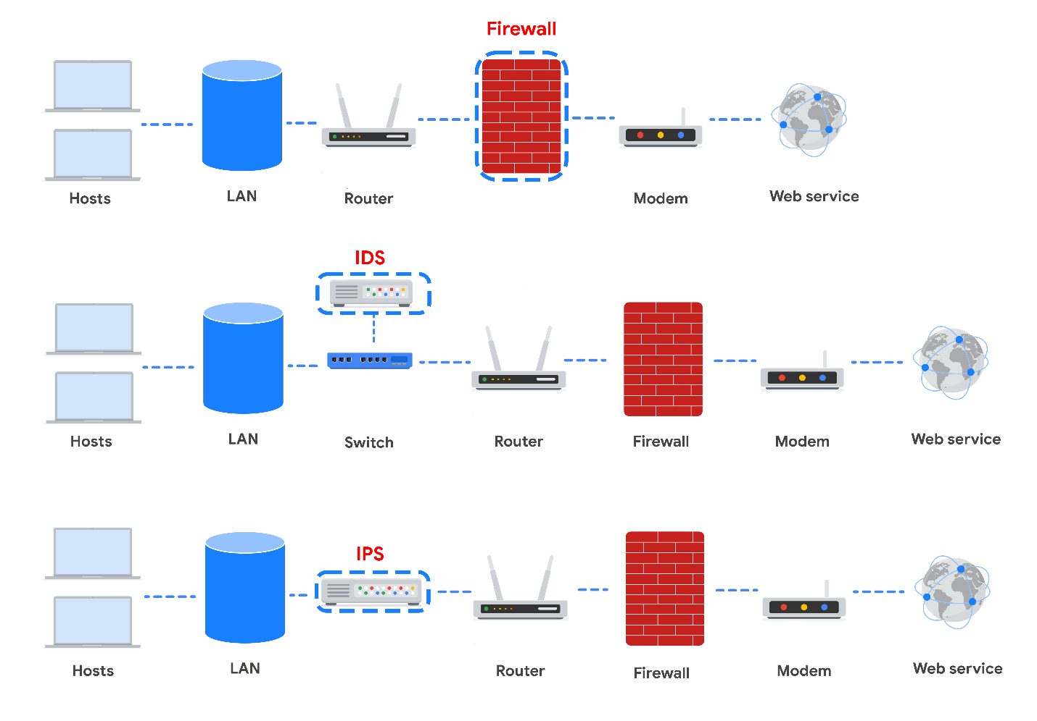

Take note of where each tool is located on the network. Each tool has its own place in the network’s architecture. Security analysts are required to understand the network topologies shown in the diagrams throughout this reading.

## Firewall

So far in this course, you learned about stateless firewalls, stateful firewalls, and next-generation firewalls (NGFWs), and the security advantages of each of them.

Most firewalls are similar in their basic functions. Firewalls allow or block traffic based on a set of rules. As data packets enter a network, the packet header is inspected and allowed or denied based on its port number. NGFWs are also able to inspect packet payloads. Each system should have its own firewall, regardless of the network firewall.

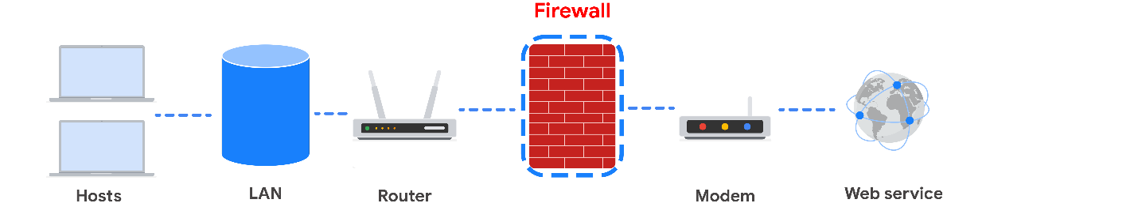

## Intrusion Detection System

An **intrusion detection system** (IDS) is an application that monitors system activity and alerts on possible intrusions. An IDS alerts administrators based on the signature of malicious traffic.

The IDS is configured to detect known attacks. IDS systems often sniff data packets as they move across the network and analyze them for the characteristics of known attacks. Some IDS systems review not only for signatures of known attacks, but also for anomalies that could be the sign of malicious activity. When the IDS discovers an anomaly, it sends an alert to the network administrator who can then investigate further.

The limitations to IDS systems are that they can only scan for known attacks or obvious anomalies. New and sophisticated attacks might not be caught. The other limitation is that the IDS doesn’t actually stop the incoming traffic if it detects something awry. It’s up to the network administrator to catch the malicious activity before it does anything damaging to the network.

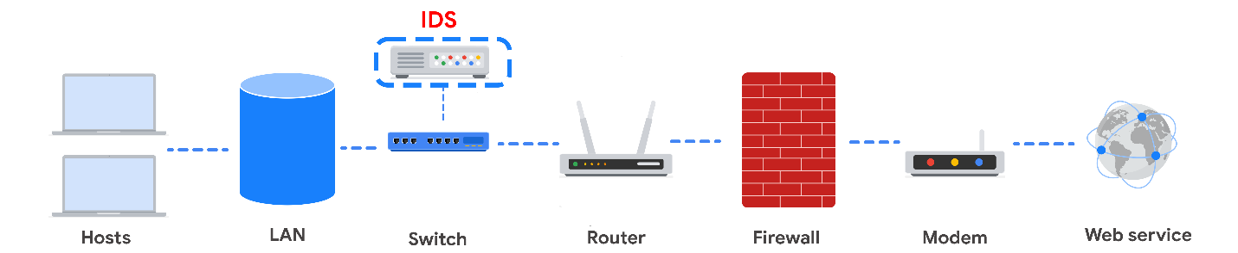

When combined with a firewall, an IDS adds another layer of defense. The IDS is placed behind the firewall and before entering the LAN, which allows the IDS to analyze data streams after network traffic that is disallowed by the firewall has been filtered out. This is done to reduce noise in IDS alerts, also referred to as false positives.

## Intrusion Prevention System

An **intrusion prevention system (IPS)** is an application that monitors system activity for intrusive activity and takes action to stop the activity. It offers even more protection than an IDS because it actively stops anomalies when they are detected, unlike the IDS that simply reports the anomaly to a network administrator.

An IPS searches for signatures of known attacks and data anomalies. An IPS reports the anomaly to security analysts and blocks a specific sender or drops network packets that seem suspect.

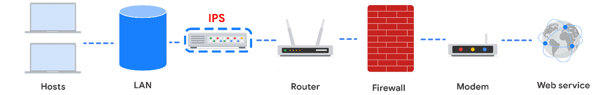

The IPS (like an IDS) sits behind the firewall in the network architecture. This offers a high level of security because risky data streams are disrupted before they even reach sensitive parts of the network. However, one potential limitation is that it is inline: If it breaks, the connection between the private network and the internet breaks. Another limitation of IPS is the possibility of false positives, which can result in legitimate traffic getting dropped.

## Full packet capture devices

Full packet capture devices can be incredibly useful for network administrators and security professionals. These devices allow you to record and analyze all of the data that is transmitted over your network. They also aid in investigating alerts created by an IDS.

## Security Information and Event Management

A **security information and event management system (SIEM)** is an application that collects and analyzes log data to monitor critical activities in an organization. SIEM tools work in real time to report suspicious activity in a centralized dashboard. SIEM tools additionally analyze network log data sourced from IDSs, IPSs, firewalls, VPNs, proxies, and DNS logs. SIEM tools are a way to aggregate security event data so that it all appears in one place for security analysts to analyze. This is referred to as a single pane of glass.

Below, you can review an example of a dashboard from Google Cloud’s SIEM tool, Chronicle. **Chronicle** is a cloud-native tool designed to retain, analyze, and search data.

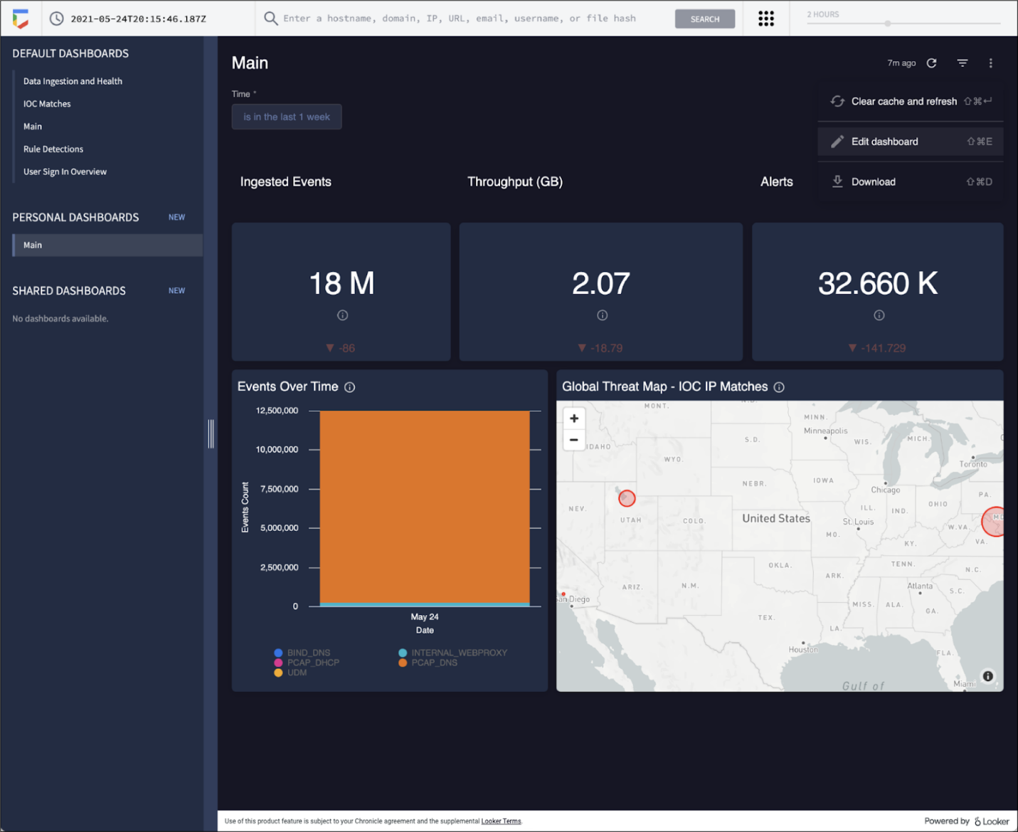

**Splunk** is another common SIEM tool. Splunk offers different SIEM tool options: Splunk Enterprise and Splunk Cloud. Both options include detailed dashboards which help security professionals to review and analyze an organization's data. There are also other similar SIEM tools available, and it's important for security professionals to research the different tools to determine which one is most beneficial to the organization.

A SIEM tool doesn’t replace the expertise of security analysts, or of the network- and system-hardening activities covered in this course, but they’re used in combination with other security methods. Security analysts often work in a Security Operations Center (SOC) where they can monitor the activity across the network. They can then use their expertise and experience to determine how to respond to the information on the dashboard and decide when the events meet the criteria to be escalated to oversight.

## Key takeaways

| **Devices / Tools** | **Advantages** | **Disadvantages** |
| --- | --- | --- |
| Firewall | A firewall allows or blocks traffic based on a set of rules. | A firewall is only able to filter packets based on information provided in the header of the packets. |
| Intrusion Detection System (IDS) | An IDS detects and alerts admins about possible intrusions, attacks, and other malicious traffic. | An IDS can only scan for known attacks or obvious anomalies; new and sophisticated attacks might not be caught. It doesn’t actually stop the incoming traffic. |
| Intrusion Prevention System (IPS) | An IPS monitors system activity for intrusions and anomalies and takes action to stop them. | An IPS is an inline appliance. If it fails, the connection between the private network and the internet breaks. It might detect false positives and block legitimate traffic. |
| Security Information and Event Management (SIEM) | A SIEM tool collects and analyzes log data from multiple network machines. It aggregates security events for monitoring in a central dashboard. | A SIEM tool only reports on possible security issues. It does not take any actions to stop or prevent suspicious events. |

Each of these devices or tools cost money to purchase, install, and maintain. An organization might need to hire additional personnel to monitor the security tools, as in the case of a SIEM. Decision-makers are tasked with selecting the appropriate level of security based on cost and risk to the organization. You will learn more about choosing levels of security later in the course.

# Secure the cloud

Earlier in this course, you were introduced to [cloud computing](https://www.coursera.org/learn/networks-and-network-security/lecture/BGlnq/cloud-networks)

. **Cloud computing** is a model for allowing convenient and on-demand network access to a shared pool of configurable computing resources. These resources can be configured and released with minimal management effort or interaction with the service provider.

Just like any other IT infrastructure, a cloud infrastructure needs to be secured. This reading will address some main security considerations that are unique to the cloud and introduce you to the shared responsibility model used for security in the cloud. Many organizations that use cloud resources and infrastructure express concerns about the privacy of their data and resources. This concern is addressed through cryptography and other additional security measures, which will be discussed later in this course.

## Cloud security considerations

Many organizations choose to use cloud services because of the ease of deployment, speed of deployment, cost savings, and scalability of these options. Cloud computing presents unique security challenges that cybersecurity analysts need to be aware of.

### Identity access management

**Identity access management (IAM)** is a collection of processes and technologies that helps organizations manage digital identities in their environment. This service also authorizes how users can use different cloud resources. A common problem that organizations face when using the cloud is the loose configuration of cloud user roles. An improperly configured user role increases risk by allowing unauthorized users to have access to critical cloud operations.

### Configuration

The number of available cloud services adds complexity to the network. Each service must be carefully configured to meet security and compliance requirements. This presents a particular challenge when organizations perform an initial migration into the cloud. When this change occurs on their network, they must ensure that every process moved into the cloud has been configured correctly. If network administrators and architects are not meticulous in correctly configuring the organization’s cloud services, they could leave the network open to compromise. Misconfigured cloud services are a common source of cloud security issues.

### Attack surface

Cloud service providers (CSPs) offer numerous applications and services for organizations at a low cost.

Every service or application on a network carries its own set of risks and vulnerabilities and increases an organization’s overall attack surface. An increased attack surface must be compensated for with increased security measures.

Cloud networks that utilize many services introduce lots of entry points into an organization’s network. However, if the network is designed correctly, utilizing several services does not introduce more entry points into an organization’s network design. These entry points can be used to introduce malware onto the network and pose other security vulnerabilities. It is important to note that CSPs often defer to more secure options, and have undergone more scrutiny than a traditional on-premises network.

### Zero-day attacks

Zero-day attacks are an important security consideration for organizations using cloud or traditional on-premise network solutions. A **zero day** attack is an exploit that was previously unknown. CSPs are more likely to know about a zero day attack occurring before a traditional IT organization does. CSPs have ways of patching hypervisors and migrating workloads to other virtual machines. These methods ensure the customers are not impacted by the attack. There are also several tools available for patching at the operating system level that organizations can use.

### Visibility and tracking

Network administrators have access to every data packet crossing the network with both on-premise and cloud networks. They can sniff and inspect data packets to learn about network performance or to check for possible threats and attacks.

This kind of visibility is also offered in the cloud through flow logs and tools, such as packet mirroring. CSPs take responsibility for security in the cloud, but they do not allow the organizations that use their infrastructure to monitor traffic on the CSP’s servers. Many CSPs offer strong security measures to protect their infrastructure. Still, this situation might be a concern for organizations that are accustomed to having full access to their network and operations. CSPs pay for third-party audits to verify how secure a cloud network is and identify potential vulnerabilities. The audits can help organizations identify whether any vulnerabilities originate from on-premise infrastructure and if there are any compliance lapses from their CSP.

### Things change fast in the cloud

CSPs are large organizations that work hard to stay up-to-date with technology advancements. For organizations that are used to being in control of any adjustments made to their network, this can be a potential challenge to keep up with. Cloud service updates can affect security considerations for the organizations using them. For example, connection configurations might need to be changed based on the CSP’s updates.

Organizations that use CSPs usually have to update their IT processes. It is possible for organizations to continue following established best practices for changes, configurations, and other security considerations. However, an organization might have to adopt a different approach in a way that aligns with changes made by the CSP.

Cloud networking offers various options that might appear attractive to a small company—options that they could never afford to build on their own premises. However, it is important to consider that each service adds complexity to the security profile of the organization, and they will need security personnel to monitor all of the cloud services.

## Shared responsibility model

A commonly accepted cloud security principle is the shared responsibility model. The **shared responsibility model** states that the CSP must take responsibility for security involving the cloud infrastructure, including physical data centers, hypervisors, and host operating systems. The company using the cloud service is responsible for the assets and processes that they store or operate in the cloud.

The shared responsibility model ensures that both the CSP and the users agree about where their responsibility for security begins and ends. A problem occurs when organizations assume that the CSP is taking care of security that they have not taken responsibility for. One example of this is cloud applications and configurations. The CSP takes responsibility for securing the cloud, but it is the organization’s responsibility to ensure that services are configured properly according to the security requirements of their organization.

# Cryptography and cloud security

Earlier in this course, you were introduced to the concepts of the shared responsibility model and identity and access management (IAM). Similar to on-premise networks, cloud networks also need to be secured through a mixture of security hardening practices and cryptography.

This reading will address common cloud security hardening practices, what to consider when implementing cloud security measures, and the fundamentals of cryptography. Since cloud infrastructure is becoming increasingly common, it’s important to understand how cloud networks operate and how to secure them.

## Cloud security hardening

There are various techniques and tools that can be used to secure cloud network infrastructure and resources. Some common cloud security hardening techniques include incorporating IAM, hypervisors, baselining, cryptography, and cryptographic erasure.

### Identity access management (IAM)

**Identity access management (IAM)** is a collection of processes and technologies that helps organizations manage digital identities in their environment. This service also authorizes how users can leverage different cloud resources.

### Hypervisors

A **hypervisor** abstracts the host’s hardware from the operating software environment. There are two types of hypervisors. Type one hypervisors run on the hardware of the host computer. An example of a type one hypervisor is VMware®'s ESXi. Type two hypervisors operate on the software of the host computer. An example of a type two hypervisor is VirtualBox. Cloud service providers (CSPs) commonly use type one hypervisors. CSPs are responsible for managing the hypervisor and other virtualization components. The CSP ensures that cloud resources and cloud environments are available, and it provides regular patches and updates. Vulnerabilities in hypervisors or misconfigurations can lead to virtual machine escapes (VM escapes). A VM escape is an exploit where a malicious actor gains access to the primary hypervisor, potentially the host computer and other VMs. As a CSP customer, you will rarely deal with hypervisors directly.

### Baselining

Baselining for cloud networks and operations cover how the cloud environment is configured and set up. A baseline is a fixed reference point. This reference point can be used to compare changes made to a cloud environment. Proper configuration and setup can greatly improve the security and performance of a cloud environment. Examples of establishing a baseline in a cloud environment include: restricting access to the admin portal of the cloud environment, enabling password management, enabling file encryption, and enabling threat detection services for SQL databases.

## Cryptography in the cloud

Cryptography can be applied to secure data that is processed and stored in a cloud environment. Cryptography uses encryption and secure key management systems to provide data integrity and confidentiality. Cryptographic encryption is one of the key ways to secure sensitive data and information in the cloud.

Encryption is the process of scrambling information into ciphertext, which is not readable to anyone without the encryption key. Encryption primarily originated from manually encoding messages and information using an algorithm to convert any given letter or number to a new value. Modern encryption relies on the secrecy of a key, rather than the secrecy of an algorithm. Cryptography is an important tool that helps secure cloud networks and data at rest to prevent unauthorized access. You’ll learn more about cryptography in-depth in an upcoming course.

## Cryptographic erasure

Cryptographic erasure is a method of erasing the encryption key for the encrypted data. When destroying data in the cloud, more traditional methods of data destruction are not as effective. Crypto-shredding is a newer technique where the cryptographic keys used for decrypting the data are destroyed. This makes the data undecipherable and prevents anyone from decrypting the data. When crypto-shredding, all copies of the key need to be destroyed so no one has any opportunity to access the data in the future.

## Key Management

Modern encryption relies on keeping the encryption keys secure. Below are the measures you can take to further protect your data when using cloud applications:

* Trusted platform module (TPM). TPM is a computer chip that can securely store passwords, certificates, and encryption keys.
* Cloud hardware security module (CloudHSM). CloudHSM is a computing device that provides secure storage for cryptographic keys and processes cryptographic operations, such as encryption and decryption.

Organizations and customers do not have access to the cloud service provider (CSP) directly, but they can request audits and security reports by contacting the CSP. Customers typically do not have access to the specific encryption keys that CSPs use to encrypt the customers’ data. However, almost all CSPs allow customers to provide their own encryption keys, depending on the service the customer is accessing. In turn, the customer is responsible for their encryption keys and ensuring the keys remain confidential. The CSP is limited in how they can help the customer if the customer’s keys are compromised or destroyed. One key benefit of the shared responsibility model is that the customer is not entirely responsible for maintenance of the cryptographic infrastructure. Organizations can assess and monitor the risk involved with allowing the CSP to manage the infrastructure by reviewing a CSPs audit and security controls. For federal contractors, FEDRAMP provides a list of verified CSPs.

## **Terms and definitions from Course 3, Module 4**

**Baseline configuration (baseline image):** A documented set of specifications within a system that is used as a basis for future builds, releases, and updates

**Hardware:** The physical components of a computer

**Multi-factor authentication (MFA):** A security measure which requires a user to verify their identity in two or more ways to access a system or network

**Network log analysis:** The process of examining network logs to identify events of interest

**Operating system (OS):** The interface between computer hardware and the user

**Patch update:** A software and operating system update that addresses security vulnerabilities within a program or product

**Penetration testing (pen test):** A simulated attack that helps identify vulnerabilities in systems, networks, websites, applications, and processes

**Security hardening:** The process of strengthening a system to reduce its vulnerabilities and attack surface

**Security information and event management (SIEM):** An application that collects and analyzes log data to monitor critical activities for an organization

**World-writable file:** A file that can be altered by anyone in the world

# Linux resources

Previously, you were introduced to the Linux community and some resources that exist to help Linux users. Linux has many options available to give users the information they need. This reading will review these resources. When you’re aware of the resources available to you, you can continue to learn Linux independently. You can also discover even more ways that Linux can support your work as a security analyst.

## Linux community

Linux has a large online community, and this is a huge resource for Linux users of all levels. You can likely find the answers to your questions with a simple online search. Troubleshooting issues by searching and reading online is an effective way to discover how others approached your issue. It’s also a great way for beginners to learn more about Linux.

The [UNIX and Linux Stack Exchange](https://unix.stackexchange.com/)

is a trusted resource for troubleshooting Linux issues. The Unix and Linux Stack Exchange is a question and answer website where community members can ask and answer questions about Linux. Community members vote on answers, so the higher quality answers are displayed at the top. Many of the questions are related to specific topics from advanced users, and the topics might help you troubleshoot issues as you continue using Linux.

## Integrated Linux support

Linux also has several commands that you can use for support.

### **man**

The man command displays information on other commands and how they work. It’s short for “manual.” To search for information on a command, enter the command after man. For example, entering man chown returns detailed information about chown, including the various options you can use with it. The output of the man command is also called a “man page.”

### **apropos**

The apropos command searches the man page descriptions for a specified string. Man pages can be lengthy and difficult to search through if you’re looking for a specific keyword. To use apropos, enter the keyword after apropos.

You can also include the -a option to search for multiple words. For example, entering apropos -a graph editor outputs man pages that contain both the words “graph" and "editor” in their descriptions.

### **whatis**

The whatis command displays a description of a command on a single line. For example, entering whatis nano outputs the description of nano. This command is useful when you don't need a detailed description, just a general idea of the command. This might be as a reminder. Or, it might be after you discover a new command through a colleague or online resource and want to know more.

## Key takeaways

There are many resources available for troubleshooting issues or getting support for Linux. Linux has a large global community of users who ask and answer questions on online resources, such as the Unix and Linux Stack Exchange. You can also use integrated support commands in Linux, such as man, apropos, and whatis.

## Resources for more information

# SQL filtering versus Linux filtering

Previously, you explored the Linux commands that allow you to filter for specific information contained within files or directories. And, more recently, you examined how SQL helps you efficiently filter for the information you need. In this reading, you'll explore differences between the two tools as they relate to filtering. You'll also learn that one way to access SQL is through the Linux command line.

## **Accessing SQL**

There are many interfaces for accessing SQL and many different versions of SQL. One way to access SQL is through the Linux command line.

To access SQL from Linux, you need to type in a command for the version of SQL that you want to use. For example, if you want to access SQLite, you can enter the command **sqlite3** in the command line.

After this, any commands typed in the command line will be directed to SQL instead of Linux commands.

## **Differences between Linux and SQL filtering**

Although both Linux and SQL allow you to filter through data, there are some differences that affect which one you should choose.

### **Purpose**

Linux filters data in the context of files and directories on a computer system. It’s used for tasks like searching  for specific files, manipulating file permissions, or managing processes.

SQL is used to filter data within a database management system. It’s used for querying and manipulating data stored in tables and retrieving specific information based on defined criteria.

### **Syntax**

Linux uses various commands and command-line options specific to each filtering tool. Syntax varies depending on the tool and purpose. Some examples of Linux commands are find, sed, cut, e grep

SQL uses the Structured Query Language (SQL), a standardized language with specific keywords and clauses for filtering data across different SQL databases. Some examples of SQL keywords and clauses are WHERE, SELECT, JOIN

### **Structure**

SQL offers a lot more structure than Linux, which is more free-form and not as tidy.

For example, if you wanted to access a log of employee log-in attempts, SQL would have each record separated into columns. Linux would print the data as a line of text without this organization. As a result, selecting a specific column to analyze would be easier and more efficient in SQL.

In terms of structure, SQL provides results that are more easily readable and that can be adjusted more quickly than when using Linux.

### **Joining tables**

Some security-related decisions require information from different tables. SQL allows the analyst to join multiple tables together when returning data. Linux doesn’t have that same functionality; it doesn’t allow data to be connected to other information on your computer. This is more restrictive for an analyst going through security logs.

### **Best uses**

As a security analyst, it’s important to understand when you can use which tool. Although SQL has a more organized structure and allows you to join tables, this doesn’t mean that there aren’t situations that would require you to filter data in Linux.

A lot of data used in cybersecurity will be stored in a database format that works with SQL. However, other logs might be in a format that is not compatible with SQL. For instance, if the data is stored in a text file, you cannot search through it with SQL. In those cases, it is useful to know how to filter in Linux.

# Query a database

Previously, you explored how SQL is an important tool in the world of cybersecurity and is essential when querying databases. You examined a few basic SQL queries and keywords used to extract needed information from a database. In this reading, you’ll review those basic SQL queries and learn a new keyword that will help you organize your output. You'll also learn about the Chinook database, which this course uses for queries in readings and quizzes.

## Basic SQL query

There are two essential keywords in any SQL query: SELECT and FROM. You will use these keywords every time you want to query a SQL database. Using them together helps SQL identify what data you need from a database and the table you are returning it from.

The video demonstrated this SQL query:

SELECT employee_id, device_id

FROM employees;

In readings and quizzes, this course uses a sample database called the Chinook database to run queries. The Chinook database includes data that might be created at a digital media company. A security analyst employed by this company might need to query this data.  For example, the database contains eleven tables, including an employees table, a customers table, and an invoices table. These tables include data such as names and addresses.

As an example, you can run this query to return data from the customers table of the Chinook database:

1

2

### **SELECT**

The SELECT keyword indicates which columns to return. For example, you can return the customerid column from the Chinook database with

SELECT customerid

You can also select multiple columns by separating them with a comma. For example, if you want to return both the customerid and city columns, you should write SELECT customerid, city.

If you want to return all columns in a table, you can follow the SELECT keyword with an asterisk (*). The first line in the query will be SELECT *.

**Note:** Although the tables you're querying in this course are relatively small, using SELECT * may not be advisable when working with large databases and tables; in those cases, the final output may be difficult to understand and might be slow to run.

### **FROM**

The SELECT keyword always comes with the FROM keyword. FROM indicates which table to query. To use the FROM keyword, you should write it after the SELECT keyword, often on a new line, and follow it with the name of the table you’re querying. If you want to return all columns from the customers table, you can write:

SELECT *

FROM customers;

When you want to end the query here, you put a semicolon (;) at the end to tell SQL that this is the entire query.

**Note:** Line breaks are not necessary in SQL queries, but are often used to make the query easier to understand. If you prefer, you can also write the previous query on one line as

SELECT * FROM customers;

## ORDER BY

Database tables are often very complicated, and this is where other SQL keywords come in handy. ORDER BY is an important keyword for organizing the data you extract from a table.

ORDER BY sequences the records returned by a query based on a specified column or columns. This can be in either ascending or descending order.

### **Sorting in ascending order**

To use the ORDER BY keyword, write it at the end of the query and specify a column to base the sort on. In this example, SQL will return the customerid, city, and country columns from the customers table, and the records will be sequenced by the city column:

1

2

3

The ORDER BY keyword sorts the records based on the column specified after this keyword. By default, as shown in this example, the sequence will be in ascending order. This means

* if you choose a column containing numeric data, it sorts the output from the smallest to largest. For example, if sorting on customerid, the ID numbers are sorted from smallest to largest.
* if the column contains alphabetic characters, such as in the example with the city column, it orders the records from the beginning of the alphabet to the end.

### **Sorting in descending order**

You can also use the ORDER BY with the DESC keyword to sort in descending order. The DESC keyword is short for "descending" and tells SQL to sort numbers from largest to smallest, or alphabetically from Z to A. This can be done by following ORDER BY with the DESC keyword. For example, you can run this query to examine how the results differ when DESC is applied:

1

2

3

Now, cities at the end of the alphabet are listed first.

### **Sorting based on multiple columns**

You can also choose multiple columns to order by. For example, you might first choose the country and then the city column. SQL then sorts the output by country, and for rows with the same country, it sorts them based on city. You can run this to explore how SQL displays this:

# The WHERE clause and basic operators

Previously, you focused on how to refine your SQL queries by using the WHERE clause to filter results. In this reading, you’ll further explore how to use the WHERE clause, the LIKE operator and the percentage sign (%) wildcard. You’ll also be introduced to the underscore (_), another wildcard that can help you filter queries.

## How filtering helps

As a security analyst, you'll often be responsible for working with very large and complicated security logs. To find the information you need, you'll often need to use SQL to filter the logs.

In a cybersecurity context, you might use filters to find the login attempts of a specific user or all login attempts made at the time of a security issue. As another example, you might filter to find the devices that are running a specific version of an application.

## WHERE

To create a filter in SQL, you need to use the keyword WHERE. WHERE indicates the condition for a filter.

If you needed to email employees with a title of IT Staff, you might use a query like the one in the following example. You can run this example to examine what it returns:

1

2

3

Rather than returning all records in the employees table, this WHERE clause instructs SQL to return only those that contain 'IT Staff' in the title column. It uses the equals sign (=) operator to set this condition.

**Note:** You should place the semicolon (;) where the query ends. When you add a filter to a basic query, the semicolon is after the filter.

## Filtering for patterns

You can also filter based on a pattern. For example, you can identify entries that start or end with a certain character or characters. Filtering for a pattern requires incorporating two more elements into your WHERE clause:

* a wildcard
* the LIKE operator

### **Wildcards**

A **wildcard** is a special character that can be substituted with any other character. Two of the most useful wildcards are the percentage sign (%) and the underscore (_):

* The percentage sign substitutes for any number of other characters.
* The underscore symbol only substitutes for one other character.

These wildcards can be placed after a string, before a string, or in both locations depending on the pattern you’re filtering for.

The following table includes these wildcards applied to the string 'a' and examples of what each pattern would return.

| **Pattern** | **Results that could be returned** |
| --- | --- |
| 'a%' | apple123, art, a |
| 'a_' | as, an, a7 |
| 'a__' | ant, add, a1c |
| '%a' | pizza, Z6ra, a |
| '_a' | ma, 1a, Ha |
| '%a%' | Again, back, a |
| '_a_' | Car, ban, ea7 |

### **LIKE**

To apply wildcards to the filter, you need to use the LIKE operator instead of an equals sign (=). LIKE is used with WHERE to search for a pattern in a column.

For instance, if you want to email employees with a title of either 'IT Staff' or 'IT Manager', you can use LIKE operator combined with the % wildcard:

1

2

3

This query returns all records with values in the title column that start with the pattern of 'IT'. This means both 'IT Staff' and 'IT Manager' are returned.

As another example, if you want to search through the invoices table to find all customers located in states with an abbreviation of 'NY', 'NV', 'NS' or 'NT', you can use the 'N_' pattern on the state column:

1

2

3

This returns all the records with state abbreviations that follow this pattern.

## Key takeaways

Filters are important when refining what your query returns. WHERE is an essential keyword for adding a filter to your query.  You can also filter for patterns by combining the LIKE operator with the percentage sign (%) and the underscore (_) wildcards.

# More on filters with AND, OR, and NOT

Previously, you explored how to add filters containing the AND, OR, and NOT operators to your SQL queries. In this reading, you'll continue to explore how these operators can help you refine your queries.

## Logical operators

AND, OR, and NOT allow you to filter your queries to return the specific information that will help you in your work as a security analyst. They are all considered logical operators.

### AND

First, AND is used to filter on two conditions. AND specifies that both conditions must be met simultaneously.

As an example, a cybersecurity concern might affect only those customer accounts that meet both the condition of being handled by a support representative with an ID of 5 and the condition of being located in the USA. To find the names and emails of those specific customers, you should place the two conditions on either side of the AND operator in the WHERE clause:

1

2

3

+-----------+----------+-------------------------+---------+--------------+

| FirstName | LastName | Email | Country | SupportRepId |

+-----------+----------+-------------------------+---------+--------------+

| Jack | Smith | jacksmith@microsoft.com | USA | 5 |

| Kathy | Chase | kachase@hotmail.com | USA | 5 |

| Victor | Stevens | vstevens@yahoo.com | USA | 5 |

| Julia | Barnett | jubarnett@gmail.com | USA | 5 |

+-----------+----------+-------------------------+---------+--------------+

Running this query returns four rows of information about the customers. You can use this information to contact them about the security concern.

### OR

The OR operator also connects two conditions, but OR specifies that either condition can be met. It returns results where the first condition, the second condition, or both are met.

For example, if you are responsible for finding all customers who are either in the USA or Canada so that you can communicate information about a security update, you can use an OR operator to find all the needed records. As the following query demonstrates, you should place the two conditions on either side of the OR operator in the WHERE clause:

1

2

3

The query returns all customers in either the US or Canada.

**Note:** Even if both conditions are based on the same column, you need to write out both full conditions. For instance, the query in the previous example contains the filter WHERE country = 'Canada' OR country = 'USA'.

### NOT

Unlike the previous two operators, the NOT operator only works on a single condition, and not on multiple ones. The NOT operator negates a condition. This means that SQL returns all records that don’t match the condition specified in the query.

For example, if a cybersecurity issue doesn't affect customers in the USA but might affect those in other countries, you can return all customers who are not in the USA. This would be more efficient than creating individual conditions for all of the other countries. To use the NOT operator for this task, write the following query and place NOT directly after WHERE:

1

2

3

SQL returns every entry where the customers are not from the USA.

**Pro tip:** Another way of finding values that are not equal to a certain value is by using the <> operator or the != operator. For example, WHERE country <> 'USA' and WHERE country != 'USA' are the same filters as WHERE NOT country = 'USA'.

## Combining logical operators

Logical operators can be combined in filters. For example, if you know that both the USA and Canada are not affected by a cybersecurity issue, you can combine operators to return customers in all countries besides these two. In the following query, NOT is placed before the first condition, it's joined to a second condition with AND, and then NOT is also placed before that second condition. You can run it to explore what it returns:

1

2

3

## Key takeaways

Logical operators allow you to create more specific filters that target the security-related information you need. The AND operator requires two conditions to be true simultaneously, the OR operator requires either one or both conditions to be true, and the NOT operator negates a condition. Logical operators can be combined together to create even more specific queries.

Previously, you explored SQL joins and how to use them to join data from multiple tables when these tables share a common column. You also examined how there are different types of joins, and each of them returns different rows from the tables being joined. In this reading, you'll review these concepts and more closely analyze the syntax needed for each type of join.

## Inner joins

The first type of join that you might perform is an inner join.INNER JOIN returns rows matching on a specified column that exists in more than one table.



It only returns the rows where there is a match, but like other types of joins, it returns all specified columns from all joined tables. For example, if the query joins two tables with SELECT *, all columns in both of the tables are returned.

**Note:** If a column exists in both of the tables, it is returned twice when SELECT * is used.

### The syntax of an inner join

To write a query using INNER JOIN, you can use the following syntax:

SELECT *

FROM employees

INNER JOIN machines ON employees.device_id = machines.device_id;

You must specify the two tables to join by including the first or left table after FROM and the second or right table after INNER JOIN.

After the name of the right table, use the ON keyword and the = operator to indicate the column you are joining the tables on. It's important that you specify both the table and column names in this portion of the join by placing a period (.) between the table and the column.

In addition to selecting all columns, you can select only certain columns.  For example, if you only want the join to return the username, operating_system and device_id columns, you can write this query:

SELECT username, operating_system, employees.device_id

FROM  employees

INNER JOIN machines ON employees.device_id = machines.device_id;

**Note**: In the example query, username and operating_system only appear in one of the two tables, so they are written with just the column name. On the other hand, because device_id appears in both tables, it's necessary to indicate which one to return by specifying both the table and column name (employees.device_id).

## Outer joins

Outer joins expand what is returned from a join. Each type of outer join returns all rows from either one table or both tables.

### Left joins

When joining two tables, LEFT JOINreturns all the records of the first table, but only returns rows of the second table that match on a specified column.



The syntax for using LEFT JOIN is demonstrated in the following query:

SELECT *

FROM employees

LEFT JOIN machines ON employees.device_id = machines.device_id;

As with all joins, you should specify the first or left table as the table that comes after FROM and the second or right table as the table that comes after LEFT JOIN. In the example query, because employees is the left table, all of its records are returned. Only records that match on the device_id column are returned from the right table, machines.

### Right joins

When joining two tables, RIGHT JOIN returns all of the records of the second table, but only returns rows from the first table that match on a specified column.



The following query demonstrates the syntax for RIGHT JOIN:

SELECT *

FROM employees

RIGHT JOIN machines ON employees.device_id = machines.device_id;

RIGHT JOIN has the same syntax as LEFT JOIN, with the only difference being the keyword RIGHT JOIN instructs SQL to produce different output. The query returns all records from machines, which is the second or right table. Only matching records are returned from employees, which is the first or left table.

**Note:**  You can use LEFT JOIN and RIGHT JOIN and return the exact same results if you use the tables in reverse order. The following RIGHT JOIN query returns the exact same result as the LEFT JOIN query demonstrated in the previous section:

SELECT *

FROM machines

RIGHT JOIN employees ON employees.device_id = machines.device_id;

All that you have to do is switch the order of the tables that appear before and after the keyword used for the join, and you will have swapped the left and right tables.

### Full outer joins

FULL OUTER JOIN returns all records from both tables. You can think of it as a way of completely merging two tables.



You can review the syntax for using FULL OUTER JOIN in the following query:

SELECT *

FROM employees

FULL OUTER JOIN machines ON employees.device_id = machines.device_id;

The results of a FULL OUTER JOIN query include all records from both tables. Similar to INNER JOIN, the order of tables does not change the results of the query.

## Key takeaways

# Understand risks, threats, and vulnerabilities

When security events occur, you’ll need to work in close coordination with others to address the problem. Doing so quickly requires clear communication between you and your team to get the job done.

Previously, you learned about three foundational security terms:

* **Risk**: Anything that can impact the confidentiality, integrity, or availability of an asset
* **Threat**: Any circumstance or event that can negatively impact assets
* **Vulnerability**: A weakness that can be exploited by a threat

These words tend to be used interchangeably in everyday life. But in security, they are used to describe very specific concepts when responding to and planning for security events. In this reading, you’ll identify what each term represents and how they are related.

## Security risk

Security plans are all about how an organization defines risk. However, this definition can vary widely by organization. As you may recall, a **risk** is anything that can impact the confidentiality, integrity, or availability of an asset. Since organizations have particular assets that they value, they tend to differ in how they interpret and approach risk.

One way to interpret risk is to consider the potential effects that negative events can have on a business. Another way to present this idea is with this calculation:

**Likelihood x Impact = Risk**

For example, you risk being late when you drive a car to work. This negative event is more likely to happen if you get a flat tire along the way. And the impact could be serious, like losing your job. All these factors influence how you approach commuting to work every day. The same is true for how businesses handle security risks.

In general, we calculate risk in this field to help:

* Prevent costly and disruptive events
* Identify improvements that can be made to systems and processes
* Determine which risks can be tolerated
* Prioritize the critical assets that require attention

The business impact of a negative event will always depend on the asset and the situation. Your primary focus as a security professional will be to focus on the likelihood side of the equation by dealing with certain factors that increase the odds of a problem.

## Risk factors

As you’ll discover throughout this course, there are two broad risk factors that you’ll be concerned with in the field:

* Threats
* Vulnerabilities

The risk of an asset being harmed or damaged depends greatly on whether a threat takes advantage of vulnerabilities.

Let’s apply this to the risk of being late to work. A threat would be a nail puncturing your tire, since tires are vulnerable to running over sharp objects. In terms of security planning, you would want to reduce the likelihood of this risk by driving on a clean road.

### **Categories of threat**

**Threats** are circumstances or events that can negatively impact assets. There are many different types of threats. However, they are commonly categorized as two types: intentional and unintentional.

For example, an intentional threat might be a malicious hacker who gains access to sensitive information by targeting a misconfigured application. An unintentional threat might be an employee who holds the door open for an unknown person and grants them access to a restricted area. Either one can cause an event that must be responded to.

### **Categories of vulnerability**

**Vulnerabilities** are weaknesses that can be exploited by threats. There’s a wide range of vulnerabilities, but they can be grouped into two categories: technical and human.

For example, a technical vulnerability can be misconfigured software that might give an unauthorized person access to important data. A human vulnerability can be a forgetful employee who loses their access card in a parking lot. Either one can lead to risk.

# ommon classification requirements

**Asset management** is the process of tracking assets and the risks that affect them. The idea behind this process is simple: you can only protect what you know you have.

Previously, you learned that identifying, tracking, and classifying assets are all important parts of asset management. In this reading, you’ll learn more about the purpose and benefits of asset classification, including common classification levels.



## Why asset management matters

Keeping assets safe requires a workable system that helps businesses operate smoothly. Setting these systems up requires having detailed knowledge of the assets in an environment. For example, a bank needs to have money available each day to serve its customers. Equipment, devices, and processes need to be in place to ensure that money is available and secure from unauthorized access.

Organizations protect a variety of different assets. Some examples might include:

* Digital assets such as customer data or financial records.
* Information systems that process data, like networks or software.
* Physical assets which can include facilities, equipment, or supplies.
* Intangible assets such as brand reputation or intellectual property.

Regardless of its type, every asset should be classified and accounted for. As you may recall, **asset classification** is the practice of labeling assets based on sensitivity and importance to an organization. Determining each of those two factors varies, but the sensitivity and importance of an asset typically requires knowing the following:

* What you have
* Where it is
* Who owns it, and
* How important it is

An organization that classifies its assets does so based on these characteristics. Doing so helps them determine the sensitivity and value of an asset.

## Common asset classifications

Asset classification helps organizations implement an effective risk management strategy. It also helps them prioritize security resources, reduce IT costs, and stay in compliance with legal regulations.

The most common classification scheme is: restricted, confidential, internal-only, and public.

* **Restricted** is the highest level. This category is reserved for incredibly sensitive assets,  like need-to-know information.
* **Confidential** refers to assets whose disclosure may lead to a significant negative impact on an organization.
* **Internal-only** describes assets that are available to employees and business partners.
* **Public** is the lowest level of classification. These assets have no negative consequences to the organization if they’re released.

How this scheme is applied depends greatly on the characteristics of an asset. It might surprise you to learn that identifying an asset’s owner is sometimes the most complicated characteristic to determine.

**Note:** Although many organizations adopt this classification scheme, there can be variability at the highest levels. For example, government organizations label their most sensitive assets as confidential instead of restricted.

## Challenges of classifying information

Identifying the owner of certain assets is straightforward, like the owner of a building. Other types of assets can be trickier to identify. This is especially true when it comes to information.

For example, a business might issue a laptop to one of its employees to allow them to work remotely. You might assume the business is the asset owner in this situation. But, what if the employee uses the laptop for personal matters, like storing their photos?

Ownership is just one characteristic that makes classifying information a challenge. Another concern is that information can have multiple classification values at the same time. For example, consider a letter addressed to you in the mail. The letter contains some public information that’s okay to share, like your name. It also contains fairly confidential pieces of information that you’d rather only be available to certain people, like your address. You’ll learn more about how these challenges are addressed as you continue through the program.

## Key takeaways

Every business is different. Each business will have specific requirements to address when devising their security strategy. Knowing why and how businesses classify their assets is an important skill to have as a security professional. Information is one of the most important assets in the world. As a cybersecurity professional, you will be closely involved with protecting information from damage, disclosure, and misuse. Recognizing the challenges that businesses face classifying this type of asset is a key to helping them solve their security needs.

# The emergence of cloud security

One of the most significant technology developments this century has been the emergence of cloud computing. The United Kingdom's National Cyber Security Centre defines cloud computing as, “An on-demand, massively scalable service, hosted on shared infrastructure, accessible via the internet.”

Earlier, you learned that most information is in the form of data, which is in a constant state of change. In recent years, businesses started moving their data to the cloud. The adoption of cloud-based services has complicated how information is kept safe online. In this reading, you’ll learn about these challenges and the opportunities they’ve created for security professionals.



## Soaring into the cloud

Starting an online business used to be a complicated and costly process. In years past, companies had to build and maintain their own internal solutions to operate in the digital marketplace. Now, it’s much easier for anyone to participate because of the cloud.

The availability of cloud technologies has drastically changed how businesses operate online. These new tools allow companies to scale and adapt quickly while also lowering their costs. Despite these benefits, the shift to cloud-based services has also introduced a range of new cybersecurity challenges that put assets at risk.

## Cloud-based services

The term cloud-based services refers to a variety of on demand or web-based business solutions. Depending on a company’s needs and budget, services can range from website hosting, to application development environments, to entire back-end infrastructure.

There are three main categories of cloud-based services:

* Software as a service (SaaS)
* Platform as a service (PaaS)
* Infrastructure as a service (IaaS)

### **Software as a service (SaaS)**

SaaS refers to front-end applications that users access via a web browser. The service providers host, manage, and maintain all of the back-end systems for those applications. Common examples of SaaS services include applications like Gmail™ email service, Slack, and Zoom software.

### **Platform as a service (PaaS)**

PaaS refers to back-end application development tools that clients can access online. Developers use these resources to write code and build, manage, and deploy their own apps. Meanwhile, the cloud service providers host and maintain the back-end hardware and software that the apps use to operate. Some examples of PaaS services include Google App Engine™ platform, Heroku®, and VMware Cloud Foundry.

### **Infrastructure as a service (IaaS)**

IaaS customers are given remote access to a range of back-end systems that are hosted by the cloud service provider. This includes data processing servers, storage, networking resources, and more. Resources are commonly licensed as needed, making it a cost-effective alternative to buying and maintaining on premises.

Cloud-based services allow companies to connect with their customers, employees, and business partners over the internet. Some of the largest organizations in the world offer cloud-based services:

* Google Cloud Platform
* Microsoft Azure

## Cloud security

Shifting applications and infrastructure over to the cloud can make it easier to operate an online business. It can also complicate keeping data private and safe. Cloud security is a growing subfield of cybersecurity that specifically focuses on the protection of data, applications, and infrastructure in the cloud.

In a traditional model, organizations had their entire IT infrastructure on premises. Protecting those systems was entirely up to the internal security team in that environment. These responsibilities are not so clearly defined when part or all of an operational environment is in the cloud.

For example, a PaaS client pays to access the resources they need to build their applications. So, it is reasonable to expect them to be responsible for securing the apps they build. On the other hand, the responsibility for maintaining the security of the servers they are accessing should belong to the cloud service provider because there are other clients using the same systems.

In cloud security, this concept is known as the shared responsibility model. Clients are commonly responsible for securing anything that is directly within their control:

* Identity and access management
* Resource configuration
* Data handling

**Note:** The amount of responsibility that is delegated to a service provider varies depending on the service being used: SaaS, PaaS, and IaaS.

## Cloud security challenges

All service providers do their best to deliver secure products to their customers. Much of their success depends on preventing breaches and how well they can protect sensitive information. However, since data is stored in the cloud and accessed over the internet, several challenges arise:

* **Misconfiguration** is one of the biggest concerns. Customers of cloud-based services are responsible for configuring their own security environment. Oftentimes, they use out-of-the-box configurations that fail to address their specific security objectives.
* **Cloud-native breaches** are more likely to occur due to misconfigured services.
* **Monitoring access might be difficult** depending onthe client and level of service.
* **Meeting regulatory standards** is also a concern, particularly in industries that are required by law to follow specific requirements such as HIPAA, PCI DSS, and GDPR.

Many other challenges exist besides these. As more businesses adopt cloud-based services, there’s a growing need for cloud security professionals to meet a growing number of risks. Burning Glass, a leading labor market analytics firm, ranks cloud security among the most in-demand skills in cybersecurity.

## Key takeaways

So much of the global marketplace has shifted to cloud-based services. Cloud technology is still new, resulting in the emergence of new security models and a range of security challenges. And it’s likely that other concerns might arise as more businesses become reliant on the cloud. Being familiar with the cloud and the different services that are available is an important step towards supporting any organizations efforts to protect information online.

# Security guidelines in action

Organizations often face an overwhelming amount of risk. Developing a security plan from the beginning that addresses all risk can be challenging. This makes security frameworks a useful option.

Previously, you learned about the NIST Cybersecurity Framework (CSF). A major benefit of the CSF is that it's flexible and can be applied to any industry. In this reading, you’ll explore how the NIST CSF can be implemented.

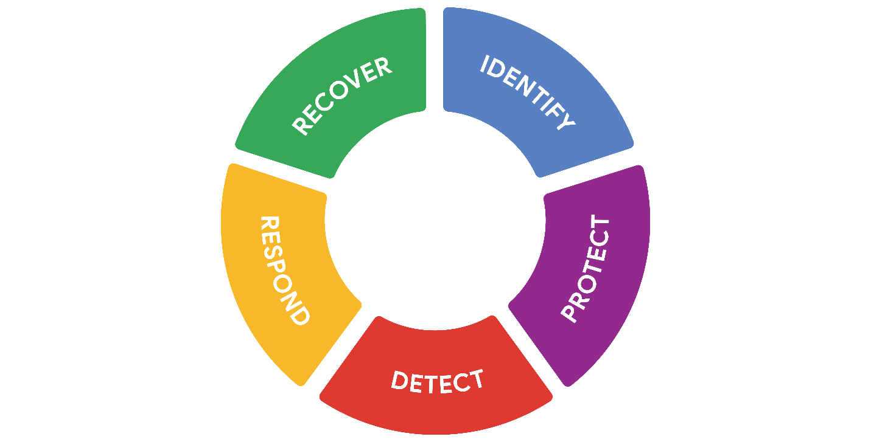

## Origins of the framework

Originally released in 2014, NIST developed the Cybersecurity Framework to protect critical infrastructure in the United States. NIST was selected to develop the CSF because they are an unbiased source of scientific data and practices. NIST eventually adapted the CSF to fit the needs of businesses in the public and private sector. Their goal was to make the framework more flexible, making it easier to adopt for small businesses or anyone else that might lack the resources to develop their own security plans.

## Components of the CSF

As you might recall, the framework consists of three main components: the core, tiers, and profiles. In the following sections, you'll learn more about each of these CSF components.

### **Core**

The CSF core is a set of desired cybersecurity outcomes that help organizations customize their security plan. It consists of five functions, or parts: Identify, Protect, Detect, Respond, and Recover. These functions are commonly used as an informative reference to help organizations identify their most important assets and protect those assets with appropriate safeguards. The CSF core is also used to understand ways to detect attacks and develop response and recovery plans should an attack happen.

### **Tiers**

The CSF tiers are a way of measuring the sophistication of an organization's cybersecurity program. CSF tiers are measured on a scale of 1 to 4. Tier 1 is the lowest score, indicating that a limited set of security controls have been implemented. Overall, CSF tiers are used to assess an organization's security posture and identify areas for improvement.

### **Profiles**

The CSF profiles are pre-made templates of the NIST CSF that are developed by a team of industry experts. CSF profiles are tailored to address the specific risks of an organization or industry. They are used to help organizations develop a baseline for their cybersecurity plans, or as a way of comparing their current cybersecurity posture to a specific industry standard.

**Note:** The core, tiers, and profiles were each designed to help any business improve their security operations. Although there are only three components, the entire framework consists of a complex system of subcategories and processes.

## Implementing the CSF

As you might recall, compliance is an important concept in security. **Compliance** is the process of adhering to internal standards and external regulations. In other words, compliance is a way of measuring how well an organization is protecting their assets. The **NIST Cybersecurity Framework (CSF)** is a voluntary framework that consists of standards, guidelines, and best practices to manage cybersecurity risk. Organizations may choose to use the CSF to achieve compliance with a variety of regulations.

**Note:** Regulations are rules that must be followed, while frameworks are resources you can choose to use.

Since its creation, many businesses have used the NIST CSF. However, CSF can be a challenge to implement due to its high level of detail. It can also be tough to find where the framework fits in. For example, some businesses have established security plans, making it unclear how CSF can benefit them. Alternatively, some businesses might be in the early stages of building their plans and need a place to start.

In any scenario, the U.S. Cybersecurity and Infrastructure Security Agency (CISA) provides detailed guidance that any organization can use to implement the CSF. This is a quick overview and summary of their recommendations:

* **Create a current profile** of the security operations and outline the specific needs of your business.
* **Perform a risk assessment** to identify which of your current operations are meeting business and regulatory standards.
* **Analyze and prioritize existing gaps** in security operations that place the businesses assets at risk.
* **Implement a plan of action** to achieve your organization’s goals and objectives.

**Pro tip:** Always consider current risk, threat, and vulnerability trends when using the NIST CSF.

You can learn more about implementing the CSF in [this report by CISA that outlines how the framework was applied in the commercial facilities sector](https://www.cisa.gov/sites/default/files/publications/Commercial_Facilities_Sector_Cybersecurity_Framework_Implementation_Guidance_FINAL_508.pdf)

.

## Industries embracing the CSF

The NIST CSF has continued to evolve since its introduction in 2014. Its design is influenced by the standards and best practices of some of the largest companies in the world.

A benefit of the framework is that it aligns with the security practices of many organizations across the global economy. It also helps with regulatory compliance that might be shared by business partners.

## Key takeaways

The NIST CSF is a flexible resource that organizations may choose to use to assess and improve their security posture. It's a useful framework that combines the security best practices of industries around the world. Implementing the CSF can be a challenge for any organization. The CSF can help business meet regulatory compliance requirements to avoid financial and reputational risks.

# Principle of least privilege

Security controls are essential to keeping sensitive data private and safe. One of the most common controls is the principle of least privilege, also referred to as PoLP or least privilege. The **principle of least privilege** is a security concept in which a user is only granted the minimum level of access and authorization required to complete a task or function.

Least privilege is a fundamental security control that supports the confidentiality, integrity, and availability (CIA) triad of information. In this reading, you'll learn how the principle of least privilege reduces risk, how it's commonly implemented, and why it should be routinely audited.

## Limiting access reduces risk

Every business needs to plan for the risk of data theft, misuse, or abuse. Implementing the principle of least privilege can greatly reduce the risk of costly incidents like data breaches by:

* Limiting access to sensitive information
* Reducing the chances of accidental data modification, tampering, or loss
* Supporting system monitoring and administration

Least privilege greatly reduces the likelihood of a successful attack by connecting specific resources to specific users and placing limits on what they can do. It's an important security control that should be applied to any asset. Clearly defining who or what your users are is usually the first step of implementing least privilege effectively.

**Note:** Least privilege is closely related to another fundamental security principle, the separation of duties—a security concept that divides tasks and responsibilities among different users to prevent giving a single user complete control over critical business functions. You'll learn more about separation of duties in a different reading about identity and access management.

## Determining access and authorization

To implement least privilege, access and authorization must be determined first. There are two questions to ask to do so:

* Who is the user?
* How much access do they need to a specific resource?

Determining who the user is usually straightforward. A user can refer to a person, like a customer, an employee, or a vendor. It can also refer to a device or software that's connected to your business network. In general, every user should have their own account. Accounts are typically stored and managed within an organization's directory service.

These are the most common types of user accounts:

* **Guest accounts** are provided to external users who need to access an internal network, like customers, clients, contractors, or business partners.
* **User accounts** are assigned to staff based on their job duties.
* **Service accounts** are granted to applications or software that needs to interact with other software on the network.
* **Privileged accounts** have elevated permissions or administrative access.

It's best practice to determine a baseline access level for each account type before implementing least privilege. However, the appropriate access level can change from one moment to the next. For example, a customer support representative should only have access to your information while they are helping you. Your data should then become inaccessible when the support agent starts working with another customer and they are no longer actively assisting you. Least privilege can only reduce risk if user accounts are routinely and consistently monitored.

**Pro tip:** Passwords play an important role when implementing the principle of least privilege. Even if user accounts are assigned appropriately, an insecure password can compromise your systems.

## Auditing account privileges

Setting up the right user accounts and assigning them the appropriate privileges is a helpful first step. Periodically auditing those accounts is a key part of keeping your company’s systems secure.

There are three common approaches to auditing user accounts:

* Usage audits
* Privilege audits
* Account change audits

As a security professional, you might be involved with any of these processes.

### **Usage audits**

When conducting a usage audit, the security team will review which resources each account is accessing and what the user is doing with the resource. Usage audits can help determine whether users are acting in accordance with an organization’s security policies. They can also help identify whether a user has permissions that can be revoked because they are no longer being used.

### **Privilege audits**

Users tend to accumulate more access privileges than they need over time, an issue known as privilege creep. This might occur if an employee receives a promotion or switches teams and their job duties change. Privilege audits assess whether a user's role is in alignment with the resources they have access to.

### **Account change audits**

Account directory services keep records and logs associated with each user. Changes to an account are usually saved and can be used to audit the directory for suspicious activity, like multiple attempts to change an account password. Performing account change audits helps to ensure that all account changes are made by authorized users.

**Note:** Most directory services can be configured to alert system administrators of suspicious activity.

# The data lifecycle

Organizations of all sizes handle a large amount of data that must be kept private. You learned that data can be vulnerable whether it is at rest, in use, or in transit. Regardless of the state it is in, information should be kept private by limiting access and authorization.

In security, data vulnerabilities are often mapped in a model known as the data lifecycle. Each stage of the data lifecycle plays an important role in the security controls that are put in place to maintain the CIA triad of information. In this reading, you will learn about the data lifecycle, the plans that determine how data is protected, and the specific types of data that require extra attention.

## The data lifecycle

The data lifecycle is an important model that security teams consider when protecting information. It influences how they set policies that align with business objectives. It also plays an important role in the technologies security teams use to make information accessible.

In general, the data lifecycle has five stages. Each describe how data flows through an organization from the moment it is created until it is no longer useful:

* Collect
* Store
* Use
* Archive
* Destroy

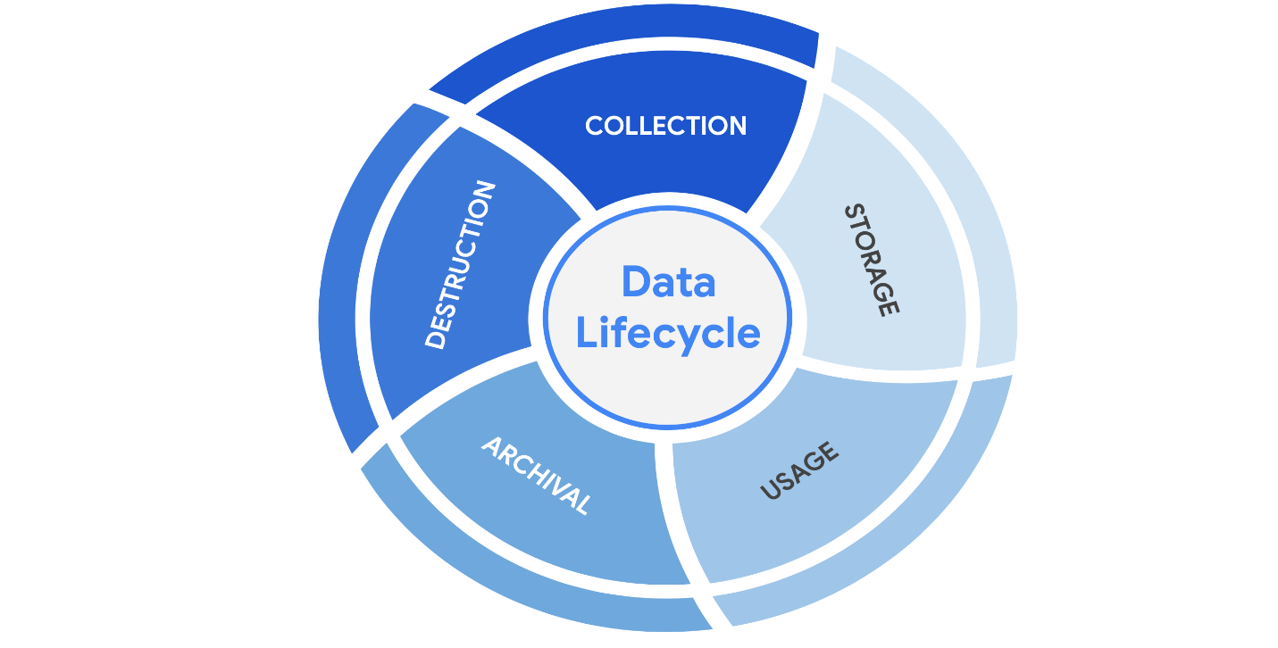

Protecting information at each stage of this process describes the need to keep it accessible and recoverable should something go wrong.

## Data governance

Businesses handle massive amounts of data every day. New information is constantly being collected from internal and external sources. A structured approach to managing all of this data is the best way to keep it private and secure.

Data governance is a set of processes that define how an organization manages information. Governance often includes policies that specify how to keep data private, accurate, available, and secure throughout its lifecycle.

Effective data governance is a collaborative activity that relies on people. Data governance policies commonly categorize individuals into a specific role:

* **Data owner:** the person that decides who can access, edit, use, or destroy their information.
* **Data custodian**: anyone or anything that's responsible for the safe handling, transport, and storage of information.
* **Data steward**: the person or group that maintains and implements data governance policies set by an organization.

Businesses store, move, and transform data using a wide range of IT systems. Data governance policies often assign accountability to data owners, custodians, and stewards.

**Note:** As a data custodian, you will primarily be  responsible for maintaining security and privacy rules for your organization.

## Protecting data at every stage

Most security plans include a specific policy that outlines how information will be managed across an organization. This is known as a data governance policy. These documents clearly define procedures that should be followed to participate in keeping data safe. They place limits on who or what can access data. Security professionals are important participants in data governance. As a data custodian, you will be responsible for ensuring that data isn’t damaged, stolen, or misused.

## Legally protected information

Data is more than just a bunch of 1s and 0s being processed by a computer. Data can represent someone's personal thoughts, actions, and choices. It can represent a purchase, a sensitive medical decision, and everything in between. For this reason, data owners should be the ones deciding whether or not to share their data. As a security professional, protecting a person's data privacy decisions must always be respected.

Securing data can be challenging. In large part, that's because data owners generate more data than they can manage. As a result, data custodians and stewards sometimes lack direct, explicit instructions on how they should handle specific types of data. Governments and other regulatory agencies have bridged this gap by creating rules that specify the types of information that organizations must protect by default:

* **PII** is any information used to infer an individual's identity. Personally identifiable information, or PII, refers to information that can be used to contact or locate someone.
* **PHI** stands for protected health information.  In the U.S., it is regulated by the Health Insurance Portability and Accountability Act (HIPAA), which defines PHI as “information that relates to the past, present, or future physical or mental health or condition of an individual.” In the EU, PHI has a similar definition but it is regulated by the General Data Protection Regulation (GDPR).
* **SPII** is a specific type of PII that falls under stricter handling guidelines. The S stands for sensitive, meaning this is a type of personally identifiable information that should only be accessed on a need-to-know basis, such as a bank account number or login credentials.

Overall, it's important to protect all types of personal information from unauthorized use and disclosure.

# Information privacy: Regulations and compliance

Security and privacy have a close relationship. As you may recall, people have the right to control how their personal data is collected and used. Organizations also have a responsibility to protect the information they are collecting from being compromised or misused. As a security professional, you will be highly involved in these efforts.

Previously, you learned how regulations and compliance reduce security risk. To review, refer to [the reading about how security controls, frameworks, and compliance regulations](https://www.coursera.org/learn/foundations-of-cybersecurity/supplement/xu4pr/controls-frameworks-and-compliance)

are used together to manage security and minimize risk. In this reading, you will learn how information privacy regulations affect data handling practices. You'll also learn about some of the most influential security regulations in the world.

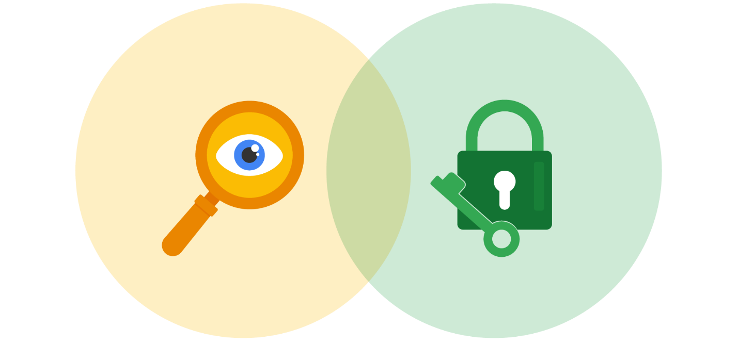

## Information security vs. information privacy

Security and privacy are two terms that often get used interchangeably outside of this field. Although the two concepts are connected, they represent specific functions:

* **Information privacy** refers to the protection of unauthorized access and distribution of data.
* **Information security** (InfoSec) refers to the practice of keeping data in all states away from unauthorized users.

The key difference: Privacy is about providing people with control over their personal information and how it's shared. Security is about protecting people’s choices and keeping their information safe from potential threats.

For example, a retail company might want to collect specific kinds of personal information about its customers for marketing purposes, like their age, gender, and location. How this private information will be used should be disclosed to customers before it's collected. In addition, customers should be given an option to opt-out if they decide not to share their data.

Once the company obtains consent to collect personal information, it might implement specific security controls in place to protect that private data from unauthorized access, use, or disclosure. The company should also have security controls in place to respect the privacy of all stakeholders and anyone who chose to opt-out.

**Note:** Privacy and security are both essential for maintaining customer trust and brand reputation.

## Why privacy matters in security

Data privacy and protection are topics that started gaining a lot of attention in the late 1990s. At that time, tech companies suddenly went from processing people’s data to storing and using it for business purposes. For example, if a user searched for a product online, companies began storing and sharing access to information about that user’s search history with other companies. Businesses were then able to deliver personalized shopping experiences to the user for free.

Eventually this practice led to a global conversation about whether these organizations had the right to collect and share someone’s private data. Additionally, the issue of data security became a greater concern; the more organizations collected data, the more vulnerable it was to being abused, misused, or stolen.

Many organizations became more concerned about the issues of data privacy. Businesses became more transparent about how they were collecting, storing, and using information. They also began implementing more security measures to protect people's data privacy. However, without clear rules in place, protections were inconsistently applied.

**Note:** The more data is collected, stored, and used, the more vulnerable it is to breaches and threats.

## Notable privacy regulations

Businesses are required to abide by certain laws to operate. As you might recall, **regulations** are rules set by a government or another authority to control the way something is done. Privacy regulations in particular exist to protect a user from having their information collected, used, or shared without their consent. Regulations may also describe the security measures that need to be in place to keep private information away from threats.

Three of the most influential industry regulations that every security professional should know about are:

* General Data Protection Regulation (GDPR)
* Payment Card Industry Data Security Standard (PCI DSS)
* Health Insurance Portability and Accountability Act (HIPAA)

### **GDPR**

GDPR is a set of rules and regulations developed by the European Union (EU) that puts data owners in total control of their personal information. Under GDPR, types of personal information include a person's name, address, phone number, financial information, and medical information.

The GDPR applies to any business that handles the data of EU citizens or residents, regardless of where that business operates. For example, a US based company that handles the data of EU visitors to their website is subject to the GDPRs provisions.

### **PCI DSS**

PCI DSS is a set of security standards formed by major organizations in the financial industry. This regulation aims to secure credit and debit card transactions against data theft and fraud.

### **HIPAA**

HIPAA is a U.S. law that requires the protection of sensitive patient health information. HIPAA prohibits the disclosure of a person's medical information without their knowledge and consent.

**Note:** These regulations influence data handling at many organizations around the world even though they were developed by specific nations.

Several other security and privacy compliance laws exist. Which ones your organization needs to follow will depend on the industry and the area of authority. Regardless of the circumstances, regulatory compliance is important to every business.

## Security assessments and audits

Businesses should comply with important regulations in their industry. Doing so validates that they have met a minimum level of security while also demonstrating their dedication to maintaining data privacy.

Meeting compliance standards is usually a continual, two-part process of security audits and assessments:

* A **security audit** is a review of an organization's security controls, policies, and procedures against a set of expectations.
* A **security assessment** is a check to determine how resilient current security implementations are against threats.

For example, if a regulation states that multi-factor authentication (MFA) must be enabled for all administrator accounts, an audit might be conducted to check those user accounts for compliance. After the audit, the internal team might perform a security assessment that determines many users are using weak passwords. Based on their assessment, the team could decide to enable MFA on all user accounts to improve their overall security posture.

**Note:** Compliance with legal regulations, such as GDPR, can be determined during audits.

As a security analyst, you are likely to be involved with security audits and assessments in the field. Businesses usually perform security audits less frequently, approximately once per year. Security audits may be performed both internally and externally by different third-party groups.

In contrast, security assessments are usually performed more frequently, about every three-to-six months. Security assessments are typically performed by internal employees, often as preparation for a security audit. Both evaluations are incredibly important ways to ensure that your systems are effectively protecting everyone's privacy.

# Symmetric and asymmetric encryption

Previously, you learned these terms:

* **Encryption**: the process of converting data from a readable format to an encoded format
* **Public key infrastructure** (PKI):  an encryption framework that secures the exchange of online information
* **Cipher**: an algorithm that encrypts information

All digital information deserves to be kept private, safe, and secure. Encryption is one key to doing that! It is useful for transforming information into a form that unintended recipients cannot understand. In this reading, you’ll compare symmetric and asymmetric encryption and learn about some well-known algorithms for each.

## Types of encryption

There are two main types of encryption:

* **Symmetric encryption** is the use of a single secret key to exchange information. Because it uses one key for encryption and decryption, the sender and receiver must know the secret key to lock or unlock the cipher.
* **Asymmetric encryption** is the use of a public and private key pair for encryption and decryption of data. It uses two separate keys: a public key and a private key. The public key is used to encrypt data, and the private key decrypts it. The private key is only given to users with authorized access.

## The importance of key length

Ciphers are vulnerable to **brute force attacks**, which use a trial and error process to discover private information. This tactic is the digital equivalent of trying every number in a combination lock trying to find the right one. In modern encryption, longer key lengths are considered to be more secure. Longer key lengths mean more possibilities that an attacker needs to try to unlock a cipher.

One drawback to having long encryption keys is slower processing times. Although short key lengths are generally less secure, they’re much faster to compute. Providing fast data communication online while keeping information safe is a delicate balancing act.

## Approved algorithms

Many web applications use a combination of symmetric and asymmetric encryption. This is how they balance user experience with safeguarding information. As an analyst, you should be aware of the most widely-used algorithms.

### **Symmetric algorithms**

* Triple DES (3DES) is known as a block cipher because of the way it converts plaintext into ciphertext in “blocks.” Its origins trace back to the Data Encryption Standard (DES), which was developed in the early 1970s. DES was one of the earliest symmetric encryption algorithms that generated 64-bit keys. A **bit** is the smallest unit of data measurement on a computer. As you might imagine, Triple DES generates keys that are 192 bits, or three times as long. Despite the longer keys, many organizations are moving away from using Triple DES due to limitations on the amount of data that can be encrypted. However, Triple DES is likely to remain in use for backwards compatibility purposes.
* Advanced Encryption Standard (AES)is one of the most secure symmetric algorithms today. AES generates keys that are 128, 192, or 256 bits. Cryptographic keys of this size are considered to be safe from brute force attacks. It’s estimated that brute forcing an AES 128-bit key could take a modern computer billions of years!

### **Asymmetric algorithms**

* Rivest Shamir Adleman (RSA)is named after its three creators who developed it while at the Massachusetts Institute of Technology (MIT). RSA is one of the first asymmetric encryption algorithms that produces a public and private key pair. Asymmetric algorithms like RSA produce even longer key lengths. In part, this is due to the fact that these functions are creating two keys. RSA key sizes are 1,024, 2,048, or 4,096 bits. RSA is mainly used to protect highly sensitive data.
* Digital Signature Algorithm (DSA)is a standard asymmetric algorithm that was introduced by NIST in the early 1990s. DSA also generates key lengths of 2,048 bits. This algorithm is widely used today as a complement to RSA in public key infrastructure.

### **Generating keys**

These algorithms must be implemented when an organization chooses one to protect their data. One way this is done is using OpenSSL, which is an open-source command line tool that can be used to generate public and private keys. OpenSSL is commonly used by computers to verify digital certificates that are exchanged as part of public key infrastructure.

**Note:** OpenSSL is just one option. There are various others available that can generate keys with any of these common algorithms.

In early 2014, OpenSSL disclosed a vulnerability, known as the [Heartbleed bug](https://en.wikipedia.org/wiki/Heartbleed)

, that exposed sensitive data in the memory of websites and applications. Although unpatched versions of OpenSSL are still available, the Heartbleed bug was patched later that year (2014). Many businesses today use the secure versions of OpenSSL to generate public and private keys, demonstrating the importance of using up-to-date software.

## Obscurity is not security

In the world of cryptography, a cipher must be proven to be unbreakable before claiming that it is secure. According to [Kerchoff’s principle](https://en.wikipedia.org/wiki/Kerckhoffs%27s_principle)

, cryptography should be designed in such a way that all the details of an algorithm—except for the private key—should be knowable without sacrificing its security. For example, you can access all the details about how AES encryption works online and yet it is still unbreakable.

Occasionally, organizations implement their own, custom encryption algorithms. There have been instances where those secret cryptographic systems have been quickly cracked after being made public.

**Pro tip:** A cryptographic system should not be considered secure if it requires secrecy around how it works.

### Encryption is everywhere

Companies use both symmetric and asymmetric encryption. They often work as a team, balancing security with user experience.

For example, websites tend to use asymmetric encryption to secure small blocks of data that are important. Usernames and passwords are often secured with asymmetric encryption while processing login requests. Once a user gains access, the rest of their web session often switches to using symmetric encryption for its speed.

Using data encryption like this is increasingly required by law. Regulations like the Federal Information Processing Standards (FIPS 140-3) and the General Data Protection Regulation (GDPR) outline how data should be collected, used, and handled. Achieving compliance with either regulation is critical to demonstrating to business partners and governments that customer data is handled responsibly.

# The evolution of hash functions

Hash functions are important controls that are part of every company's security strategy. Hashing is widely used for authentication and **non-repudiation**, the concept that the authenticity of information can’t be denied.

Previously, you learned that **hash functions** are algorithms that produce a code that can't be decrypted.Hash functions convert information into a unique value that can then be used to determine its integrity. In this reading, you’ll learn about the origins of hash functions and how they’ve changed over time.

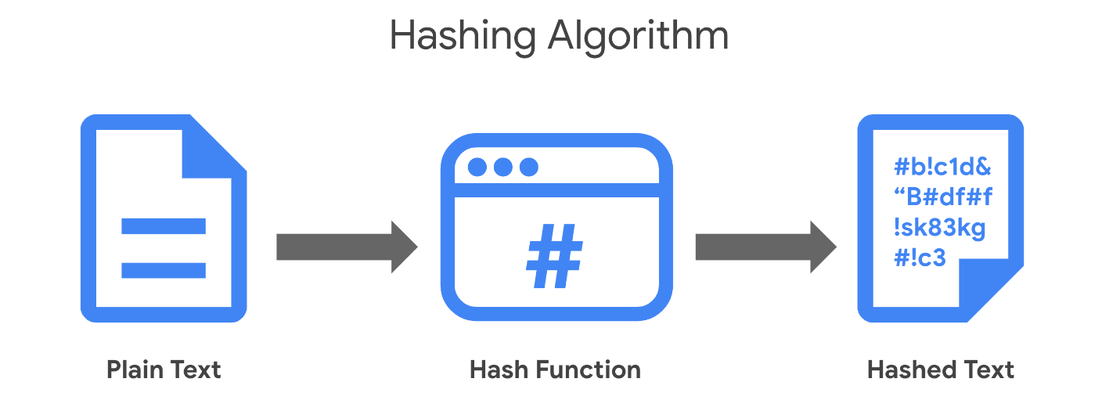

## Origins of hashing

Hash functions have been around since the early days of computing. They were originally created as a way to quickly search for data. Since the beginning, these algorithms have been designed to represent data of any size as small, fixed-size values, or digests. Using a hash table, which is a data structure that's used to store and reference hash values, these small values became a more secure and efficient way for computers to reference data.

One of the earliest hash functions is Message Digest 5, more commonly known as MD5. Professor Ronald Rivest of the Massachusetts Institute of Technology (MIT) developed MD5 in the early 1990s as a way to verify that a file sent over a network matched its source file.

Whether it’s used to convert a single email or the source code of an application, MD5 works by converting data into a 128-bit value. You might recall that a **bit** is the smallest unit of data measurement on a computer. Bits can either be a 0 or 1. In a computer, bits represent user input in a way that computers can interpret. In a hash table, this appears as a string of 32 characters. Altering anything in the source file generates an entirely new hash value.

Generally, the longer the hash value, the more secure it is. It wasn’t long after MD5's creation that security practitioners discovered 128-bit digests resulted in a major vulnerability.

Here is an example of how plaintext gets turned into hash values:

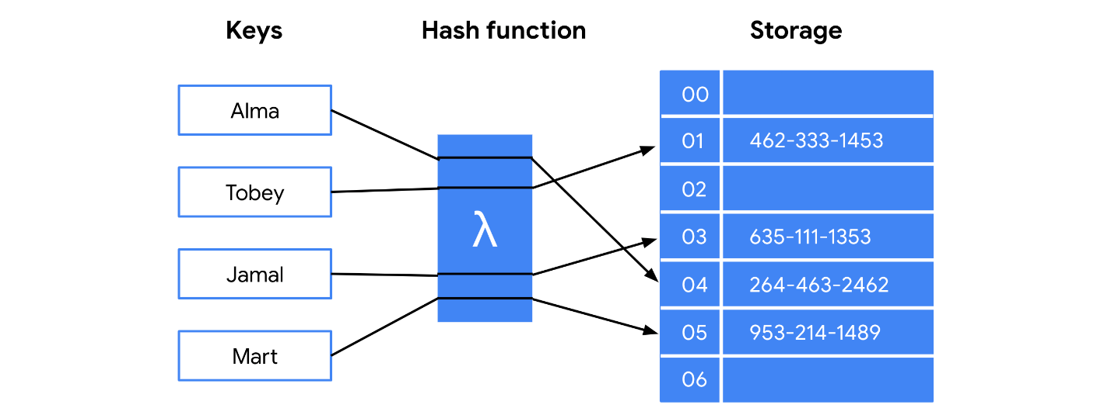

### **Hash collisions**

One of the flaws in MD5 happens to be a characteristic of all hash functions. Hash algorithms map any input, regardless of its length, into a fixed-size value of letters and numbers. What’s the problem with that? Although there are an infinite amount of possible inputs, there’s only a finite set of available outputs!

MD5 values are limited to 32 characters in length. Due to the limited output size, the algorithm is considered to be vulnerable to **hash collision**, an instance when different inputs produce the same hash value. Because hashes are used for authentication, a hash collision is similar to copying someone’s identity. Attackers can carry out collision attacks to fraudulently impersonate authentic data.

## Next-generation hashing

To avoid the risk of hash collisions, functions that generated longer values were needed. MD5's shortcomings gave way to a new group of functions known as the Secure Hashing Algorithms, or SHAs.

The National Institute of Standards and Technology (NIST) approves each of these algorithms. Numbers besides each SHA function indicate the size of its hash value in bits. Except for SHA-1, which produces a 160-bit digest, these algorithms are considered to be collision-resistant. However, that doesn’t make them invulnerable to other exploits.

**Five functions make up the SHA family of algorithms:**

* SHA-1
* SHA-224
* SHA-256
* SHA-384
* SHA-512

## Secure password storage

Passwords are typically stored in a database where they are mapped to a username. The server receives a request for authentication that contains the credentials supplied by the user. It then looks up the username in the database and compares it with the password that was provided and verifies that it matches before granting them access.

This is a safe system unless an attacker gains access to the user database. If passwords are stored in plaintext, then an attacker can steal that information and use it to access company resources. Hashing adds an additional layer of security. Because hash values can't be reversed, an attacker would not be able to steal someone's login credentials if they managed to gain access to the database.

### **Rainbow tables**

A **rainbow table** is a file of pre-generated hash values and their associated plaintext. They’re like dictionaries of weak passwords. Attackers capable of obtaining an organization’s password database can use a rainbow table to compare them against all possible values.

## Adding some “salt”

Functions with larger digests are less vulnerable to collision and rainbow table attacks. But as you’re learning, no security control is perfect.

**Salting** is an additional safeguard that's used to strengthen hash functions. A salt is a random string of characters that's added to data before it's hashed. The additional characters produce a more unique hash value, making salted data resilient to rainbow table attacks.

For example, a database containing passwords might have several hashed entries for the password "password." If those passwords were all salted, each entry would be completely different. That means an attacker using a rainbow table would be unable to find matching values for "password" in the database.

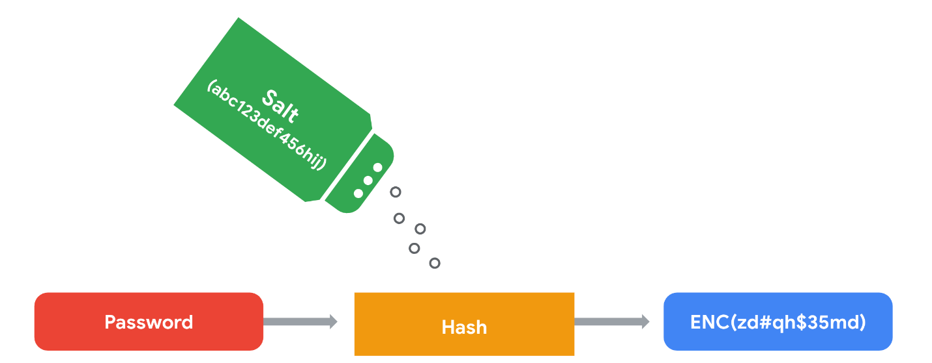

For this reason, salting has become increasingly common when storing passwords and other types of sensitive data. The length and uniqueness of a salt is important. Similar to hash values, the longer and more complex a salt is, the harder it is to crack.

# The rise of SSO and MFA

Most companies help keep their data safely locked up behind authentication systems. Usernames and passwords are the keys that unlock information for most organizations. But are those credentials enough? Information security often focuses on managing a user's access of, and authorization to, information.

Previously, you learned about the three factors of authentication: knowledge, ownership, and characteristic. Single sign-on (SSO) and multi-factor authentication (MFA) are two technologies that have become popular for implementing these authentication factors. In this reading, you’ll learn how these technologies work and why companies are adopting them.

## A better approach to authentication

**Single sign-on** (SSO) is a technology that combines several different logins into one. More companies are turning to SSO as a solution to their authentication needs for three reasons:

1. **SSO improves the user experience** by eliminating the number of usernames and passwords people have to remember.
2. **Companies can lower costs** by streamlining how they manage connected services.
3. **SSO improves overall security** by reducing the number of access points attackers can target.

This technology became available in the mid-1990s as a way to combat password fatigue, which refers to people’s tendency to reuse passwords across services. Remembering many different passwords can be a challenge, but using the same password repeatedly is a major security risk. SSO solves this dilemma by shifting the burden of authentication away from the user.

## How SSO works

SSO works by automating how trust is established between a user and a service provider. Rather than placing the responsibility on an employee or customer, SSO solutions use trusted third-parties to prove that a user is who they claim to be. This is done through the exchange of encrypted access tokens between the identity provider and the service provider.

Similar to other kinds of digital information, these access tokens are exchanged using specific protocols. SSO implementations commonly rely on two different authentication protocols: LDAP and SAML. LDAP, which stands for Lightweight Directory Access Protocol, is mostly used to transmit information on-premises; SAML, which stands for Security Assertion Markup Language, is mostly used to transmit information off-premises, like in the cloud.

**Note:** LDAP and SAML protocols are often used together.

Here's an example of how SSO can connect a user to multiple applications with one access token:

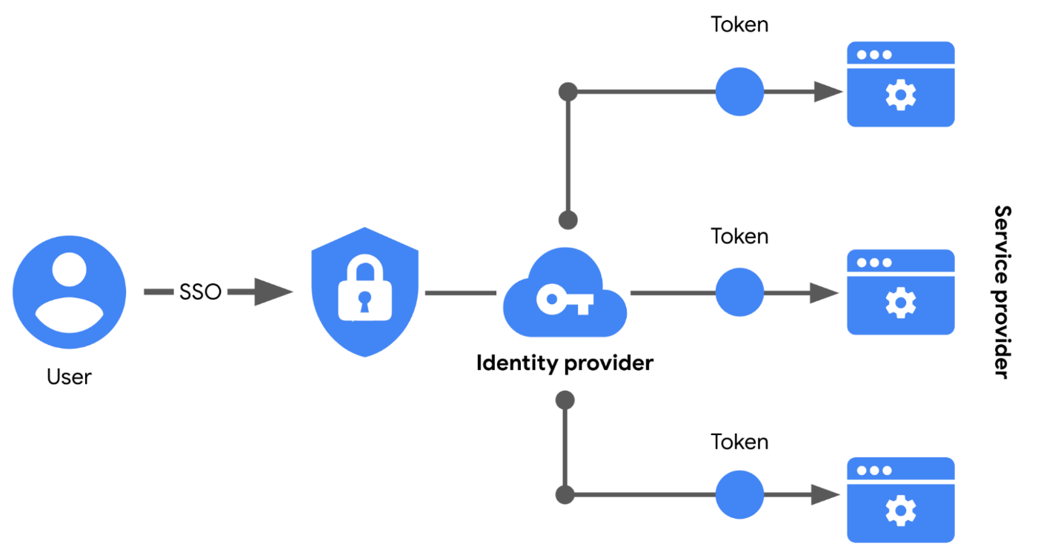

## Limitations of SSO

Usernames and passwords alone are not always the most secure way of protecting sensitive information. SSO provides useful benefits, but there’s still the risk associated with using one form of authentication. For example, a lost or stolen password could expose information across multiple services. Thankfully, there’s a solution to this problem.

## MFA to the rescue

**Multi-factor authentication** (MFA) requires a user to verify their identity in two or more ways to access a system or network. In a sense, MFA is similar to using an ATM to withdraw money from your bank account. First, you insert a debit card into the machine as one form of identification. Then, you enter your PIN number as a second form of identification. Combined, both steps, or factors, are used to verify your identity before authorizing you to access the account.

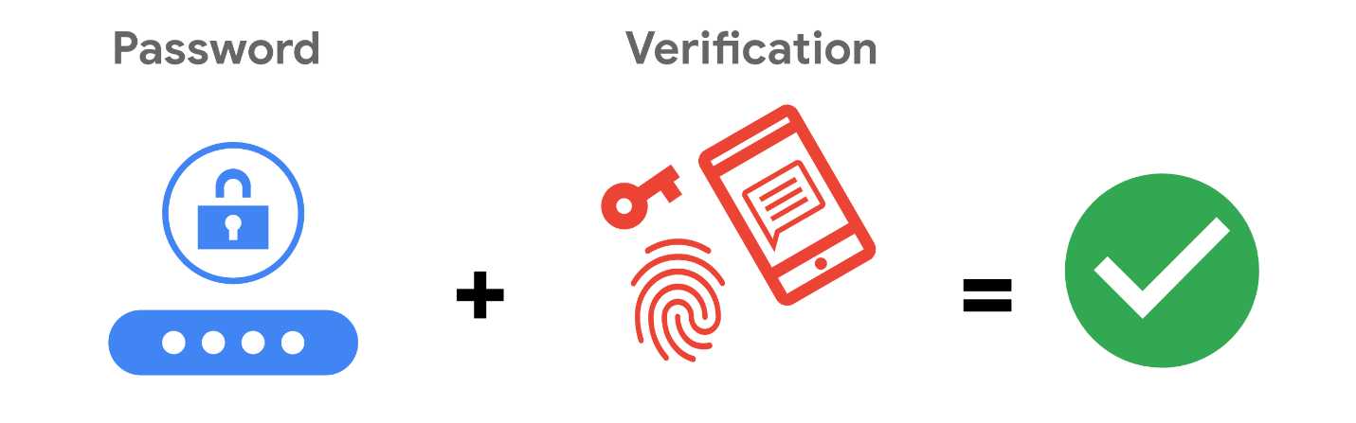

## Strengthening authentication

MFA builds on the benefits of SSO. It works by having users prove that they are who they claim to be. The user must provide two factors (2FA) or three factors (3FA) to authenticate their identification. The MFA process asks users to provide these proofs, such as:

* **Something a user knows:** most commonly a username and password
* **Something a user has:** normally received from a service provider, like a one-time passcode (OTP) sent via SMS
* **Something a user is:** refers to physical characteristics of a user, like their fingerprints or facial scans

Requiring multiple forms of identification is an effective security measure, especially in cloud environments. It can be difficult for businesses in the cloud to ensure that the users remotely accessing their systems are not threat actors. MFA can reduce the risk of authenticating the wrong users by requiring forms of identification that are difficult to imitate or brute force.

# Identity and access management

Security is more than simply combining processes and technologies to protect assets. Instead, security is about ensuring that these processes and technologies are creating a secure environment that supports a defense strategy. A key to doing this is implementing two fundamental security principles that limit access to organizational resources:

* The **principle of least privilege** in which a user is only granted the minimum level of access and authorization required to complete a task or function.
* **Separation of duties**, which is the principle that users should not be given levels of authorization that would allow them to misuse a system.

Both principles typically support each other. For example, according to least privilege, a person who needs permission to approve purchases from the IT department shouldn't have the permission to approve purchases from every department. Likewise, according to separation of duties, the person who can approve purchases from the IT department should be different from the person who can input new purchases.

In other words, least privilege limits the access that an individual receives, while separation of duties divides responsibilities among multiple people to prevent any one person from having too much control.

**Note:** Separation of duties is sometimes referred to as segregation of duties.

Previously, you learned about the authentication, authorization, and accounting (AAA) framework. Many businesses used this model to implement these two security principles and manage user access. In this reading, you’ll learn about the other major framework for managing user access,identity and access management(IAM). You will learn about the similarities between AAA and IAM and how they're commonly implemented.

## Identity and access management (IAM)

As organizations become more reliant on technology, regulatory agencies have put more pressure on them to demonstrate that they’re doing everything they can to prevent threats. **Identity and access management** (IAM) is a collection of processes and technologies that helps organizations manage digital identities in their environment. Both AAA and IAM systems are designed to authenticate users, determine their access privileges, and track their activities within a system.

Either model used by your organization is more than a single, clearly defined system. They each consist of a collection of security controls that ensure the right user is granted access to the right resources at the right time and for the right reasons. Each of those four factors is determined by your organization's policies and processes.

**Note:** A user can either be a person, a device, or software.

## Authenticating users

To ensure the right user is attempting to access a resource requires some form of proof that the user is who they claim to be. In a [video on authentication controls](https://www.coursera.org/learn/assets-threats-and-vulnerabilities/item/r6XuB)

, you learned that there are a few factors that can be used to authenticate a user:

* **Knowledge**, or something the user knows
* **Ownership**, or something the user possesses
* **Characteristic**, or something the user is

Authentication is mainly verified with login credentials. **Single sign-on** (SSO), a technology that combines several different logins into one, and **multi-factor authentication** (MFA), a security measure that requires a user to verify their identity in two or more ways to access a system or network, are other tools that organizations use to authenticate individuals and systems.

**Pro tip:** Another way to remember this authentication model is: something you know, something you have, and something you are.

### **User provisioning**

Back-end systems need to be able to verify whether the information provided by a user is accurate. To accomplish this, users must be properly provisioned. **User provisioning** is the process of creating and maintaining a user's digital identity. For example, a college might create a new user account when a new instructor is hired. The new account will be configured to provide access to instructor-only resources while they are teaching. Security analysts are routinely involved with provisioning users and their access privileges.

**Pro tip:** Another role analysts have in IAM is to deprovision users. This is an important practice that removes a user's access rights when they should no longer have them.

### **Granting authorization**

If the right user has been authenticated, the network should ensure the right resources are made available. There are three common frameworks that organizations use to handle this step of IAM:

* Mandatory access control (MAC)
* Discretionary access control (DAC)
* Role-based access control (RBAC)

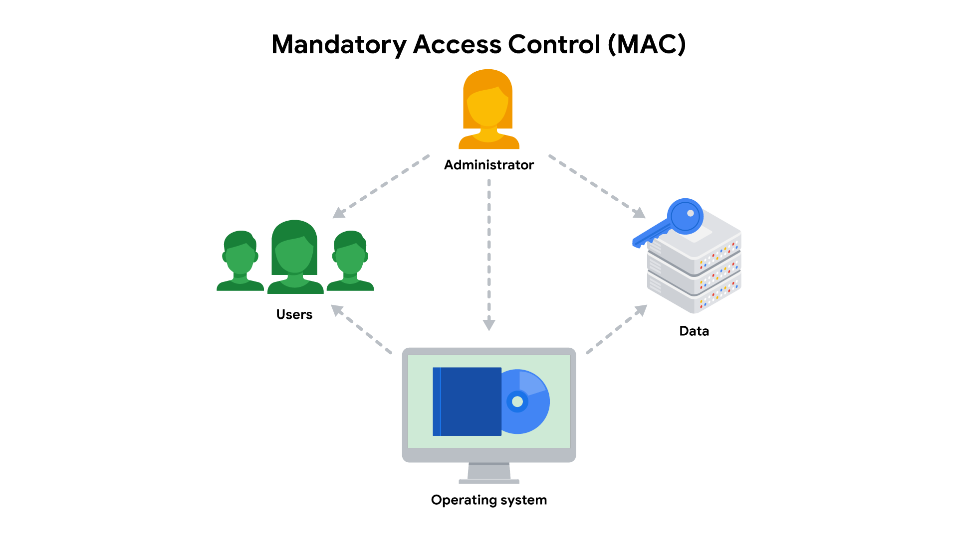

### **Mandatory Access Control (MAC)**

MAC is the strictest of the three frameworks. Authorization in this model is based on a strict need-to-know basis. Access to information must be granted manually by a central authority or system administrator. For example, MAC is commonly applied in law enforcement, military, and other government agencies where users must request access through a chain of command. MAC is also known as non-discretionary control because access isn’t given at the discretion of the data owner.

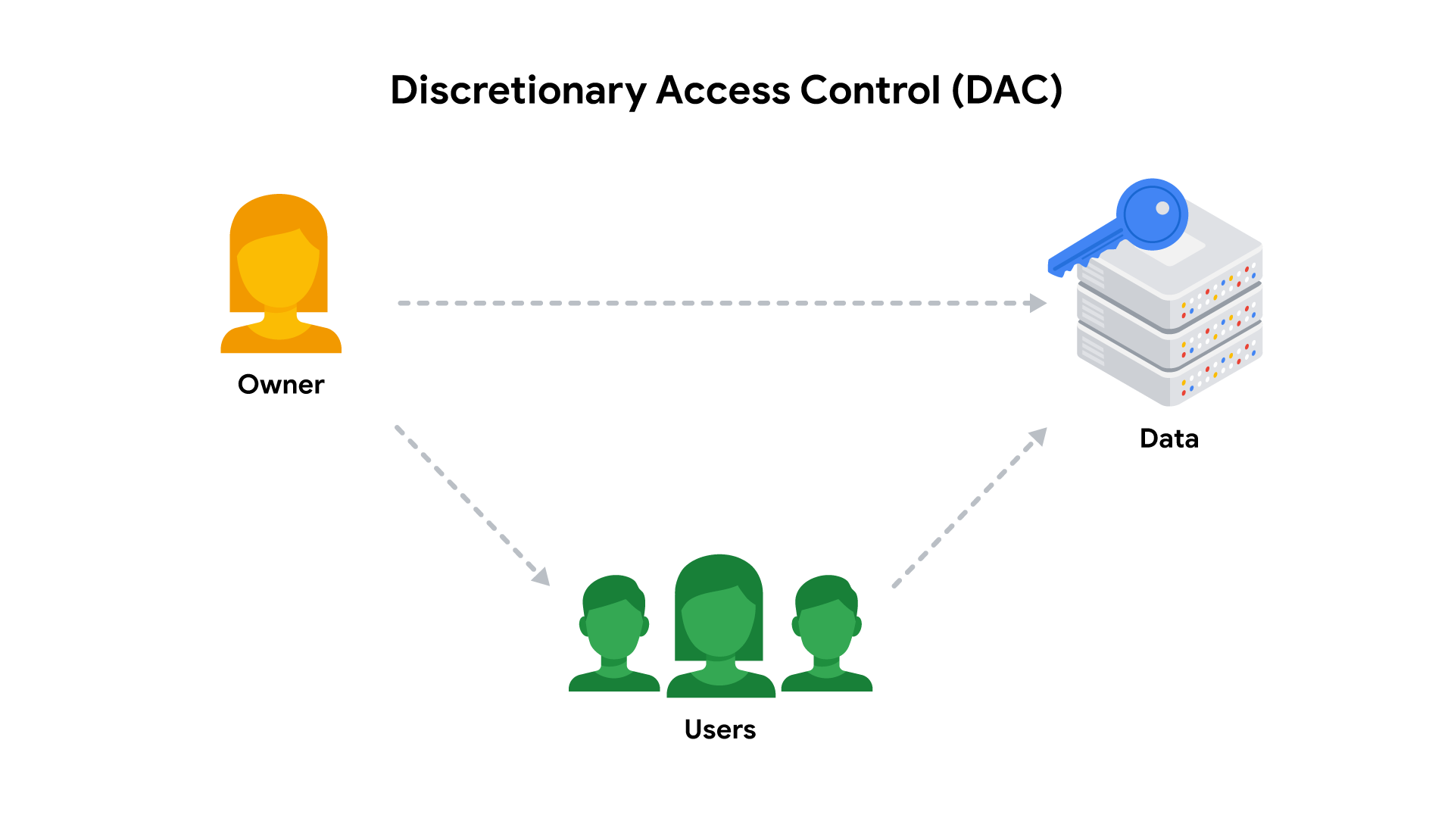

### **Discretionary Access Control (DAC)**

DAC is typically applied when a data owner decides appropriate levels of access. One example of DAC is when the owner of a Google Drive folder shares editor, viewer, or commentor access with someone else.

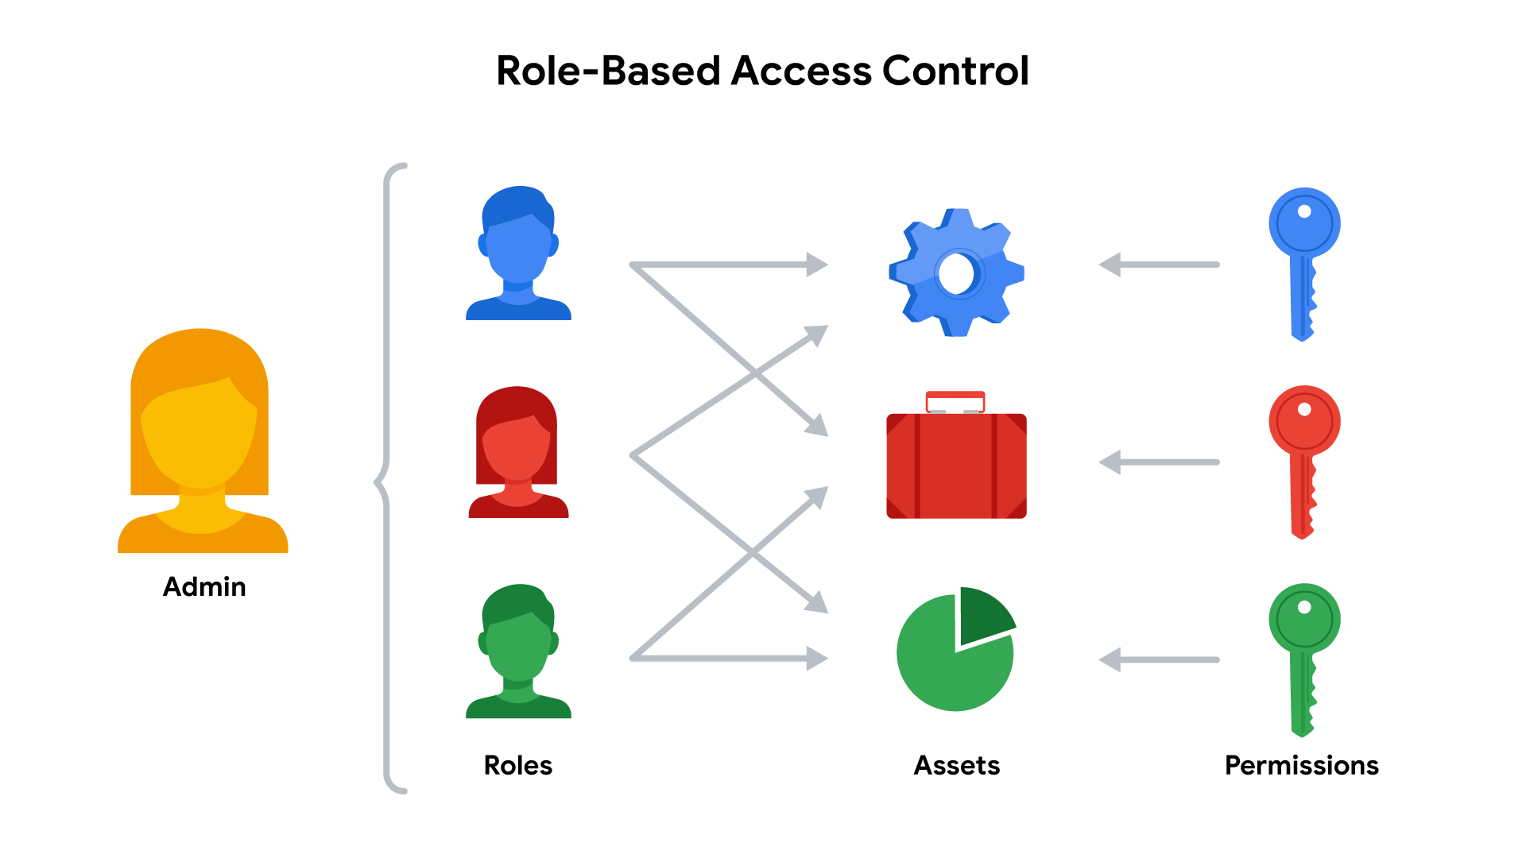

### **Role-Based Access Control (RBAC)**

RBAC is used when authorization is determined by a user's role within an organization. For example, a user in the marketing department may have access to user analytics but not network administration.

## Access control technologies

Users often experience authentication and authorization as a single, seamless experience. In large part, that’s due to access control technologies that are configured to work together. These tools offer the speed and automation needed by administrators to monitor and modify access rights. They also decrease errors and potential risks.

An organization's IT department sometimes develops and maintains customized access control technologies on their own. A typical IAM or AAA system consists of a user directory, a set of tools for managing data in that directory, an authorization system, and an auditing system. Some organizations create custom systems to tailor them to their security needs. However, building an in-house solution comes at a steep cost of time and other resources.

Instead, many organizations opt to license third-party solutions that offer a suite of tools that enable them to quickly secure their information systems. Keep in mind, security is about more than combining a bunch of tools. It’s always important to configure these technologies so they can help to provide a secure environment.

## Key takeaways

Controlling access requires a collection of systems and tools. IAM and AAA are common frameworks for implementing least privilege and separation of duties. As a security analyst, you might be responsible for user provisioning and collaborating with other IAM or AAA teams. Having familiarity with these models is valuable for helping organizations achieve their security objectives. They each ensure that the right user is granted access to the right resources at the right time and for the right reasons.

## Resources for more information

# The OWASP Top 10

To prepare for future risks, security professionals need to stay informed. Previously, you learned about the **CVE® list**, an openly accessible dictionary of known vulnerabilities and exposures. The CVE® list is an important source of information that the global security community uses to share information with each other.

In this reading, you’ll learn about another important resource that security professionals reference, the Open Web Application Security Project, recently renamed Open Worldwide Application Security Project® (OWASP). You’ll learn about OWASP’s role in the global security community and how companies use this resource to focus their efforts.

## What is OWASP?

OWASP is a nonprofit foundation that works to improve the security of software. OWASP is an open platform that security professionals from around the world use to share information, tools, and events that are focused on securing the web.

## The OWASP Top 10

One of OWASP’s most valuable resources is the OWASP Top 10. The organization has published this list since 2003 as a way to spread awareness of the web’s most targeted vulnerabilities. The Top 10 mainly applies to new or custom made software. Many of the world's largest organizations reference the OWASP Top 10 during application development to help ensure their programs address common security mistakes.

**Pro tip:** OWASP’s Top 10 is updated every few years as technologies evolve. Rankings are based on how often the vulnerabilities are discovered and the level of risk they present.

**Note:** Auditors also use the OWASP Top 10 as one point of reference when checking for regulatory compliance.

## Common vulnerabilities

Businesses often make critical security decisions based on the vulnerabilities listed in the OWASP Top 10. This resource influences how businesses design new software that will be on their network, unlike the CVE® list, which helps them identify improvements to existing programs. These are the most regularly listed vulnerabilities that appear in their rankings to know about:

### **Broken access control**

Access controls limit what users can do in a web application. For example, a blog might allow visitors to post comments on a recent article but restricts them from deleting the article entirely. Failures in these mechanisms can lead to unauthorized information disclosure, modification, or destruction. They can also give someone unauthorized access to other business applications.

### **Cryptographic failures**

Information is one of the most important assets businesses need to protect. Privacy laws such as General Data Protection Regulation (GDPR) require sensitive data to be protected by effective encryption methods. Vulnerabilities can occur when businesses fail to encrypt things like personally identifiable information (PII). For example, if a web application uses a weak hashing algorithm, like MD5, it’s more at risk of suffering a data breach.

### **Injection**

Injection occurs when malicious code is inserted into a vulnerable application. Although the app appears to work normally, it does things that it wasn’t intended to do. Injection attacks can give threat actors a backdoor into an organization’s information system. A common target is a website’s login form. When these forms are vulnerable to injection, attackers can insert malicious code that gives them access to modify or steal user credentials.

### **Insecure design**

Applications should be designed in such a way that makes them resilient to attack. When they aren’t, they’re much more vulnerable to threats like injection attacks or malware infections. Insecure design refers to a wide range of missing or poorly implemented security controls that should have been programmed into an application when it was being developed.

### **Security misconfiguration**

Misconfigurations occur when security settings aren’t properly set or maintained. Companies use a variety of different interconnected systems. Mistakes often happen when those systems aren’t properly set up or audited. A common example is when businesses deploy equipment, like a network server, using default settings. This can lead businesses to use settings that fail to address the organization's security objectives.

### **Vulnerable and outdated components**

Vulnerable and outdated components is a category that mainly relates to application development. Instead of coding everything from scratch, most developers use open-source libraries to complete their projects faster and easier. This publicly available software is maintained by communities of programmers on a volunteer basis. Applications that use vulnerable components that have not been maintained are at greater risk of being exploited by threat actors.

### **Identification and authentication failures**

Identification is the keyword in this vulnerability category. When applications fail to recognize who should have access and what they’re authorized to do, it can lead to serious problems. For example, a home Wi-Fi router normally uses a simple login form to keep unwanted guests off the network. If this defense fails, an attacker can invade the homeowner’s privacy.

### **Software and data integrity failures**

Software and data integrity failures are instances when updates or patches are inadequately reviewed before implementation. Attackers might exploit these weaknesses to deliver malicious software. When that occurs, there can be serious downstream effects. Third parties are likely to become infected if a single system is compromised, an event known as a supply chain attack.

A famous example of a supply chain attack is the [SolarWinds cyber attack (2020)](https://www.gao.gov/blog/solarwinds-cyberattack-demands-significant-federal-and-private-sector-response-infographic)

where hackers injected malicious code into software updates that the company unknowingly released to their customers.

### **Security logging and monitoring failures**

In security, it’s important to be able to log and trace back events. Having a record of events like user login attempts is critical to finding and fixing problems. Sufficient monitoring and incident response is equally important.

### **Server-side request forgery**

Companies have public and private information stored on web servers. When you use a hyperlink or click a button on a website, a request is sent to a server that should validate who you are, fetch the appropriate data, and then return it to you.

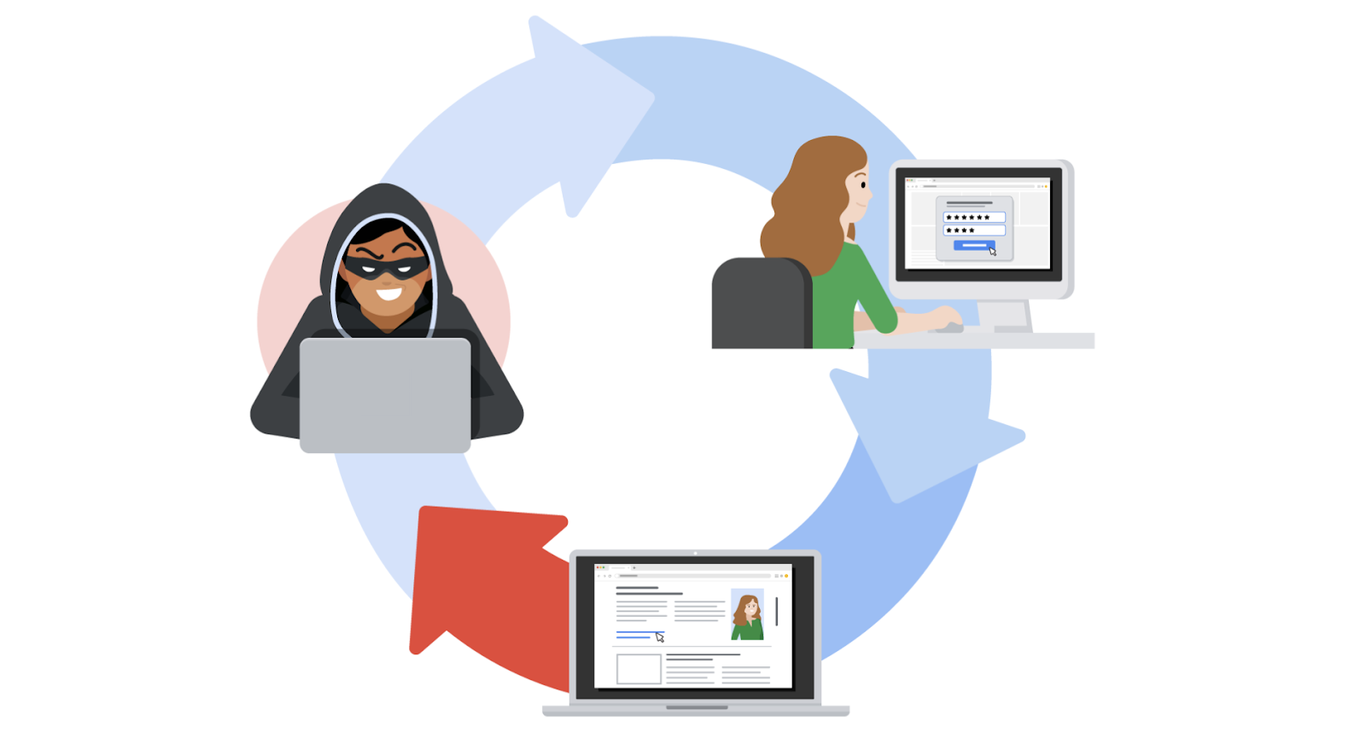

Server-side request forgeries (SSRFs) are when attackers manipulate the normal operations of a server to read or update other resources on that server. These are possible when an application on the server is vulnerable. Malicious code can be carried by the vulnerable app to the host server that will fetch unauthorized data.

# Open source intelligence

Cyber attacks can sometimes be prevented with the right information, which starts with knowing where your systems are vulnerable. Previously, you learned that the CVE® list and scanning tools are two useful ways of finding weaknesses. But, there are other ways to identify vulnerabilities and threats.

In this reading, you’ll learn about open-source intelligence, commonly known as OSINT. OSINT is the collection and analysis of information from publicly available sources to generate usable intelligence. It's commonly used to support cybersecurity activities, like identifying potential threats and vulnerabilities. You'll learn why open-source intelligence is gathered and how it can improve cybersecurity. You’ll also learn about commonly used resources and tools for gathering information and intelligence.

## Information vs intelligence

The terms intelligence and information are often used interchangeably, making it easy to mix them up. Both are important aspects of cybersecurity that differ in their focus and objectives.

Information refers to the collection of raw data or facts about a specific subject. Intelligence, on the other hand, refers to the analysis of information to produce knowledge or insights that can be used to support decision-making.

For example, new information might be released about an update to the operating system (OS) that's installed on your organization's workstations. Later, you might find that new cyber threats have been linked to this new update by researching multiple cybersecurity news resources. The analysis of this information can be used as intelligence to guide your organization's decision about installing the OS updates on employee workstations.

In other words, intelligence is derived from information through the process of analysis, interpretation, and integration. Gathering information and intelligence are both important aspects of cybersecurity.

## Intelligence improves decision-making

Businesses often use information to gain insights into the behavior of their customers. Insights, or intelligence, can then be used to improve their decision making. In security, open-source information is used in a similar way to gain insights into threats and vulnerabilities that can pose risks to an organization.

OSINT plays a significant role in **information security (InfoSec)**, which is the practice of keeping data in all states away from unauthorized users.

For example, a company's InfoSec team is responsible for protecting their network from potential threats. They might utilize OSINT to monitor online forums and hacker communities for discussions about emerging vulnerabilities. If they come across a forum post discussing a newly discovered weakness in a popular software that the company uses, the team can quickly assess the risk, prioritize patching efforts, and implement necessary safeguards to prevent an attack.

Here are some of the ways OSINT can be used to generate intelligence:

* To provide insights into cyber attacks
* To detect potential data exposures
* To evaluate existing defenses
* To identify unknown vulnerabilities

Collecting intelligence is sometimes part of the vulnerability management process. Security teams might use OSINT to develop profiles of potential targets and make data driven decisions on improving their defenses.

## OSINT tools

There's an enormous amount of open-source information online. Finding relevant information that can be used to gather intelligence is a challenge. Information can be gathered from a variety of sources, such as search engines, social media, discussion boards, blogs, and more. Several tools also exist that can be used in your intelligence gathering process. Here are just a few examples of tools that you can explore:

* [VirusTotal](https://www.virustotal.com/gui/home/upload)

• is a service that allows anyone to analyze suspicious files, domains, URLs, and IP addresses for malicious content.

• [MITRE ATT&CK®](https://attack.mitre.org/)

• is a knowledge base of adversary tactics and techniques based on real-world observations.

• [OSINT Framework](https://osintframework.com/)

• is a web-based interface where you can find OSINT tools for almost any kind of source or platform.

• [Have I been Pwned](https://haveibeenpwned.com/)

* is a tool that can be used to search for breached email accounts.

There are numerous other OSINT tools that can be used to find specific types of information. Remember, information can be gathered from a variety of sources. Ultimately, it's your responsibility to thoroughly research any available information that's relevant to the problem you’re trying to solve.

# pproaches to vulnerability scanning

Previously, you learned about a **vulnerability assessment**, which is the internal review process of an organization's security systems. An organization performs vulnerability assessments to identify weaknesses and prevent attacks. Vulnerability scanning tools are commonly used to simulate threats by finding vulnerabilities in an attack surface. They also help security teams take proactive steps towards implementing their remediation strategy.

Vulnerability scanners are important tools that you'll likely use in the field. In this reading, you’ll explore how vulnerability scanners work and the types of scans they can perform.

## What is a vulnerability scanner?

A **vulnerability scanner** is software that automatically compares known vulnerabilities and exposures against the technologies on the network. In general, these tools scan systems to find misconfigurations or programming flaws.

Scanning tools are used to analyze each of the five attack surfaces that you learned about in [the video about the defense in depth strategy](https://www.coursera.org/learn/assets-threats-and-vulnerabilities/lecture/IdvXj/defense-in-depth-strategy)

:

1. **Perimeter layer**,like authentication systems that validate user access
2. **Network layer**,which is made up of technologies like network firewalls and others
3. **Endpoint layer**,which describes devices on a network, like laptops, desktops, or servers
4. **Application layer**,which involves the software that users interact with
5. **Data layer**, which includes any information that’s stored, in transit, or in use

When a scan of any layer begins, the scanning tool compares the findings against databases of security threats. At the end of the scan, the tool flags any vulnerabilities that it finds and adds them to its reference database. Each scan adds more information to the database, helping the tool be more accurate in its analysis.

**Note:** Vulnerability databases are also routinely updated by the company that designed the scanning software.

## Performing scans

Vulnerability scanners are meant to be non-intrusive. Meaning, they don’t break or take advantage of a system like an attacker would. Instead, they simply scan a surface and alert you to any potentially unlocked doors in your systems.

**Note:** While vulnerability scanners are non-intrusive, there are instances when a scan can inadvertently cause issues, like crash a system.

There are a few different ways that these tools are used to scan a surface. Each approach corresponds to the pathway a threat actor might take. Next, you can explore each type of scan to get a clearer picture of this.

**External vs. internal**

External and internal scans simulate an attacker's approach.

External scans test the perimeter layer outside of the internal network. They analyze outward facing systems, like websites and firewalls. These kinds of scans can uncover vulnerable things like vulnerable network ports or servers.

Internal scans start from the opposite end by examining an organization's internal systems. For example, this type of scan might analyze application software for weaknesses in how it handles user input.

### **Authenticated vs. unauthenticated**

Authenticated and unauthenticatedscans simulate whether or not a user has access to a system.

Authenticated scans might test a system by logging in with a real user account or even with an admin account. These service accounts are used to check for vulnerabilities, like broken access controls.

Unauthenticated scans simulate external threat actors that do not have access to your business resources. For example, a scan might analyze file shares within the organization that are used to house internal-only documents. Unauthenticated users should receive "access denied" results if they tried opening these files. However, a vulnerability would be identified if you were able to access a file.

### **Limited vs. comprehensive**

Limited and comprehensive scans focus on particular devices that are accessed by internal and external users.

Limited scans analyze particular devices on a network, like searching for misconfigurations on a firewall.

Comprehensive scans analyze all devices connected to a network. This includes operating systems, user databases, and more.

**Pro tip:** Discovery scanning should be done prior to limited or comprehensive scans. Discovery scanning is used to get an idea of the computers, devices, and open ports that are on a network.

## Key takeaways

## **Terms and definitions from Course 5, M**odule **3**

**Advanced persistent threat (APT):** An instance when a threat actor maintains unauthorized access to a system for an extended period of time

**Attack surface:** All the potential vulnerabilities that a threat actor could exploit

**Attack tree:** A diagram that maps threats to assets

**Attack vector:** The pathways attackers use to penetrate security defenses

**Bug bounty:** Programs that encourage freelance hackers to find and report vulnerabilities

**Common Vulnerabilities and Exposures (CVE®) list:** An openly accessible dictionary of known vulnerabilities and exposures

**Common Vulnerability Scoring System (CVSS):** A measurement system that scores the severity of a vulnerability

**CVE Numbering Authority (CNA):** An organization that volunteers to analyze and distribute information on eligible CVEs

**Defense in depth:** A layered approach to vulnerability management that reduces risk

**Exploit:** A way of taking advantage of a vulnerability

**Exposure:** A mistake that can be exploited by a threat

**Hacker:** Any person who uses computers to gain access to computer systems, networks, or data

**MITRE:** A collection of non-profit research and development centers

**Security hardening:** The process of strengthening a system to reduce its vulnerability and attack surface

**Threat actor:** Any person or group who presents a security risk

**Vulnerability:** A weakness that can be exploited by a threat

**Vulnerability assessment:** The internal review process of a company’s security systems

**Vulnerability management:** The process of finding and patching vulnerabilities

**Vulnerability scanner:** Software that automatically compares existing common vulnerabilities and exposures against the technologies on the network

**Zero-day:** An exploit that was previously unknown

# Social engineering tactics

Social engineering attacks are a popular choice among threat actors. That’s because it’s often easier to trick people into providing them with access, information, or money than it is to exploit a software or network vulnerability.

As you might recall, **social engineering** is a manipulation technique that exploits human error to gain private information, access, or valuables. It's an umbrella term that can apply to a broad range of attacks. Each technique is designed to capitalize on the trusting nature of people and their willingness to help. In this reading, you will learn about specific social engineering tactics to watch out for. You’ll also learn ways that organizations counter these threats.

## Social engineering risks



Social engineering is a form of deception that takes advantage of the way people think. It preys on people’s natural feelings of curiosity, generosity, and excitement. Threat actors turn those feelings against their targets by affecting their better judgment. Social engineering attacks can be incredibly harmful because of how easy they can be to accomplish.

One of the highest-profile social engineering attacks that occurred in recent years was the [Twitter Hack of 2020](https://www.dfs.ny.gov/Twitter_Report)

. During that incident, a group of hackers made phone calls to Twitter employees pretending to be from the IT department. Using this basic scam, the group managed to gain access to the organization’s network and internal tools. This allowed them to take over the accounts of high-profile users, including politicians, celebrities, and entrepreneurs.

Attacks like this are just one example of the chaos threat actors can create using basic social engineering techniques. These attacks present serious risks because they don’t require sophisticated computer skills to perform. Defending against them requires a multi-layered approach that combines technological controls with user awareness.

## Signs of an attack

Oftentimes, people are unable to tell that an attack is happening until it's too late. Social engineering is such a dangerous threat because it typically allows attackers to bypass technological defenses that are in their way. Although these threats are difficult to prevent, recognizing the signs of social engineering is a key to reducing the likelihood of a successful attack.

These are common types of social engineering to watch out for:

* **Baiting** is a social engineering tactic that tempts people into compromising their security. A common example is USB baiting that relies on someone finding an infected USB drive and plugging it into their device.
* **Phishing** is the use of digital communications to trick people into revealing sensitive data or deploying malicious software. It is one of the most common forms of social engineering, typically performed via email.
* **Quid pro quo** is a type of baiting used to trick someone into believing that they’ll be rewarded in return for sharing access, information, or money. For example, an attacker might impersonate a loan officer at a bank and call customers offering them a lower interest rate on their credit card. They'll tell the customers that they simply need to provide their account details to claim the deal.
* **Tailgating** is a social engineering tactic in which unauthorized people follow an authorized person into a restricted area. This technique is also sometimes referred to as piggybacking.
* **Watering hole** is a type of attack when a threat actor compromises a website frequently visited by a specific group of users. Oftentimes, these watering hole sites are infected with malicious software. An example is the Holy Water attack of 2020 that infected various religious, charity, and volunteer websites.

Attackers might use any of these techniques to gain unauthorized access to an organization. Everyone is vulnerable to them, from entry-level employees to senior executives. However, you can reduce the risks of social engineering attacks at any business by teaching others what to expect.

## Encouraging caution

Spreading awareness usually starts with comprehensive security training. When it comes to social engineering, there are three main areas to focus on when teaching others:

* **Stay alert** of suspicious communications and unknown people, especially when it comes to email. For example, look out for spelling errors and double-check the sender's name and email address.
* **Be cautious** about sharing information, especially over social media. Threat actors often search these platforms for any information they can use to their advantage.
* **Control curiosity** when something seems too good to be true. This can include wanting to click on attachments or links in emails and advertisements.

**Pro tip:** Implementing technologies like firewalls, multi-factor authentication (MFA), block lists, email filtering, and others helps layers the defenses should someone make a mistake.

Ideally, security training extends beyond employees. Educating customers about social engineering threats is also a key to mitigating these threats. And security analysts play an important part in promoting safe practices. For example, a big part of an analyst's job is testing systems and documenting best practices for others at an organization to follow.

## Key takeaways

People’s willingness to help one another and their trusting nature is what makes social engineering such an appealing tactic for criminals. It just takes one act of kindness or a momentary lapse in judgment for an attack to work. Criminals go to great lengths to make their attacks difficult to detect. They rely on a variety of manipulation techniques to trick their targets into granting them access. For that reason, implementing effective controls and recognizing the signs of an attack go a long way towards preventing threats.

## Resources for more information

Here are two additional resources to review that will help you continue developing your understanding of social engineering trends and security practices:

* [OUCH!](https://www.sans.org/newsletters/ouch/)

• is a free monthly newsletter from the SANS Institute that reports on social engineering trends and other security topics.

• [Scamwatch](https://www.scamwatch.gov.au/)

* is a resource for news and tools for recognizing, avoiding, and reporting social engineering scams.

# Types of phishing

Phishing is one of the most common types of **social engineering**, which are manipulation techniques that exploit human error to gain private information, access, or valuables. Previously, you learned how **phishing** is the use of digital communications to trick people into revealing sensitive data or deploying malicious software.

Sometimes, phishing attacks appear to come from a trusted person or business. This can lead unsuspecting recipients into acting against their better judgment, causing them to break security procedures. In this reading, you’ll learn about common phishing tactics used by attackers today.



## The origins of phishing

Phishing has been around since the early days of the internet. It can be traced back to the 1990s. At the time, people across the world were coming online for the first time. As the internet became more accessible it began to attract the attention of malicious actors. These malicious actors realized that the internet gave them a level of anonymity to commit their crimes.

### **Early persuasion tactics**

One of the earliest instances of phishing was aimed at a popular chat service called AOL Instant Messenger (AIM). Users of the service began receiving emails asking them to verify their accounts or provide personal billing information. The users were unaware that these messages were sent by malicious actors pretending to be service providers.

This was one of the first examples of mass phishing, which describesattacks that send malicious emails out to a large number of people, increasing the likelihood of baiting someone into the trap.

During the AIM attacks, malicious actors carefully crafted emails that appeared to come directly from AOL. The messages used official logos, colors, and fonts to trick unsuspecting users into sharing their information and account details.

Attackers used the stolen information to create fraudulent AOL accounts they could use to carry out other crimes anonymously. AOL was forced to adapt their security policies to address these threats. The chat service began including messages on their platforms to warn users about phishing attacks.

### **How phishing has evolved**

Phishing continued evolving at the turn of the century as businesses and newer technologies began entering the digital landscape. In the early 2000s, e-commerce and online payment systems started to become popular alternatives to traditional marketplaces. The introduction of online transactions presented new opportunities for attackers to commit crimes.

A number of techniques began to appear around this time period, many of which are still used today. There are five common types of phishing that every security analyst should know:

* **Email phishing** is a type of attack sent via email in which threat actors send messages pretending to be a trusted person or entity.
* **Smishing** is a type of phishing that uses Short Message Service (SMS), a technology that powers text messaging. Smishing covers all forms of text messaging services, including Apple’s iMessages, WhatsApp, and other chat mediums on phones.
* **Vishing** refers to the use of voice calls or voice messages to trick targets into providing personal information over the phone.
* **Spear phishing** is a subset of email phishing in which specific people are purposefully targeted, such as the accountants of a small business.
* **Whaling** refers to a category of spear phishing attempts that are aimed at high-ranking executives in an organization.

Since the early days of phishing, email attacks remain the most common types that are used. While they were originally used to trick people into sharing access credentials and credit card information, email phishing became a popular method to infect computer systems and networks with malicious software.

In late 2003, attackers around the world created fraudulent websites that resembled businesses like eBay and PayPal™. Mass phishing campaigns to distribute malicious programs were also launched against e-commerce and banking sites.



### **Recent trends**

Starting in the 2010s, attackers began to shift away from mass phishing attempts that relied on baiting unsuspecting people into a trap. Leveraging new technologies, criminals began carrying out what’s known astargeted phishing attempts. Targeted phishing describes attacks that are sent to specific targets using highly customized methods to create a strong sense of familiarity.

A type of targeted phishing that evolved in the 2010s is angler phishing. **Angler phishing** is a technique where attackers impersonate customer service representatives on social media. This tactic evolved from people’s tendency to complain about businesses online. Threat actors intercept complaints from places like message boards or comment sections and contact the angry customer via social media. Like the AIM attacks of the 1990s, they use fraudulent accounts that appear similar to those of actual businesses. They then trick the angry customers into sharing sensitive information with the promise of fixing their problem.

## Key takeaways

Phishing tactics have become very sophisticated over the years. Unfortunately, there isn't a perfect solution that prevents these attacks from happening. Tactics, like email phishing that started in the last century, remain an effective and profitable method of attack for criminals online today.

There isn’t a technological solution to prevent phishing entirely. However, there are many ways to reduce the damage from these attacks when they happen. One way is to spread awareness and inform others. As a security professional, you may be responsible for helping others identify forms of social engineering, like phishing. For example, you might create training programs that educate employees about topics like phishing. Sharing your knowledge with others is an important responsibility that helps build a culture of security.

# An introduction to malware

Previously, you learned that **malware** is software designed to harm devices or networks. Since its first appearance on personal computers decades ago, malware has developed into a variety of strains. Being able to identify different types of malware and understand the ways in which they are spread will help you stay alert and be informed as a security professional.

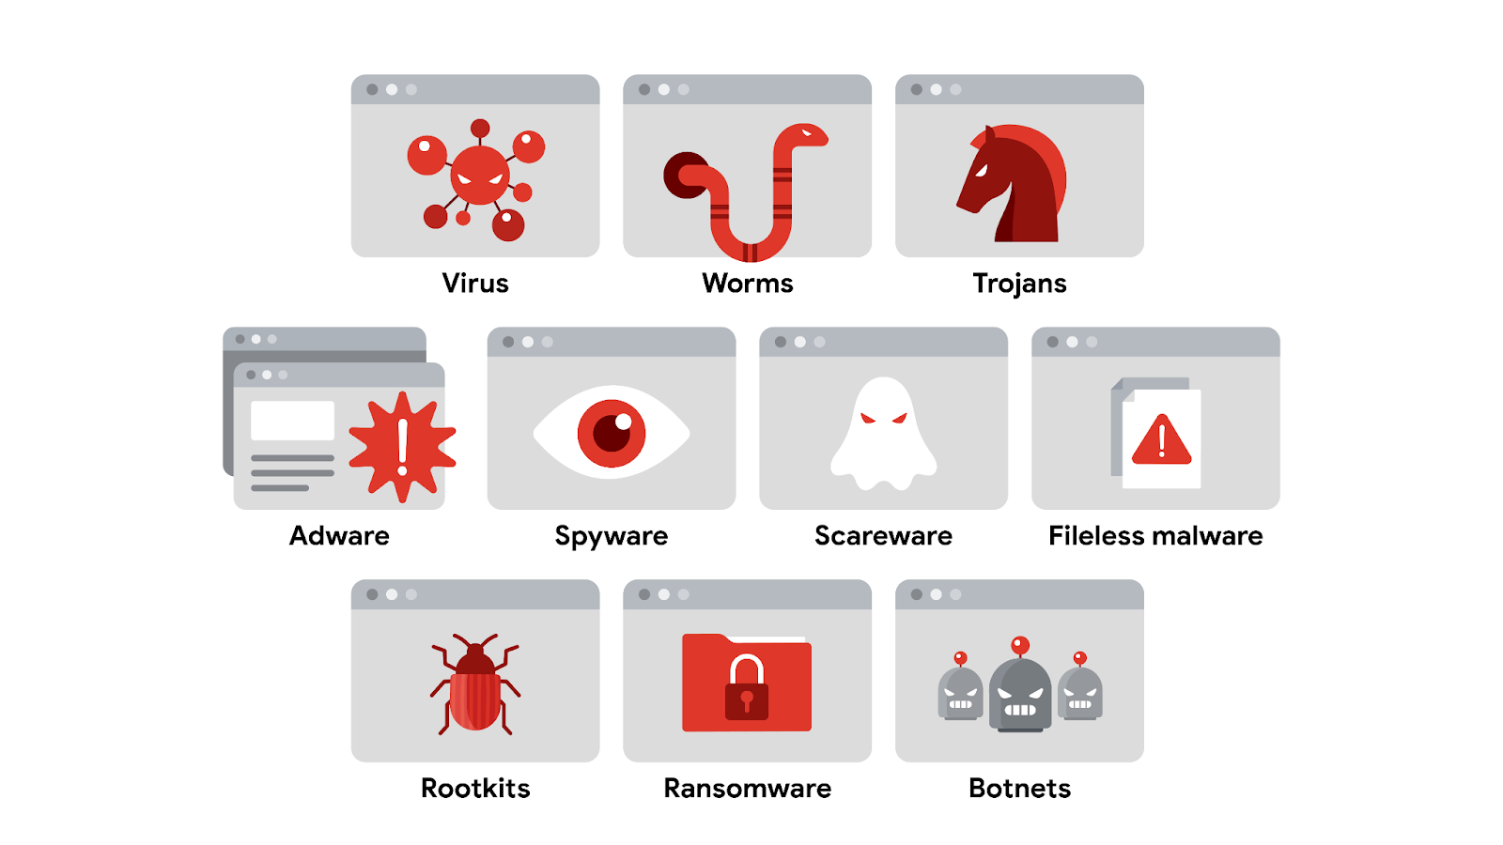

## Virus

A **virus** is malicious code written to interfere with computer operations and cause damage to data and software. This type of malware must be installed by the target user before it can spread itself and cause damage. One of the many ways that viruses are spread is through phishing campaigns where malicious links are hidden within links or attachments.

## Worm

A **worm** is malware that can duplicate and spread itself across systems on its own. Similar to a virus, a worm must be installed by the target user and can also be spread with tactics like malicious email. Given a worm's ability to spread on its own, attackers sometimes target devices, drives, or files that have shared access over a network.

A well known example is the Blaster worm, also known as Lovesan, Lovsan, or MSBlast. In the early 2000s, this worm spread itself on computers running Windows XP and Windows 2000 operating systems. It would force devices into a continuous loop of shutting down and restarting. Although it did not damage the infected devices, it was able to spread itself to hundreds of thousands of users around the world. Many variants of the Blaster worm have been deployed since the original and can infect modern computers.

**Note:** Worms were very popular attacks in the mid 2000s but are less frequently used in recent years.

## Trojan

A trojan, also called a **Trojan horse**, is malware that looks like a legitimate file or program. This characteristic relates to how trojans are spread. Similar to viruses, attackers deliver this type of malware hidden in file and application downloads. Attackers rely on tricking unsuspecting users into believing they’re downloading a harmless file, when they’re actually infecting their own device with malware that can be used to spy on them, grant access to other devices, and more.

## Adware

Advertising-supported software, or **adware**, is a type of legitimate software that is sometimes used to display digital advertisements in applications. Software developers often use adware as a way to lower their production costs or to make their products free to the public—also known as freeware or shareware. In these instances, developers monetize their product through ad revenue rather than at the expense of their users.

Malicious adware falls into a sub-category of malware known as a **potentially unwanted application (PUA)**. A PUA is a type of unwanted software that is bundled in with legitimate programs which might display ads, cause device slowdown, or install other software. Attackers sometimes hide this type of malware in freeware with insecure design to monetize ads for themselves instead of the developer. This works even when the user has declined to receive ads.

## Spyware

**Spyware** is malware that's used to gather and sell information without consent. It's also considered a PUA. Spyware is commonly hidden in bundleware, additional software that is sometimes packaged with other applications. PUAs like spyware have become a serious challenge in the open-source software development ecosystem. That’s because developers tend to overlook how their software could be misused or abused by others.

## Scareware

Another type of PUA is **scareware**. This type of malware employs tactics to frighten users into infecting their own device. Scareware tricks users by displaying fake warnings that appear to come from legitimate companies. Email and pop-ups are just a couple of ways scareware is spread. Both can be used to deliver phony warnings with false claims about the user's files or data being at risk.

## Fileless malware

**Fileless malware** does not need to be installed by the user because it uses legitimate programs that are already installed to infect a computer. This type of infection resides in memory where the malware never touches the hard drive. This is unlike the other types of malware, which are stored within a file on disk. Instead, these stealthy infections get into the operating system or hide within trusted applications.

**Pro tip:** Fileless malware is detected by performing memory analysis, which requires experience with operating systems.

## Rootkits

A **rootkit** is malware that provides remote, administrative access to a computer. Most attackers use rootkits to open a backdoor to systems, allowing them to install other forms of malware or to conduct network security attacks.

This kind of malware is often spread by a combination of two components: a dropper and a loader. A **dropper** is a type of malware that comes packed with malicious code which is delivered and installed onto a target system. For example, a dropper is often disguised as a legitimate file, such as a document, an image, or an executable to deceive its target into opening, or dropping it, onto their device. If the user opens the dropper program, its malicious code is executed and it hides itself on the target system.

Multi-staged malware attacks, where multiple packets of malicious code are deployed, commonly use a variation called a loader. A **loader** is a type of malware that downloads strains of malicious code from an external source and installs them onto a target system. Attackers might use loaders for different purposes, such as to set up another type of malware---a botnet.

## Botnet

A **botnet**, short for “robot network,” is a collection of computers infected by malware that are under the control of a single threat actor, known as the “bot-herder.” Viruses, worms, and trojans are often used to spread the initial infection and turn the devices into a bot for the bot-herder. The attacker then uses file sharing, email, or social media application protocols to create new bots and grow the botnet. When a target unknowingly opens the malicious file, the computer, or bot, reports the information back to the bot-herder, who can execute commands on the infected computer.

## Ransomware

Ransomware describes a malicious attack where threat actors encrypt an organization's data and demand payment to restore access. According to the Cybersecurity and Infrastructure Security Agency (CISA), ransomware crimes are on the rise and becoming increasingly sophisticated. Ransomware infections can cause significant damage to an organization and its customers. An example is the [WannaCry](https://en.wikipedia.org/wiki/WannaCry_ransomware_attack)

attack that encrypts a victim's computer until a ransom payment of cryptocurrency is paid.

# Prevent injection attacks

Previously, you learned that **Structured Query Language** (SQL) is a programming language used to create, interact with, and request information from a database. SQL is one of the most common programming languages used to interact with databases because it is widely supported by a range of database products.

As you might recall, malicious **SQL injection** is a type of attack that executes unexpected queries on a database. Threat actors perform SQL injections to modify, delete, or steal information from databases. A SQL injection is a common attack vector that is used to gain unauthorized access to web applications. Due to the language's popularity with developers, SQL injections are regularly listed in the OWASP® Top 10 because developers tend to focus on making their applications work correctly rather than protecting their products from injection.

In this reading, you'll learn about SQL queries and how they are used to request information from a database. You will also learn about the three classes of SQL injection attacks used to manipulate vulnerable queries. You will also learn ways to identify when websites are vulnerable and ways to address those gaps.

## SQL queries

Every bit of information that’s accessed online is stored in a database. A **database** is an organized collection of information or data in one place. A database can include data such as an organization's employee directory or customer payment methods. In SQL, database information is organized in tables. SQL is commonly used for retrieving, inserting, updating, or deleting information in tables using queries.

A SQL query is a request for data from a database. For example, a SQL query can request data from an organization's employee directory such as employee IDs, names, and job titles. A human resources application can accept an input that queries a SQL table to filter the data and locate a specific person. SQL injections can occur anywhere within a vulnerable application that can accept a SQL query.

Queries are usually initiated in places where users can input information into an application or a website via an input field. Input fields include features that accept text input such as login forms, search bars, or comment submission boxes. A SQL injection occurs when an attacker exploits input fields that aren't programmed to filter out unwanted text. SQL injections can be used to manipulate databases, steal sensitive data, or even take control of vulnerable applications.

## SQL injection categories

There are three main categories of SQL injection:

* In-band
* Out-of-band
* Inferential

In the following sections, you'll learn that each type describes how a SQL injection is initiated and how it returns the results of the attack.

### **In-band SQL injection**

In-band, or classic, SQL injection is the most common type. An in-band injection is one that uses the same communication channel to launch the attack and gather the results.

For example, this might occur in the search box of a retailer's website that lets customers find products to buy. If the search box is vulnerable to injection, an attacker could enter a malicious query that would be executed in the database, causing it to return sensitive information like user passwords. The data that's returned is displayed back in the search box where the attack was initiated.

### **Out-of-band SQL injection**

An out-of-band injection is one that uses a different communication channel  to launch the attack and gather the results.

For example, an attacker could use a malicious query to create a connection between a vulnerable website and a database they control. This separate channel would allow them to bypass any security controls that are in place on the website's server, allowing them to steal sensitive data

**Note:** Out-of-band injection attacks are very uncommon because they'll only work when certain features are enabled on the target server.

### **Inferential SQL injection**

Inferential SQL injection occurs when an attacker is unable to directly see the results of their attack. Instead, they can interpret the results by analyzing the behavior of the system.

For example, an attacker might perform a SQL injection attack on the login form of a website that causes the system to respond with an error message. Although sensitive data is not returned, the attacker can figure out the database's structure based on the error. They can then use this information to craft attacks that will give them access to sensitive data or to take control of the system.

## Injection Prevention

SQL queries are often programmed with the assumption that users will only input relevant information. For example, a login form that expects users to input their email address assumes the input will be formatted a certain way, such as jdoe@domain.com. Unfortunately, this isn’t always the case.

A key to preventing SQL injection attacks is to escape user inputs—preventing someone from inserting any code that a program isn't expecting.

There are several ways to escape user inputs:

* **Prepared statements**: a coding technique that executes SQL statements before passing them on to a database
* **Input sanitization**: programming that removes user input which could be interpreted as code.
* **Input validation**: programming that ensures user input meets a system's expectations.

Using a combination of these techniques can help prevent SQL injection attacks. In the security field, you might need to work closely with application developers to address vulnerabilities that can lead to SQL injections. [OWASP's SQL injection detection techniques](https://owasp.org/www-project-web-security-testing-guide/latest/4-Web_Application_Security_Testing/07-Input_Validation_Testing/05-Testing_for_SQL_Injection)

is a useful resource if you're interested in investigating SQL injection vulnerabilities on your own.

# Traits of an effective threat model

**Threat modeling** is the process of identifying assets, their vulnerabilities, and how each is exposed to threats. It is a strategic approach that combines various security activities, such as vulnerability management, threat analysis, and incident response. Security teams commonly perform these exercises to ensure their systems are adequately protected. Another use of threat modeling is to proactively find ways of reducing risks to any system or business process.

Traditionally, threat modeling is associated with the field of application development. In this reading, you will learn about common threat modeling frameworks that are used to design software that can withstand attacks. You'll also learn about the growing need for application security and ways that you can participate.

## Why application security matters

Applications have become an essential part of many organizations' success. For example, web-based applications allow customers from anywhere in the world to connect with businesses, their partners, and other customers.

Mobile applications have also changed the way people access the digital world. Smartphones are often the main way that data is exchanged between users and a business. The volume of data being processed by applications makes securing them a key to reducing risk for everyone who’s connected.

For example, say an application uses Java-based logging libraries with the Log4Shell vulnerability ([CVE-2021-44228](https://nvd.nist.gov/vuln/detail/CVE-2021-44228)

). If it's not patched, this vulnerability can allow remote code execution that an attacker can use to gain full access to your system from anywhere in the world. If exploited, a critical vulnerability like this can impact millions of devices.

## Defending the application layer

Defending the application layer requires proper testing to uncover weaknesses that can lead to risk. Threat modeling is one of the primary ways to ensure that an application meets security requirements. A DevSecOps team, which stands for development, security, and operations, usually performs these analyses.

A typical threat modeling process is performed in a cycle:

* Define the scope
* Identify threats
* Characterize the environment
* Analyze threats
* Mitigate risks
* Evaluate findings

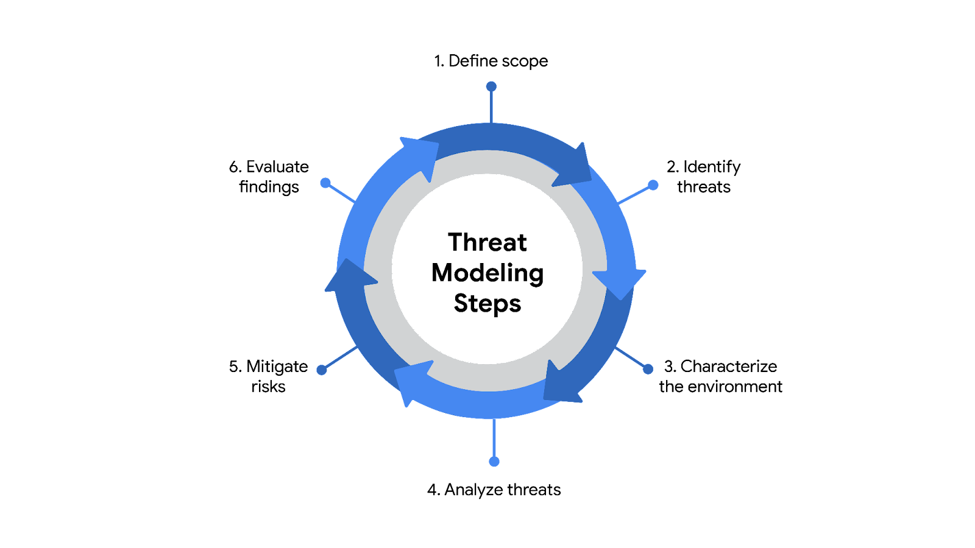

Ideally, threat modeling should be performed before, during, and after an application is developed. However, conducting a thorough software analysis takes time and resources. Everything from the application's architecture to its business purposes should be evaluated. As a result, a number of threat-modeling frameworks have been developed over the years to make the process smoother.

**Note:** Threat modeling should be incorporated at every stage of the software development lifecycle, or SDLC.

## Common frameworks

When performing threat modeling, there are multiple methods that can be used, such as:

* STRIDE
* PASTA
* Trike
* VAST

Organizations might use any one of these to gather intelligence and make decisions to improve their security posture. Ultimately, the “right” model depends on the situation and the types of risks an application might face.

### **STRIDE**

STRIDE is a threat-modeling framework developed by Microsoft. It’s commonly used to identify vulnerabilities in six specific attack vectors. The acronym represents each of these vectors: spoofing, tampering, repudiation, information disclosure, denial of service, and elevation of privilege.

### **PASTA**

The **Process of Attack Simulation and Threat Analysis** (PASTA) is a risk-centric threat modeling process developed by two OWASP leaders and supported by a cybersecurity firm called VerSprite. Its main focus is to discover evidence of viable threats and represent this information as a model. PASTA's evidence-based design can be applied when threat modeling an application or the environment that supports that application. Its seven stage process consists of various activities that incorporate relevant security artifacts of the environment, like vulnerability assessment reports.

### **Trike**

Trike is an open source methodology and tool that takes a security-centric approach to threat modeling. It's commonly used to focus on security permissions, application use cases, privilege models, and other elements that support a secure environment.

### **VAST**

The Visual, Agile, and Simple Threat (VAST) Modeling framework is part of an automated threat-modeling platform called ThreatModeler®. Many security teams opt to use VAST as a way of automating and streamlining their threat modeling assessments.

## Participating in threat modeling

Threat modeling is often performed by experienced security professionals, but it’s almost never done alone. This is especially true when it comes to securing applications. Programs are complex systems responsible for handling a lot of data and processing  a variety of commands from users and other systems.

One of the keys to threat modeling is asking the right questions:

* What are we working on?
* What kinds of things can go wrong?
* What are we doing about it?
* Have we addressed everything?
* Did we do a good job?

It takes time and practice to learn how to work with things like data flow diagrams and attack trees. However, anyone can learn to be an effective threat modeler. Regardless of your level of experience, participating in one of these exercises always starts with simply asking the right questions.

# Glossary terms from module 4

## Terms and definitions from Course 5, Module 4

**Angler phishing:** A technique where attackers impersonate customer service representatives on social media

**Advanced persistent threat (APT):** Instances when a threat actor maintains unauthorized access to a system for an extended period of time

**Adware:** A type of legitimate software that is sometimes used to display digital advertisements in applications

**Attack tree:** A diagram that maps threats to assets

**Baiting:** A social engineering tactic that tempts people into compromising their security

**Botnet:** A collection of computers infected by malware that are under the control of a single threat actor, known as the “bot-herder"

**Cross-site scripting (XSS):** An injection attack that inserts code into a vulnerable website or web application

**Cryptojacking:** A form of malware that installs software to illegally mine cryptocurrencies

**DOM-based XSS attack:** An instance when malicious script exists in the webpage a browser loads

**Dropper:** A type of malware that comes packed with malicious code which is delivered and installed onto a target system

**Fileless malware:** Malware that does not need to be installed by the user because it uses legitimate programs that are already installed to infect a computer

**Hacker:** Any person or group who uses computers to gain unauthorized access to data

**Identity and access management (IAM):** A collection of processes and technologies that helps organizations manage digital identities in their environment

**Injection attack:** Malicious code inserted into a vulnerable application

**Input validation:** Programming that validates inputs from users and other programs

**Intrusion detection system (IDS):** An application that monitors system activity and alerts on possible intrusions

**Loader:** A type of malware that downloads strains of malicious code from an external source and installs them onto a target system

**Malware:** Software designed to harm devices or networks

**Process of Attack Simulation and Threat Analysis (PASTA):** A popular threat modeling framework that’s used across many industries

**Phishing:** The use of digital communications to trick people into revealing sensitive data or deploying malicious software

**Phishing kit:** A collection of software tools needed to launch a phishing campaign

**Prepared statement:** A coding technique that executes SQL statements before passing them onto the database

**Potentially unwanted application (PUA):** A type of unwanted software that is bundled in with legitimate programs which might display ads, cause device slowdown, or install other software

**Quid pro quo:** A type of baiting used to trick someone into believing that they’ll be rewarded in return for sharing access, information, or money

**Ransomware:** Type of malicious attack where attackers encrypt an organization’s data and demand payment to restore access

**Reflected XSS attack:** An instance when malicious script is sent to a server and activated during the server’s response

**Rootkit:** Malware that provides remote, administrative access to a computer

**Scareware:** Malware that employs tactics to frighten users into infecting their device

**Smishing**: The use of text messages to trick users to obtain sensitive information or to impersonate a known source

**Social engineering:** A manipulation technique that exploits human error to gain private information, access, or valuables

**Spear phishing:** A malicious email attack targeting a specific user or group of users, appearing to originate from a trusted source

**Spyware:** Malware that’s used to gather and sell information without consent

**SQL (Structured Query Language):** A programming language used to create, interact with, and request information from a database

**SQL injection:** An attack that executes unexpected queries on a database

**Stored XSS attack:** An instance when malicious script is injected directly on the server

**Tailgating:** A social engineering tactic in which unauthorized people follow an authorized person into a restricted area

**Threat:** Any circumstance or event that can negatively impact assets

**Threat actor:** Any person or group who presents a security risk

**Threat modeling:** The process of identifying assets, their vulnerabilities, and how each is exposed to threats

**Trojan horse:** Malware that looks like a legitimate file or program

**Vishing:** The exploitation of electronic voice communication to obtain sensitive information or to impersonate a known source

**Watering hole attack**: A type of attack when a threat actor compromises a website frequently visited by a specific group of users

**Whaling:** A category of spear phishing attempts that are aimed at high-ranking executives in an organization

**Web-based exploits:** Malicious code or behavior that’s used to take advantage of coding flaws in a web application

# Roles in response

So far, you've been introduced to the **National Institute of Standards and Technology (NIST) Incident Response Lifecycle**, which is a framework for incident response consisting of four phases:

* Preparation
* Detection and Analysis
* Containment, Eradication, and Recovery
* Post-incident activity

As a security professional, you'll work on a team to monitor, detect, and respond to incidents. Previously, you learned about a **computer security incident response team (CSIRT)** and a **security operations center (SOC)**. This reading explains the different functions, roles, and responsibilities that make up CSIRTs and SOCs.

Understanding the composition of incident response teams will help you navigate an organization’s hierarchy, openly collaborate and communicate with others, and work cohesively to respond to incidents. You may even discover specific roles that you’re interested in pursuing as you begin your security career!

## Command, control, and communication

A **computer security incident response team (CSIRT)** is a specialized group of security professionals that are trained in incident management and response. During incident response, teams can encounter a variety of different challenges. For incident response to be effective and efficient, there must be clear command**,** control, and communication of the situation to achieve the desired goal.

* **Command** refers to having the appropriate leadership and direction to oversee the response.
* **Control** refers to the ability to manage technical aspects during incident response, like coordinating resources and assigning tasks.
* **Communication** refers to the ability to keep stakeholders informed.

Establishing a CSIRT organizational structure with clear and distinctive roles aids in achieving an effective and efficient response.

## Roles in CSIRTs

CSIRTs are organization dependent, so they can vary in their structure and operation. Structurally, they can exist as a separate, dedicated team or as a task force that meets when necessary. CSIRTs involve both nonsecurity and security professionals. Nonsecurity professionals are often consulted to offer their expertise on the incident. These professionals can be from external departments, such as human resources, public relations, management, IT, legal, and others. Security professionals involved in a CSIRT typically include three key security related roles:

1. **Security analyst**
2. **Technical lead**
3. **Incident coordinator**

### **Security analyst**

The job of the **security** **analyst** is to continuously monitor an environment for any security threats. This includes:

* Analyzing and triaging alerts
* Performing root-cause investigations
* Escalating or resolving alerts

If a critical threat is identified, then analysts escalate it to the appropriate team lead, such as the technical lead.

### **Technical lead**

The job of the technical lead is to manage all of the technical aspects of the incident response process, such as applying software patches or updates. They do this by first determining the root cause of the incident. Then, they create and implement the strategies for containing, eradicating, and recovering from the incident. Technical leads often collaborate with other teams to ensure their incident response priorities align with business priorities, such as reducing disruptions for customers or returning to normal operations.

### **Incident coordinator**

Responding to an incident also requires cross-collaboration with nonsecurity professionals. CSIRTs will often consult with and leverage the expertise of members from external departments. The job of the incident coordinator is to coordinate with the relevant departments during a security incident. By doing so, the lines of communication are open and clear, and all personnel are made aware of the incident status. Incident coordinators can also be found in other teams, like the SOC.

### **Other roles**

Depending on the organization, many other roles can be found in a CSIRT, including a dedicated communications lead, a legal lead, a planning lead, and more.

**Note**: Teams, roles, responsibilities, and organizational structures can differ for each company. For example, some different job titles for incident coordinator include incident commander and incident manager.

## Security operations center

A **security operations center (SOC)** is an organizational unit dedicated to monitoring networks, systems, and devices for security threats or attacks. Structurally, a SOC (usually pronounced "sock") often exists as its own separate unit or within a CSIRT. You may be familiar with the term blue team, which refers to the security professionals who are responsible for defending against all security threats and attacks at an organization. A SOC is involved in various types of blue team activities, such as network monitoring, analysis, and response to incidents.

## SOC organization

A SOC is composed of SOC analysts, SOC leads, and SOC managers. Each role has its own respective responsibilities. SOC analysts are grouped into three different tiers.

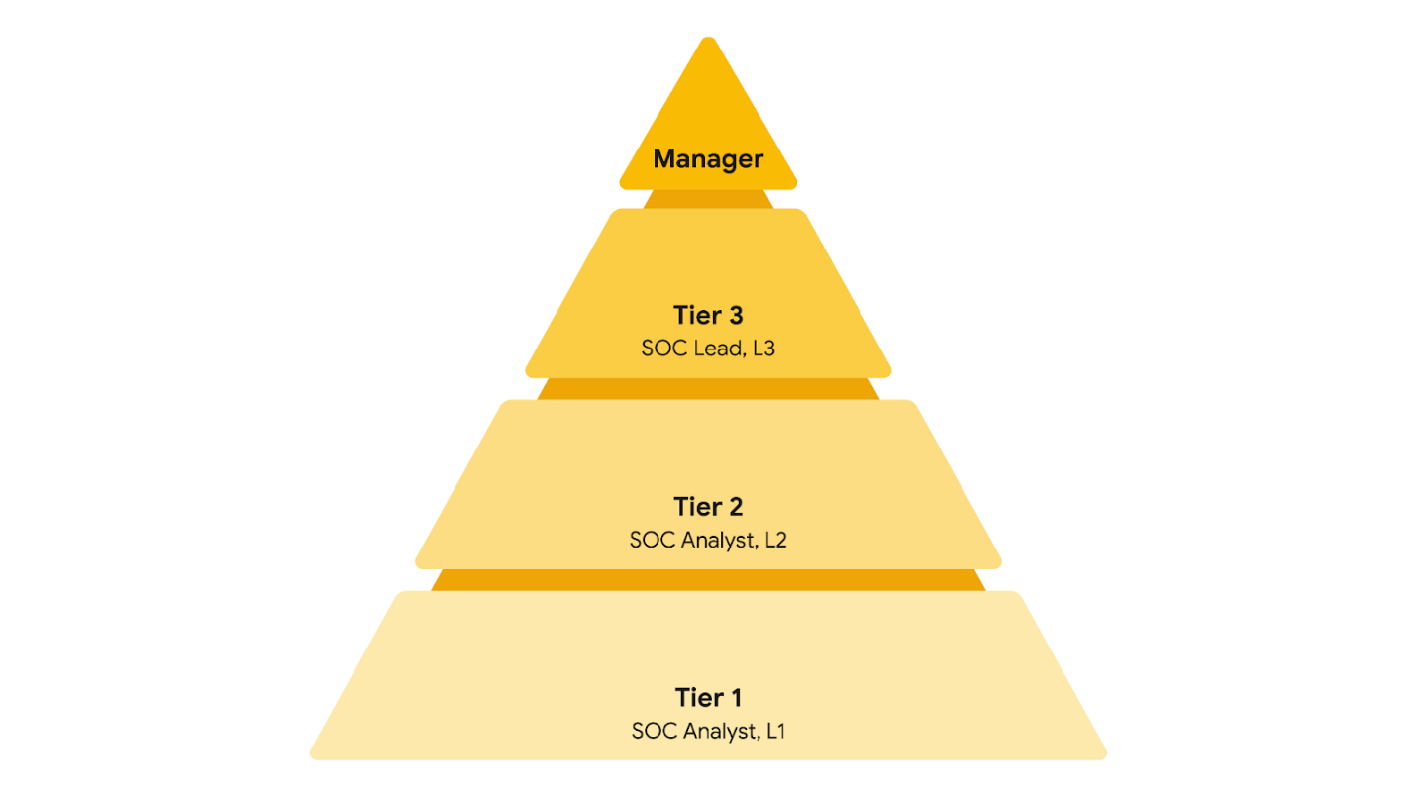

### **Tier 1 SOC analyst**

The first tier is composed of the least experienced SOC analysts who are known as level 1s (L1s). They are responsible for:

* Monitoring, reviewing, and prioritizing alerts based on criticality or severity
* Creating and closing alerts using ticketing systems
* Escalating alert tickets to Tier 2 or Tier 3

### **Tier 2 SOC analyst**

The second tier comprises the more experienced SOC analysts, or level 2s (L2s). They are responsible for:

* Receiving escalated tickets from L1 and conducting deeper investigations
* Configuring and refining security tools
* Reporting to the SOC Lead

### **Tier 3 SOC lead**

The third tier of a SOC is composed of the SOC leads, or level 3s (L3s). These highly experienced professionals are responsible for:

* Managing the operations of their team
* Exploring methods of detection by performing advanced detection techniques, such as malware and forensics analysis
* Reporting to the SOC manager

### **SOC manager**

The SOC manager is at the top of the pyramid and is responsible for:

* Hiring, training, and evaluating the SOC team members
* Creating performance metrics and managing the performance of the SOC team
* Developing reports related to incidents, compliance, and auditing
* Communicating findings to stakeholders such as executive management

### **Other roles**

SOCs can also contain other specialized roles such as:

* **Forensic investigators**: Forensic investigators are commonly L2s and L3s who collect, preserve, and analyze digital evidence related to security incidents to determine what happened.
* **Threat hunters**: Threat hunters are typically L3s who work to detect, analyze, and defend against new and advanced cybersecurity threats using threat intelligence.

**Note**: Just like CSIRTs, the organizational structure of a SOC can differ depending on the organization.

# Overview of detection tools

Previously, you explored **intrusion detection system** (**IDS**) and **intrusion prevention system** (**IPS**) technologies. In this reading, you’ll compare and contrast these tools and learn about **endpoint detection and response** (**EDR**). As a security analyst, you'll likely work with these different tools, so it's important to understand their functions.

## Why you need detection tools

Detection tools work similarly to home security systems. Whereas home security systems monitor and protect homes against intrusion, cybersecurity detection tools help organizations protect their networks and systems against unwanted and unauthorized access. For organizations to protect their systems from security threats or attacks, they must be made aware when there is any indication of an intrusion. Detection tools make security professionals aware of the activity happening on a network or a system. The tools do this by continuously monitoring networks and systems for any suspicious activity. Once something unusual or suspicious is detected, the tool triggers an alert that notifies the security professional to investigate and stop the possible intrusion.

## Detection tools

As a security analyst, you'll likely encounter **IDS**, **IPS**, and **EDR** detection tools at some point, but it's important to understand the differences between them. Here is a comparison chart for quick reference:

| **Capability** | **IDS** | **IPS** | **EDR** |
| --- | --- | --- | --- |
| Detects malicious activity | ✓ | ✓ | ✓ |
| Prevents intrusions | N/A | ✓ | ✓ |
| Logs activity | ✓ | ✓ | ✓ |
| Generates alerts | ✓ | ✓ | ✓ |
| Performs behavioral analysis | N/A | N/A | ✓ |

## Overview of IDS tools

An **intrusion detection system** (**IDS**) is an application that monitors system activity and alerts on possible intrusions. An IDS provides continuous monitoring of network events to help protect against security threats or attacks. The goal of an IDS is to detect potential malicious activity and generate an alert once such activity is detected. An IDS does not stop or prevent the activity. Instead, security professionals will investigate the alert and act to stop it, if necessary.

For example, an IDS can send out an alert when it identifies a suspicious user login, such as an unknown IP address logging into an application or a device at an unusual time. But, an IDS will not stop or prevent any further actions, like blocking the suspicious user login.

Examples of IDS tools include Zeek, Suricata, Snort®, and Sagan.

### **Detection categories**

As a security analyst, you will investigate alerts that an IDS generates. There are four types of detection categories you should be familiar with:

1. **A true positive** is an alert that correctly detects the presence of an attack.
2. **A true negative** is a state where there is no detection of malicious activity. This is when no malicious activity exists and no alert is triggered.
3. **A false positive** is an alert that incorrectly detects the presence of a threat. This is when an IDS identifies an activity as malicious, but it isn't. False positives are an inconvenience for security teams because they spend time and resources investigating an illegitimate alert.
4. **A false negative** is a state where the presence of a threat is not detected. This is when malicious activity happens but an IDS fails to detect it. False negatives are dangerous because security teams are left unaware of legitimate attacks that they can be vulnerable to.

## Overview of IPS tools

An **intrusion prevention system** (**IPS**) is an application that monitors system activity for intrusive activity and takes action to stop the activity. An IPS works similarly to an IDS. But, IPS monitors system activity to detect and alert on intrusions, and it also takes action to prevent the activity and minimize its effects. For example, an IPS can send an alert and modify an access control list on a router to block specific traffic on a server.

**Note:** Many IDS tools can also operate as an IPS. Tools like Suricata, Snort, and Sagan have both IDS and IPS capabilities.

## Overview of EDR tools

**Endpoint detection and response** (**EDR**) is an application that monitors an endpoint for malicious activity. EDR tools are installed on endpoints. Remember that an **endpoint** is any device connected on a network. Examples include end-user devices, like computers, phones, tablets, and more.

EDR tools monitor, record, and analyze endpoint system activity to identify, alert, and respond to suspicious activity. Unlike IDS or IPS tools, EDRs collect endpoint activity data and perform behavioral analysis to identify threat patterns happening on an endpoint. Behavioral analysis uses the power of machine learning and artificial intelligence to analyze system behavior to identify malicious or unusual activity. EDR tools also use automation to stop attacks without the manual intervention of security professionals. For example, if an EDR detects an unusual process starting up on a user’s workstation that normally is not used, it can automatically block the process from running.

Tools like Open EDR®, Bitdefender™ Endpoint Detection and Response, and FortiEDR™ are examples of EDR tools.

**Note**: Security information and event management (SIEM) tools also have detection capabilities, which you'll explore later.

# Overview of SIEM technology

Previously, you learned about the SIEM process. In this reading, you'll explore more about this process and why SIEM tools are an important part of incident detection and response. As a refresher, a **security information and event management** (**SIEM**) tool is an application that collects and analyzes log data to monitor critical activities in an organization. You might recall that SIEM tools help security analysts perform **log analysis** which is the process of examining logs to identify events of interest.

## SIEM advantages

SIEM tools collect and manage security-relevant data that can be used during investigations. This is important because SIEM tools provide awareness about the activity that occurs between devices on a network. The information SIEM tools provide can help security teams quickly investigate and respond to security incidents. SIEM tools have many advantages that can help security teams effectively respond to and manage incidents. Some of the advantages are:

* **Access to event data:** SIEM tools provide access to the event and activity data that happens on a network, including real-time activity. Networks can be connected to hundreds of different systems and devices. SIEM tools have the ability to ingest all of this data so that it can be accessed.
* **Monitoring, detecting, and alerting:** SIEM tools continuously monitor systems and networks in real-time. They then analyze the collected data using detection rules to detect malicious activity. If an activity matches the rule, an alert is generated and sent out for security teams to assess.
* **Log storage:** SIEM tools can act as a system for data retention, which can provide access to historical data. Data can be kept or deleted after a period depending on an organization's requirements.

## The SIEM process

The SIEM process consists of three critical steps:

1. **Collect and aggregate data**
2. **Normalize data**
3. **Analyze data**

By understanding these steps, organizations can utilize the power of SIEM tools to gather, organize, and analyze security event data from different sources. Organizations can later use this information to improve their ability to identify and mitigate potential threats.

### **Collect and aggregate data**

SIEM tools require data for them to be effectively used. During the first step, the SIEM collects event data from various sources like firewalls, servers, routers, and more. This data, also known as logs, contains event details like timestamps, IP addresses, and more. **Logs** are a record of events that occur within an organization’s systems. After all of this log data is collected, it gets aggregated in one location. Aggregation refers to the process of consolidating log data into a centralized place. Through collection and aggregation, SIEM tools eliminate the need for manually reviewing and analyzing event data by accessing individual data sources. Instead, all event data is accessible in one location—the SIEM.

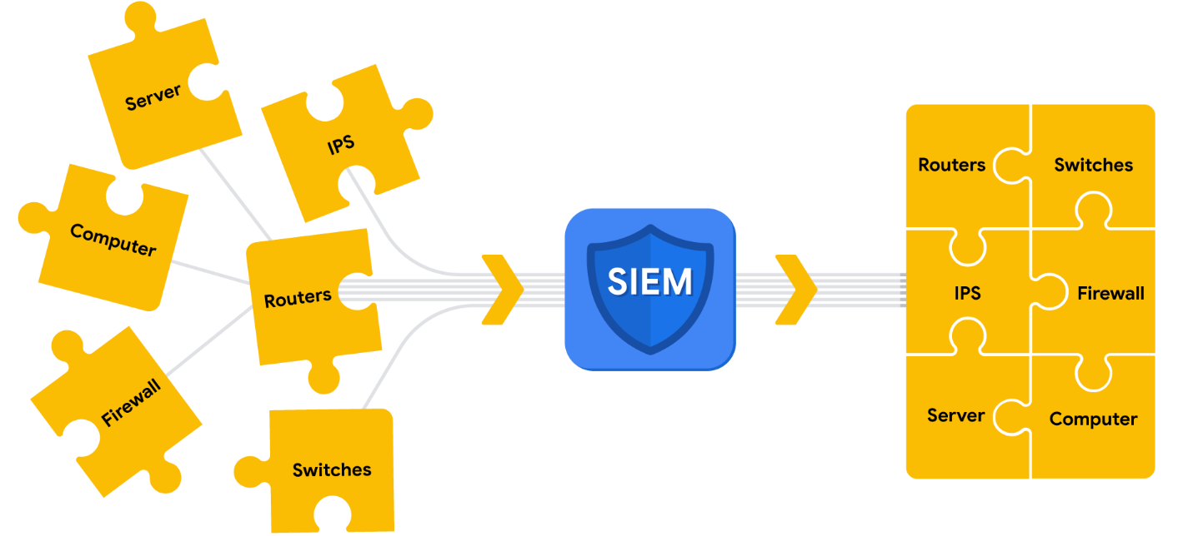

Parsing can occur during the first step of the SIEM process when data is collected and aggregated. Parsing maps data according to their fields and their corresponding values. For example, the following log example contains fields with values. At first, it might be difficult to interpret information from this log based on its format:

April 3 11:01:21 server sshd[1088]: Failed password for user nuhara from 218.124.14.105 port 5023

In a parsed format, the fields and values are extracted and paired making them easier to read and interpret:

* host = server
* process = sshd
* source_user = nuhara
* source ip = 218.124.14.105
* source port = 5023

### **Normalize data**

SIEM tools collect data from many different sources. This data must be transformed into a single format so that it can be easily processed by the SIEM. However, each data source is different and data can be formatted in many different ways. For example, a firewall log can be formatted differently than a server log.



Collected event data should go through the process of normalization. Normalization converts data into a standard, structured format that is easily searchable.

### **Analyze data**

After log data has been collected, aggregated, and normalized, the SIEM must do something useful with all of the data to enable security teams to investigate threats. During this final step in the process, SIEM tools analyze the data. Analysis can be done with some type of detection logic such as a set of rules and conditions. SIEM tools then apply these rules to the data, and if any of the log activity matches a rule, alerts are sent out to cybersecurity teams.

**Note**: A part of the analysis process includes correlation. Correlation involves the comparison of multiple log events to identify common patterns that indicate potential security threats.

## SIEM tools

There are many SIEM tools. The following are some SIEM tools commonly used in the cybersecurity industry:

* AlienVault® OSSIM™
* Chronicle
* Elastic
* Exabeam
* IBM QRadar® Security Intelligence Platform
* LogRhythm
* Splunk

# Maintain awareness with network monitoring

Network communication can be noisy! Events like sending an email, streaming a video, or visiting a website all produce network communications in the form of network traffic and network data. As a reminder, **network traffic** is the amount of data that moves across a network. It can also include the type of data that is transferred, such as HTTP. **Network** **data** is the data that's transmitted between devices on a network.

Network monitoring is essential in maintaining situational awareness of any activity on a network. By collecting and analyzing network traffic, organizations can detect suspicious network activity. But before networks can be monitored, you must know exactly what to monitor. In this reading, you'll learn more about the importance of network monitoring, ways to monitor your network, and network monitoring tools.

## Know your network

As you’ve learned, networks connect devices, and devices then communicate and exchange data using network protocols. Network communications provide information about connections such as source and destination IP addresses, amount of data transferred, date and time, and more. This information can be valuable for security professionals when developing a **baseline** of normal or expected behavior.

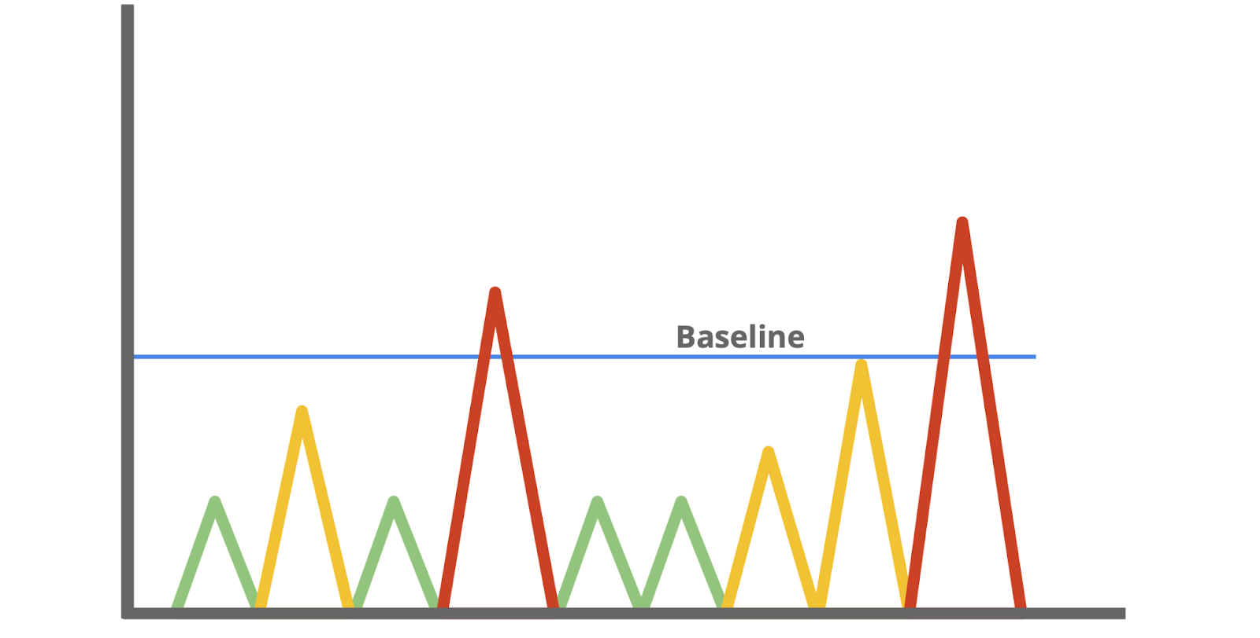

A baseline is a reference point that’s used for comparison. You've probably encountered or used baselines at some point. For example, a grocery amount for a personal budget is an example of a baseline that can be used to help identify any patterns or changes in spending habits. In security, baselines help establish a standard of expected or normal behavior for systems, devices, and networks. Essentially, by knowing the baseline of normal network behavior, you'll be better able to identify abnormal network behavior.

## Monitor your network

Once you’ve determined a baseline, you can monitor a network to identify any deviations from that baseline. Monitoring involves examining network components to detect unusual activities, such as large and unusual data transfers. Here are examples of network components that can be monitored to detect malicious activity:

### **Flow analysis**

Flow refers to the movement of network communications and includes information related to packets, protocols, and ports. Packets can travel to ports, which receive and transmit communications. Ports are often, but not always, associated with network protocols. For example, port 443 is commonly used by HTTPS which is a protocol that provides website traffic encryption.

However, malicious actors can use protocols and ports that are not commonly associated to maintain communications between the compromised system and their own machine. These communications are what’s known as **command and control (C2)**,which are the techniques used by malicious actors to maintain communications with compromised systems.

For example, malicious actors can use HTTPS protocol over port 8088 as opposed to its commonly associated port 443 to communicate with compromised systems. Organizations must know which ports should be open and approved for connections, and watch out for any mismatches between ports and their associated protocols.

### **Packet payload information**

Network packets contain components related to the transmission of the packet. This includes details like source and destination IP address, and the packet payload information, which is the actual data that’s transmitted. Often, this data is encrypted and requires decryption for it to be readable. Organizations can monitor the payload information of packets to uncover unusual activity, such as sensitive data transmitting outside of the network, which could indicate a possible data exfiltration attack.

### **Temporal patterns**

Network packets contain information relating to time. This information is useful in understanding time patterns. For example, a company operating in North America experiences bulk traffic flows between 9 a.m. to 5 p.m., which is the baseline of normal network activity. If large volumes of traffic are suddenly outside of the normal hours of network activity, then this is considered off baseline and should be investigated.

Through network monitoring, organizations can promptly detect network intrusions and work to prevent them from happening by securing network components.

## Protect your network

In this program, you’ve learned about **security operations centers** (**SOC**) and their role in monitoring systems against security threats and attacks. Organizations may deploy a **network operations center** (**NOC**), which is an organizational unit that monitors the performance of a network and responds to any network disruption, such as a network outage. While a SOC is focused on maintaining the security of an organization through detection and response, a NOC is responsible for maintaining network performance, availability, and uptime.



Security analysts monitor networks to identify any signs of potential security incidents known as **indicators of compromise** (**IoC**) and  protect networks from threats or attacks. To do this, they must understand the environment that network communications travel through so that they can identify deviations in network traffic.

### **Network monitoring tools**

Network monitoring can be automated or performed manually. Some common network monitoring tools can include:

* **Intrusion detection systems** (**IDS**) monitor system activity and alert on possible intrusions. An IDS will detect and alert on the deviations you’ve configured it to detect. Most commonly, IDS tools will monitor the content of packet payload to detect patterns associated with threats such as malware or phishing attempts.
* **Network protocol analyzers**, also known as packet sniffers, are tools designed to capture and analyze data traffic within a network. They can be used to analyze network communications manually in detail. Examples include tools such as tcpdump and Wireshark, which can be used by security professionals to record network communications through packet captures. Packet captures can then be investigated to identify potentially malicious activity.

## Key takeaways

Monitoring and protecting networks from intrusions and attacks are key responsibilities of security professionals. You can’t protect what you don’t know. As a security analyst, you’ll need to know the components of a network and the communications that happen on it, so you can better protect it. Baselines provide a way to understand network traffic by uncovering common patterns which help in identifying any deviations from the expected traffic patterns. Tools like intrusion detection systems and network protocol analyzers support efforts in monitoring network activities.

# Learn more about packet captures

The role of security analysts involves monitoring and analyzing network traffic flows. One way to do this is by generating packet captures and then analyzing the captured traffic to identify unusual activity on a network.

Previously, you explored the fundamentals of networks. Throughout this section, you’ll refer to your foundation in networking to better understand network traffic flows. In this reading, you'll learn about the three main aspects of network analysis: packets, network protocol analyzers, and packet captures.

## Packets

Previously in the program, you learned that a **data packet** is a basic unit of information that travels from one device to another within a network. Detecting network intrusions begins at the packet level. That's because packets form the basis of information exchange over a network. Each time you perform an activity on the internet—like visiting a website—packets are sent and received between your computer and the website’s server. These packets are what help transmit information through a network. For example, when uploading an image to a website, the data gets broken up into multiple packets, which then get routed to the intended destination and reassembled upon delivery.

In cybersecurity, packets provide valuable information that helps add context to events during investigations. Understanding the transfer of information through packets will not only help you develop insight on network activity, it will also help you identify abnormalities and better defend networks from attacks.

Packets contain three components: the header, the payload, and the footer. Here’s a description of each of these components.

### **Header**

Packets begin with the most essential component: theheader. Packets can have several headers depending on the protocols used such as an Ethernet header, an IP header, a TCP header, and more. Headers provide information that’s used to route packets to their destination. This includes information about the source and destination IP addresses, packet length, protocol, packet identification numbers, and more.

Here is an IPv4 header with the information it provides:

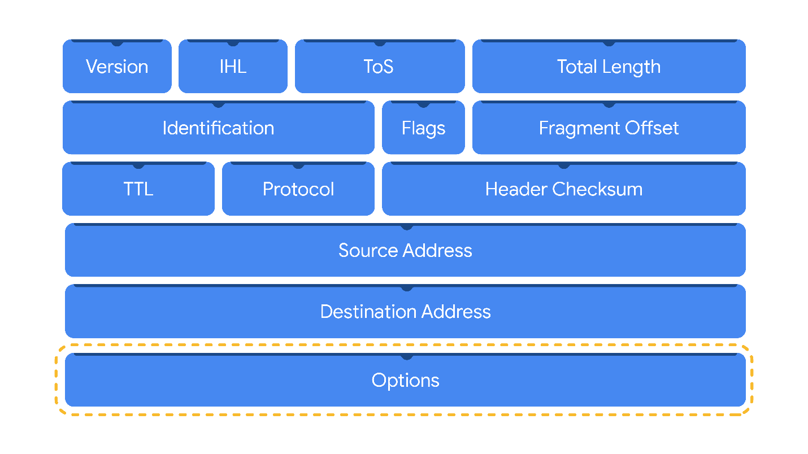

### **Payload**

Thepayload component directly follows the header and contains the actual data being delivered. Think back to the example of uploading an image to a website; the payload of this packet would be the image itself.

### **Footer**

The footer, also known as the trailer, is located at the end of a packet. The Ethernet protocol uses footers to provide error-checking information to determine if data has been corrupted. In addition, Ethernet network packets that are analyzed might not display footer information due to network configurations.

**Note:** Most protocols, such as the Internet Protocol (IP), do not use footers.

## Network protocol analyzers

**Network protocol analyzers** **(packet sniffers)** are tools designed to capture and analyze data traffic within a network. Examples of network protocol analyzers include tcpdump, Wireshark, and TShark.

Beyond their use in security as an investigative tool used to monitor networks and identify suspicious activity, network protocol analyzers can be used to collect network statistics, such as bandwidth or speed, and troubleshoot network performance issues, like slowdowns.

Network protocol analyzers can also be used for malicious purposes. For example, malicious actors can use network protocol analyzers to capture packets containing sensitive data, such as account login information.

Here’s a network diagram illustrating how packets get transmitted from a sender to the receiver. A network protocol analyzer is placed in the middle of the communications to capture the data packets that travel over the wire.



### **How network protocol analyzers work**

Network protocol analyzers use both software and hardware capabilities to capture network traffic and display it for security analysts to examine and analyze. Here’s how:

1. First, packets must be collected from the network via the **Network Interface Card (NIC)**, which is hardware that connects computers to a network, like a router. NICs receive and transmit network traffic, but by default they only listen to network traffic that’s addressed to them. To capture all network traffic that is sent over the network, a NIC must be switched to a mode that has access to all visible network data packets. In wireless interfaces this is often referred to as monitoring mode, and in other systems it may be called promiscuous mode. This mode enables the NIC to have access to all visible network data packets, but it won’t help analysts access all packets across a network. A network protocol analyzer must be positioned in an appropriate network segment to access all traffic between different hosts.
2. The network protocol analyzer collects the network traffic in raw binary format. Binary format consists of 0s and 1s and is not as easy for humans to interpret. The network protocol analyzer takes the binary and converts it so that it’s displayed in a human-readable format, so analysts can easily read and understand the information.

### **Capturing packets**

**Packet sniffing** is the practice of capturing and inspecting data packets across a network. A **packet capture (p-cap)** is a file containing data packets intercepted from an interface or network. Packet captures can be viewed and further analyzed using network protocol analyzers. For example, you can filter packet captures to only display information that's most relevant to your investigation, such as packets sent from a specific IP address.

**Note**: Using network protocol analyzers to intercept and examine private network communications without permission is considered illegal in many places.

P-cap files can come in many formats depending on the packet capture library that’s used. Each format has different uses and network tools may use or support specific packet capture file formats by default. You should be familiar with the following libraries and formats:

1. **Libpcap** is a packet capture library designed to be used by Unix-like systems, like Linux and MacOS®. Tools like tcpdump use Libpcap as the default packet capture file format.
2. **WinPcap** is an open-source packet capture library designed for devices running Windows operating systems. It’s considered an older file format and isn’t predominantly used.
3. **Npcap** is a librarydesigned by the port scanning tool Nmap that is commonly used in Windows operating systems.
4. **PCAPng** is a modern file format that can simultaneously capture packets and store data. Its ability to do both explains the “ng,” which stands for “next generation.”

**Pro tip:** Analyzing your home network can be a good way to practice using these tools.

# nvestigate packet details

So far, you've learned about how network protocol analyzers (packet sniffers) intercept network communications. You've also learned how you can analyze packet captures (p-caps) to gain insight into the activity happening on a network. As a security analyst, you'll use your packet analysis skills to inspect network packets and identify suspicious activity during investigations.

In this reading, you'll re-examine IPv4 and IPv6 headers. Then, you'll explore how you can use Wireshark to investigate the details of packet capture files.

## Internet Protocol (IP)

Packets form the foundation of data exchange over a network, which means that detection begins at the packet level. The **Internet Protocol (IP)** includes a set of standards used for routing and addressing data packets as they travel between devices on a network. IP operates as the foundation for all communications over the internet.

IP ensures that packets reach their destinations. There are two versions of IP that you will find in use today: IPv4 and IPv6. Both versions use different headers to structure packet information.

### **IPv4**

IPv4 is the most commonly used version of IP. There are thirteen fields in the header:

* **Version**: This field indicates the IP version. For an IPv4 header, IPv4 is used.
* **Internet Header Length (IHL)**: This field specifies the length of the IPv4 header including any Options.
* **Type of Service (ToS)**: This field provides information about packet priority for delivery.
* **Total Length**: This field specifies the total length of the entire IP packet including the header and the data.
* **Identification**: Packets that are too large to send are fragmented into smaller pieces. This field specifies a unique identifier for fragments of an original IP packet so that they can be reassembled once they reach their destination.
* **Flags**: This field provides information about packet fragmentation including whether the original packet has been fragmented and if there are more fragments in transit.
* **Fragment Offset**: This field is used to identify the correct sequence of fragments.
* **Time to Live (TTL)**: This field limits how long a packet can be circulated in a network, preventing packets from being forwarded by routers indefinitely.
* **Protocol**: This field specifies the protocol used for the data portion of the packet.
* **Header Checksum**: This field specifies a checksum value which is used for error-checking the header.
* **Source Address**: This field specifies the source address of the sender.
* **Destination Address**: This field specifies the destination address of the receiver.
* **Options**: This field is optional and can be used to apply security options to a packet.

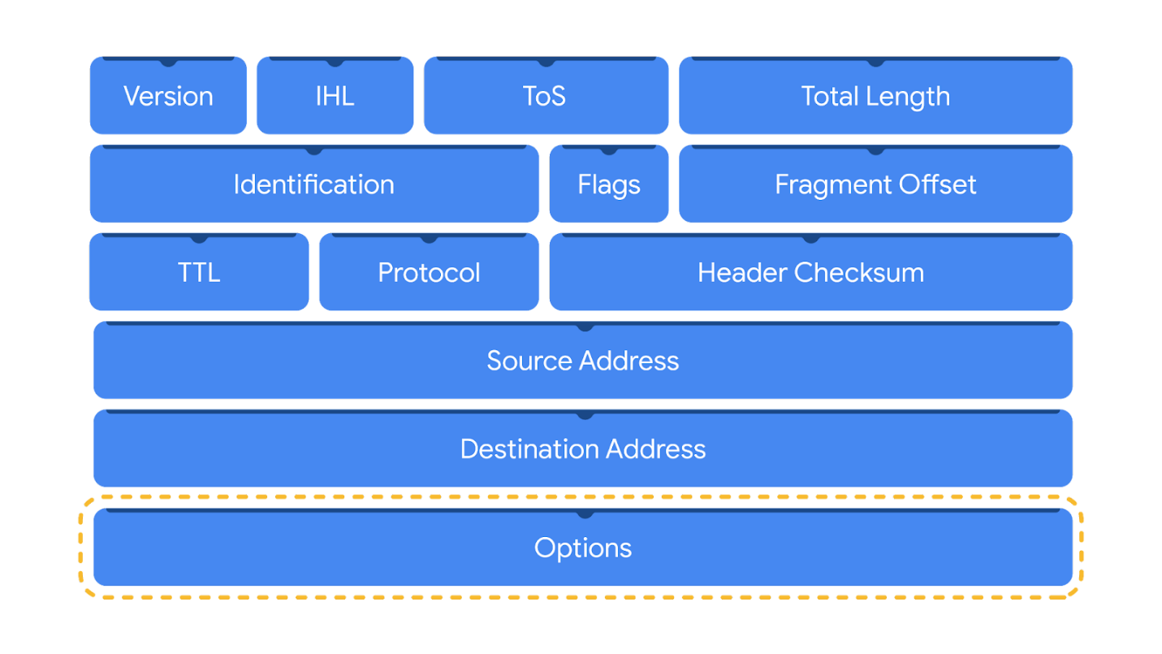

### **IPv6**

IPv6 adoption has been increasing because of its large address space. There are eight fields in the header:

* **Version**: This field indicates the IP version. For an IPv6 header, IPv6 is used.
* **Traffic Class**: This field is similar to the IPv4 Type of Service field. The Traffic Class field provides information about the packet's priority or class to help with packet delivery.
* **Flow Label**: This field identifies the packets of a flow. A flow is the sequence of packets sent from a specific source.
* **Payload Length**: This field specifies the length of the data portion of the packet.
* **Next Header**: This field indicates the type of header that follows the IPv6 header such as TCP.
* **Hop Limit**: This field is similar to the IPv4 Time to Live field. The Hop Limit limits how long a packet can travel in a network before being discarded.
* **Source Address**: This field specifies the source address of the sender.
* **Destination Address**: This field specifies the destination address of the receiver.

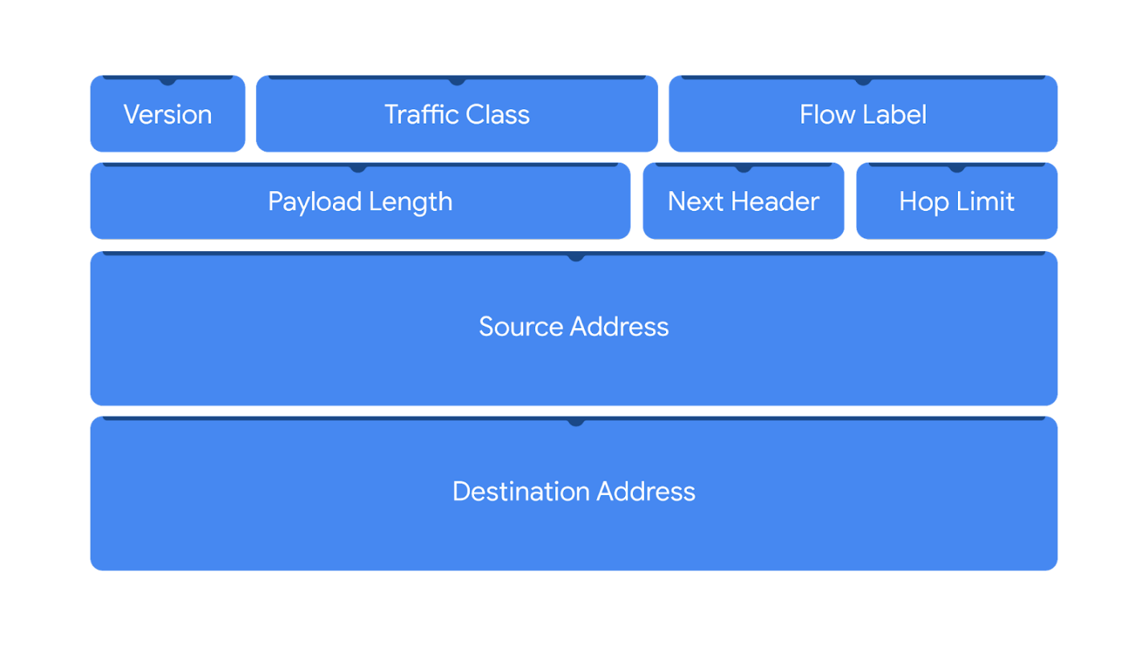

Header fields contain valuable information for investigations and tools like Wireshark help to display these fields in a human-readable format.

## Wireshark

**Wireshark** is an open-source network protocol analyzer. It uses a graphical user interface (GUI), which makes it easier to visualize network communications for packet analysis purposes. Wireshark has many features to explore that are beyond the scope of this course. You'll focus on how to use basic filtering to isolate network packets so that you can find what you need.

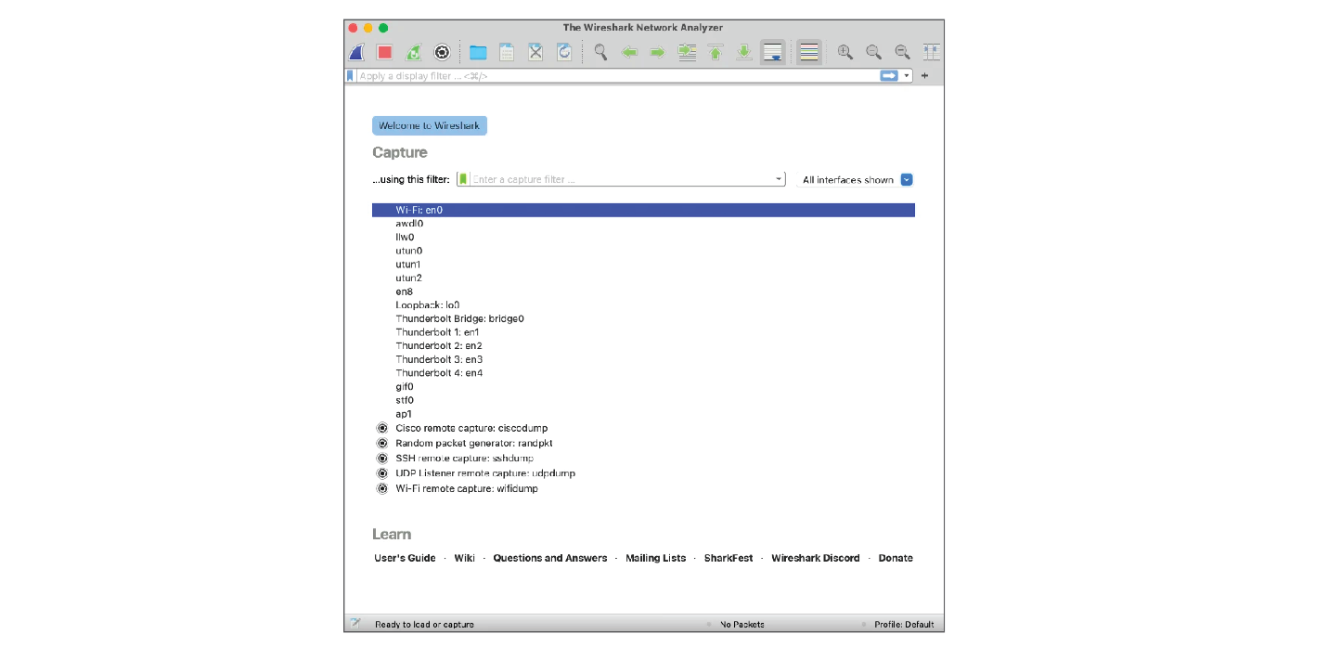

### Display filters

Wireshark's display filters let you apply filters to packet capture files. This is helpful when you are inspecting packet captures with large volumes of information. Display filters will help you find specific information that's most relevant to your investigation. You can filter packets based on information such as protocols, IP addresses, ports, and virtually any other property found in a packet. Here, you'll focus on display filtering syntax and filtering for protocols, IP addresses, and ports.

### Comparison operators

You can use different comparison operators to locate specific header fields and values. Comparison operators can be expressed using either abbreviations or symbols. For example, this filter using the == equal symbol in this filter ip.src == 8.8.8.8 is identical to using the eq abbreviation in this filter ip.src eq 8.8.8.8.

This table summarizes the different types of comparison operators you can use for display filtering.

| **Operator type** | **Symbol** | **Abbreviation** |
| --- | --- | --- |
| Equal | == | eq |
| Not equal | != | ne |
| Greater than | > | gt |
| Less than | < | lt |
| Greater than or equal to | >= | ge |
| Less than or equal to | <= | le |

**Pro tip:** You can combine comparison operators with Boolean logical operators like and and or to create complex display filters. Parentheses can also be used to group expressions and to prioritize search terms.

### Contains operator

The contains operator is used to filter packets that contain an exact match of a string of text. Here is an example of a filter that displays all HTTP streams that match the keyword "moved".

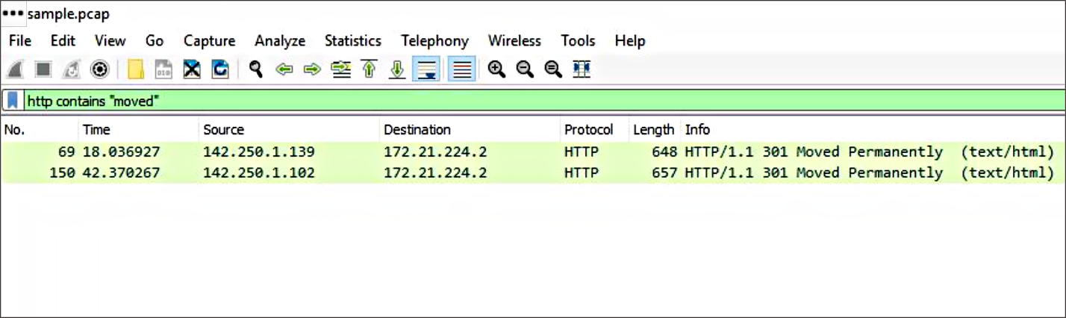

### Matches operator

The matches operator is used to filter packets based on the regular expression (regex) that's specified. Regular expression is a sequence of characters that forms a pattern. You'll explore more about regular expressions later in this program.

## Filter toolbar

You can apply filters to a packet capture using Wireshark's filter toolbar. In this example, dns is the applied filter, which means Wireshark will only display packets containing the DNS protocol.

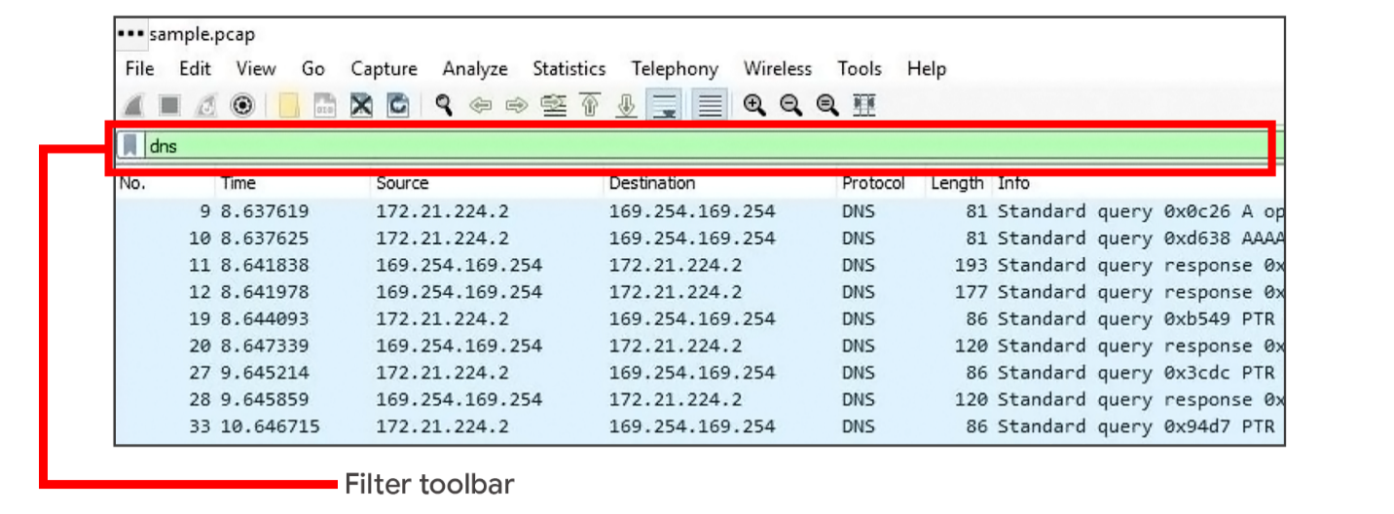

**Pro tip**: Wireshark uses different colors to represent protocols. You can customize colors and create your own filters.

### **Filter for protocols**

Protocol filtering is one of the simplest ways you can use display filters. You can simply enter the name of the protocol to filter. For example, to filter for DNS packets simply type dns in the filter toolbar. Here is a list of some protocols you can filter for:

* dns
* http
* ftp
* ssh
* arp
* telnet
* icmp

### **Filter for an IP address**

You can use display filters to locate packets with a specific IP address.

For example, if you would like to filter packets that contain a specific IP address use ip.addr, followed by a space, the equal == comparison operator, and the IP address. Here is an example of a display filter that filters for the IP address 172.21.224.2:

ip.addr == 172.21.224.2

To filter for packets originating from a specific source IP address, you can use the ip.src filter. Here is an example that looks for the 10.10.10.10 source IP address:

ip.src == 10.10.10.10

To filter for packets delivered to a specific destination IP address, you can use the ip.dst filter. Here is an example that searches for the 4.4.4.4 destination IP address:

ip.dst == 4.4.4.4

### **Filter for a MAC address**

You can also filter packets according to the **Media Access Control (MAC) address**. As a refresher, a MAC address is a unique alphanumeric identifier that is assigned to each physical device on a network.

Here's an example:

eth.addr == 00:70:f4:23:18:c4

### **Filter for ports**

Port filtering is used to filter packets based on port numbers. This is helpful when you want to isolate specific types of traffic. DNS traffic uses TCP or UDP port 53 so this will list traffic related to DNS queries and responses only.

For example, if you would like to filter for a UDP port:

udp.port == 53

Likewise, you can filter for TCP ports as well:

tcp.port == 25

## Follow streams

Wireshark provides a feature that lets you filter for packets specific to a protocol and view streams. A stream or conversation is the exchange of data between devices using a protocol. Wireshark reassembles the data that was transferred in the stream in a way that's simple to read.

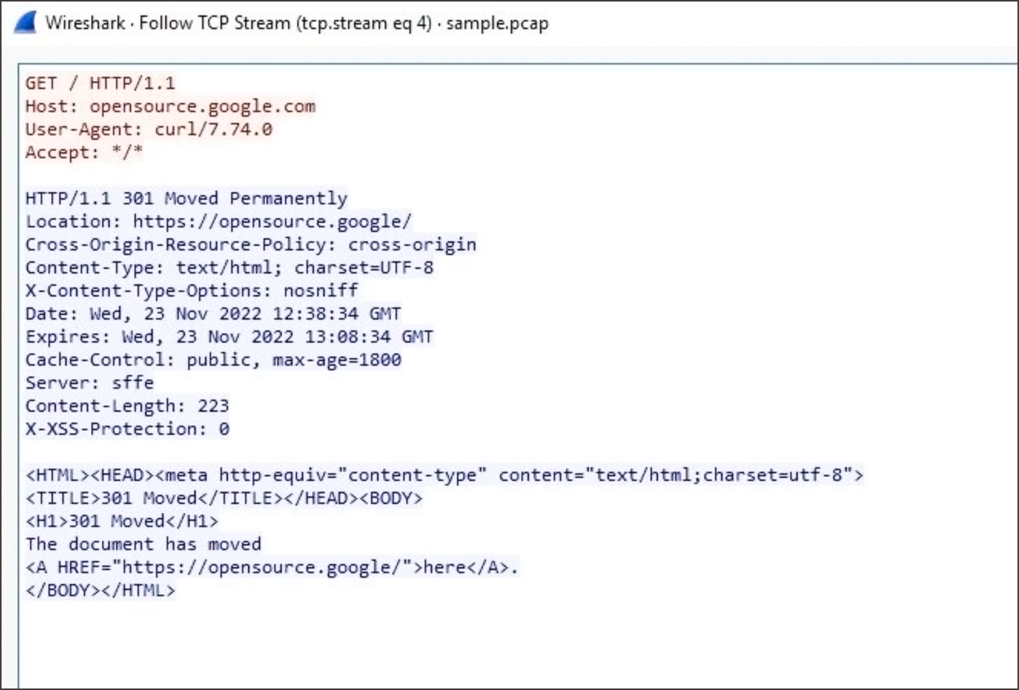

Following a protocol stream is useful when trying to understand the details of a conversation. For example, you can examine the details of an HTTP conversation to view the content of the exchanged request and response messages.

# Overview of tcpdump

As a security analyst, you’ll use network protocol analyzers to help defend against any network intrusions. Previously, you learned the following terms related to network monitoring and analysis:

* A **network protocol analyzer (packet sniffer)** is a tool designed to capture and analyze data traffic within a network.
* **Packet sniffing** is the practice of capturing and inspecting data packets across a network.

In this reading, you'll learn more about tcpdump, a network protocol analyzer that can be used to capture and view network communications.

## What is tcpdump?

**Tcpdump** is a command-line network protocol analyzer. Recall that a **command-line interface (CLI)** is a text-based user interface that uses commands to interact with the computer.

Tcpdump is used to capture network traffic. This traffic can be saved to a **packet capture (p-cap)**, which is a file containing data packets intercepted from an interface or network. The p-cap file can be accessed, analyzed, or shared at a later time. Analysts use tcpdump for a variety of reasons, from troubleshooting network issues to identifying malicious activity. Tcpdump comes pre-installed in many Linux distributions and can also be installed on other Unix-based operating systems such as macOS®.

**Note**: It's common for network traffic to be encrypted, which means data is encoded and unreadable. Inspecting the network packets might require decrypting the data using the appropriate private keys.

## Capturing packets with tcpdump

Previously in this program, you learned that a Linux **root user (or superuser)** has elevated privileges to modify the system. You also learned that the **sudo** command temporarily grants elevated permissions to specific users in Linux. Like many other packet sniffing tools, you’ll need to have administrator-level privileges to capture network traffic using tcpdump. This means you will need to either be logged in as the root user or have the ability to use the sudo command. Here is a breakdown of the tcpdump syntax for capturing packets:

sudo tcpdump [-i interface] [option(s)] [expression(s)]

* The sudo tcpdump command begins running tcpdump using elevated permissions as sudo.
* The -i parameter specifies the network interface to capture network traffic. You must specify a network interface to capture from to begin capturing packets. For example, if you specify -i any you’ll sniff traffic from all network interfaces on the system.
* The option(s) are optional and provide you with the ability to alter the execution of the command. The expression(s) are a way to further filter network traffic packets so that you can isolate network traffic. You’ll learn more about option(s) and expression(s) in the next section.

**Note**: Before you can begin capturing network traffic, you must identify which network interface you'll want to use to capture packets from. You can use the -D flag to list the network interfaces available on a system.

## Options

With tcpdump, you can apply options, also known as flags, to the end of commands to filter network traffic. Short options are abbreviated and represented by a hyphen and a single character like -i. Long options are spelled out using a double hyphen like --interface. Tcpdump has over fifty options that you can explore using [the manual page](https://www.tcpdump.org/manpages/tcpdump.1.html)

. Here, you’ll examine a couple of essential tcpdump options including how to write and read packet capture files.

**Note**: Options are case sensitive. For example, a lowercase -w is a separate option with a different use than the option with an uppercase -W.

**Note**: tcpdump options that are written using short options can be written with or without a space between the option and its value. For example, sudo tcpdump -i any -c 3 and sudo tcpdump -iany -c3 are equivalent commands.

### **-w**

Using the -w flag, you can write or save the sniffed network packets to a packet capture file instead of just printing it out in the terminal. This is very useful because you can refer to this saved file for later analysis. In this command, tcpdump is capturing network traffic from all network interfaces and saving it to a packet capture file named packetcapture.pcap:

### sudo tcpdump -i any -w packetcapture.pcap

### **-r**

Using the -r flag, you can read a packet capture file by specifying the file name as a parameter. Here is an example of a tcpdump command that reads a file called packetcapture.pcap:

### sudo tcpdump -r packetcapture.pcap

### **-v**

As you’ve learned, packets contain a lot of information. By default, tcpdump will not print out all of a packet's information. This option, which stands for verbose, lets you control how much packet information you want tcpdump to print out.

There are three levels of verbosity you can use depending on how much packet information you want tcpdump to print out. The levels are -v, -vv, and -vvv. The level of verbosity increases with each added v. The verbose option can be helpful if you’re looking for packet information like the details of a packet’s IP header fields. Here’s an example of a tcpdump command that reads the packetcapture.pcap file with verbosity:

### sudo tcpdump -r packetcapture.pcap -v

### **-c**

The -c option stands for count. This option lets you control how many packets tcpdump will capture. For example, specifying -c 1 will only print out one single packet, whereas -c 10 prints out 10 packets. This example is telling tcpdump to only capture the first three packets it sniffs from any network interface:

### sudo tcpdump -i any -c 3

### **-n**

By default, tcpdump will perform name resolution. This means that tcpdump automatically converts IP addresses to names. It will also resolve ports to commonly associated services that use these ports. This can be problematic because tcpdump isn’t always accurate in name resolution. For example, tcpdump can capture traffic from port 80 and automatically translates port 80 to HTTP in the output. However, this is misleading because port 80 isn’t always going to be using HTTP; it could be using a different protocol.

Additionally, name resolution uses what’s known as a reverse DNS lookup. A reverse DNS lookup is a query that looks for the domain name associated with an IP address. If you perform a reverse DNS lookup on an attacker’s system, they might be alerted that you are investigating them through their DNS records.

Using the -n flag disables this automatic mapping of numbers to names and is considered to be best practice when sniffing or analyzing traffic. Using -n will not resolve hostnames, whereas -nn will not resolve both hostnames or ports. Here’s an example of a tcpdump command that reads the packetcapture.pcap file with verbosity and disables name resolution:

### sudo tcpdump -r packetcapture.pcap -v -n

**Pro tip:** You can combine options together. For example, -v and -n can be combined as -vn. But, if an option accepts a parameter right after it like -c 1 or -r capture.pcap then you can’t combine other options to it.

## Expressions

Using filter expressions in tcpdump commands is also optional, but knowing how and when to use filter expressions can be helpful during packet analysis. There are many ways to use filter expressions.

If you want to specifically search for network traffic by protocol, you can use filter expressions to isolate network packets. For example, you can filter to find only IPv6 traffic using the filter expression ip6.

You can also use boolean operators like and, or, or not to further filter network traffic for specific IP addresses, ports, and more. The example below reads the packetcapture.pcap file and combines two expressions ip and port 80 using the and boolean operator:

sudo tcpdump -r packetcapture.pcap -n 'ip and port 80'

**Pro tip:** You can use single or double quotes to ensure that tcpdump executes all of the expressions. You can also use parentheses to group and prioritize different expressions. Grouping expressions is helpful for complex or lengthy commands. For example, the command ip and (port 80 or port 443) tells tcpdump to prioritize executing the filters enclosed in the parentheses before filtering for IPv4.

## Interpreting output

Once you run a command to capture packets, tcpdump will print the output of the command as the sniffed packets. In the output, tcpdump prints one line of text for each packet with each line beginning with a timestamp. Here’s an example of a command and output for a single TCP packet:

sudo tcpdump -i any -v -c 1

This command tells tcpdump to capture packets on -i any network interface. The option -v prints out the packet with detailed information and the option -c 1 prints out only one packet. Here is the output of this command:

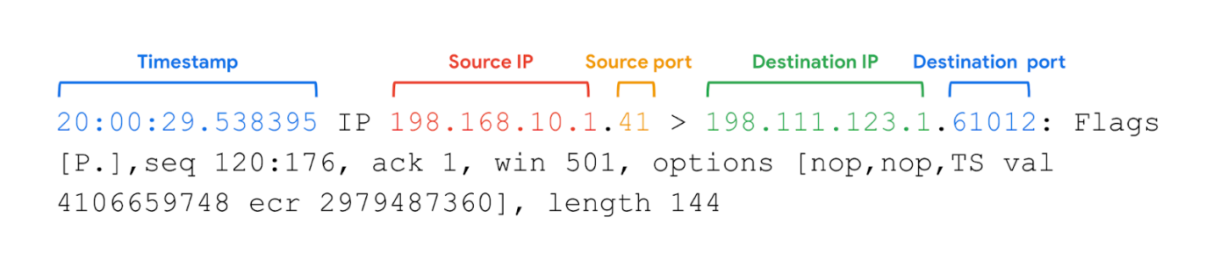

1. **Timestamp**: The output begins with the timestamp, which starts with hours, minutes, seconds, and fractions of a second.
2. **Source IP:** The packet’s origin is provided by its source IP address.
3. **Source port:** This port number is where the packet originated.
4. **Destination IP:** The destination IP address is where the packet is being transmitted to.
5. **Destination port:** This port number is where the packet is being transmitted to.

The remaining output contains details of the TCP connection including flags and sequence number. The options information is additional packet information that the  -v option has provided.

# Cybersecurity incident detection methods

Security analysts use detection tools to help them discover threats, but there are additional methods of detection that can be used as well.

Previously, you learned about how detection tools can identify attacks like data exfiltration. In this reading, you’ll be introduced to different detection methods that organizations can employ to discover threats.

## Methods of detection

During the **Detection and Analysis Phase** of the incident response lifecycle, security teams are notified of a possible incident and work to investigate and verify the incident by collecting and analyzing data. As a reminder, **detection** refers to the prompt discovery of security events and **analysis** involves the investigation and validation of alerts.

As you’ve learned, an intrusion detection system (IDS) can detect possible intrusions and send out alerts to security analysts to investigate the suspicious activity. Security analysts can also use security information and event management (SIEM) tools to detect, collect, and analyze security data.

You’ve also learned that there are challenges with detection. Even the best security teams can fail to detect real threats for a variety of reasons. For example, detection tools can only detect what security teams configure them to monitor. If they aren’t properly configured, they can fail to detect suspicious activity, leaving systems vulnerable to attack. It’s important for security teams to use additional methods of detection to increase their coverage and accuracy.

### **Threat hunting**

Threats evolve and attackers advance their tactics and techniques. Automated, technology-driven detection can be limited in keeping up to date with the evolving threat landscape. Human-driven detection like threat hunting combines the power of technology with a human element to discover hidden threats left undetected by detection tools.

**Threat hunting** is the proactive search for threats on a network. Security professionals use threat hunting to uncover malicious activity that was not identified by detection tools and as a way to do further analysis on detections. Threat hunting is also used to detect threats before they cause damage. For example, fileless malware is difficult for detection tools to identify. It’s a form of malware that uses sophisticated evasion techniques such as hiding in memory instead of using files or applications, allowing it to bypass traditional methods of detection like signature analysis. With threat hunting, the combination of active human analysis and technology is used to identify threats like fileless malware.

**Note**: Threat hunting specialists are known as threat hunters. Threat hunters perform research on emerging threats and attacks and then determine the probability of an organization being vulnerable to a particular attack. Threat hunters use a combination of threat intelligence, indicators of compromise, indicators of attack, and machine learning to search for threats in an organization.

### **Threat intelligence**

Organizations can improve their detection capabilities by staying updated on the evolving threat landscape and understanding the relationship between their environment and malicious actors. One way to understand threats is by using **threat intelligence**, which is evidence-based threat information that provides context about existing or emerging threats.

Threat intelligence can come from private or public sources like:

* **Industry reports**: These often include details about attacker's tactics, techniques, and procedures (TTP).
* **Government advisories:** Similar to industry reports, government advisories include details about attackers' TTP.
* **Threat data feeds**: Threat data feeds provide a stream of threat-related data that can be used to help protect against sophisticated attackers like **advanced persistent threats (APTs)**. APTs are instances when a threat actor maintains unauthorized access to a system for an extended period of time. The data is usually a list of indicators like IP addresses, domains, and file hashes.

It can be difficult for organizations to efficiently manage large volumes of threat intelligence. Organizations can leverage a threat intelligence platform (TIP) which is an application that collects, centralizes, and analyzes threat intelligence from different sources. TIPs provide a centralized platform for organizations to identify and prioritize relevant threats and improve their security posture.

**Note**: Threat intelligence data feeds are best used to add context to detections. They should not drive detections completely and should be assessed before applied to an organization.

### **Cyber deception**

Cyber deception involves techniques that deliberately deceive malicious actors with the goal of increasing detection and improving defensive strategies.

**Honeypots** are an example of an active cyber defense mechanism that uses deception technology. Honeypots are systems or resources that are created as decoys vulnerable to attacks with the purpose of attracting potential intruders. For example, having a fake file labeled Client Credit Card Information - 2022 can be used to capture the activity of malicious actors by tricking them into accessing the file because it appears to be legitimate. Once a malicious actor tries to access this file, security teams are alerted.

## Key takeaways

Various detection methods can be implemented to identify and locate security events in an environment. It’s essential for organizations to use a variety of detection methods, tools, and technologies to adapt to the ever evolving threat landscape and better protect assets.

# Indicators of compromise

In this reading, you’ll be introduced to the concept of the Pyramid of Pain and you'll explore examples of the different types of indicators of compromise. Understanding and applying this concept helps organizations improve their defense and reduces the damage an incident can cause.

## Indicators of compromise

**Indicators of compromise** (**IoCs**) are observable evidence that suggests signs of a potential security incident. IoCs chart specific pieces of evidence that are associated with an attack, like a file name associated with a type of malware. You can think of an IoC as evidence that points to something that's already happened, like noticing that a valuable has been stolen from inside of a car.

**Indicators of attack** (**IoA**) are the series of observed events that indicate a real-time incident.  IoAs focus on identifying the behavioral evidence of an attacker, including their methods and intentions.

Essentially, IoCs help to identify the who and what of an attack after it's taken place, while IoAs focus on finding the why and how of an ongoing or unknown attack. For example, observing a process that makes a network connection is an example of an IoA. The filename of the process and the IP address that the process contacted are examples of the related IoCs.

**Note**: Indicators of compromise are not always a confirmation that a security incident has happened. IoCs may be the result of human error, system malfunctions, and other reasons not related to security.

## Pyramid of Pain

Not all indicators of compromise are equal in the value they provide to security teams. It’s important for security professionals to understand the different types of indicators of compromise so that they can quickly and effectively detect and respond to them. This is why security researcher David J. Bianco created the concept of the [Pyramid of Pain](http://detect-respond.blogspot.com/2013/03/the-pyramid-of-pain.html)

, with the goal of improving how indicators of compromise are used in incident detection.

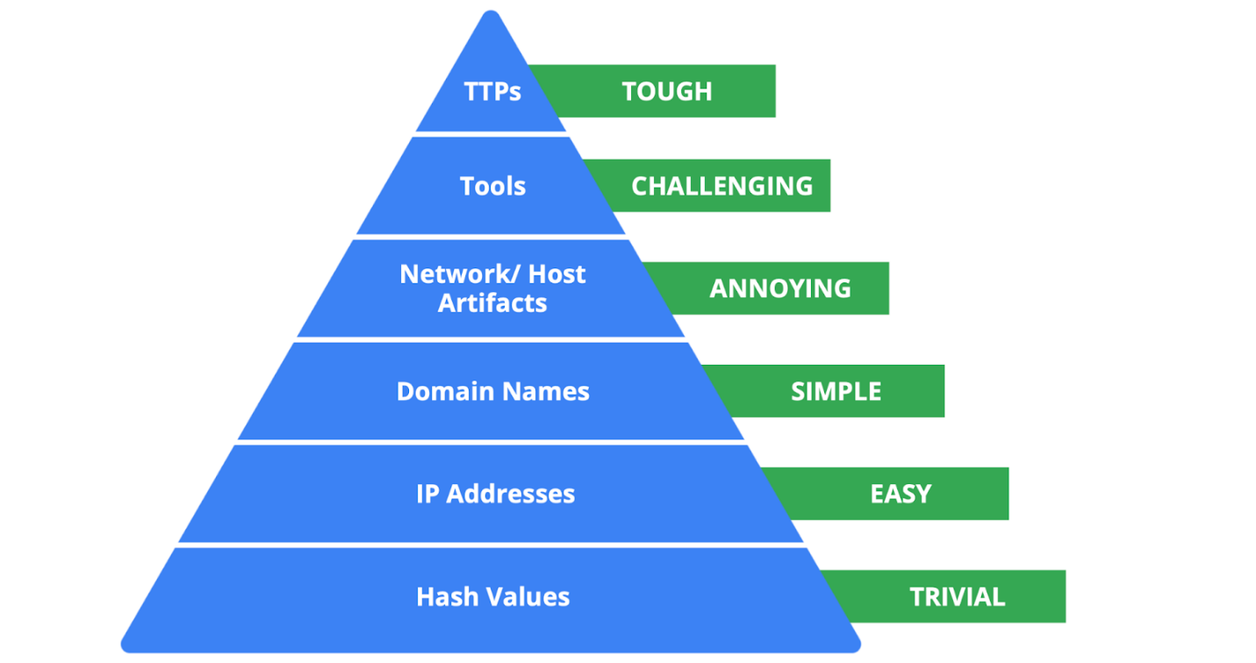

The Pyramid of Pain captures the relationship between indicators of compromise and the level of difficulty that malicious actors experience when indicators of compromise are blocked by security teams. It lists the different types of indicators of compromise that security professionals use to identify malicious activity.

Each type of indicator of compromise is separated into levels of difficulty. These levels represent the “pain” levels that an attacker faces when security teams block the activity associated with the indicator of compromise. For example, blocking an IP address associated with a malicious actor is labeled as easy because malicious actors can easily use different IP addresses to work around this and continue with their malicious efforts. If security teams are able to block the IoCs located at the top of the pyramid, the more difficult it becomes for attackers to continue their attacks. Here’s a breakdown of the different types of indicators of compromise found in the Pyramid of Pain.

1. **Hash values**: Hashes that correspond to known malicious files. These are often used to provide unique references to specific samples of malware or to files involved in an intrusion.
2. **IP addresses**: An internet protocol address like 192.168.1.1
3. **Domain names**: A web address such as www.google.com
4. **Network artifacts**: Observable evidence created by malicious actors on a network. For example, information found in network protocols such as User-Agent strings.
5. **Host artifacts:** Observable evidence created by malicious actors on a host. A host is any device that’s connected on a network. For example, the name of a file created by malware.
6. **Tools**: Software that’s used by a malicious actor to achieve their goal. For example, attackers can use password cracking tools like John the Ripper to perform password attacks to gain access into an account.
7. **Tactics, techniques, and procedures (TTPs)**: This is the behavior of a malicious actor. Tactics refer to the high-level overview of the behavior. Techniques provide detailed descriptions of the behavior relating to the tactic. Procedures are highly detailed descriptions of the technique. TTPs are the hardest to detect.

# Analyze indicators of compromise with investigative tools

So far, you've learned about the different types of detection methods that can be used to detect security incidents. This reading explores how investigative tools can be used during investigations to analyze suspicious **indicators of compromise (IoCs)** and build context around alerts. Remember, an IoC is observable evidence that suggests signs of a potential security incident.

## Adding context to investigations

You've learned about the Pyramid of Pain which describes the relationship between indicators of compromise and the level of difficulty that malicious actors experience when indicators of compromise are blocked by security teams. You also learned about different types of IoCs, but as you know, not all IoCs are equal. Malicious actors can manage to evade detection and continue compromising systems despite having their IoC-related activity blocked or limited.

For example, identifying and blocking a single IP address associated with malicious activity does not provide a broader insight on an attack, nor does it stop a malicious actor from continuing their activity. Focusing on a single piece of evidence is like fixating on a single section of a painting: You miss out on the bigger picture.



Security analysts need a way to expand the use of IoCs so that they can add context to alerts. **Threat intelligence** is evidence-based threat information that provides context about existing or emerging threats. By accessing additional information related to IoCs, security analysts can expand their viewpoint to observe the bigger picture and construct a narrative that helps inform their response actions.



By adding context to an IoC—for instance, identifying other artifacts related to the suspicious IP address, such as suspicious network communications or unusual processes—security teams can start to develop a detailed picture of a security incident. This context can help security teams detect security incidents faster and take a more informed approach in their response.

## The power of crowdsourcing

**Crowdsourcing** is the practice of gathering information using public input and collaboration. Threat intelligence platforms use crowdsourcing to collect information from the global cybersecurity community. Traditionally, an organization's response to incidents was performed in isolation. A security team would receive and analyze an alert, and then work to remediate it without additional insights on how to approach it. Without crowdsourcing, attackers can perform the same attacks against multiple organizations.

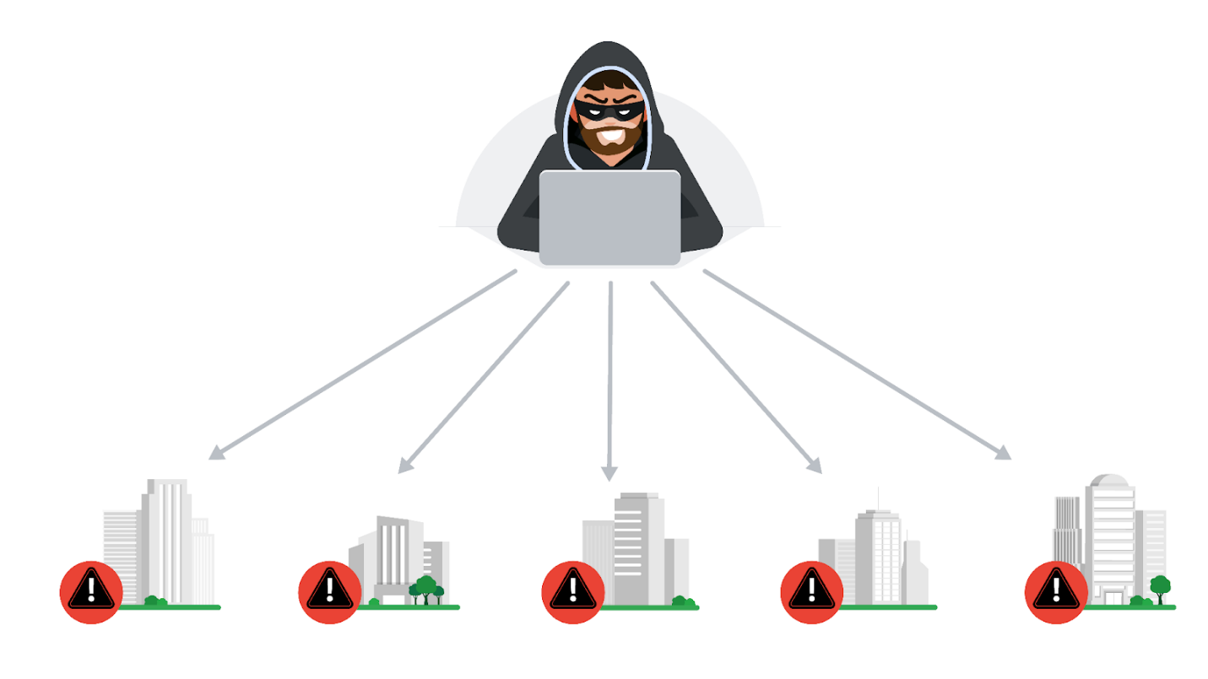

With crowdsourcing, organizations harness the knowledge of millions of other cybersecurity professionals, including cybersecurity product vendors, government agencies, cloud providers, and more. Crowdsourcing allows people and organizations from the global cybersecurity community to openly share and access a collection of threat intelligence data, which helps to continuously improve detection technologies and methodologies.

Examples of information-sharing organizations include Information Sharing and Analysis Centers (ISACs), which focus on collecting and sharing sector-specific threat intelligence to companies within specific industries like energy, healthcare, and others. **Open-source intelligence (OSINT)** is the collection and analysis of information from publicly available sources to generate usable intelligence. OSINT can also be used as a method to gather information related to threat actors, threats, vulnerabilities, and more.

This threat intelligence data is used to improve the detection methods and techniques of security products, like detection tools or anti-virus software. For example, attackers often perform the same attacks on multiple targets with the hope that one of them will be successful. Once an organization detects an attack, they can immediately publish the attack details, such as malicious files, IP addresses, or URLs, to tools like VirusTotal. This threat intelligence can then help other organizations defend against the same attack.

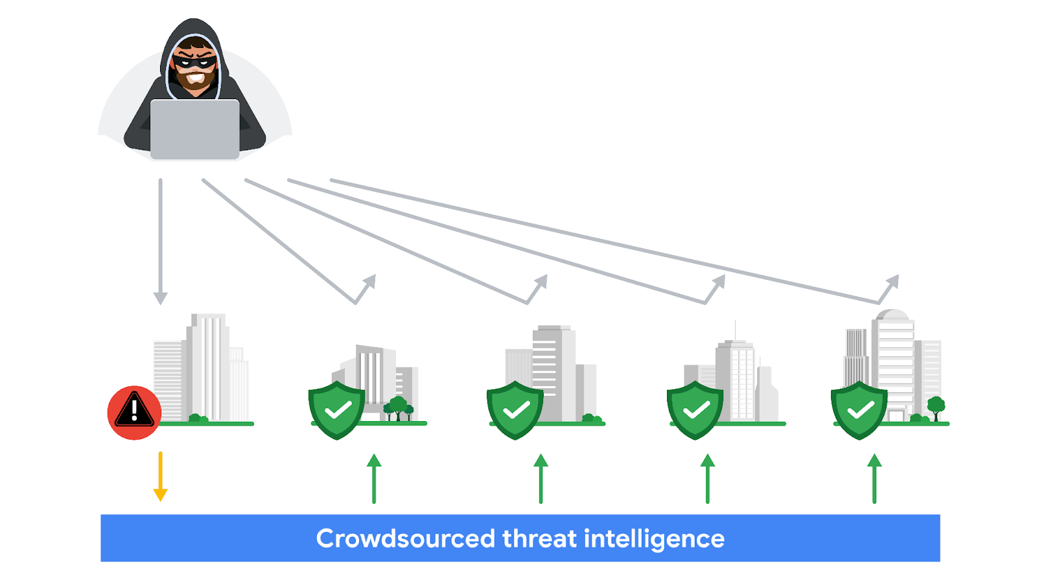

## VirusTotal

[**VirusTotal**](https://www.virustotal.com/gui/home)

is a service that allows anyone to analyze suspicious files, domains, URLs, and IP addresses for malicious content. VirusTotal also offers additional services and tools for enterprise use. This reading focuses on the VirusTotal website, which is available for free and non-commercial use.

It can be used to analyze suspicious files, IP addresses, domains, and URLs to detect cybersecurity threats such as malware. Users can submit and check artifacts, like file hashes or IP addresses, to get VirusTotal reports, which provide additional information on whether an IoC is considered malicious or not, how that IoC is connected or related to other IoCs in the dataset, and more.

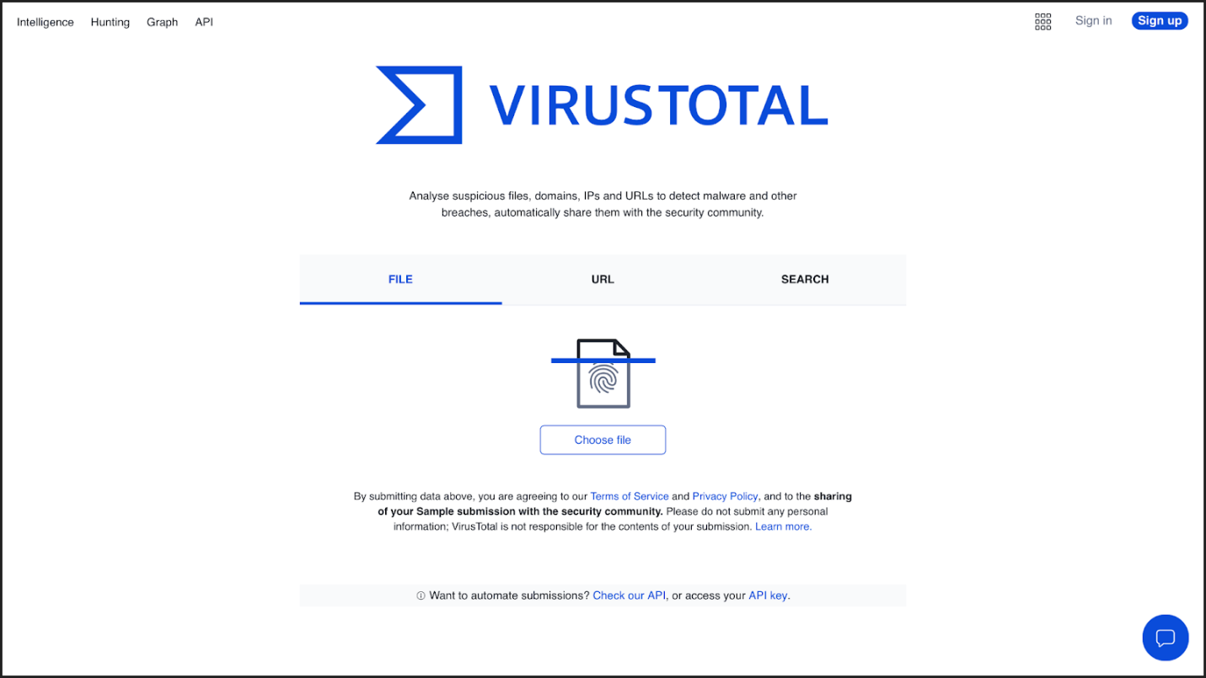

Here is a breakdown of the reports summary:

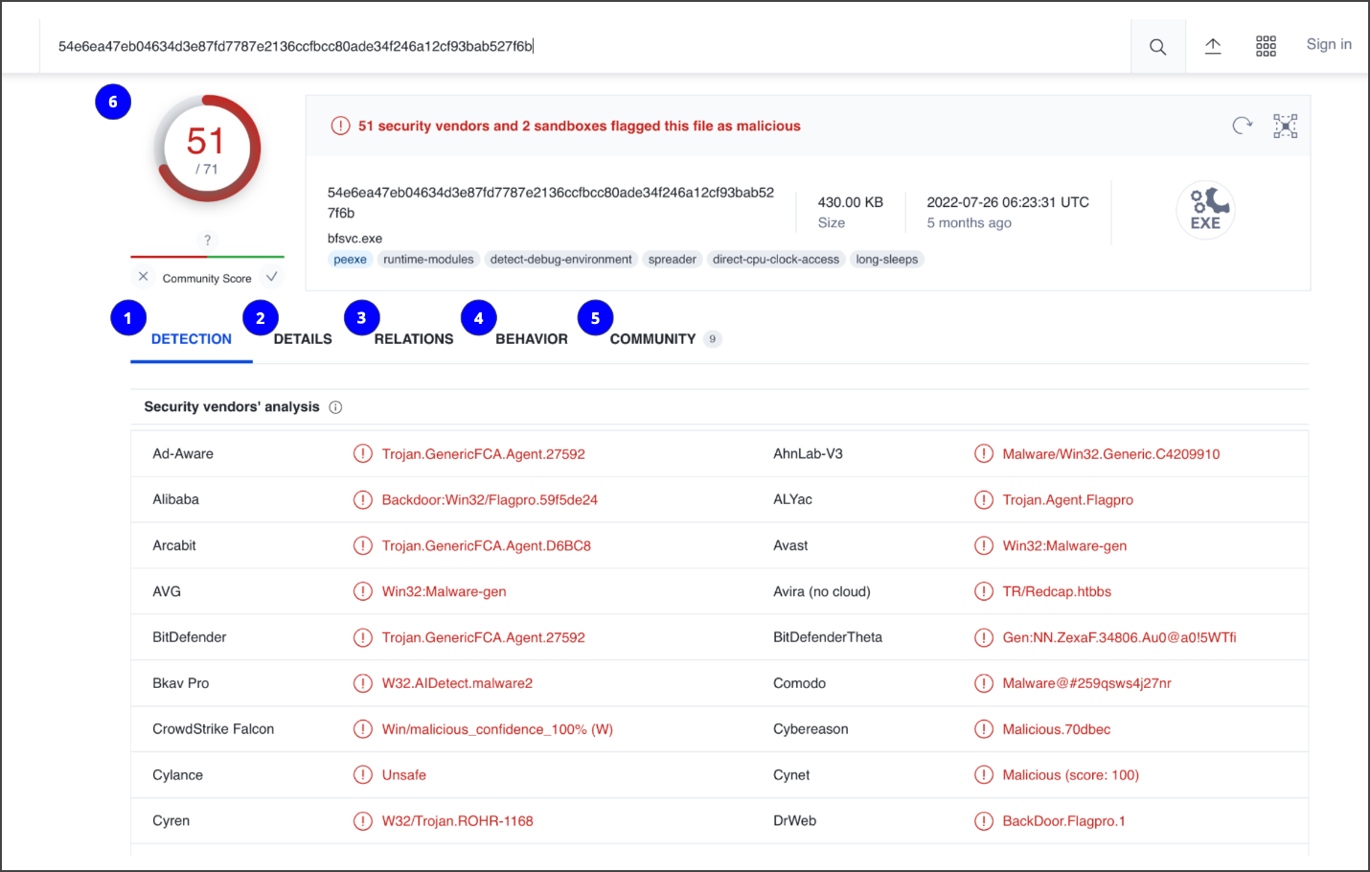

1. **Detection**: The Detection tab provides a list of third-party security vendors and their detection verdicts on an IoC. For example, vendors can list their detection verdict as malicious, suspicious, unsafe, and more.
2. **Details**: The Details tab provides additional information extracted from a static analysis of the IoC. Information such as different hashes, file types, file sizes, headers, creation time, and first and last submission information can all be found in this tab.
3. **Relations**: The Relations tab provides related IoCs that are somehow connected to an artifact, such as contacted URLs, domains, IP addresses, and dropped files if the artifact is an executable.
4. **Behavior**: The Behavior tab contains information related to the observed activity and behaviors of an artifact after executing it in a controlled or sandboxed environment. This information includes tactics and techniques detected, network communications, registry and file systems actions, processes, and more.
5. **Community:** The Community tab is where members of the VirusTotal community, such as security professionals or researchers, can leave comments and insights about the IoC.
6. **Vendors’ ratio and community score**: The score displayed at the top of the report is the vendors’ ratio. The vendors’ ratio shows how many security vendors have flagged the IoC as malicious overall. Below this score, there is also the community score, based on the inputs of the VirusTotal community. The more detections a file has and the higher its community score is, the more likely that the file is malicious.

**Note**: Data uploaded to VirusTotal will be publicly shared with the entire VirusTotal community. Be careful of what you submit, and make sure you do not upload personal information.

## Other tools

There are other investigative tools that can be used to analyze IoCs. These tools can also share the data that's uploaded to them to the security community.

### **Jotti malware scan**

[Jotti's malware scan](https://virusscan.jotti.org/)

is a free service that lets you scan suspicious files with several antivirus programs. There are some limitations to the number of files that you can submit.

### **Urlscan.io**

[Urlscan.io](https://urlscan.io/)

is a free service that scans and analyzes URLs and provides a detailed report summarizing the URL information.

### **MalwareBazaar**

[MalwareBazaar](https://bazaar.abuse.ch/browse/)

is a free repository for malware samples. Malware samples are a great source of threat intelligence that can be used for research purposes.

# The triage process

Previously, you learned that triaging is used to assess alerts and assign priority to incidents. In this reading, you'll explore the triage process and its benefits. As a security analyst, you'll be responsible for analyzing security alerts. Having the skills to effectively triage is important because it allows you to address and resolve security alerts efficiently.

## Triage process

Incidents can have the potential to cause significant damage to an organization. Security teams must respond quickly and efficiently to prevent or limit the impact of an incident before it becomes too late. **Triage** is the prioritizing of incidents according to their level of importance or urgency. The triage process helps security teams evaluate and prioritize security alerts and allocate resources effectively so that the most critical issues are addressed first.

The triage process consists of three steps:

1. Receive and assess
2. Assign priority
3. Collect and analyze

### **Receive and assess**

During this first step of the triage process, a security analyst receives an alert from an alerting system like an **intrusion detection system** (IDS). You might recall that an IDS is an application that monitors system activity and alerts on possible intrusions. The analyst then reviews the alert to verify its validity and ensure they have a complete understanding of the alert.

This involves gathering as much information as possible about the alert, including details about the activity that triggered the alert, the systems and assets involved, and more. Here are some questions to consider when verifying the validity of an alert:

* **Is the alert a false positive?** Security analysts must determine whether the alert is a genuine security concern or a **false positive**, or an alert that incorrectly detects the presence of a threat.
* **Was this alert triggered in the past?** If so, how was it resolved? The history of an alert can help determine whether the alert is a new or recurring issue.
* **Is the alert triggered by a known vulnerability?** If an alert is triggered by a known vulnerability, security analysts can leverage existing knowledge to determine an appropriate response and minimize the impact of the vulnerability.
* **What is the severity of the alert?** The severity of an alert can help determine the priority of the response so that critical issues are quickly escalated.

### **Assign priority**

Once the alert has been properly assessed and verified as a genuine security issue, it needs to be prioritized accordingly. Incidents differ in their impact, size, and scope, which affects the response efforts. To manage time and resources, security teams must prioritize how they respond to various incidents because not all incidents are equal. Here are some factors to consider when determining the priority of an incident:

* **Functional impact:** Security incidents that target information technology systems impact the service that these systems provide to its users. For example, a ransomware incident can severely impact the confidentiality, availability, and integrity of systems. Data can be encrypted or deleted, making it completely inaccessible to users. Consider how an incident impacts the existing business functionality of the affected system.
* **Information impact:** Incidents can affect the confidentiality, integrity, and availability of an organization’s data and information. In a data exfiltration attack, malicious actors can steal sensitive data. This data can belong to third party users or organizations. Consider the effects that information compromise can have beyond the organization.
* **Recoverability:** How an organization recovers from an incident depends on the size and scope of the incident and the amount of resources available. In some cases, recovery might not be possible, like when a malicious actor successfully steals proprietary data and shares it publicly. Spending time, effort, and resources on an incident with no recoverability can be wasteful. It’s important to consider whether recovery is possible and consider whether it’s worth the time and cost.

**Note**: Security alerts often come with an assigned priority or severity level that classifies the urgency of the alert based on a level of prioritization.

### **Collect and analyze**

The final step of the triage process involves the security analyst performing a comprehensive analysis of the incident. Analysis involves gathering evidence from different sources, conducting external research, and documenting the investigative process. The goal of this step is to gather enough information to make an informed decision to address it. Depending on the severity of the incident, escalation to a level two analyst or a manager might be required. Level two analysts and managers might have more knowledge on using advanced techniques to address the incident.

## Benefits of triage

By prioritizing incidents based on their potential impact, you can reduce the scope of impact to the organization by ensuring a timely response. Here are some benefits that triage has for security teams:

* **Resource management:** Triaging alerts allows security teams to focus their resources on threats that require urgent attention. This helps team members avoid dedicating time and resources to lower priority tasks and might also reduce response time.
* **Standardized approach:** Triage provides a standardized approach to incident handling. Process documentation, like playbooks, help to move alerts through an iterative process to ensure that alerts are properly assessed and validated. This ensures that only valid alerts are moved up to investigate.

# Business continuity considerations

Previously, you learned about how security teams develop incident response plans to help ensure that there is a prepared and consistent process to quickly respond to security incidents. In this reading, you'll explore the importance that business continuity planning has in recovering from incidents.

## Business continuity planning

Security teams must be prepared to minimize the impact that security incidents can have on their normal business operations. When an incident occurs, organizations might experience significant disruptions to the functionality of their systems and services. Prolonged disruption to systems and services can have serious effects, causing legal, financial, and reputational damages. Organizations can use business continuity planning so that they can remain operational during any major disruptions.

Similar to an incident response plan, a **business** **continuity plan (BCP)** is a document that outlines the procedures to sustain business operations during and after a significant disruption. A BCP helps organizations ensure that critical business functions can resume or can be quickly restored when an incident occurs.

Entry level security analysts aren't typically responsible for the development and testing of a BCP. However, it's important that you understand how BCPs provide organizations with a structured way to respond and recover from security incidents.

**Note**: Business continuity plans are not the same as disaster recovery plans. Disaster recovery plans are used to recover information systems in response to a major disaster. These disasters can range from hardware failure to the destruction of facilities from a natural disaster, like a flood.

### **Consider the impacts of ransomware to business continuity**

Impacts of a security incident such as ransomware can be devastating for business operations. Ransomware attacks targeting critical infrastructure such as healthcare can have the potential to cause significant disruption. Depending on the severity of a ransomware attack, the accessibility, availability, and delivery of essential healthcare services can be impacted. For example, ransomware can encrypt data, resulting in disabled access to medical records, which prevents healthcare providers from accessing patient records. At a larger scale, security incidents that target the assets, systems, and networks of critical infrastructure can also undermine national security, economic security, and the health and safety of the public. For this reason, BCPs help to minimize interruptions to operations so that essential services can be accessed.

### **Recovery strategies**

When an outage occurs due to a security incident, organizations must have some sort of a functional recovery plan set to resolve the issue and get systems fully operational. BCPs can include strategies for recovery that focus on returning to normal operations. Site resilience is one example of a recovery strategy.

### **Site resilience**

**Resilience** is the ability to prepare for, respond to, and recover from disruptions. Organizations can design their systems to be resilient so that they can continue delivering services despite facing disruptions. An example is site resilience, which is used to ensure the availability of networks, data centers, or other infrastructure when a disruption happens. There are three types of recovery sites used for site resilience:

* **Hot sites**: A fully operational facility that is a duplicate of an organization's primary environment. Hot sites can be activated immediately when an organization's primary site experiences failure or disruption.
* **Warm sites**:A facility that contains a fully updated and configured version of the hot site. Unlike hot sites, warm sites are not fully operational and available for immediate use but can quickly be made operational when a failure or disruption occurs.
* **Cold sites**:A backup facility equipped with some of the necessary infrastructure required to operate an organization's site. When a disruption or failure occurs, cold sites might not be ready for immediate use and might need additional work to be operational.

# Best practices for log collection and management

In this reading, you’ll examine some best practices related to log management, storage, and protection. Understanding the best practices related to log collection and management will help improve log searches and better support your efforts in identifying and resolving security incidents.

## Logs

Data sources such as devices generate data in the form of events. A **log** is a record of events that occur within an organization's systems. Logs contain log entries and each entry details information corresponding to a single event that happened on a device or system. Originally, logs served the sole purpose of troubleshooting common technology issues. For example, error logs provide information about why an unexpected error occurred and help to identify the root cause of the error so that it can be fixed. Today, virtually all computing devices produce some form of logs that provide valuable insights beyond troubleshooting.

Security teams access logs from logging receivers like SIEM tools which consolidate logs to provide a central repository for log data. Security professionals use logs to perform **log** **analysis**, which is the process of examining logs to identify events of interest. Logs help uncover the details surrounding the 5 W's of incident investigation: who triggered the incident, what happened, when the incident took place, where the incident took place, and why the incident occurred.

### **Types of logs**

Depending on the data source, different log types can be produced. Here’s a list of some common log types that organizations should record:

* **Network**: Network logs are generated by network devices like firewalls, routers, or switches.
* **System**: System logs are generated by operating systems like Chrome OS™, Windows, Linux, or macOS®.
* **Application**: Application logs are generated by software applications and contain information relating to the events occurring within the application such as a smartphone app.
* **Security**: Security logs are generated by various devices or systems such as antivirus software and intrusion detection systems. Security logs contain security-related information such as file deletion.
* **Authentication**: Authentication logs are generated whenever authentication occurs such as a successful login attempt into a computer.

### **Log details**

Generally, logs contain a date, time, location, action, and author of the action. Here is an example of an authentication log:

Login Event [05:45:15] User1 Authenticated successfully

Logs contain information and can be adjusted to contain even more information. Verboselogging records additional, detailed information beyond the default log recording. Here is an example of the same log above but logged as verbose.

Login Event [2022/11/16 05:45:15.892673] auth_performer.cc:470 User1 Authenticated successfully from device1 (192.168.1.2)

## Log management

Because all devices produce logs, it can quickly become overwhelming for organizations to keep track of all the logs that are generated. To get the most value from your logs, you need to choose exactly what to log, how to access it easily, and keep it secure using log management. **Log management** is the process of collecting, storing, analyzing, and disposing of log data.

### **What to log**

The most important aspect of log management is choosing what to log. Organizations are different, and their logging requirements can differ too. It's important to consider which log sources are most likely to contain the most useful information depending on your event of interest. This might be configuring log sources to reduce the amount of data they record, such as excluding excessive verbosity. Some information, including but not limited to phone numbers, email addresses, and names, form personally identifiable information (PII), which requires special handling and in some jurisdictions might not be possible to be logged.

### **The issue with overlogging**

From a security perspective, it can be tempting to log everything. This is the most common mistake organizations make. Just because it can be logged, doesn't mean it needs to be logged. Storing excessive amounts of logs can have many disadvantages with some SIEM tools. For example, overlogging can increase storage and maintenance costs. Additionally, overlogging can increase the load on systems, which can cause performance issues and affect usability, making it difficult to search for and identify important events.

### **Log retention**

Organizations might operate in industries with regulatory requirements. For example, some regulations require organizations to retain logs for set periods of time and organizations can implement log retention practices in their log management policy.

Organizations that operate in the following industries might need to modify their log management policy to meet regulatory requirements:

* Public sector industries, like the Federal Information Security Modernization Act (FISMA)
* Healthcare industries, like the Health Insurance Portability and Accountability Act of 1996 (HIPAA)
* Financial services industries, such as the Payment Card Industry Data Security Standard (PCI DSS), the Gramm-Leach-Bliley Act (GLBA), and the Sarbanes-Oxley Act of 2002 (SOX)

# Overview of log file formats

You’ve learned about how logs record events that happen on a network, or system. In security, logs provide key details about activities that occurred across an organization, like who signed into an application at a specific point in time. As a security analyst, you’ll use **log analysis**, which is the process of examining logs to identify events of interest. It’s important to know how to read and interpret different log formats so that you can uncover the key details surrounding an event and identify unusual or malicious activity. In this reading, you’ll review the following log formats:

* JSON
* Syslog
* XML
* CSV
* CEF

## JavaScript Object Notation (JSON)

JavaScript Object Notation (JSON) is a file format that is used to store and transmit data. JSON is known for being lightweight and easy to read and write. It is used for transmitting data in web technologies and is also commonly used in cloud environments. JSON syntax is derived from JavaScript syntax. If you are familiar with JavaScript, you might recognize that JSON contains components from JavaScript including:

* Key-value pairs
* Commas
* Double quotes
* Curly brackets
* Square brackets

### **Key-value pairs**

A **key-value** **pair** is a set of data that represents two linked items: a key and its corresponding value. A key-value pair consists of a key followed by a colon, and then followed by a value. An example of a key-value pair is  "Alert": "Malware".

**Note**: For readability, it is recommended that key-value pairs contain a space before or after the colon that separates the key and value.

### **Commas**

Commas are used to separate data. For example: "Alert": "Malware", "Alert code": 1090, "severity": 10.

### **Double quotes**

Double quotes are used to enclose text data, which is also known as a string, for example:  "Alert": "Malware". Data that contains numbers is notenclosed in quotes, like this: "Alert code": 1090.

### **Curly brackets**

Curly brackets enclose an **object**, which is a data type that stores data in a comma-separated list of key-value pairs. Objects are often used to describe multiple properties for a given key. JSON log entries start and end with a curly bracket. In this example, User is the object that contains multiple properties:

"User": {  "id": "1234",  "name": "user", "role": "engineer" }

### **Square brackets**

Square brackets are used to enclose an **array**, which is a data type that stores data in a comma-separated ordered list. Arrays are useful when you want to store data as an ordered collection, for example: ["Administrators", "Users", "Engineering"].

## Syslog

Syslog is a standard for logging and transmitting data. It can be used to refer to any of its three different capabilities:

1. **Protocol**: The syslog protocol is used to transport logs to a centralized log server for log management. It uses port 514 for plaintext logs and port 6514 for encrypted logs.
2. **Service**: The syslog service acts as a log forwarding service that consolidates logs from multiple sources into a single location. The service works by receiving and then forwarding any syslog log entries to a remote server.
3. **Log format**: The syslog log format is one of the most commonly used log formats that you will be focusing on. It is the native logging format used in  Unix® systems. It consists of three components: a header, structured-data, and a message.

## Syslog log example

Here is an example of a syslog entry that contains all three components: a header, followed by structured-data, and a message:

<236>1 2022-03-21T01:11:11.003Z virtual.machine.com evntslog - ID01 [user@32473 iut="1" eventSource="Application" eventID="9999"] This is a log entry!

### **Header**

The header contains details like the timestamp; the hostname, which is the name of the machine that sends the log; the application name; and the message ID.

* **Timestamp**: The timestamp in this example is 2022-03-21T01:11:11.003Z, where 2022-03-21 is the date in YYYY-MM-DD format. T is used to separate the date and the time. 01:11:11.003 is the 24-hour format of the time and includes the number of milliseconds 003. Z indicates the timezone, which is Coordinated Universal Time (UTC).
* **Hostname**: virtual.machine.com
* **Application**: evntslog
* **Message** **ID**: ID01

### **Structured-data**

The structured-data portion of the log entry contains additional logging information. This information is enclosed in square brackets and structured in key-value pairs. Here, there are three keys with corresponding values: [user@32473 iut="1" eventSource="Application" eventID="9999"].

### **Message**

The message contains a detailed log message about the event. Here, the message is This is a log entry!.

### **Priority (PRI)**

The priority (PRI) field indicates the urgency of the logged event and is contained with angle brackets. In this example, the priority value is <236> . Generally, the lower the priority level, the more urgent the event is.

**Note**: Syslog headers can be combined with JSON, and XML formats. Custom log formats also exist.

## XML (eXtensible Markup Language)

XML (eXtensible Markup Language) is a language and a format used for storing and transmitting data. XML is a native file format used in Windows systems. XML syntax uses the following:

* Tags
* Elements
* Attributes

### **Tags**

XML uses tags to store and identify data. Tags are pairs that must contain a start tag and an end tag. The start tag encloses data with angle brackets, for example <tag>,  whereas the end of a tag encloses data with angle brackets and a forward slash like this: </tag>.

### **Elements**

XML elements include both the data contained inside of a tag and the tags itself. All XML entries must contain at least one root element. Root elements contain other elements that sit underneath them, known as child elements.

Here is an example:

<Event> <EventID>4688</EventID> <Version>5</Version> </Event>

In this example, <Event> is the root element and contains two child elements <EventID> and <Version>. There is data contained in each respective child element.

### **Attributes**

XML elements can also contain attributes. Attributes are used to provide additional information about elements. Attributes are included as the second part of the tag itself and must always be quoted using either single or double quotes.

For example:

<EventData> <Data Name='SubjectUserSid'>S-2-3-11-160321</Data> <Data Name='SubjectUserName'>JSMITH</Data> <Data Name='SubjectDomainName'>ADCOMP</Data> <Data Name='SubjectLogonId'>0x1cf1c12</Data> <Data Name='NewProcessId'>0x1404</Data> </EventData>

In the first line for this example, the tag is <Data> and it uses the attribute  Name='SubjectUserSid' to describe the data enclosed in the tag S-2-3-11-160321.

## CSV (Comma Separated Value)

CSV (Comma Separated Value) uses commas to separate data values. In CSV logs, the position of the data corresponds to its field name, but the field names themselves might not be included in the log. It’s critical to understand what fields the source device (like an IPS, firewall, scanner, etc.) is including in the log.

Here is an example:

2009-11-24T21:27:09.534255,ALERT,192.168.2.7, 1041,x.x.250.50,80,TCP,ALLOWED,1:2001999:9,"ET MALWARE BTGrab.com Spyware Downloading Ads",1

## CEF (Common Event Format)

**Common Event Format (CEF)** is a log format that uses key-value pairs to structure data and identify fields and their corresponding values. The CEF syntax is defined as containing the following fields:

CEF:Version|Device Vendor|Device Product|Device Version|Signature ID|Name|Severity|Extension

Fields are all separated with a pipe character |. However, anything in the Extension part of the CEF log entry must be written in a key-value format. Syslog is a common method used to transport logs like CEF. When Syslog is used a timestamp and hostname will be prepended to the CEF message. Here is an example of a CEF log entry that details malicious activity relating to a worm infection:

Sep 29 08:26:10 host CEF:1|Security|threatmanager|1.0|100|worm successfully stopped|10|src=10.0.0.2 dst=2.1.2.2 spt=1232

Here is a breakdown of the fields:

* **Syslog Timestamp**: Sep 29 08:26:10
* **Syslog Hostname**: host
* **Version**:CEF:1
* **Device Vendor**: Security
* **Device Product**: threatmanager
* **Device Version**:1.0
* **Signature ID**:100
* **Name**:worm successfully stopped
* **Severity**:10
* **Extension**: This field contains data written as key-value pairs. There are two IP addresses, src=10.0.0.2 and dst=2.1.2.2, and a source port number spt=1232. Extensions are not required and are optional to add.

This log entry contains details about a Security application called threatmanager that successfully stopped a worm from spreading from the internal network at 10.0.0.2 to the external network 2.1.2.2 through the port 1232. A high severity level of 10 is reported.

**Note**: Extensions and syslog prefix are optional to add to a CEF log.

## Key takeaways

There is no standard format used in logging, and many different log formats exist. As a security analyst, you will analyze logs that originate from different sources. Knowing how to interpret different log formats will help you determine key information that you can use to support your investigations.

# Detection tools and techniques

In this reading, you’ll examine the different types of intrusion detection system (IDS) technologies and the alerts they produce. You’ll also explore the two common detection techniques used by detection systems. Understanding the capabilities and limitations of IDS technologies and their detection techniques will help you interpret security information to identify, analyze, and respond to security events.

As you’ve learned, an **intrusion detection system (IDS)** is an application that monitors system activity and alerts on possible intrusions. IDS technologies help organizations monitor the activity that happens on their systems and networks to identify indications of malicious activity.  Depending on the location you choose to set up an IDS, it can be either host-based or network-based.

## Host-based intrusion detection system

A **host-based intrusion detection system (HIDS)** is an application that monitors the activity of the host on which it's installed. A HIDS is installed as an agent on a host. A host is also known as an **endpoint**,which is any device connected to a network like a computer or a server.

Typically, HIDS agents are installed on all endpoints and used to monitor and detect security threats. A HIDS monitors internal activity happening on the host to identify any unauthorized or abnormal behavior. If anything unusual is detected, such as the installation of an unauthorized application, the HIDS logs it and sends out an alert.

In addition to monitoring inbound and outbound traffic flows, HIDS can have additional capabilities, such as monitoring file systems, system resource usage, user activity, and more.

This diagram shows a HIDS tool installed on a computer. The dotted circle around the host indicates that it is only monitoring the local activity on the single computer on which it’s installed.

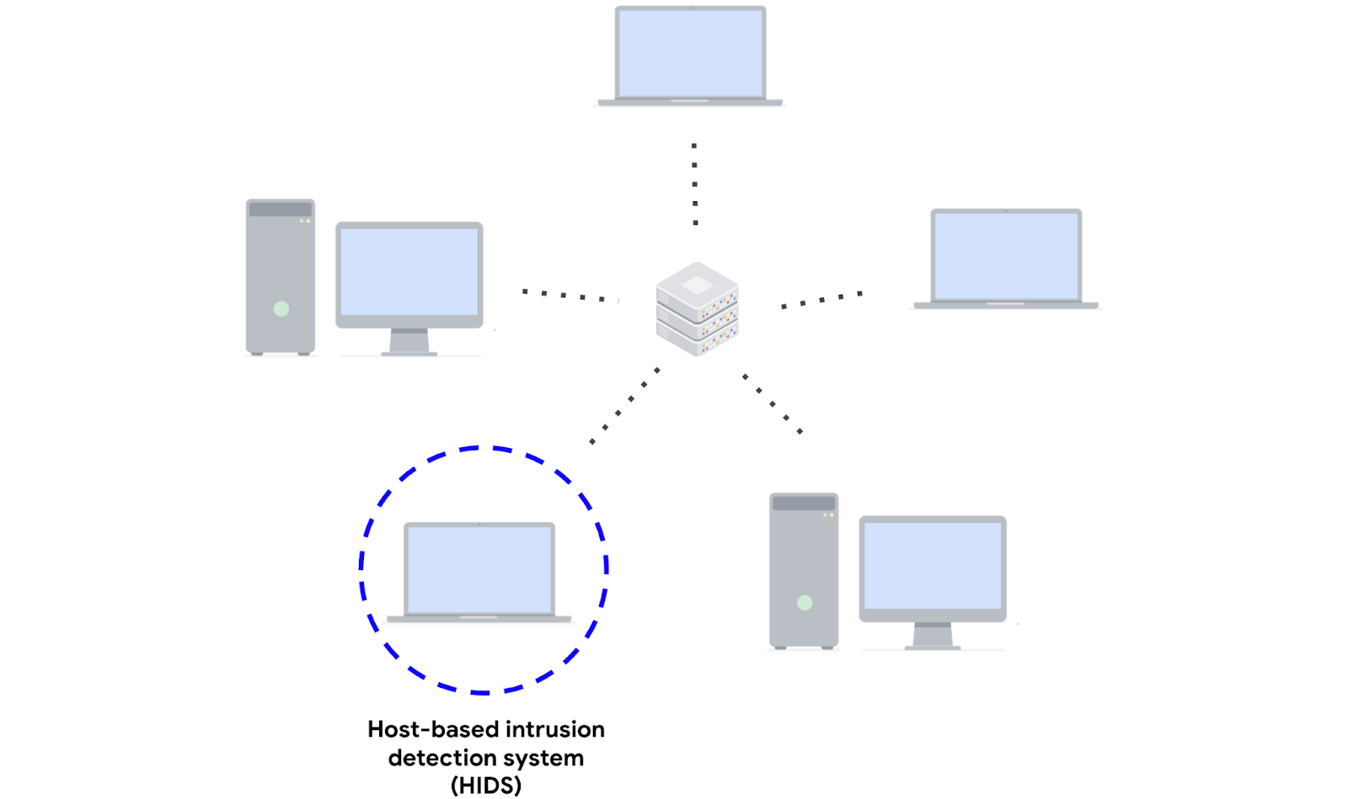

## Network-based intrusion detection system

A **network-based intrusion detection system** **(NIDS)** is an application that collects and monitors network traffic and network data. NIDS software is installed on devices located at specific parts of the network that you want to monitor. The NIDS application inspects network traffic from different devices on the network. If any malicious network traffic is detected, the NIDS logs it and generates an alert.

This diagram shows a NIDS that is installed on a network. The highlighted circle around the server and computers indicates that the NIDS is installed on the server and is monitoring the activity of the computers.

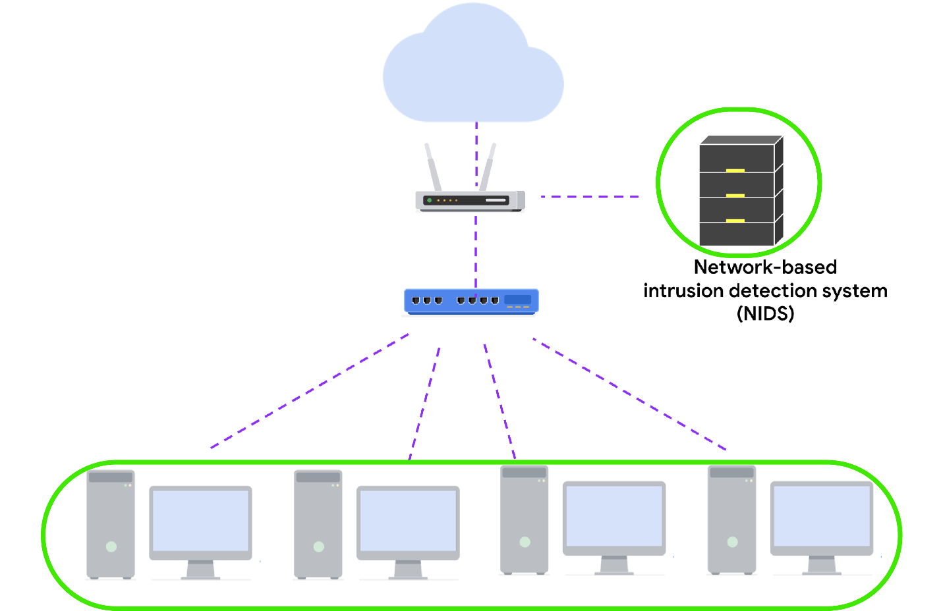

Using a combination of HIDS and NIDS to monitor an environment can provide a multi-layered approach to intrusion detection and response. HIDS and NIDS tools provide a different perspective on the activity occurring on a network and the individual hosts that are connected to it. This helps provide a comprehensive view of the activity happening in an environment.

## Detection techniques

Detection systems can use different techniques to detect threats and attacks. The two types of detection techniques that are commonly used by IDS technologies are signature-based analysis and anomaly-based analysis.

## Signature-based analysis

**Signature analysis**, or signature-based analysis, is a detection method that is used to find events of interest. A **signature** is a pattern that is associated with malicious activity. Signatures can contain specific patterns like a sequence of binary numbers, bytes, or even specific data like an IP address.

Previously, you explored the Pyramid of Pain, which is a concept that prioritizes the different types of **indicators of compromise** (IoCs) associated with an attack or threat, such as IP addresses, tools, tactics, techniques, and more. IoCs and other indicators of attack can be useful for creating targeted signatures to detect and block attacks.

Different types of signatures can be used depending on which type of threat or attack you want to detect. For example, an anti-malware signature contains patterns associated with malware. This can include malicious scripts that are used by the malware. IDS tools will monitor an environment for events that match the patterns defined in this malware signature. If an event matches the signature, the event gets logged and an alert is generated.

### **Advantages**

* **Low rate of false positives:** Signature-based analysis is very efficient at detecting known threats because it is simply comparing activity to signatures. This leads to fewer false positives. Remember that a **false positive** is an alert that incorrectly detects the presence of a threat.

### **Disadvantages**

* **Signatures can be evaded:** Signatures are unique, and attackers can modify their attack behaviors to bypass the signatures. For example, attackers can make slight modifications to malware code to alter its signature and avoid detection.
* **Signatures require updates:** Signature-based analysis relies on a database of signatures to detect threats. Each time a new exploit or attack is discovered, new signatures must be created and added to the signature database.
* **Inability to detect unknown threats:** Signature-based analysis relies on detecting known threats through signatures. Unknown threats can't be detected, such as new malware families or **zero-day** attacks, which are exploits that were previously unknown.

## Anomaly-based analysis

**Anomaly-based analysis** is a detection method that identifies abnormal behavior. There are two phases to anomaly-based analysis: a training phase and a detection phase. In the training phase, a baseline of normal or expected behavior must be established. Baselines are developed by collecting data that corresponds to normal system behavior. In the detection phase, the current system activity is compared against this baseline. Activity that happens outside of the baseline gets logged, and an alert is generated.

### **Advantages**

* **Ability to detect new and evolving threats:** Unlike signature-based analysis, which uses known patterns to detect threats, anomaly-based analysis can detect unknown threats.

### **Disadvantages**

* **High rate of false positives:** Any behavior that deviates from the baseline can be flagged as abnormal, including non-malicious behaviors. This leads to a high rate of false positives.
* **Pre-existing compromise:** The existence of an attacker during the training phase will include malicious behavior in the baseline. This can lead to missing a pre-existing attacker.

# Log sources and log ingestion

In this reading, you’ll explore more on the importance of log ingestion. You may recall that **security information and event management** (**SIEM**) tools collect and analyze log data to monitor critical activities in an organization. You also learned about **log analysis,** which is the process of examining logs to identify events of interest. Understanding how log sources are ingested into SIEM tools is important because it helps security analysts understand the types of data that are being collected, and can help analysts identify and prioritize security incidents.

## SIEM process overview

Previously, you covered the SIEM process. As a refresher, the process consists of three steps:

1. **Collect and aggregate data**: SIEM tools collect event data from various data sources.
2. **Normalize data**: Event data that's been collected becomes normalized. Normalization converts data into a standard format so that data is structured in a consistent way and becomes easier to read and search. While data normalization is a common feature in many SIEM tools, it's important to note that SIEM tools vary in their data normalization capabilities.
3. **Analyze data**: After the data is collected and normalized, SIEM tools analyze and correlate the data to identify common patterns that indicate unusual activity.

This reading focuses on the first step of this process, the collection and aggregation of data.

## Log ingestion

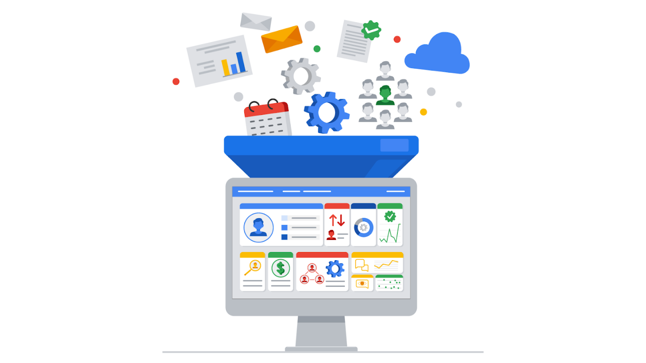

Data is required for SIEM tools to work effectively. SIEM tools must first collect data using log ingestion. Log ingestion is the process of collecting and importing data from log sources into a SIEM tool. Data comes from any source that generates log data, like a server.

In log ingestion, the SIEM creates a copy of the event data it receives and retains it within its own storage. This copy allows the SIEM to analyze and process the data without directly modifying the original source logs. The collection of event data provides a centralized platform for security analysts to analyze the data and respond to incidents. This event data includes authentication attempts, network activity, and more.

### Log forwarders

There are many ways SIEM tools can ingest log data. For instance, you can manually upload data or use software to help collect data for log ingestion. Manually uploading data may be inefficient and time-consuming because networks can contain thousands of systems and devices. Hence, it's easier to use software that helps collect data.

A common way that organizations collect log data is to use log forwarders. Log forwarders are software that automate the process of collecting and sending log data. Some operating systems have native log forwarders. If you are using an operating system that does not have a native log forwarder, you would need to install a third-party log forwarding software on a device. After installing it, you'd configure the software to specify which logs to forward and where to send them. For example, you can configure the logs to be sent to a SIEM tool. The SIEM tool would then process and normalize the data. This allows the data to be easily searched, explored, correlated, and analyzed.

**Note**: Many SIEM tools utilize their own proprietary log forwarders. SIEM tools can also integrate with open-source log forwarders. Choosing the right log forwarder depends on many factors such as the specific requirements of your system or organization, compatibility with your existing infrastructure, and more.

## Key takeaways

SIEM tools require data to be effective. As a security analyst, you will utilize SIEM tools to access events and analyze logs when you're investigating an incident. In your security career, you may even be tasked with configuring a SIEM to collect log data. It's important that you understand how data is ingested into SIEM tools because this enables you to understand where log sources come from which can help you identify the source of a security incident.

# Search methods with SIEM tools

So far, you’ve learned about how you can use **security information and event management (SIEM)** tools to search for security events such as failed login attempts. Remember, SIEM is an application that collects and analyzes log data to monitor critical activities in an organization. In this reading, you’ll examine how SIEM tools like Splunk and Chronicle use different search methods to find, filter, and transform search results.

Not all organizations use the same SIEM tool to gather and centralize their security data. As a security analyst, you’ll need to be ready to learn how to use different SIEM tools. It’s important to understand the different types of searches you can perform using SIEM tools so that you can find relevant event data to support your security investigations.

## Splunk searches

As you’ve learned, Splunk has its own querying language called **Search Processing Language (SPL)**. SPL is used to search and retrieve events from indexes using Splunk’s Search & Reporting app. An SPL search can contain many different commands and arguments. For example, you can use commands to transform your search results into a chart format or filter results for specific information.

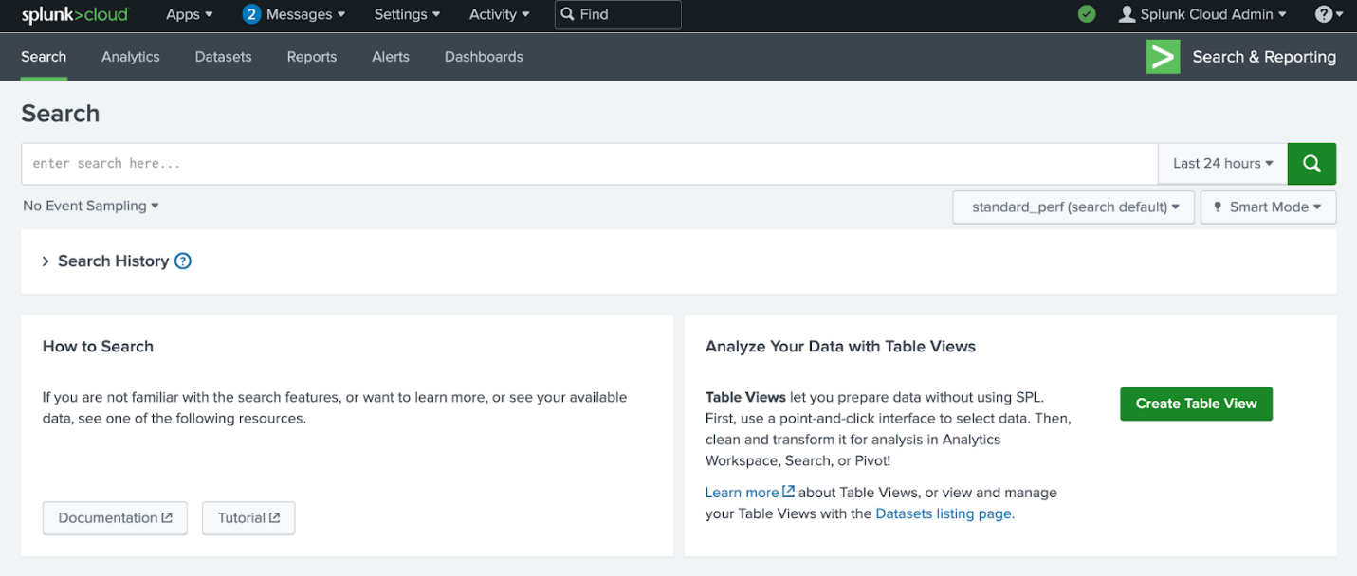

Here is an example of a basic SPL search that is querying an index for a failed event:

index=main fail

* index=main: This is the beginning of the search command that tells Splunk to retrieve events from an  index named main. An index stores event data that's been collected and processed by Splunk.
* fail: This is the search term. This tells Splunk to return any event that contains the term fail.

Knowing how to effectively use SPL has many benefits. It helps shorten the time it takes to return search results. It also helps you obtain the exact results you need from various data sources. SPL supports many different types of searches that are beyond the scope of this reading. If you would like to learn more about SPL, explore [Splunk's Search Reference](https://docs.splunk.com/Documentation/Splunk/9.0.2/SearchReference/UnderstandingSPLsyntax)

.

### **Pipes**

Previously, you might have learned about how piping is used in the Linux bash shell. As a refresher, piping sends the output of one command as the input to another command.

SPL also uses the pipe character | to separate the individual commands in the search. It's also used to chain commands together so that the output of one command combines into the next command. This is useful because you can refine data in various ways to get the results you need using a single command.

Here is an example of two commands that are piped together:

index=main fail| chart count by host

* index=main fail: This is the beginning of the search command that tells Splunk to retrieve events from an  index named main for events containing the search term fail.
* |: The pipe character separates and chains the two commands index=main and chart count by host. This means that the output of the first command index=main is used as the input of the second command chart count by host.
* chart count by host: This command tells Splunk to transform the search results by creating a chart according to the  count or number of events. The argument by host tells Splunk to list the events by host, which are the names of the devices the events come from. This command can be helpful in identifying hosts with excessive failure counts in an environment.

### **Wildcard**

A **wildcard** is a special character that can be substituted with any other character. A wildcard is usually symbolized by an asterisk character *. Wildcards match characters in string values. In Splunk, the wildcard that you use depends on the command that you are using the wildcard with. Wildcards are useful because they can help find events that contain data that is similar but not entirely identical. Here is an example of using a wildcard to expand the search results for a search term:

index=main fail*

* index=main: This command retrieves events from an index named main.
* fail*: The wildcard after fail represents any character. This tells Splunk to search for all possible endings that contain the term fail. This expands the search results to return any event that contains the term fail such as “failed” or “failure”.

**Pro tip**: Double quotations are used to specify a search for an exact phrase or string. For example, if you want to only search for events that contain the exact phrase login failure, you can enclose the phrase in double quotations "login failure". This search will match only events that contain the exact phrase login failure and not other events that contain the words failure or login separately.

## Chronicle searches

In Chronicle, you can search for events using the Search field. You can also use Procedural Filtering to apply filters to a search to further refine the search results. For example, you can use Procedural Filtering to include or exclude search results that contain specific information relating to an event type or log source. There are two types of searches you can perform to find events in Chronicle, a Unified Data Mode (UDM) Search or a Raw Log Search.

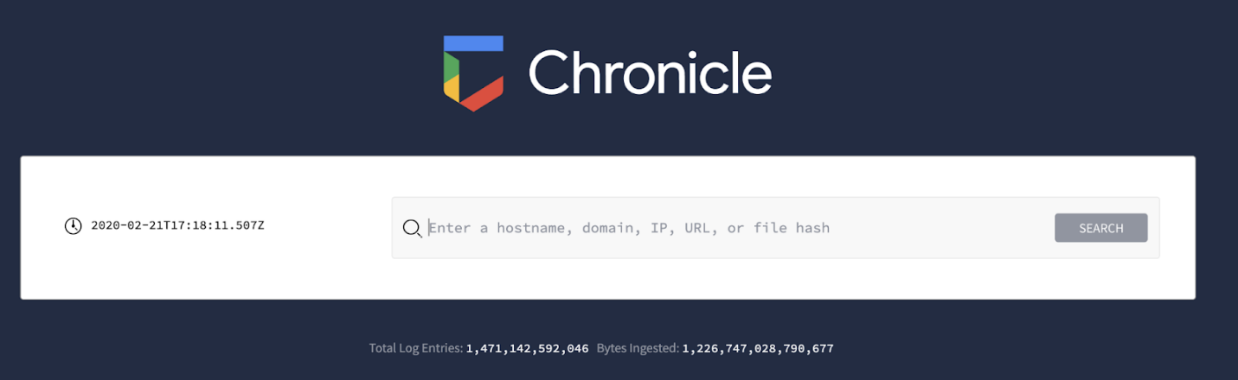

### **Unified Data Model (UDM) Search**

The UDM Search is the default search type used in Chronicle. You can perform a UDM search by typing your search, clicking on “Search,” and selecting “UDM Search.” Through a UDM Search, Chronicle searches security data that has been ingested, parsed, and normalized. A UDM Search retrieves search results faster than a Raw Log Search because it searches through indexed and structured data that’s normalized in UDM.

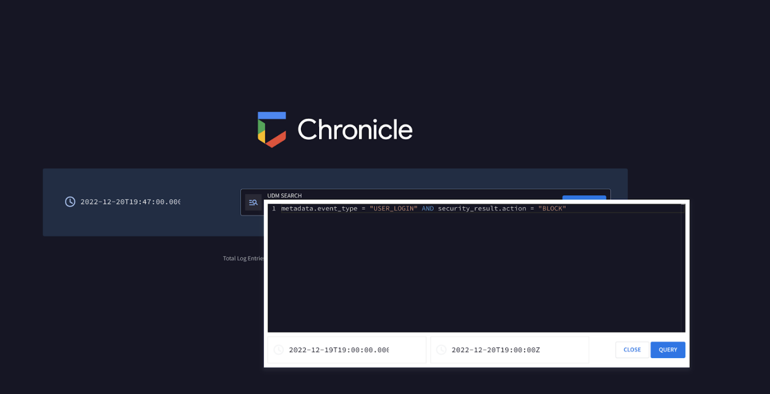

A UDM Search retrieves events formatted in UDM and these events contain UDM fields. There are many different types of UDM fields that can be used to query for specific information from an event. Discussing all of these UDM fields is beyond the scope of this reading, but you can learn more about UDM fields by exploring [Chronicle's UDM field list](https://cloud.google.com/chronicle/docs/reference/udm-field-list)

. Know that all UDM events contain a set of common fields including:

* **Entities**: Entities are also known as nouns. All UDM events must contain at least one entity. This field provides additional context about a device, user, or process that’s involved in an event. For example, a UDM event that contains entity information includes the details of the origin of an event such as the hostname, the username, and IP address of the event.
* **Event metadata**: This field provides a basic description of an event, including what type of event it is, timestamps, and more.
* **Network metadata**:This field provides information about network-related events and protocol details.
* **Security results**:This field provides the security-related outcome of events. An example of a security result can be an antivirus software detecting and quarantining a malicious file by reporting "virus detected and quarantined."

Here’s an example of a simple UDM search that uses the event metadata field to locate events relating to user logins:

metadata.event_type = “USER_LOGIN”

* metadata.event_type = “USER_LOGIN”: This UDM field metadata.event_type contains information about the event type. This includes information like timestamp, network connection, user authentication, and more. Here, the event type specifies USER_LOGIN, which searches for events relating to authentication.

Using just the metadata fields, you can quickly start searching for events. As you continue practicing searching in Chronicle using UDM Search, you will encounter more fields. Try using these fields to form specific searches to locate different events.

### **Raw Log Search**

If you can't find the information you are searching for through the normalized data, using a Raw Log Search will search through the raw, unparsed logs. You can perform a Raw Log Search by typing your search, clicking on “Search,” and selecting “Raw Log Search.” Because it is searching through raw logs, it takes longer than a structured search. In the Search field, you can perform a Raw Log Search by specifying information like usernames, filenames, hashes, and more. Chronicle will retrieve events that are associated with the search.

**Pro tip**: Raw Log Search supports the use of regular expressions, which can help you narrow down a search to match on specific patterns.

# Get to know Python

In this reading, you will explore how programming works, how a computer processes the Python programming language, and how Python is used in cybersecurity.

## How programming works

**Programming** is a process that can be used to create a specific set of instructions for a computer to execute tasks. Computer programs exist everywhere. Computers, cell phones, and many other electronic devices are all given instructions by computer programs.

There are multiple programming languages used to create computer programs. Python is one of these. Programming languages are converted to binary numbers, which are a series of 0s and 1s that represent the operations that the computer's central processing unit (CPU) should perform. Each instruction corresponds to a specific operation, such as adding two numbers or loading a value from memory.

It would be very time-consuming for humans to communicate this way. Programming languages like Python make it easier to write code because you can use less syntax when instructing computers to perform complex processes.

## Using Python to program

Python is a general purpose programming language that can be used to solve a variety of problems. For example, it can be used to build websites, perform data analysis, and automate tasks.

Python code must be converted through an interpreter before the computer can process it. An **interpreter** is a computer program that translates Python code into runnable instructions line by line.

### **Python versions**

There are multiple versions of Python. In this course, you are using Python 3. While using Python, it's important to keep track of the version you're using. There are differences in the syntax of each version. **Syntax** refers to the rules that determine what is correctly structured in a computing language.

## Python in cybersecurity

In cybersecurity, Python is used especially for automation. **Automation** is the use of technology to reduce human and manual effort to perform common and repetitive tasks. These are some specific areas of cybersecurity in which Python might be used to automate specific tasks:

* Log analysis
* Malware analysis
* Access control list management
* Intrusion detection
* Compliance checks
* Network scanning

# Python environments

You can run Python through a variety of environments. These environments include notebooks, integrated development environments (IDEs), and the command line. This reading will introduce you to these environments. It will focus primarily on notebooks because this is how you'll interact with Python in this course.

## Notebooks

One way to write Python code is through a notebook. In this course, you'll interact with Python through notebooks. A **notebook** is an online interface for writing, storing, and running code. They also allow you to document information about the code. Notebook content either appears in a code cell or markdown cell.

### **Code cells**

Code cells are meant for writing and running code. A notebook provides a mechanism for running these code cells. Often, this is a play button located within the cell. When you run the code, its output appears after the code.

### **Markdown cells**

Markdown cells are meant for describing the code. They allow you to format text in the markdown language. Markdown language is used for formatting plain text in text editors and code editors. For example, you might indicate that text should be in a certain header style.

### **Common notebook environments**

Two common notebook environments are [Jupyter Notebook](https://jupyter.org/about)

and [Google Colaboratory](https://colab.sandbox.google.com/)

(or Google Colab). They allow you to run several programming languages, including Python.

## Integrated development environments (IDEs)

Another option for writing Python code is through an **integrated development environment (IDE),** or a software application for writing code that provides editing assistance and error correction tools. Integrated development environments include a graphical user interface (GUI) that provides programmers with a variety of options to customize and build their programs.

## Command line

The command line is another environment that allows you to run Python programs. Previously, you learned that a **command-line interface (CLI)** is a text-based user interface that uses commands to interact with the computer. By entering commands into the command line, you can access all files and directories saved on your hard drive, including files containing Python code you want to run. You can also use the command line to open a file editor and create a new Python file.

# More about data types

Previously, you explored data types in Python. A **data type** is a category for a particular type of data item. You focused on string, list, float, integer, and Boolean data. These are the data types you'll work with in this course. This reading will expand on these data types. It will also introduce three additional types.

## String

In Python, **string data** is data consisting of an ordered sequence of characters. Characters in a string may include letters, numbers, symbols, and spaces. These characters must be placed within quotation marks. These are all valid strings:

* "updates needed"
* "20%"
* "5.0"
* "35"
* "**/**/**"
* ""

**Note:** The last item (""), which doesn't contain anything within the quotation marks, is called an empty string.

You can use the print() function to display a string. You can explore this by running this code:

1

updates needed

The code prints "updates needed".

You can place strings in either double quotation marks ("") or single quotation marks (''). The following code demonstrates that the same message prints when the string is in single quotation marks:

1

updates needed

**Note:** Choosing one type of quotation marks and using it consistently makes it easier to read your code. This course uses double quotation marks.

## List

In Python, **list data** is a data structure that consists of a collection of data in sequential form. Lists elements can be of any data type, such as strings, integers, Booleans, or even other lists. The elements of a list are placed within square brackets, and each element is separated by a comma. The following lists contains elements of various data types:

* [12, 36, 54, 1, 7]
* ["eraab", "arusso", "drosas"]
* [True, False, True, True]
* [15, "approved", True, 45.5, False]
* []

**Note:** The last item [], which doesn't contain anything within the brackets, is called an empty list.

You can also use the print() function to display a list:

1

This displays a list containing the integers 12, 36, 54, 1, and 7.

### **Integer**

In Python, **integer data** is data consisting of a number that does not include a decimal point. These are all examples of integer data:

* -100
* -12
* -1
* 0
* 1
* 20
* 500

Integers are not placed in quotation marks. You can use the print() function to display an integer. When you run this code, it displays 5:

1

You can also use the print() function to perform mathematical operations with integers. For example, this code adds two integers:

1

The result is 7. You can also subtract, multiply, or divide two integers.

## Float

**Float data** is data consisting of a number with a decimal point. All of the following are examples of float data:

* -2.2
* -1.34
* 0.0
* 0.34

Just like integer data, float data is not placed in quotation marks. In addition, you can also use the print() function to display float data or to perform mathematical calculations with float data. You can run the following code to review the result of this calculation:

1

The output is 4.0.

**Note:** Dividing two integer values or two float values results in float output when you use the symbol /:

1

2

The output of both calculations is the float value of .25.

If you want to return a whole number from a calculation, you must use the symbol // instead:

1

2

It will round down to the nearest whole number. In the case of print(1//4), the output is the integer value of 0 because using this symbol rounds down the calculation from .25 to the nearest whole number. In the case of print(1.0//4.0), the output is the float value of 0.0 because it maintains the float data type of the values in the calculation while also rounding down to the nearest whole number.

## Boolean

Boolean data is data that can only be one of two values: either True or False.

You should not place Boolean values in quotation marks. When you run the following code, it displays the Boolean value of True:

1

You can also return a Boolean value by comparing numbers. Because 9 is not greater than 10, this code evaluates to False:

1

## Additional data types

In this course, you will work with the string, list, integer, float and Boolean data types, but there are other data types. These additional data types include tuple data, dictionary data, and set data.

### **Tuple**

**Tuple data** is a data structure that consists of a collection of data that cannot be changed. Like lists, tuples can contain elements of varying data types.

A difference between tuple data and list data is that it is possible to change the elements in a list, but it is not possible to change the elements in a tuple. This could be useful in a cybersecurity context. For example, if software identifiers are stored in a tuple to ensure that they will not be altered, this can provide assurance that an access control list will only block the intended software.

The syntax of a tuple is also different from the syntax of a list. A tuple is placed in parentheses rather than brackets. These are all examples of the tuple data type:

* ("wjaffrey", "arutley", "dkot")
* (46, 2, 13, 2, 8, 0, 0)
* (True, False, True, True)
* ("wjaffrey", 13, True)

**Pro tip:** Tuples are more memory efficient than lists, so they are useful when you are working with a large quantity of data.

### **Dictionary**

**Dictionary data** is data that consists of one or more key-value pairs. Each key is mapped to a value. A colon (:) is placed between the key and value. Commas separate key-value pairs from other key-value pairs, and the dictionary is placed within curly brackets ({}).

Dictionaries are useful when you want to store and retrieve data in a predictable way. For example, the following dictionary maps a building name to a number. The building name is the value, and the number is the key. A colon is placed after the key.

{ 1: "East",

  2: "West",

  3: "North",

  4: "South" }

### **Set**

In Python, **set data** is data that consists of an unordered collection of unique values. This means no two values in a set can be the same.

Elements in a set are always placed within curly brackets and are separated by a comma. These elements can be of any data type. This example of a set contains strings of usernames:

{"jlanksy", "drosas", "nmason"}

# More on conditionals in Python

Previously, you explored conditional statements and how they’re useful in automating tasks in Python. So far, you’ve focused on the if and else keywords. In this reading, you’ll review these and learn another keyword, elif. You’ll also learn how you can apply the and, or, and not operators to your conditions.

## How conditional statements work

A **conditional statement** is a statement that evaluates code to determine whether it meets a specific set of conditions. When a condition is met, it evaluates to a Boolean value of True and performs specified actions. When the condition isn’t met, it evaluates a Boolean value of False and doesn’t perform the specified actions.

In conditional statements, the condition is often based on a comparison of two values. This table summarizes common comparison operators used to compare numerical values.

| **operator** | **use** |
| --- | --- |
| > | greater than |
| < | less than |
| >= | greater than or equal to |
| <= | less than or equal to |
| == | equal to |
| != | not equal to |

**Note:** The equal to (==) and not equal to (!=) operators are also commonly used to compare string data.

## if statements

The keyword if starts a conditional statement. It’s a necessary component of any conditional statement. In the following example, if begins a statement that tells Python to print an "OK" message when the HTTP response status code equals 200:

if status == 200:

    print("OK")

This code consists of a header and a body.

### **The header of an if statement**

The first line of this code is the header. In the header of an if statement, the keyword if is followed by the condition. Here, the condition is that the status variable is equal to a value of 200. The condition can be placed in parentheses:

if (status == 200):

    print("OK")

In cases like this one, placing parentheses around conditions in Python is optional. You might want to include them if it helps you with code readability. However, this condition will be processed the same way if written without parentheses.

In other situations, because Python evaluates the conditions in parentheses first, parentheses can affect how Python processes conditions. You will read more about one of these in the section of this reading on not.

**Note:** You must always place a colon (:) at the end of the header. Without this syntax, the code will produce an error.

**The body of an if statement**

After the header of an if statement comes the body of the if statement. This tells Python what action or actions to perform when the condition evaluates to True. In this example, there is just one action, printing "OK" to the screen. In other cases, there might be more lines of code with additional actions.

**Note:** For the body of the if statement to execute as intended, it must be indented further than the header. Additionally, if there are multiple lines of code within the body, they must all be indented consistently.

## Continuing conditionals with else and elif

In the previous example, if the HTTP status response code was not equal to 200, the condition would evaluate to False and Python would continue with the rest of the program. However, it’s also possible to specify alternative actions with else and elif.

### **else statements**

The keyword else precedes a code section that only evaluates when all conditions that precede it within the conditional statement evaluate to False.

In the following example, when the HTTP response status code is not equal to 200, it prints an alternative message of "check other status":

if status == 200:

    print("OK")

else:

    print("check other status")

**Note:** Like with if,a colon (:) is required after else, and the body that follows the else header is indented.

### **elif statements**

In some cases, you might have multiple alternative actions that depend on new conditions. In that case, you can use elif. The elif keyword precedes a condition that is only evaluated when previous conditions evaluate to False. Unlike with else, there can be multiple elif statements following if.

For example, you might want to print one message if the HTTP response status code is 200, one message if it is 400, and one if it is 500. The following code demonstrates how you can use elif for this:

if status == 200:

    print("OK")

elif status == 400:

    print("Bad Request")

elif status == 500:

    print("Internal Server Error")

Python will first check if the value of status is 200, and if this evaluates to False, it will go onto the first elif statement. There, it will check whether the value of status is 400. If that evaluates to True, it will print "Bad Request", but if it evaluates to False, it will go on to the next elif statement.

If you want the code to print another message when all conditions evaluate to False, then you can incorporate else after the last elif. In this example, if it reaches the else statement, it prints a message to check the status:

if status == 200:

    print("OK")

elif status == 400:

    print("Bad Request")

elif status == 500:

    print("Internal Server Error")

else:

    print("check other status")

Just like with if and else, it’s important to place a colon (:) after the elif header and indent the code that follows this header.

**Note:** Python processes multiple elif statements differently than multiple if statements. When it reaches an elif statement that evaluates to True, it won’t check the following elif statements. On the other hand, Python will run all if statements.

## Logical operators for multiple conditions

In some cases, you might want Python to perform an action based on a more complex condition. You might require two conditions to evaluate to True. Or, you might require only one of two conditions to evaluate to True. Or, you might want Python to perform an action when a condition evaluates to False. The operators and, or, and not can be used in these cases.

### **and**

The and operator requires both conditions on either side of the operator to evaluate to True. For example, all HTTP status response codes between 200 and 226 relate to successful responses. You can use and to join a condition of being greater than or equal to 200 with another condition of being less than or equal to 226:

if status >= 200 and status <= 226:

    print("successful response")

When both conditions are True, then the "successful response" message will print.

### **or**

The or operator requires only one of the conditions on either side of the operator to evaluate to True. For example, both a status code of 100 and a status code of 102 are informational responses. Using or, you could ask Python to print an "informational response" message when the code is either 100 or 102:

if status == 100 or status == 102:

    print("informational response")

Only one of these conditions needs to be met for Python to print the message.

### **not**

The not operator negates a given condition so that it evaluates to False if the condition is True and to True if it is False. For example, if you want to indicate that Python should check the status code when it’s something outside of the successful range, you can use not:

if not(status >= 200 and status <= 226):

    print("check status")

Python first checks whether the value of status is greater than or equal to 200 and less than or equal to 226, and then because of the operator not, it inverts this. This means it will print the message if status is less than 200 or greater than 226.

**Note:** In this case, the parentheses are necessary for the code to apply not to both conditions. Python will evaluate the conditions within the parentheses first. This means it will first evaluate the conditions on either side of the and operator and then apply not to both of them.

# More on loops in Python

Previously, you explored iterative statements. An **iterative statement** is code that repeatedly executes a set of instructions. Depending on the criteria, iterative statements execute zero or more times. We iterated through code using both for loops and while loops. In this reading, you’ll recap the syntax of loops. Then, you'll learn how to use the break and continue keywords to control the execution of loops.

## for loops

If you need to iterate through a specified sequence, you should use a for loop.

The following for loop iterates through a sequence of usernames. You can run it to observe the output:

1

2

The first line of this code is the loop header. In the loop header, the keyword for signals the beginning of a for loop. Directly after for, the loop variableappears. The **loop variable** is a variable that is used to control the iterations of a loop. In for loops, the loop variable is part of the header. In this example, the loop variable is i.

The rest of the loop header indicates the sequence to iterate through. The in operator appears before the sequence to tell Python to run the loop for every item in the sequence. In this example, the sequence is the list of usernames. The loop header must end with a colon (:).

The second line of this example for loop is the loop body. The body of the for loop might consist of multiple lines of code. In the body, you indicate what the loop should do with each iteration. In this case, it's to print(i), or in other words, to display the current value of the loop variable during that iteration of the loop. For Python to execute the code properly, the loop body must be indented further than the loop header.

**Note:** When used in a for loop, the in operator precedes the sequence that the for loop will iterate through. When used in a conditional statement, the in operator is used to evaluate whether an object is part of a sequence.  The example if "elarson" in ["tshah", "bmoreno", "elarson"] evaluates to True because "elarson" is part of the sequence following in.

## **Looping through a list**

Using for loops in Python allows you to easily iterate through lists, such as a list of computer assets. In the following for loop, asset is the loop variable and another variable, computer_assets, is the sequence. The computer_assets variable stores a list. This means that on the first iteration the value of asset will be the first element in that list, and on the second iteration, the value of asset will be the second element in that list. You can run the code to observe what it outputs:

1

2

3

**Note:** It is also possible to loop through a string. This will return every character one by one. You can observe this by running the following code block that iterates through the string "security":

1

2

3

### **Using  range()**

Another way to iterate through a for loop is based on a sequence of numbers, and this can be done with range(). The range() function generates a sequence of numbers. It accepts inputs for the start point, stop point, and increment in parentheses. For example, the following code indicates to start the sequence of numbers at 0, stop at 5, and increment each time by 1:

range(0, 5, 1)

**Note:** The start point is inclusive, meaning that 0 will be included in the sequence of numbers, but the stop point is exclusive, meaning that 5 will be excluded from the sequence. It will conclude one integer before the stopping point.

When you run this code, you can observe how 5 is excluded from the sequence:

1

2

You should be aware that it's always necessary to include the stop point, but if the start point is the default value of 0 and the increment is the default value of 1, they don't have to be specified in the code. If you run this code, you will get the same results:

1

2

**Note:** If the start point is anything other than 0 or the increment is anything other than 1, they should be specified.

## while loops

If you want a loop to iterate based on a condition, you should use a while loop. As long as the condition is True, the loop continues, but when it evaluates to False, the while loop exits. The following while loop continues as long as the condition that i < 5 is True:

1

2

3

4

In this while loop, the loop header is the line while i < 5:. Unlike with for loops, the value of a loop variable used to control the iterations is not assigned within the loop header in a while loop. Instead, it is assigned outside of the loop. In this example, i is assigned a starting value of 1 in a line preceding the loop.

The keyword while signals the beginning of a while loop. After this, the loop header indicates the condition that determines when the loop terminates. This condition uses the same comparison operators as conditional statements. Like in a for loop, the header of a while loop must end with a colon (:).

The body of a while loop indicates the actions to take with each iteration. In this example, it is to display the value of i and to increment the value of i by 1. In order for the value of i to change with each iteration, it's necessary to indicate this in the body of the while loop. In this example, the loop iterates four times until it reaches a value of 5.

### Integers in the loop condition

Often, as just demonstrated, the loop condition is based on integer values. For example, you might want to allow a user to log in as long as they've logged in less than five times. Then, your loop variable, login_attempts, can be initialized to 0, incremented by 1 in the loop, and the loop condition can specify to iterate only when the variable is less than 5. You can run the code below and review the count of each login attempt:

1

2

3

4

The value of login_attempts went from 0 to 4 before the loop condition evaluated to False. Therefore, the values of 0 through 4 print, and the value 5 does not print.

### Boolean values in the loop condition

Conditions in while loops can also depend on other data types, including comparisons of Boolean data. In Boolean data comparisons, your loop condition can check whether a loop variable equals a value like True or False. The loop iterates an indeterminate number of times until the Boolean condition is no longer True.

In the example below, a Boolean value is used to exit a loop when a user has made five login attempts. A variable called count keeps track of each login attempt and changes the login_status variable to False when the count equals 4. (Incrementing count from 0 to 4 represents five login attempts.) Because the while condition only iterates when login_status is True, it will exit the loop. You can run this to explore this output:

1

2

3

4

5

6

7

The code prints a message to try again four times, but exits the loop once login_status is set to False.

## Managing loops

You can use the break and continue keywords to further control your loop iterations. Both are incorporated into a conditional statement within the body of the loop. They can be inserted to execute when the condition in an if statement is True. The break keyword is used to break out of a loop. The continue keyword is used to skip an iteration and continue with the next one.

## **break**

When you want to exit a for or while loop based on a particular condition in an if statement being True, you can write a conditional statement in the body of the loop and write the keyword break in the body of the conditional.

The following example demonstrates this. The conditional statement with break instructs Python to exit the for loop if the value of the loop variable asset is equal to "desktop20". On the second iteration, this condition evaluates to True. You can run this code to observe this in the output:

1

2

3

4

5

As expected, the values of "desktop20" and "smartphone03" don't print because the loop breaks on the second iteration.

## **continue**

When you want to skip an iteration based on a certain condition in an if statement being True, you can add the keyword continue in the body of a conditional statement within the loop. In this example, continue will execute when the loop variable of asset is equal to "desktop20". You can run this code to observe how this output differs from the previous example with break:

1

2

3

4

5

The value "desktop20" in the second iteration doesn't print. However, in this case, the loop continues to the next iteration, and "smartphone03" is printed.

## Infinite loops

If you create a loop that doesn't exit, this is called an infinite loop. In these cases, you should press CTRL-C or CTRL-Z on your keyboard to stop the infinite loop. You might need to do this when running a service that constantly processes data, such as a web server.

# Python functions in cybersecurity

Previously, you explored how to define and call your own functions. In this reading, you’ll revisit what you learned about functions and examine how functions can improve efficiency in a cybersecurity setting.

## Functions in cybersecurity

A **function** is a section of code that can be reused in a program. Functions are important in Python because they allow you to automate repetitive parts of your code. In cybersecurity, you will likely adopt some processes that you will often repeat.

When working with security logs, you will often encounter tasks that need to be repeated. For example, if you were responsible for finding malicious login activity based on failed login attempts, you might have to repeat the process for multiple logs.

To work around that, you could define a function that takes a log as its input and returns all potentially malicious logins. It would be easy to apply this function to different logs.

## Defining a function

In Python, you'll work with built-in functions and user-defined functions. **Built-in functions** are functions that exist within Python and can be called directly. The print() function is an example of a built-in function.

**User-defined functions** are functions that programmers design for their specific needs. To define a function, you need to include a function header and the body of your function.

### **Function header**

The function header is what tells Python that you are starting to define a function. For example, if you want to define a function that displays an "investigate activity" message, you can include this function header:

def display_investigation_message():

The def keyword is placed before a function name to define a function. In this case, the name of that function is display_investigation_message.

The parentheses that follow the name of the function and the colon (:) at the end of the function header are also essential parts of the syntax.

**Pro tip**: When naming a function, give it a name that indicates what it does. This will make it easier to remember when calling it later.

### **Function body**

The body of the function is an indented block of code after the function header that defines what the function does. The indentation is very important when writing a function because it separates the definition of a function from the rest of the code.

To add a body to your definition of the display_investigation_message() function, add an indented line with the print() function. Your function definition becomes the following:

def display_investigation_message():

    print("investigate activity")

## Calling a function

After defining a function, you can use it as many times as needed in your code. Using a function after defining it is referred to as calling a function. To call a function, write its name followed by parentheses. So, for the function you previously defined, you can use the following code to call it:

display_investigation_message()

Although you'll use functions in more complex ways as you expand your understanding, the following code provides an introduction to how the display_investigation_message() function might be part of a larger section of code. You can run it and analyze its output:

1

2

3

4

5

6

7

8

9

10

application_log:

investigate activity

The display_investigation_message() function is used twice within the code. It will print "investigate activity" messages about two different logs when the specified conditions evaluate to True. In this example, only the first conditional statement evaluates to True, so the message prints once.

This code calls the function from within conditionals, but you might call a function from a variety of locations within the code.

**Note:** Calling a function inside of the body of its function definition can create an infinite loop. This happens when it is not combined with logic that stops the function call when certain conditions are met. For example, in the following function definition, after you first call func1(), it will continue to call itself and create an infinite loop:

def func1():

    func1()

Previously, you explored built-in functions in Python, including print(), type(), max(), and sorted(). **Built-in functions** are functions that exist within Python and can be called directly. In this reading, you’ll explore these further and also learn about the min() function. In addition, you'll review how to pass the output of one function into another function.

## print()

The print() function outputs a specified object to the screen. The print() function is one of the most commonly used functions in Python because it allows you to output any detail from your code.

To use the print() function, you pass the object you want to print as an argument to the function. The print() function takes in any number of arguments, separated by a comma, and prints all of them. For example, you can run the following code that prints a string, a variable, another string, and an integer together:

1

2

Investigate failed login attempts during September if more than 100

## type()

The type() function returns the data type of its argument. The type() function helps you keep track of the data types of variables to avoid errors throughout your code.

To use it, you pass the object as an argument, and it returns its data type. It only accepts one argument. For example, you could specify type("security") or type(7).

### Passing one function into another

When working with functions, you often need to pass them through print() if you want to output the data type to the screen. This is the case when using a function like type(). Consider the following code:

1

<class 'str'>

It displays str, which means that the argument passed to the type() function is a string. This happens because the type() function is processed first and its output is passed as an argument to the print() function.

## max() and min()

The max() function returns the largest numeric input passed into it. The min() function returns the smallest numeric input passed into it.

The max() and min() functions accept arguments of either multiple numeric values or of an iterable like a list, and they return the largest or smallest value respectively.

In a cybersecurity context, you could use these functions to identify the longest or shortest session that a user logged in for. If a specific user logged in seven times during a week, and you stored their access times in minutes in a list, you can use the max() and min() functions to find and print their longest and shortest sessions:

1

2

3

## sorted()

The sorted() function sorts the components of a list. The sorted() function also works on any iterable, like a string, and returns the sorted elements in a list. By default, it sorts them in ascending order. When given an iterable that contains numbers, it sorts them from smallest to largest; this includes iterables that contain numeric data as well as iterables that contain string data beginning with numbers. An iterable that contains strings that begin with alphabetic characters will be sorted alphabetically.

The sorted() function takes an iterable, like a list or a string, as an input. So, for example, you can use the following code to sort the list of login sessions from shortest to longest:

1

2

This displays the sorted list.

The sorted() function does not change the iterable that it sorts. The following code illustrates this:

1

2

3

[2, 12, 14, 19, 22, 32, 57]

[12, 2, 32, 19, 57, 22, 14]

The first print() function displays the sorted list. However, the second print() function, which does not include the sorted() function, displays the list as assigned to time_list in the first line of code.

One more important detail about the sorted() function is that it cannot take lists or strings that have elements of more than one data type. For example, you can’t use the list [1, 2, "hello"].

## Key takeaways

Built-in functions are powerful tools in Python that allow you to perform tasks with one simple command. The print() function prints its arguments to the screen, the type() function returns the data type of its argument, the min() and max() functions return the smallest and largest values of an iterable respectively, and sorted() organizes its argument.

## Resources for more information

# Import modules and libraries in Python

Previously, you explored libraries and modules. You learned that a **module** is a Python file that contains additional functions, variables, classes, and any kind of runnable code. You also learned that a **library** is a collection of modules that provide code users can access in their programs. You were introduced to a few modules in the Python Standard Library and a couple of external libraries. In this reading, you'll learn how to import a module that exists in the Python Standard Library and use its functions. You'll also expand your understanding of external libraries.

## The Python Standard Library

The **Python Standard Library** is an extensive collection of Python code that often comes packaged with Python. It includes a variety of modules, each with pre-built code centered around a particular type of task.

For example, you were previously introduced to the following modules in the Python Standard Library:

* The re module, which provides functions used for searching for patterns in log files
* The csv module, which provides functions used when working with .csv files
* The glob and os modules, which provide functions used when interacting with the command line
* The time and datetime modules, which provide functions used when working with timestamps

Another Python Standard Library module is statistics. The statistics module includes functions used when calculating statistics related to numeric data. For example, mean() is a function in the statistics module that takes numeric data as input and calculates its mean (or average). Additionally, median() is a function in the statistics module that takes numeric data as input and calculates its median (or middle value).

## How to import modules from the Python Standard Library

To access modules from the Python Standard Library, you need to import them. You can choose to either import a full module or to only import specific functions from a module.

### **Importing an entire module**

To import an entire Python Standard Library module, you use the import keyword. The import keyword searches for a module or library in a system and adds it to the local Python environment. After import, specify the name of the module to import. For example, you can specify import statistics to import the statistics module. This will import all the functions inside of the statistics module for use later in your code.

As an example, you might want to use the mean() function from the statistics module to calculate the average number of failed login attempts per month for a particular user. In the following code block, the total number of failed login attempts for each of the twelve months is stored in a list called monthly_failed_attempts. Run this code and analyze how mean() can be used to calculate the average of these monthly failed login totals and store it in mean_failed_attempts:

1

2

3

4

The output returns a mean of 35.25. You might notice the outlying value of 178 and want to find the middle value as well. To do this through the median() function, you can use the following code:

1

2

3

4

This gives you the value of 20.5, which might also be useful for analyzing the user's failed login attempt statistics.

**Note:** When importing an entire Python Standard Library module, you need to identify the name of the module with the function when you call it. You can do this by placing the module name followed by a period (.) before the function name. For example, the previous code blocks use statistics.mean() and statistics.median() to call those functions.

### **Importing specific functions from a module**

To import a specific function from the Python Standard Library, you can use the from keyword. For example, if you want to import just the median() function from the statistics module, you can write from statistics import median.

To import multiple functions from a module, you can separate the functions you want to import with a comma. For instance, from statistics import mean, median imports both the mean() and the median() functions from the statistics module.

An important detail to note is that if you import specific functions from a module, you no longer have to specify the name of the module before those functions. You can examine this in the following code, which specifically imports only the median() and the mean() functions from the statistics module and performs the same calculations as the previous examples:

1

2

3

4

5

6

It is no longer necessary to specify statistics.mean() or statistics.median() and instead the code incorporates these functions as mean() and median().

## External libraries

In addition to the Python Standard Library, you can also download external libraries and incorporate them into your Python code. For example, previously you were introduced to Beautiful Soup (bs4) for parsing HTML files and NumPy (numpy) for arrays and mathematical computations. Before using them in a Jupyter Notebook or a Google Colab environment, you need to install them first.

To install a library, such as numpy, in either environment, you can run the following line prior to importing the library:

%pip install numpy

This installs the library so you can use it in your notebook.

After a library is installed, you can import it directly into Python using the import keyword in a similar way to how you used it to import modules from the Python Standard Library. For example, after the numpy install, you can use this code to import it:

import numpy

# Ensure proper syntax and readability in Python

Previously, you were introduced to the PEP 8 style guide and its stylistic guidelines for programmers working in Python. You also learned about how adding comments and using correct indentation makes your code more readable. Additionally, correct indentation ensures your code is executed properly. This reading explores these ideas further and also focuses on common items to check in the syntax of your code to ensure it runs.

## Comments

A **comment** is a note programmers make about the intentions behind their code. Comments make it easier for you and other programmers to read and understand your code.

It’s important to start your code with a comment that explains what the program does. Then, throughout the code, you should add additional comments about your intentions behind specific sections.

When adding comments, you can add both single-line comments and multi-line comments.

### **Single-line comments**

Single-line comments in Python begin with the (#) symbol. According to the PEP 8 style guide, it’s best practice to keep all lines in Python under 79 characters to maintain readability, and this includes comments.

Single-line comments are often used throughout your program to explain the intention behind specific sections of code. For example, this might be when you're explaining simpler components of your program, such as the following for loop:

# Print elements of 'computer_assets' list

computer_assets = ["laptop1", "desktop20", "smartphone03"]

for asset in computer_assets:

    print(asset)

**Note:** Comments are important when writing more complex code, like functions, or multiple loops or conditional statements. However, they're optional when writing less complex code like reassigning a variable.

### **Multi-line comments**

Multi-line comments are used when you need more than 79 characters in a single comment. For example, this might occur when defining a function if the comment describes its inputs and their data types as well as its output.

There are two commonly used ways of writing multi-line comments in Python. The first is by using the hashtag (#) symbol over multiple lines:

# remaining_login_attempts() function takes two integer parameters,

# the maximum login attempts allowed and the total attempts made,

# and it returns an integer representing remaining login attempts

def remaining_login_attempts(maximum_attempts, total_attempts):

    return maximum_attempts - total_attempts

Another way of writing multi-line comments is by using documentation strings and not assigning them to a variable. Documentation strings, also called docstrings, are strings that are written over multiple lines and are used to document code. To create a documentation string, use triple quotation marks (""" """).

You could add the comment to the function in the previous example in this way too:

"""

remaining_login_attempts() function takes two integer parameters,

the maximum login attempts allowed and the total attempts made,

and it returns an integer representing remaining login attempts

"""

## Correct indentation

**Indentation** is space added at the beginning of a line of code. In Python, you should indent the body of conditional statements, iterative statements, and function definitions. Indentation is not only necessary for Python to interpret this syntax properly, but it can also make it easier for you and other programmers to read your code.

The PEP 8 style guide recommends that indentations should be four spaces long. For example, if you had a conditional statement inside of a while loop, the body of the loop would be indented four spaces and the body of the conditional would be indented four spaces beyond that. This means the conditional would be indented eight spaces in total.

count = 0

login_status = True

while login_status == True:

    print("Try again.")

    count = count + 1

    if count == 4:

        login_status = False

## Maintaining correct syntax

Syntax errors involve invalid usage of the Python language. They are incredibly common with Python, so focusing on correct syntax is essential in ensuring that your code runs. Awareness of common errors will help you more easily fix them.

Syntax errors often occur because of mistakes with data types or in the headers of conditional or iterative statements or of function definitions.

### Data types

Correct syntax varies depending on data type:

* Place string data in quotation marks.
  + Example: username = "bmoreno"
* Do not add quotation marks around integer, float, or Boolean data types.
  + Examples: login_attempts = 5, percentage_successful = .8, login_status = True
* Place lists in brackets and separate the elements of a list with commas.
  + Example: username_list = ["bmoreno", "tshah"]

### Colons in headers

The header of a conditional or iterative statement or of a function definition must end with a colon. For example, a colon appears at the end of the header in the following function definition:

def remaining_login_attempts(maximum_attempts, total_attempts):

    return maximum_attempts - total_attempts

## Key takeaways

The PEP 8 style guide provides recommendations for writing code that can be easily understood and read by other Python programmers. In order to make your intentions clear, you should incorporate comments into your code. Depending on the length of the comment, you can follow conventions for single-line or multi-line comments. It's also important to use correct indentation; this ensures your code will run as intended and also makes it easier to read. Finally, you should also be aware of common syntax issues so that you can more easily fix them.

## Resources for more information

# Strings and the security analyst

The ability to work with strings is important in the cybersecurity profession. Previously, you were introduced to several ways to work with strings, including functions and methods. You also learned how to extract elements in strings using bracket notation and indices. This reading reviews these concepts and explains more about using the .index() method. It also highlights examples of string data you might encounter in a security setting.

## String data in a security setting

As an analyst, string data is one of the most common data types you will encounter in Python. **String data** is data consisting of an ordered sequence of characters. It's used to store any type of information you don't need to manipulate mathematically (such as through division or subtraction). In a cybersecurity context, this includes IP addresses, usernames, URLs, and employee IDs.

You'll need to work with these strings in a variety of ways. For example, you might extract certain parts of an IP address, or you might verify whether usernames meet required criteria.

## Working with indices in strings

### Indices

An **index** is a number assigned to every element in a sequence that indicates its position. With strings, this means each character in the string has its own index.

Indices start at 0. For example, you might be working with this string containing a device ID: "h32rb17". The following table indicates the index for each character in this string:

| **character** | **index** |
| --- | --- |
| h | 0 |
| 3 | 1 |
| 2 | 2 |
| r | 3 |
| b | 4 |
| 1 | 5 |
| 7 | 6 |

You can also use negative numbers as indices. This is based on their position relative to the last character in the string:

| **character** | **index** |
| --- | --- |
| h | -7 |
| 3 | -6 |
| 2 | -5 |
| r | -4 |
| b | -3 |
| 1 | -2 |
| 7 | -1 |

### Bracket notation

**Bracket notation** refers to the indices placed in square brackets. You can use bracket notation to extract a part of a string. For example, the first character of the device ID might represent a certain characteristic of the device. If you want to extract it, you can use bracket notation for this:

"h32rb17"[0]

This device ID might also be stored within a variable called device_id. You can apply the same bracket notation to the variable:

device_id = "h32rb17"

device_id[0]

In both cases, bracket notation outputs the character h when this bracket notation is placed inside a print() function. You can observe this by running the following code:

1

2

3

You can also take a slice from a string. When you take a slice from a string, you extract more than one character from it. It's often done in cybersecurity contexts when you’re only interested in a specific part of a string. For example, this might be certain numbers in an IP address or certain parts of a URL.

In the device ID example, you might need the first three characters to determine a particular quality of the device. To do this, you can take a slice of the string using bracket notation. You can run this line of code to observe that it outputs "h32":

1

**Note:** The slice starts at the 0 index, but the second index specified after the colon is excluded.  This means the slice ends one position before index 3, which is at index 2.

## String functions and methods

The str() and len() functions are useful for working with strings. You can also apply methods to strings, including the .upper(), .lower(), and .index() methods. A **method** is a function that belongs to a specific data type.

### str() and len()

The str() function converts its input object into a string. As an analyst, you might use this in security logs when working with numerical IDs that aren't going to be used with mathematical processes. Converting an integer to a string gives you the ability to search through it and extract slices from it.

Consider the example of an employee ID 19329302 that you need to convert into a string. You can use the following line of code to convert it into a string and store it in a variable:

string_id = str(19329302)

The second function you learned for strings is the len() function, which returns the number of elements in an object.

As an example, if you want to verify that a certain device ID conforms to a standard of containing seven characters, you can use the len() function and a conditional. When you run the following code, it will print a message if "h32rb17" has seven characters:

1

2

3

### .upper() and .lower()

The .upper() method returns a copy of the string with all of its characters in uppercase. For example, you can change this department name to all uppercase by running the code "Information Technology".upper(). It would return the string "INFORMATION TECHNOLOGY".

Meanwhile, the .lower() method returns a copy of the string in all lowercase characters. "Information Technology".lower() would return the string "information technology".

### .index()

The .index()method finds the first occurrence of the input in a string and returns its location. For example, this code uses the .index() method to find the first occurrence of the character "r" in the device ID "h32rb17":

1

The .index() method returns 3 because the first occurrence of the character "r" is at index 3.

In other cases, the input may not be found. When this happens, Python returns an error. For instance, the code print("h32rb17".index("a")) returns an error because "a" is not in the string "h32rb17".

Also note that if a string contains more than one instance of a character, only the first one will be returned. For instance, the device ID "r45rt46" contains two instances of "r". You can run the following code to explore its output:

1

The output is 0 because .index() returns only the first instance of "r", which is at index 0. The instance of "r" at index 3 is not returned.

### Finding substrings with .index()

A **substring** is a continuous sequence of characters within a string. For example, "llo" is a substring of "hello".

The .index() method can also be used to find the index of the first occurrence of a substring. It returns the index of the first character in that substring. Consider this example that finds the first instance of the user "tshah" in a string:

1

2

The .index() method returns the index 7, which is where the substring "tshah" starts.

**Note:** When using the .index() method to search for substrings, you need to be careful. In the previous example, you want to locate the instance of "tshah". If you search for just "ts", Python will return 0 instead of 7 because "ts" is also a substring of "tsnow".

# Lists and the security analyst

Previously, you examined how to use bracket notation to access and change elements in a list and some fundamental methods for working with lists. This reading will review these concepts with new examples, introduce the .index() method as it applies to lists, and highlight how lists are used in a cybersecurity context.

## List data in a security setting

As a security analyst, you'll frequently work with lists in Python. **List data** is a data structure that consists of a collection of data in sequential form. You can use lists to store multiple elements in a single variable. A single list can contain multiple data types.

In a cybersecurity context, lists might be used to store usernames, IP addresses, URLs, device IDs, and data.

Placing data within a list allows you to work with it in a variety of ways. For example, you might iterate through a list of device IDs using a for loop to perform the same actions for all items in the list. You could incorporate a conditional statement to only perform these actions if the device IDs meet certain conditions.

## Working with indices in lists

### Indices

Like strings, you can work with lists through their indices, and indices start at 0. In a list, an index is assigned to every element in the list.

This table contains the index for each element in the list ["elarson", "fgarcia", "tshah", "sgilmore"]:

| **element** | **index** |
| --- | --- |
| "elarson" | 0 |
| "fgarcia" | 1 |
| "tshah" | 2 |
| "sgilmore" | 3 |

## Bracket notation

Similar to strings, you can use bracket notation to extract elements or slices in a list. To extract an element from a list, after the list or the variable that contains a list, add square brackets that contain the index of the element. The following example extracts the element with an index of 2 from the variable username_list and prints it. You can run this code to examine what it outputs:

1

2

This example extracts the element at index 2 directly from the list:

1

### **Extracting a slice from a list**

Just like with strings, it's also possible to use bracket notation to take a slice from a list. With lists, this means extracting more than one element from the list.

When you extract a slice from a list, the result is another list. This extracted list is called a sublist because it is part of the original, larger list.

To extract a sublist using bracket notation, you need to include two indices. You can run the following code that takes a slice from a list and explore the sublist it returns:

1

2

The code returns a sublist of ["elarson", "fgarcia"]. This is because the element at index 0, "elarson", is included in the slice, but the element at index 2, "tshah", is excluded. The slice ends one element before this index.

## Changing the elements in a list

Unlike strings, you can also use bracket notation to change elements in a list. This is because a string is **immutable** and cannot be changed after it is created and assigned a value, but lists are not immutable.

To change a list element, use similar syntax as you would use when reassigning a variable, but place the specific element to change in bracket notation after the variable name. For example, the following code changes the element at index 1 of the username_list variable to "bmoreno".

1

2

3

4

This code has updated the element at index 1 from "fgarcia" to "bmoreno".

## List methods

List methods are functions that are specific to the list data type. These include the .insert() , .remove(), .append() and .index().

### **.insert()**

The .insert() method adds an element in a specific position inside a list. It has two parameters. The first is the index where you will insert the new element, and the second is the element you want to insert.

You can run the following code to explore how this method can be used to insert a new username into a username list:

1

2

3

4

Because the first parameter is 2 and the second parameter is "wjaffrey", "wjaffrey" is inserted at index 2, which is the third position. The other list elements are shifted one position in the list. For example, "tshah" was originally located at index 2 and now is located at index 3.

### **.remove()**

The .remove() method removes the first occurrence of a specific element in a list. It has only one parameter, the element you want to remove.

The following code removes "elarson" from the username_list:

1

2

3

4

This code removes "elarson" from the list. The elements that follow "elarson" are all shifted one position closer to the beginning of the list.

**Note:** If there are two of the same element in a list, the .remove() method only removes the first instance of that element and not all occurrences.

### **.append()**

The .append() method adds input to the end of a list. Its one parameter is the element you want to add to the end of the list.

For example, you could use .append() to add "btang" to the end of the username_list:

1

2

3

4

This code places "btang" at the end of the username_list, and all other elements remain in their original positions.

The .append() method is often used with for loops to populate an empty list with elements. You can explore how this works with the following code:

1

2

3

4

5

Before the for loop, the numbers_list variable does not contain any elements. When it is printed, the empty list is displayed. Then, the for loop iterates through a sequence of numbers and uses the .append() method to add each of these numbers to numbers_list. After the loop, when the numbers_list variable is printed, it displays these numbers.

## .index()

Similar to the .index() method used for strings, the .index() method used for lists finds the first occurrence of an element in a list and returns its index. It takes the element you're searching for as an input.

**Note:** Although it has the same name and use as the .index() method used for strings, the .index() method used for lists is not the same method. Methods are defined when defining a data type, and because strings and lists are defined differently, the methods are also different.

Using the username_list variable, you can use the .index() method to find the index of the username "tshah":

1

2

3

Because the index of "tshah" is 2, it outputs this number.

Similar to the .index() method used for strings, it only returns the index of the first occurrence of a list item. So if the username "tshah" were repeated twice, it would return the index of the first instance, and not the second.

# More about regular expressions

You were previously introduced to regular expressions and a couple of symbols that you can use to construct regular expression patterns. In this reading, you'll explore additional regular expression symbols that can be used in a cybersecurity context. You'll also learn more about the re module and its re.findall() function.

## Basics of regular expressions

A **regular expression (regex)** is a sequence of characters that forms a pattern. You can use these in Python to search for a variety of patterns. This could include IP addresses, emails, or device IDs.

To access regular expressions and related functions in Python, you need to import the re module first. You should use the following line of code to import the re module:

import re

Regular expressions are stored in Python as strings. Then, these strings are used in re module functions to search through other strings. There are many functions in the re module, but you will explore how regular expressions work through re.findall(). The re.findall() function returns a list of matches to a regular expression. It requires two parameters. The first is the string containing the regular expression pattern, and the second is the string you want to search through.

The patterns that comprise a regular expression consist of alphanumeric characters and special symbols. If a regular expression pattern consists only of alphanumeric characters, Python will review the specified string for matches to this pattern and return them. In the following example, the first parameter is a regular expression pattern consisting only of the alphanumeric characters "ts". The second parameter, "tsnow, tshah, bmoreno",  is the string it will search through. You can run the following code to explore what it returns:

1

2

The output is a list of only two elements, the two matches to "ts": ['ts', 'ts'].

If you want to do more than search for specific strings, you must incorporate special symbols into your regular expressions.

## Regular expression symbols

### Symbols for character types

You can use a variety of symbols to form a pattern for your regular expression. Some of these symbols identify a particular type of character. For example, \w matches with any alphanumeric character.

**Note:** The \w symbol also matches with the underscore ( _ ).

You can run this code to explore what re.findall() returns when applying the regular expression of "\w" to the device ID of "h32rb17".

1

2

Because every character within this device ID is an alphanumeric character, Python returns a list with seven elements. Each element represents one of the characters in the device ID.

You can use these additional symbols to match to specific kinds of characters:

* . matches to all characters, including symbols
* \d matches to all single digits [0-9]
* \s matches to all single spaces
* \. matches to the period character

The following code searches through the same device ID as the previous example but changes the regular expression pattern to "\d". When you run it, it will return a different list:

1

2

This time, the list contains only four elements. Each element is one of the numeric digits in the string.

### Symbols to quantify occurrences

Other symbols quantify the number of occurrences of a specific character in the pattern. In a regular expression pattern, you can add them after a character or a symbol identifying a character type to specify the number of repetitions that match to the pattern.

For example, the + symbol represents one or more occurrences of a specific character. In the following example, the pattern places it after the "\d" symbol to find matches to one or more occurrences of a single digit:

1

2

With the regular expression "\d+", the list contains the two matches of "32" and "17".

Another symbol used to quantify the number of occurrences is the * symbol. The * symbol represents zero, one, or more occurrences of a specific character.  The following code substitutes the *  symbol for the + used in the previous example. You can run it to examine the difference:

1

2

Because it also matches to zero occurrences, the list now contains empty strings for the characters that were not single digits.

If you want to indicate a specific number of repetitions to allow, you can place this number in curly brackets ({ }) after the character or symbol. In the following example, the regular expression pattern "\d{2}" instructs Python to return all matches of exactly two single digits in a row from a string of multiple device IDs:

1

2

Because it is matching to two repetitions, when Python encounters a single digit, it checks whether there is another one following it. If there is, Python adds the two digits to the list and goes on to the next digit. If there isn't, it proceeds to the next digit without adding the first digit to the list.

**Note:** Python scans strings left-to-right when matching against a regular expression. When Python finds a part of the string that matches the first expected character defined in the regular expression, it continues to compare the subsequent characters to the expected pattern. When the pattern is complete, it starts this process again. So in cases in which three digits appear in a row, it handles the third digit as a new starting digit.

You can also specify a range within the curly brackets by separating two numbers with a comma. The first number is the minimum number of repetitions and the second number is the maximum number of repetitions. The following example returns all matches that have between one and three repetitions of a single digit:

1

2

The returned list contains elements of one digit like  "0", two digits like "32" and three digits like "825".

### Constructing a pattern

Constructing a regular expression requires you to break down the pattern you're searching for into smaller chunks and represent those chunks using the symbols you've learned. Consider an example of a string that contains multiple pieces of information about employees at an organization. For each employee, the following string contains their employee ID, their username followed by a colon (:), their attempted logins for the day, and their department:

employee_logins_string = "1001 bmoreno: 12 Marketing 1002 tshah: 7 Human Resources 1003 sgilmore: 5 Finance"

Your task is to extract the username and the login attempts, without the employee's ID number or department.

To complete this task with regular expressions, you need to break down what you're searching for into smaller components. In this case, those components are the varying number of characters in a username, a colon, a space, and a varying number of single digits. The corresponding regular expression symbols are \w+, :, \s, and \d+ respectively. Using these symbols as your regular expression, you can run the following code to extract the strings:

1

2

3

4

**Note:** Working with regular expressions can carry the risk of returning unneeded information or excluding strings that you want to return. Therefore, it's useful to test your regular expressions.

# Import files into Python

Previously, you explored how to open files in Python, convert them into strings, and read them. In this reading, you'll review the syntax needed for this. You'll also focus on why the ability to work with files is important for security analysts using Python, and you will learn about writing files.

## Working with files in cybersecurity

Security analysts may need to access a variety of files when working in Python. Many of these files will be logs. A **log** is a record of events that occur within an organization's systems.

For instance, there may be a log containing information on login attempts. This might be used to identify unusual activity that signals attempts made by a malicious actor to access the system.

As another example, malicious actors that have breached the system might be capable of attacking software applications. An analyst might need to access a log that contains information on software applications that are experiencing issues.

## Opening files in Python

To open a file called "update_log.txt" in Python for purposes of reading it, you can incorporate the following line of code:

with open("update_log.txt", "r") as file:

This line consists of the with keyword, the open() function with its two parameters, and the as keyword followed by a variable name. You must place a colon (:) at the end of the line.

### with

The keyword with handles errors and manages external resources when used with other functions. In this case, it's used with the open() function in order to open a file. It will then manage the resources by closing the file after exiting the with statement.

**Note:** You can also use the open() function without the with keyword. However, you should close the file you opened to ensure proper handling of the file.

### open()

The open() function opens a file in Python.

The first parameter identifies the file you want to open. In the following file structure, "update_log.txt" is located in the same directory as the Python file that will access it, "log_parser.ipynb":

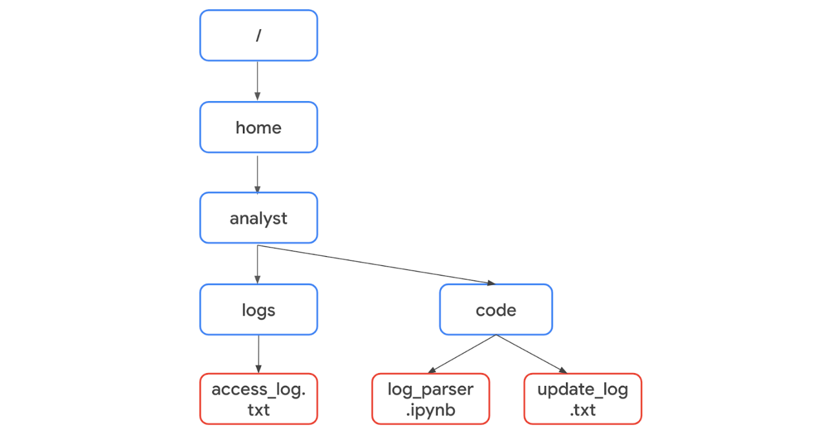

Because they're in the same directory, only the name of the file is required. The code can be written as with open("update_log.txt", "r") as file:.

However, "access_log.txt" is not in the same directory as the Python file "log_parser.ipynb". Therefore, it's necessary to specify its absolute file path. A **file path** is the location of a file or directory. An absolute file path starts from the highest-level directory, the root. In the following code, the first parameter of the open() function includes the absolute file path to "access_log.txt":

with open("/home/analyst/logs/access_log.txt", "r") as file:

**Note:** In Python, the names of files or their file paths can be handled as string data, and like all string data, you must place them in quotation marks.

The second parameter of the open() function indicates what you want to do with the file. In both of these examples, the second parameter is "r", which indicates that you want to read the file. Alternatively, you can use "w" if you want to write to a file or "a" if you want to append to a file.

### as

When you open a file using with open(), you must provide a variable that can store the file while you are within the with statement. You can do this through the keyword as followed by this variable name. The keyword as assigns a variable that references another object. The code with open("update_log.txt", "r") as file: assigns file to reference the output of the open() function within the indented code block that follows it.

## Reading files in Python

After you use the code with open("update_log.txt", "r") as file: to import "update_log.txt" into the file variable, you should indicate what to do with the file on the indented lines that follow it. For example, this code uses the .read() method to read the contents of the file:

with open("update_log.txt", "r") as file:

    updates = file.read()

print(updates)

The .read() method converts files into strings. This is necessary in order to use and display the contents of the file that was read.

In this example, the file variable is used to generate a string of the file contents through .read(). This string is then stored in another variable called updates. After this, print(updates) displays the string.

Once the file is read into the updates string, you can perform the same operations on it that you might perform with any other string. For example, you could use the .index() method to return the index where a certain character or substring appears. Or, you could use len() to return the length of this string.

## Writing files in Python

Security analysts may also need to write to files. This could happen for a variety of reasons. For example, they might need to create a file containing the approved usernames on a new allow list. Or, they might need to edit existing files to add data or to adhere to policies for standardization.

To write to a file, you will need to open the file with "w" or "a" as the second argument of open().

You should use the "w" argument when you want to replace the contents of an existing file. When working with the existing file update_log.txt, the code with open("update_log.txt", "w") as file: opens it so that its contents can be replaced.

Additionally, you can use the "w" argument to create a new file. For example, with open("update_log2.txt", "w") as file: creates and opens a new file called "update_log2.txt".

You should use the "a" argument if you want to append new information to the end of an existing file rather than writing over it. The code with open("update_log.txt", "a") as file: opens "update_log.txt" so that new information can be appended to the end. Its existing information will not be deleted.

Like when opening a file to read from it, you should indicate what to do with the file on the indented lines that follow when you open a file to write to it. With both "w" and "a", you can use the .write() method. The .write() method writes string data to a specified file.

The following example uses the .write() method to append the content of the line variable to the file "access_log.txt".

line = "jrafael,192.168.243.140,4:56:27,True"

with open("access_log.txt", "a") as file:

    file.write(line)

**Note:** Calling the .write() method without using the with keyword when importing the file might result in its arguments not being completely written to the file if the file is not properly closed in another way.

# Disaster recovery and business continuity

The role of a security professional is to ensure a company’s data and assets are protected from threats, risks, and vulnerabilities. However, sometimes things don’t go as planned. There are times when security incidents happen. You’ve already learned that security breaches can lead to financial consequences and the loss of credibility with customers or other businesses in the industry.

This reading will discuss the need to create business continuity and disaster recovery plans to minimize the impact of a security incident on an organization’s business operations. Analysts need to consider the sequence of steps to be taken by the security team before business continuity and disaster recovery plans are implemented.

## Identify and protect

Creating business continuity and disaster recovery plans are the final steps of a four-part process that most security teams go through to help ensure the security of an organization.

First, the security team identifies the assets that must be protected in the organization. Next, they determine what potential threats could negatively impact those assets. After the threats have been determined, the security team implements tools and processes to detect potential threats to assets. Lastly, the IT or appropriate business function creates the business continuity and disaster recovery plans. These plans are created in conjunction with one another. The plans help to minimize the impact of a security incident involving one of the organization’s assets.

## Business continuity plan

The impact of successful security attacks on an organization can be significant. Loss of profits and customers are two possible outcomes that organizations never want to happen. A **business continuity plan** is a document that outlines the procedures to sustain business operations during and after a significant disruption. It is created alongside a disaster recovery plan to minimize the damage of a successful security attack. Here are four essential steps for business continuity plans:

* **Conduct a business impact analysis.** The business impact analysis step focuses on the possible effects a disruption of business functions can have on an organization.
* **Identify, document, and implement steps to recover critical business functions and processes.** This step helps the business continuity team create actionable steps toward responding to a security event.
* **Organize a business continuity team.** This step brings various members of the organization together to help execute the business continuity plan, if it is needed. The members of this team are typically from the cybersecurity,  IT, HR, communications, and operations departments.
* **Conduct training for the business continuity team**. The team considers different risk scenarios and prepares for security threats during these training exercises.

## Disaster recovery plan

A **disaster recovery plan** allows an organization’s security team to outline the steps needed to minimize the impact of a security incident, such as a successful ransomware attack that has stopped the manufacturing team from retrieving certain data. It also helps the security team resolve the security threat. A disaster recovery plan is typically created alongside a business continuity plan. Steps to create a disaster recovery plan should include:

* Implementing recovery strategies to restore software
* Implementing recovery strategies to restore hardware functionality
* Identifying applications and data that might be impacted after a security incident has taken place

## Key takeaways

Disaster recovery and business continuity plans are important for an organization’s security posture. It’s essential that the security team has plans in place to keep the organization’s business operations moving forward in case a security incident does occur.

# Escalate with a purpose

You previously learned about security incident escalation and the skills needed to help you escalate incidents. In this reading, you’ll learn the importance of escalating security issues and the potential impact of failing to escalate an issue.

## Incident escalation

Security incident escalation is the process of identifying a potential security incident. During this process, potential incidents are transferred to a more experienced department or team member. As a security analyst, you’ll be expected to recognize potential issues, such as when an employee excessively enters the wrong credentials to their account, and report it to the appropriate person. When you join a new organization, you’ll learn about the specific processes and procedures for escalating incidents.

## Notification of breaches

Many countries have breach notification laws, so it's important to familiarize yourself with the laws applicable in the area your company is operating in. Breach notification laws require companies and government entities to notify individuals of security breaches involving personally identifiable information (PII). PII includes personal identification numbers (e.g., Social Security numbers, driver’s license numbers, etc.), medical records, addresses, and other sensitive customer information. As an entry-level security analyst, you’ll need to be aware of various security laws, especially because they are regularly updated.

## Low-level security issues

Low-level security issues are security risks that do not result in the exposure of PII. These issues can include the following and other risks:

* An employee having one failed login attempt on their account
* An employee downloading unapproved software onto their work laptop

These issues are not significant security challenges, but they must be investigated further in case they need to be escalated. An employee typing in a password two to three times might not be of concern. But if that employee types in a password 15 times within 30 minutes, there might be an issue that needs to be escalated. What if the multiple failed login attempts were a malicious actor attempting to compromise an employee’s account? What if an employee downloads an internet game or software on their work laptop that is infected with malware? You previously learned that malware is software designed to harm devices or networks. If malware is downloaded onto an organization’s network, it can lead to financial loss and even loss of reputation with the organization’s customers. While low-level security issues are not considered significant security threats, they should still be investigated to ensure they result in minimal impact to the organization.

## The escalation process

Every company has different protocols and procedures, including unique escalation policies. These policies detail who should be notified when a security alert is received and who should be contacted if the first responder is not available. The policy will also determine how someone should specifically escalate an incident, whether it’s via the IT desk, an incident management tool, or direct communication between security team members.

# Escalation timing

You previously learned about the potential impact even the smallest incident can have on an organization if the incident is not escalated properly. You also discovered just how important your role as an entry-level analyst will be to the effectiveness of an organization’s escalation process.

This reading will go into more detail about the role you’ll play in protecting an organization’s data and assets when it comes to escalating incidents.

## Your decisions matter

Security is a fast-paced environment with bad actors constantly trying to compromise an organization’s systems and data. This means security analysts must be prepared to make daily decisions to help keep a company’s data and systems safe. Entry-level security analysts help the security team escalate potential security incidents to the right team members. A big part of your role as a security analyst will be making decisions about which security events to escalate before they become major security incidents.

## Trust your instincts and ask questions

Confidence is an important attribute for a security analyst to have, especially when it comes to the escalation process. The security team will depend on you to be confident in your decision-making. You should be intentional about learning the organization’s escalation policy. This will help you gain confidence in making the right decisions when it comes to escalating security events. But remember to ask questions when necessary. It shows that you’re committed to constantly learning the right way to do your job.

## All security events are not equal

An important part of escalation is recognizing which assets and data are the most important for your organization. You can determine this information by reading through your onboarding materials, asking your supervisor directly about which assets and data are most important, and reviewing your company’s security policies. When you have that type of understanding, it allows you to recognize when one incident should be given a higher priority over others. You previously learned about the following incident classification types:

* **Malware infections:** Occur when malicious software designed to disrupt a system infiltrates an organization’s computers or network
* **Unauthorized access:** Occurs when an individual gains digital or physical access to a system, data,  or application without permission
* **Improper usage:** Occurs when an employee of an organization violates the organization’s acceptable use policies

Identifying a specific incident type allows you to properly prioritize and quickly escalate those incidents. Remember, an incident which directly impacts assets that are essential to business operations should always take priority over incidents that do not directly impact business operations. For example, an incident where unauthorized access has been gained to a manufacturing application should take priority over an incident where malware has infected a legacy system that does not impact business operations. As you gain experience in the cybersecurity field, you will learn how to quickly assess the priority levels of incident types.

## Quick escalation tips

A big part of your role in cybersecurity will be determining when to escalate a security event. Here are a few tips to help with this:

* Familiarize yourself with the escalation policy of the organization you work for.
* Follow the policy at all times.
* Ask questions.

# The purpose and impact of stakeholders

You previously learned about incident escalation and the various security incident classification types. You also learned about the impact these incidents can have on an organization’s business operations.

This reading will explore the individuals who have a significant interest in those business operations: stakeholders.

## Who are stakeholders?

A **stakeholder** is defined as an individual or group that has an interest in any decision or activity of an organization. A big part of what you’ll do as a security analyst is report your findings to various security stakeholders.

## Levels of stakeholders

There are many levels of stakeholders within larger organizations. As an entry-level analyst, you might only communicate directly with a few of them. Although you might not communicate with all of the security stakeholders in an organization, it’s important to have an understanding of who key stakeholders are:

* A cybersecurity risk manager is a professional responsible for leading efforts to identify, assess, and mitigate security risks within an organization.
* A Chief Executive Officer, also known as the CEO, is the highest ranking person in an organization. You are unlikely to communicate directly with this stakeholder as an entry-level analyst.
* A Chief Financial Officer, also known as the CFO, is another high-level stakeholder that you’re unlikely to communicate with directly.
* A Chief Information Security Officer, also known as the CISO, is the highest level of security stakeholder. You are also unlikely to communicate directly with this stakeholder as an entry-level analyst.
* An operations manager oversees the day-to-day security operations. These individuals lead teams related to the development and implementation of security strategies that protect an organization from cyber threats.

CFOs and CISOs are focused on the big picture, like the potential financial burden of a security incident, whereas other roles like operations managers are more focused on the impact on day-to-day operations. Although you will rarely interact directly with high-level security stakeholders, it’s still important to recognize their relevance.

## Stakeholder communications for entry-level analysts

Two examples of security stakeholders with whom you might regularly communicate are operations managers and risk managers. When you report to these stakeholders, you'll need to clearly communicate the current security issue and its possible causes. The operations managers will then determine next steps and coordinate other team members to remediate or resolve the issue.

For example, you might report multiple failed login attempts by an employee to your operations manager. This stakeholder might contact the employee’s supervisor to ensure the occurrence is a genuine issue of entering the wrong password or determine if the account has been compromised. The stakeholder and supervisor might also need to discuss the consequences for day-to-day operations if genuine failed login attempts can lead to account lockouts that might impact business operations. As an entry-level security analyst, you might play a role in implementing preventative measures once next steps have been determined.

## From one stakeholder to the next

Operations managers and risk managers are stakeholders who rely on entry-level analysts and other team members to keep them informed of security events in day-to-day operations. These stakeholders commonly report back to the CISOs and CFOs to give a broader narrative of the organization's overall security picture. Although you won't regularly communicate with high-level stakeholders, it's important to recognize that your efforts still reach the highest levels of security stakeholders in the organization. These other members of your team keep those top-level stakeholders informed on the security measures and protocols in place that are continuously helping to protect the organization.

## Key takeaways

Stakeholders play a major role in ensuring the security of an organization. Entry-level analysts should have a foundational understanding of the different levels of security stakeholders within an organization. Entry-level analysts will not communicate with every security stakeholder in a company, but there are certain stakeholders that the analyst will need to provide updates to. Those updates will eventually be reported up to the more senior-level stakeholders, such as the CISO and the CFO.

# Apply the STAR method during interviews

You’ve been learning about different techniques and strategies to use during future interviews for jobs in the cybersecurity field. In this reading, you’ll learn more details about the STAR method for answering interview questions. Implementing this strategy will help you answer interview questions with confidence and clarity.

## The STAR method

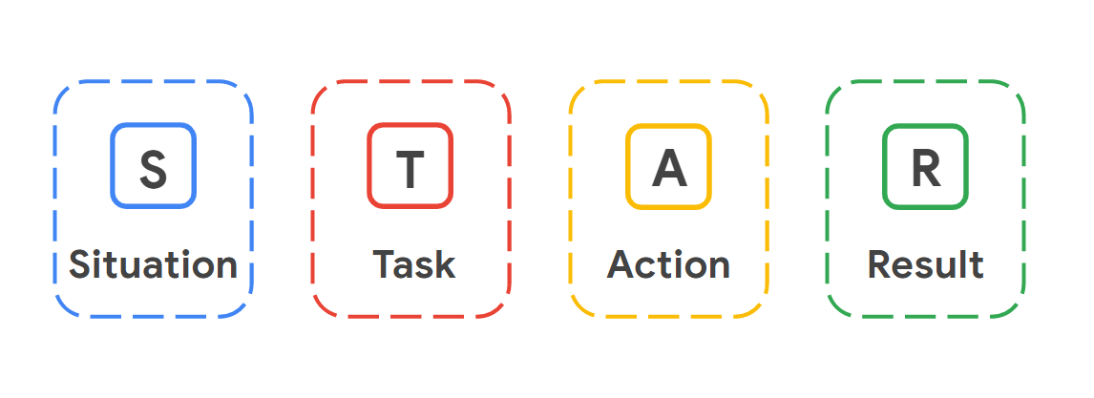

When interviewing for a job, it can be challenging to convey the right details about your professional history and skills to your interviewers. Using the STAR method can help you share your success stories effectively and strategically. STAR stands for Situation, Task, Action, and Result. Using this method enables you to describe potential challenges you faced in previous roles and gives you the opportunity to show how you thoughtfully approached solving those problems from start to finish.

### **Situation**

The **situation** is the project you worked on or a challenge that you had to overcome. For example, perhaps you had to manage a disgruntled customer’s negative feedback about your company,  a system error on your work device that slowed down a customer transaction, or being left alone in the office for an extended period of time. Fully describing the situation allows the interviewer to gain a clear understanding of the challenge you had to overcome.

### **Task**

The **task** outlines the key responsibilities or role you played in solving the challenge described in the situation phase of the STAR method. Specifying what the task is provides clarity about what your objectives were in this scenario.

### **Action**

The **action** describesthe exact steps you took to resolve the challenging situation you described in the beginning of the STAR method. The action is crucial to the STAR method because it allows the employer to understand what choices you made to achieve your desired outcome during a real conflict or challenge. Employers want employees who can think fast and make decisions that help solve problems.

### **Result**

Finally, sharing the **result** of your challenge or example shows the employers how the situation was resolved as a direct result of the actions you took. When participating in an interview, you want to make sure that any example you give with the STAR method ends in a positive result. Positive results show an employer that you are someone who has demonstrated an ability to successfully resolve issues and may lead an employer to offer you a job. Of course, not all situations have completely positive outcomes; if an employer asks you about a situation that didn’t have a positive outcome, try to focus on what you learned from the situation and how that experience helped you become a better employee.

## Key takeaways

The STAR method stands for Situation, Task, Action, and Result. Following this method helps you communicate to an employer an example of a challenge you faced in the workplace. Remember to use one of your success stories when using the STAR method on an interview. Challenges arise all the time in the security world, so being able to demonstrate an ability to overcome any type of challenge is a great trait to show off during an interview. Plus, since cybersecurity is such a team-driven industry, being able to communicate effectively to an interviewer will help you be a competitive applicant.

**Take the CompTIA Security+ exam**

The Google Cybersecurity Certificate helps prepare you for the [CompTIA Security+ exam](https://www.comptia.org/certifications/security)

, the industry-leading certification for cybersecurity roles. You’ll earn a dual credential when you complete both, which can be shared with potential employers.

As a Google Cybersecurity Certificate graduate, you have unlocked a [30% discount for the CompTIA Security+ exam](https://store.comptia.org/comptia-security-plus-exam-voucher/p/SEC-601-TSTV-20-C)

and additional [practice materials](https://store.comptia.org/comptia-certmaster-practice-for-security-plus-individual-license/p/SEC-601-CMPI-20-C). Go to the [CompTIA Store](http://store.comptia.org) and enter the discount code "GoogleSecurity2024," to buy a voucher so you can take your exam (a $117 value)